**National Smokejumper Program**

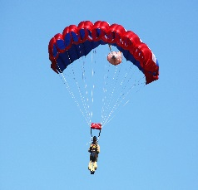



**2017 Fire Season Summary**

**November 9, 2017**

The following is a summary of the fire season, land management support, Sherpa transition, and Ram-Air parachute system transition for the Forest Service Smokejumper program 2017.

**Personnel**

This year there were 287 Forest Service Smokejumpers out of a target of 329 located across seven bases. Numbers were down by 43 or 13% due to multiple factors such as 1039/perm hiring process, attrition, and unsuccessful rookies.

**Fire Season**

Fire jumps and the number of fires jumped were higher this fire season compared to the 10-year average. The following data is for jumps out of Forest Service bases and spike bases it does not include BLM or Forest Service boosters to BLM bases.

|  |  |  |  |  |  |  |  |  |  |  |
| --- | --- | --- | --- | --- | --- | --- | --- | --- | --- | --- |
| **Smokejumper Bases** | | | | | **Spike Bases** | | | | | |
| **SJ Base** | **Fire Jumps** | **Fires**  **Jumped** | **Fires**  **Ground** | **Days on Fire**  **JMP & GRD** | **Spike Base** | **Days in Op** | **Fire Jumps** | **Fires Jumped** | **Fires**  **Ground** | **Days on Fire**  **JMP & GRD** |
| Missoula | 166 | 28 | 6 | 1361 | Lewiston, ID | 3 | 0 | 0 | 0 | 0 |
| Grangeville | 132 | 22 | 3 | 717 | Silver City, NM | 56 | 0 | 0 | 2 | 184 |
| West Yellowstone | 110 | 18 | 0 | 541 | Albuquerque, NM | 24 | 0 | 0 | 3 | 31 |
| McCall | 188 | 29 | 10 | 1413 | Miles City, MT | 54 | 99 | 17 | 2 | 335 |
| Redding | 367 | 52 | 11 | 1590 | Winnemucca, NV | 71 | 71 | 20 | 3 | 307 |
| North Cascades | 119 | 37 | 2 | 509 | Medford, OR | 8 | 24 | 6 | 0 | 72 |
| Redmond | 229 | 41 | 5 | 787 | LaGrande, OR | 10 | 39 | 10 | 0 | 170 |
| ***2017 Totals***  ***(SMJ + Spike)*** | ***1579*** | ***287*** | ***47*** | ***8042*** | Porterville, CA | 36 | 22 | 7 | 0 | 25 |
| ***10-Year AVG*** | ***1420*** | ***252*** | ***N/A*** | ***9,185*** | Fresno, CA | 2 | 9 | 1 | 0 | 3 |

*Boosters*

The following table displays jumpers filled or received on a “boost” request by base. An interesting note is that Redding (RDD) had only 80 booster fills out of 214 booster request. Booster filled and received differ because BLM data was not utilized for this report.

|  |  |  |  |  |  |  |  |  |  |
| --- | --- | --- | --- | --- | --- | --- | --- | --- | --- |
| **Boosters** | **MSO** | **GAC** | **WYS** | **MYL** | **RDD** | **RAC** | **NCSB** | **WMC** | **Total** |
| Filled | 9 | 25 | 65 | 55 | 0 | 50 | 30 | 5 | 240 |
| Received | 0 | 13 | 15 | 11 | 80 | 40 | 11 | 10 | 176 |

*Single Resource Assignments*

Forest Service Smokejumpers spent a total of 3,287 days on single resource assignments (includes initial/extended attack), which averages to 12-days or 1 assignment per smokejumperand is slightly below the 10-year average of 13-days per smokejumper. The table below highlights the number of both qualified and training assignments by advanced qualifications, many of which are national critical needs.

|  |  |  |  |  |  |  |
| --- | --- | --- | --- | --- | --- | --- |
|  | **ATGS** | **ICT3** | **DIVS** | **TFLD** | **CRWB** | **All** |
| Missoula | 0 | 17 | 13 | 11 | 10 | 60 |
| West Yellowstone | 0 | 0 | 6 | 1 | 4 | 11 |
| Grangeville | 0 | 6 | 3 | 2 | 3 | 35 |
| McCall | 4 | 1 | 9 | 20 | 2 | 57 |
| Redding | 2 | 9 | 3 | 5 | 9 | 34 |
| Redmond | 10 | 1 | 3 | 8 | 5 | 58 |
| North Cascades | 5 | 4 | 7 | 8 | 3 | 33 |
| **Totals** | **21** | **38** | **44** | **55** | **36** | **288** |

*Para-Cargo*

Of special note is the testing and evaluation of the Airborne Guidance Unit (AGU) in Redding, Ca this season. The AGU delivers para-cargo on a GPS guidance system. The AGU can be dropped at an altitude above ground between 3,000-25,000 feet. This is a promising technology to deliver critical supplies at night and during periods of poor visibility due to smoke.

The table below displays the number and pounds of paracargo delivered in support of fire suppression. Normal smokejumper para-cargo operations for initial/extended attack, and cargo delivered by smokejumper aircraft are not included.

|  |  |  |  |  |  |  |  |  |
| --- | --- | --- | --- | --- | --- | --- | --- | --- |
|  | **MSO** | **GAC** | **WYS** | **MYL** | **RDD** | **RAC** | **NCSB** | **Total** |
| **PC Requests** | 5 | 0 | 1 | 4 | 11 | 5 | 3 | **29** |
| **LBS of PC** | 20,200 | 0 | 801 | 2,878 | 19,950 | 12,500 | 5,575 | **61,904** |

**Rx and Land Management Support Assignments**

Smokejumpers continue to support land managers with prescribed fire and other land management (LM) activities. This year smokejumpers supported Rx for 1,428-days which is much less than the 10-year average of 2,363-days. This drop can be contributed to the time commitment of the transition to the Ram-Air parachute system. These impacts are expected to be temporary, but could last for several years. The following table displays the combined effort of the jump program.

|  |  |  |
| --- | --- | --- |
| **# of Rx Fire Assignments** | **Rx Fire Support (days)** | **Other LM Projects (days)** |
| 94 | 1,428 | 665 |

**Days Committed to Fire Suppression & Project Support**

This year smokejumpers were committed on fire suppression and land management support for a total 19,963-days, which averages to 70-days per smokejumper. The table below does not include daily fire preparedness/support, paracargo support, and miscellaneous projects.

|  |  |  |  |  |  |
| --- | --- | --- | --- | --- | --- |
| **Days on Fire**  **(JMP & GRD)** | **Single Resource Assignments** | **Rx Fire Support (days)** | **Other LM Projects (days)** | **Ram-Air**  **TRNG & Support**  **(estimate)** | **Total** |
| 8,042 | 3,287 | 1,428 | 665 | 6,550 | 19,963 |

**Smokejumper Injury Rates**

There were 6 minor and 4 serious injuries reported in 2017. The 2017 injury rates are significantly lower than the 25-year average.

|  |  |  |  |  |  |  |  |  |  |  |  |
| --- | --- | --- | --- | --- | --- | --- | --- | --- | --- | --- | --- |
| **Injuries 2017** | **MSO** | | **GAC** | **WYS** | | **MYL** | | **RDD** | **RAC** | | **NCSB** |
| **Minor** | 3 | | 0 | 0 | | 2 | | 1 | 0 | | 0 |
| **Serious** | 2 | | 0 | 0 | | 1 | | 0 | 1 | | 0 |
| **Injury Rates**  **2017/25-yrs** | | **2017** | | | | | **1992 to 2017** | | | | |
| **Practice** | | | **Fire** | | **Practice** | | | **Fire** | |
| **Minor Rate** | | 0.04% | | | 0.29% | | 0.10% | | | 0.37% | |
| **Serious Rate** | | 0.02% | | | 0.07% | | 0.06% | | | 0.28% | |

**Smokejumper Aircraft**

There were 6 agency owned aircraft, 6 exclusive use, and 1 call when needed aircraft utilized by the Forest Service Smokejumper program in 2017. Agency aircraft flew a total of 1,117 hours, and contract aircraft flew a total of 789 hours for a combined total of 1,906 hours in support of fire suppression, fire support, and support of land management activities. The table below displays the total hours of flight time by each aircraft.

**SD3-60 Sherpa Aircraft Transition**

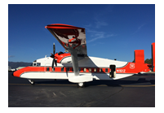

Delivery was originally scheduled for July of this year, but due to delays in the avionics system the first SD3-60 Sherpa is anticipated in December of 2017. The remaining nine Sherpa’s are expected to follow every six weeks until completed. In 2018 there should be 2-3 operational Sherpa’s in the smokejumper program.

The SD3-60 Sherpa Change Management Plan and Operations Plan have also been completed this year. The Smokejumper Aircraft Screening and Evaluation Sub-Committee is scheduled to begin evaluating the SD3-60 in March of 2018. Sherpa 161Z was used in a limited logistical role this season. Missions included a line of duty death transport, and as a display at the Oshkosh Airshow in Wisconsin.

**Ram Air Transition**

2017 marks the second year of the transition from the round FS-14 parachute system to the Ram-Air parachute system. The Ram-Air transition training (RATT) initially began as a test/evaluation program in 2008 under the guidance and training of the BLM Smokejumper Program. The following highlights accomplishments for this year:

* 26 jumpers transitioned to the Ram Air parachute this year

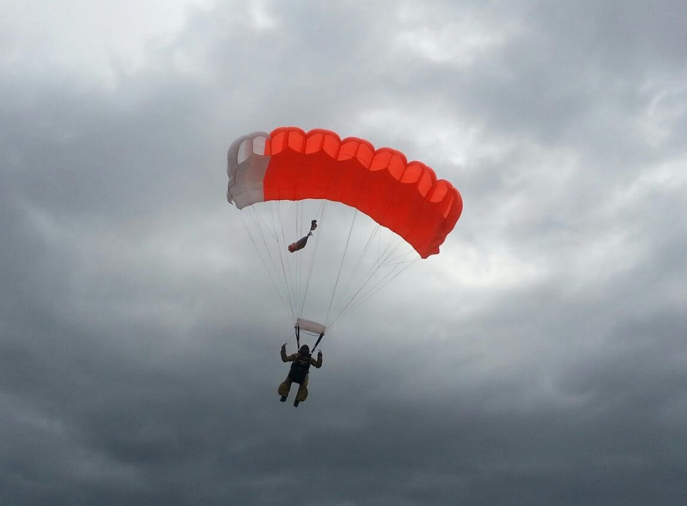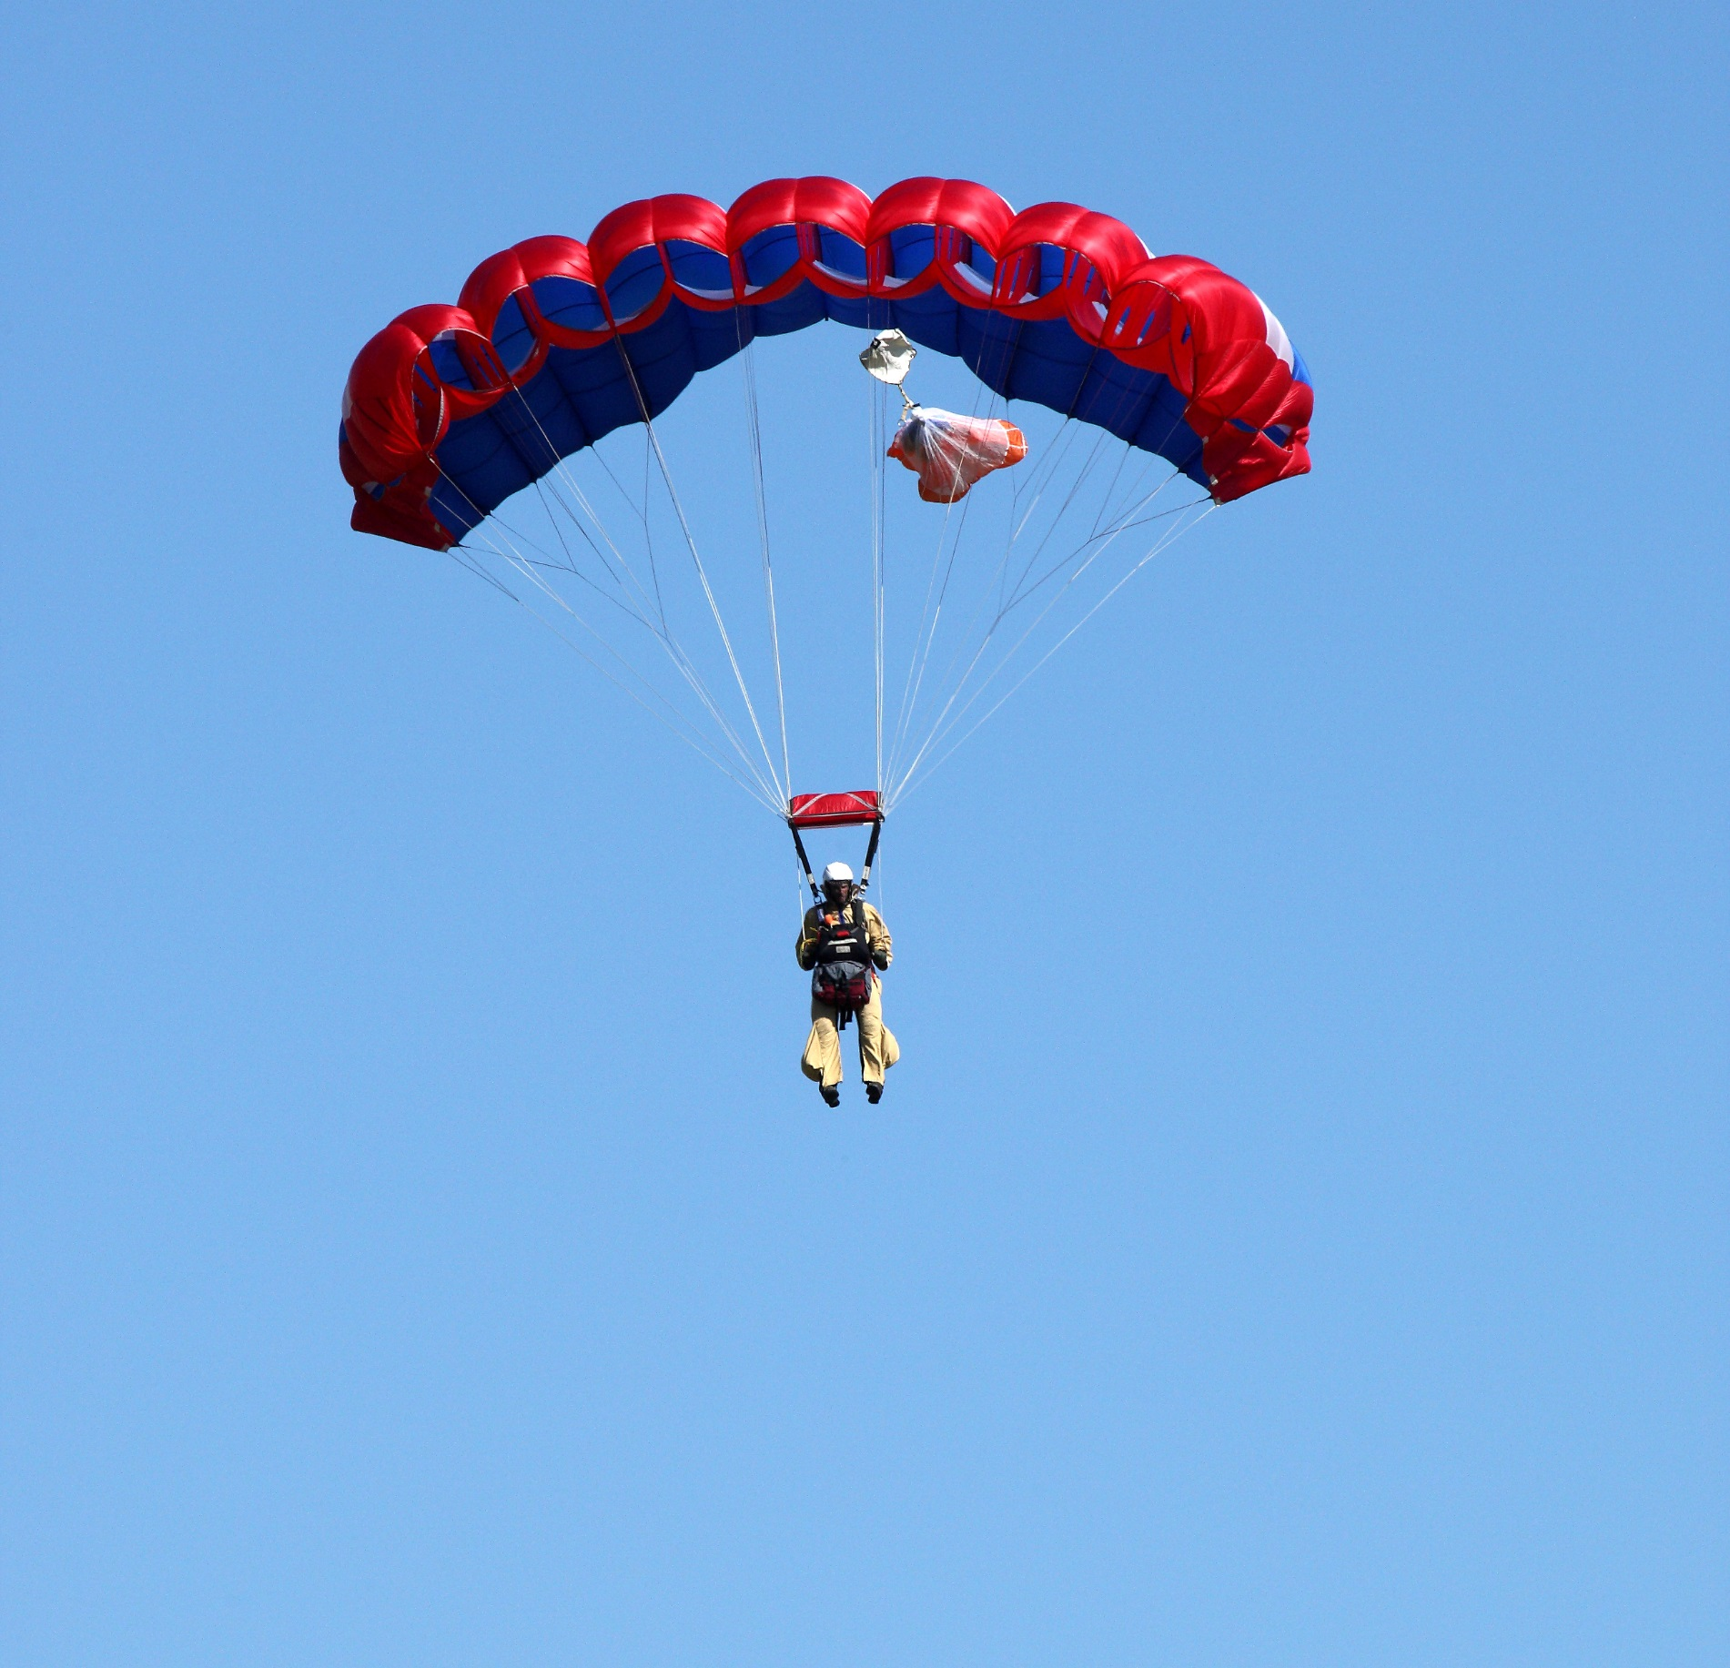

|  |  |  |  |  |
| --- | --- | --- | --- | --- |
| **MYL** | **NCSB** | **RAC** | **GAC** | **RDD** |
| 13 | 2 | 2 | 3 | 6 |

* 2 RATT’s at Missoula and McCall
* 14 Region 1 rookies completed training
* 2,381 training and proficiency jumps in 2017
* 726 fire jumps in 2017
* 56 sets of Ram-Air smokejumper equipment manufactured

The first week of October the representatives from all the Forest Service smokejumper bases and the BLM met in Missoula, MT for an AAR and to begin planning for 2018. The following table displays what the jump program agrees to train by base, and if successful, this will bring the total to 184 jumpers or 60% of the smokejumper program on the Ram-Air system:

| **Smokejumper Base** | **Ram-Air**  **Rookies**  **2018** | **1st Year RATTs**  **2018** | **Total Trainees**  **2018** | **Returning Ram-Air Jumpers** | **Total Ram-Air Jumpers** |
| --- | --- | --- | --- | --- | --- |
| **Missoula** (MSO) | 8 | 5 | 13 | 52 | 65 |
| **West Yellowstone** (WYS) | 6 | 1 | 7 | 22 | 29 |
| **Grangeville** (GAC) | 4 | 4 | 8 | 23 | 31 |
| **McCall** (MYL) | 0 | 12 | 12[1] | 17 | 29 |
| **Redmond** (RAC) | 0 | 3 | 3 | 2 | 5 |
| **North Cascades** (NCSB) | 0 | 3 | 3 | 2 | 5 |
| **Redding** (RDD) | 0 | 10 | 10 | 10 | 20 |
| **Total** | **18** | **38** | **56** | **128** | **184** |

1. The number of first year RATTs at the McCall Smokejumper Base in 2018 will increase from 12 to 14 if there is attrition in prior training sessions.