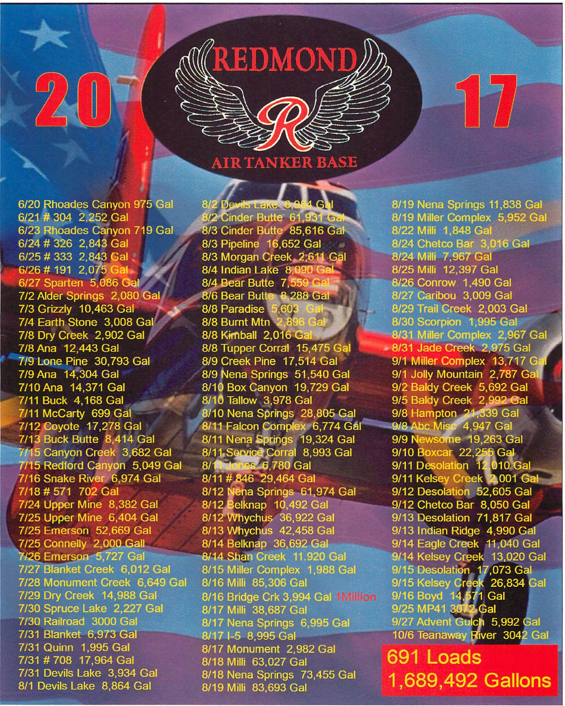

**REDMOND AIR TANKER BASE**

**2017 Accomplishments**

The Redmond Air Tanker Base (ATB) participated in the 2017 fire suppression effort by safely and efficiently loading aircraft and providing logistical support for aircrews. Although, it was an extremely busy fire season for Redmond, the base crew always maintained safety, quality service, and enthusiastic support.

Overall, the Redmond ATB supported different agencies in fighting **85** wildland fires. Flying from Redmond, 7 different air tankers carried **p91** loads and dropped over

**1,689,492** gallons of fire retardant. This is an all-time record for the base !

**NATIONAL SCOPE**

After the cancellation of the National Large Air tanker Contract in 2004, the Federal Air tanker fleet was drastically reduced from 34 air tankers to approximately 11. This year, the Federal fleet is nearly back to Pre 2004 numbers. Including the retu rn of 4 Lockheed P2-Vs, and a large number of "Jet" air tankers: (BAe-146s, C-130s, MD-87s, RJ-85s, & DC- lOs). The federal air tanker fleet, was also supplemented with SEATs, various CWN air tankers, MAFFS (Air National Guard) and Forest Service owned C-130 aircraft, and Canadian Convair 580s.

Again this year there were no "home" tankers, only "administrative bases" selected to administer a particular air tanker's paperwork. The result of this decision is that federal air tankers tend to operate only out of bases where there is fire activity or where there is a greater potential for fires to occur.

For a tenth year, Redmond was selected to be an "Admin Base". This year our air tanker was Tanker 10. **T-10** was on contract from May 19th to October 29th. It was one of the busiest Air tankers in the Federal fleet, accumulating a total of **226** flight hours. T-10 flew **285** sorties, and dropped over **854,000** gallons of retardant.

**FEDERAL AIR TANKERS**

The Redmond ATB was host to **27** different air tankers this summer. The types of

aircraft included: the Douglas DC-7, Lockheed P-2V, British Aerospace's BAE-146, & Avro RJ-85, Lockheed C-130Q, MD-87, and the Canadian Convair 580.(all Large air tankers). Also, the Air Tractor 802, (a turbine powered single engine air tanker, SEAT), as well as the Air Tractor 802 water scooper, known as the "Fire-Boss".

Large air tankers made **562** landings at the Redmond airport, which generated landing fees of **$148,472.7** for the City of Redmond.

**STATE AIR TANKER**

The State of Oregon decided to again contract for additional air tankers. These 'State' air tankers (Douglas DC-7 & SEATs), were based out of Prineville, La Grande and Medford. These aircraft provided additional protection for State and private lands throughout Oregon. This was the second year that an Oregon Department of Forestry air tanker was *not* stationed at the Redmond base. However the DC-7 from Medford and the 2 SEATs from Prineville, operated extensively f rom the Redmond Base.

The State DC-7 air tanker (T-60) was at Redmond 21 Days, it flew approximately 23

Flight Hours, and carried out 24 Loads for 72,000 Gallons of retardant.

SINGLE ENGINE AIR TANKER (S.E.A.T.)

The Redmond Air Tanker Base also supported single engine air tankers (SEATs). These are mainly contracted by the Bureau of Land Management and the Oregon Department of Forestry (O.D.F.)

This year two BLM "On-Call" SEATs were stationed at the Redmond Base from July 6th through August 7th. In addition, the SEATs stationed at the Prineville, Lakeview, Burns, John Day, and The Dalles SEAT bases, regularly reloaded out of the Redmond Tanker Base.

This season, 12 different SEATs operated out of Redmond. They supported 5 agencies, fighting 21 wildland fires. They carried out 155 loads of retardant, totaling

111,768 gallons. They flew approximately 137 Hours out of the Redmond ATB.

AIR ATTACK

The Redmond air tanker base was also the designated home for the Central Oregon Fire Management CCOFMS) Air Attack platform. This aircraft, its pilot, and the Air Tactical Group Supervisor (ATGS), provided critical support to many fire and aviation operations. The Air Attack platform was stationed at the base from June 1st to September 30th,

122 days. In 2017, it flew on 117 different fires, and acquired 296.1 Flight Hours. This is well above the yearly average of 35 fires and 122 Flight Hours.

FULL-SERVICE RETARDANT CONTRACT

For twelve years, the Redmond Air Tanker Base has administered a full-service retardant contract. This means the manufacturer of the retardant also provides personnel to: store, mix, and load retardant, as directed by the Forest Service contract and the base manager. The price per gallon is set prior to the fire season, and the contractor is paid solel y for the retardant it actually loads on to the air tankers.

In 2017, the crew pumped 691 loads, for 1,689,492 gallons of retardant. This total is almost exactly our ten year average of 700,000 gallons *plus* an extra one million gallons ! The contract ran from June 1st to October 15th. In addition to the large number of gallons, the number of days we pumped retardant was significant. Of the 137 contract days, we pumped at least one load of retardant on 68 days. About once every 2 days, (50%).

BASE PERSONNEL

The staff at the base, during the rare times of low activity, performed routine maintenance of the facility, completed landscaping projects, gained valuable training, and participated in off-unit fire assignments. We were also assisted this year by our valuable ADs, as well as multiple Detailers and Seat Managers.

**REDMOND AIR TANKER BASE**

**2017 Year End Totals**

**RETARDANT**

• Gallons of Retardant ---------------------------------------------------- **1,689,492**

• Loads of Retardant **-------------------------------------------------------------- 691**

• Retardant Cost to Fires -------------------------------------------- **$4,105,251.39**

• Retardant Contract Length ---------------------------------------------- **137 days**

• Contract Extension ---------------------------------------------------------- **0 days**

• Retardant Loads Aborted or Jettisoned ------------------------------------------ **2**

• Average Turnaround Time ------------------------------------------- **12 minutes**

**FIRE INFORMATION**

• Number of Agency Users --------------------------------------------------------- **7**

• Number of Fires Worked With Air Tankers ---------------------------------- **85**

• Number of Initial Attack Fires-------------------------------------------------- **59**

• Number of Fires Reinforced ---------------------------------------------------- **26**

• Number of Air Tankers that operated from RDM --------------------------- **27**

**LANDINGS**

• Total Number of Landings **----------------------------------------------------- 562**

• Total Landing Fee Costs (at $2.81 per lOOOlbs) ----------------- **$148,472.70**

• Types of Air Tankers Making Landings **---------------------------------------- 9**

( BAE-146, P-2V, MD-87, CV-580, DC-7, C-130Q, RJ-85, SEATs, Fire-Boss)

**PEAK OPERATIONS**

• Max # of Air Tankers Operating in One Day (AUG. 18th) ------------------ **6**

• Max # of Incidents Worked in One Day (AUG.. 18th) **----------------------- 2**

• Max.# of Loads in One Day (AUG. 18th) ----------------------------------- **47**

• Max.# of Gallons Retardant Pumped in One Day (AUG. 18th) **----136,482**

• Max # of Landings in One Day (AUG. 18th).•.**...........••••••......•....••.•• .47**

• First Air Tanker Mission Flown------------------------------------------ **6-20-17**

Where Flown: "Rhoades Canyon", BLM

• Last Air Tanker Mission Flown ---------------------------------------- **10-06-17**

Where Flown: "Teanaway River", WA-DNR

REDMOND AIR TANKER BASE

2017 Year End Totals

RETARDANT GALLONS BY AGENCY

• FS -Region 6. .. . ...... . . . .. . . . .. .. . . .. . .. . . . . .... ... .. . .. ... . .. .. ..... ... . .936, 875

• FS - Out of region . . . . . . .. . . ... . ... . . . . . . ..... . . .. ....... .. ..... . .. ....... ... 12,486

• BIA........... . . ......... ... . ... . .. . .... ... .. . ... ..... ... ... . ... ...... ..... ..262, 974

• BLM ........ . ... .... ...... ...... ... .. .. . . . .... .. . .. ... . . . .... . ... . ........ . ...354, 521

• NPS... .. .... . ... .. . . .. . . .. . . . .. .... ... . . . . . . .... . . ... .. . . . .. . .. . ....... ..... . ....2, 227

• ODF... . ... . ... . . ... . . ... .. ......... ... . .. .. . .. . .... . . . . . . ... .. ... . .. . .... ......73, 185

• DNR .. .. . . . .... .. .. .. ..... . . .. . . . ... . ..... . .. .. . .. ... ... . . .. . .. .. .. .... .. .. ...27, 564

• CALFIRE. . . . . . .. . .. . . .. . . . .. .. . . . . . . . . . . .. . . . . .......... . . . ...... . . . . .. . . .... .. ..O

• FWS . ......... ... .. .... ..... .... . . ... .. .... ... ... .. ... . . ..... . ... ........ .... .... ....O

• OTHER.. .... . . ... . . ... .... . .. . . . .. ... .. . . . .. ... .. ... . .. . .. .... . . . ... . . . .......19,660

TOTAL...................................1,689,49

BLM SEAT OPERATIONS

• LOADS...............................................................................90

• GALLONS.....................................................................64,157

• FLT. HOURS..................................................................97.45

O.D.F. SEAT OPERATIONS

• LOADS..............................................................................65

• GALLONS....................................................................47,611

• FLT. HOURS..................................................................39.28

AIRCRAFT ON BASE - 201

JUNE: T-805, T-868, T-870, T-05, T-167

JULY (1-15): T-823, T-824, T-05, T-06, T-132, T-804, T-827, T-167, T-869, T-805, T-40, T-60, T-10

JULY (16-31): T-824, T-823, T-804, T-827, T-142, T-10, T-164, T-132, T-162

AUG. (1-15): T-823, T-824, T-142, T-10, T-164, T-162, T-132, T-02, T-827, T-804, T-06, FB-210, T-805,

T-819, T-03

AUG. (16-31): T-10, T-142, T-132, T-03, T-60, T-02, T-162, T-164, T-166

SEPT. (1-15): T-02, T-60, T-166, T-142, T-162, T-804, T-827, T-860, T-829, T-164, T-05, T-166

SEPT. (16-30): T-02, T-161, T-101, T-166, T-162, T-164, T-05

OCTOBER: T-101, T-02