# Overview of the 2017 Fire Season

## Introduction

The report summarizes the 2017 fire season for Region 6 (R6) of the Forest Service and the Oregon/Washington (OR/WA) State Office of the Bureau of Land Management (BLM). While the 2017 fire season was not as severe as in 2015, when the fire season began no one expected it to be as severe as it turned out to be. The wet and snowy winter and cool spring indicated that the season would begin slow and remain relatively mild. In contrast, all knew in advance that the 2015 fire season, previously considered the worse in recent memory, would likely be bad given the lack of snowpack.

Topics covered in this report include summary statistics for the fire season, preseason information, key factors affecting how the season played out, and a timeline of the 2017 fire season. Several appendices provide more detail on different aspects of the fire season such as the use of military resources (Appendix A), the fire prevention and mitigation program (Appendix B), the use of science and technology in managing wildfires (Appendix C), air quality and smoke management (Appendix D), actions taken before and during the August total solar eclipse (Appendix E), and more detailed discussion of specific fires by subgeographic area. Appendix F covers southwest Oregon, Appendix G the central Cascades, Appendix H southeast Oregon, Appendix I the Columbia River Gorge, Appendix J to Blue Mountains, and Appendix K covers Washington.

## Basic Fire Statistics

Across Oregon and Washington, 3,712 fires started on all ownerships, burning 830,185 acres. The number of fires was only 91% of the 10-year average, but the number of acres burned was 113%, indicating that average fire size in 2017 was larger than average. In terms of the number of fires, 2017 was only the 6th worst in the last 10 years but in terms of acres burned, it was the 4th worst.

The 2017 fire season was much more severe in Oregon than in Washington. As of early October, Washington experienced 1,293 fires (93% of the 10-year average) for 167,810 acres, or only 64% of the 10-year average (Figure xa). In contrast, Oregon had 2,027 fires (89% of the 10-year average for 659,679 acres, or 139% of the 10-year average (Figure xb).

Initial attack was able to contain all but 126 of these fires for an initial attack success rate of 97%. Overall, more fires were started by people than by lightning across the two states. On the National Forests, lighting started more fires, about 60% of all starts, while on BLM-managed lands people started more fires, about 55%. Across all jurisdictions, about 44% of all fires started on National Forest system lands while only 9% started on BLM-managed lands.

In Oregon, fire starts spiked during four periods – late June, late July, early-mid-August, and early September (Figure x). The greatest number of fires, 108, started on August 10, with 86 of these from lightning. Washington saw only minor spikes in fire starts in late June, early July, and mid-July (Figure x). In both starts, the number of human-caused fires was relatively steady through the summer with somewhere between 10 and 15 fire starts per day in July and early August in Oregon and through both July and August in Washington.

## Large Fires

A large fire is one that burns at least 100 acres in forests or 300 acres in grass, shrubs, or shrub-steppe (often referred to as “rangelands”). It’s the large fires that have the most impact in people, businesses, agencies, and resources. While there were one or two large fires as early as late May, the number of large fires burning at the same time began increasing in late June and increased rapidly in August (Figure x). The peak number of large fires burning at the same time occurred on September 11-12 with 38 large fires. As of the end of October, 12 large fires were still active to some degree.

Managing large fires typically requires a large number of people and other firefighting resources. More people are needed to manage large fires in forests than in rangelands due to the types of fuels involved, typical fire behavior and the overall duration of large forest fires. A long duration rangeland fire typically lasts for about 2 weeks whereas a long duration forest fire typically lasts for several weeks to several months. The number of personnel assigned to large fires follows a similar pattern as the number of large fires, although tapering off sooner in fall. The number of people assigned to large fires increased in August and peaked on September 4 with an estimated 10,182 people assigned (Figure x).

Large fires use incident management teams (IMTs) to:

* Order and assign firefighting resources to specific locations on each fire in order to perform specific tasks (Operations),
* Develop daily plans for managing the fire, order and release firefighting resources (Plans),
* Track and report costs and claims (Finance), and
* Provide the infrastructure needed for the fire and the firefighters such as communications, food, sanitation, transportation to and from the fireline, showers, and various supplies (Logistics).

In addition, IMTs meet with cooperators and the public to explain how the fire is being managed and answer questions as well as provide the firefighters with information on what may be happening in the rest of the world (Fire Information).

Incident management teams are categorized as type 1 and type 2. Type 1 IMTs usually handle the more complex fires, including complexes of fires. Occasionally fires are large enough to require multiple incident management teams, such as on Chetco Bar. There are a limited number of IMTs both regionally and nationally, which can result in a type 2 team managing a fire that typically would have a type 1 team assigned to it or result in a team managing more than one complex of fires when each complex would have it’s own incident management team. Both situations occurred in 2017. The number of type 2 IMTs assigned to Northwest fires peaked at 10 teams on September 3 and 19 (Figure x). The number of type 1 IMTs peaked at 7 between September 5 and 10. The largest number of IMTs, both type 1 and 2, assigned at any one time was 17 on August 15th, with many of these teams managing complexes and multiple incidents.

As mentioned before, large forest fires tend to last a long time before they are contained or controlled as compared to rangeland fires. Most often, fires that start early (May and June) or late in the season (mid-September and later) are relatively short duration while those that start in the middle of fire season (July, August and early September) tend to last longer. In large part, these differences are due to how warm and dry the fuels and weather are as well as the frequency of weather events that start and spread fires. Day length and sun angle can also play a role late in the fire season as the peak burning period becomes shorter and sheltered areas do not dry out sufficiently after rain storms. However, even a forest fire starting at the peak of fire season can appear to be short-duration if another fire overtakes it. When that happens, the smaller fire ends and is absorbed into the larger fire.

Figure X illustrates the duration of several selected large wildfires in 2017. Sutherland Canyon, Straight Hollow, Ana, Hawk, and Cinder Butte were all rangeland fires. Hawk depicts one extreme of large fire duration, lasting only three days. Pup Fire appears to be short duration, but only because Happy Dog Fire overran it. In contrast, Indian Creek Fire was already a long-duration fire when Eagle Creek Fire absorbed it. Some of the longest lasting fires were Abney, Ollalie Lookout, Milli, Twin #1, Norse Peak, Burnt Peak, Knox, Happy Dog, and Brokentooth.

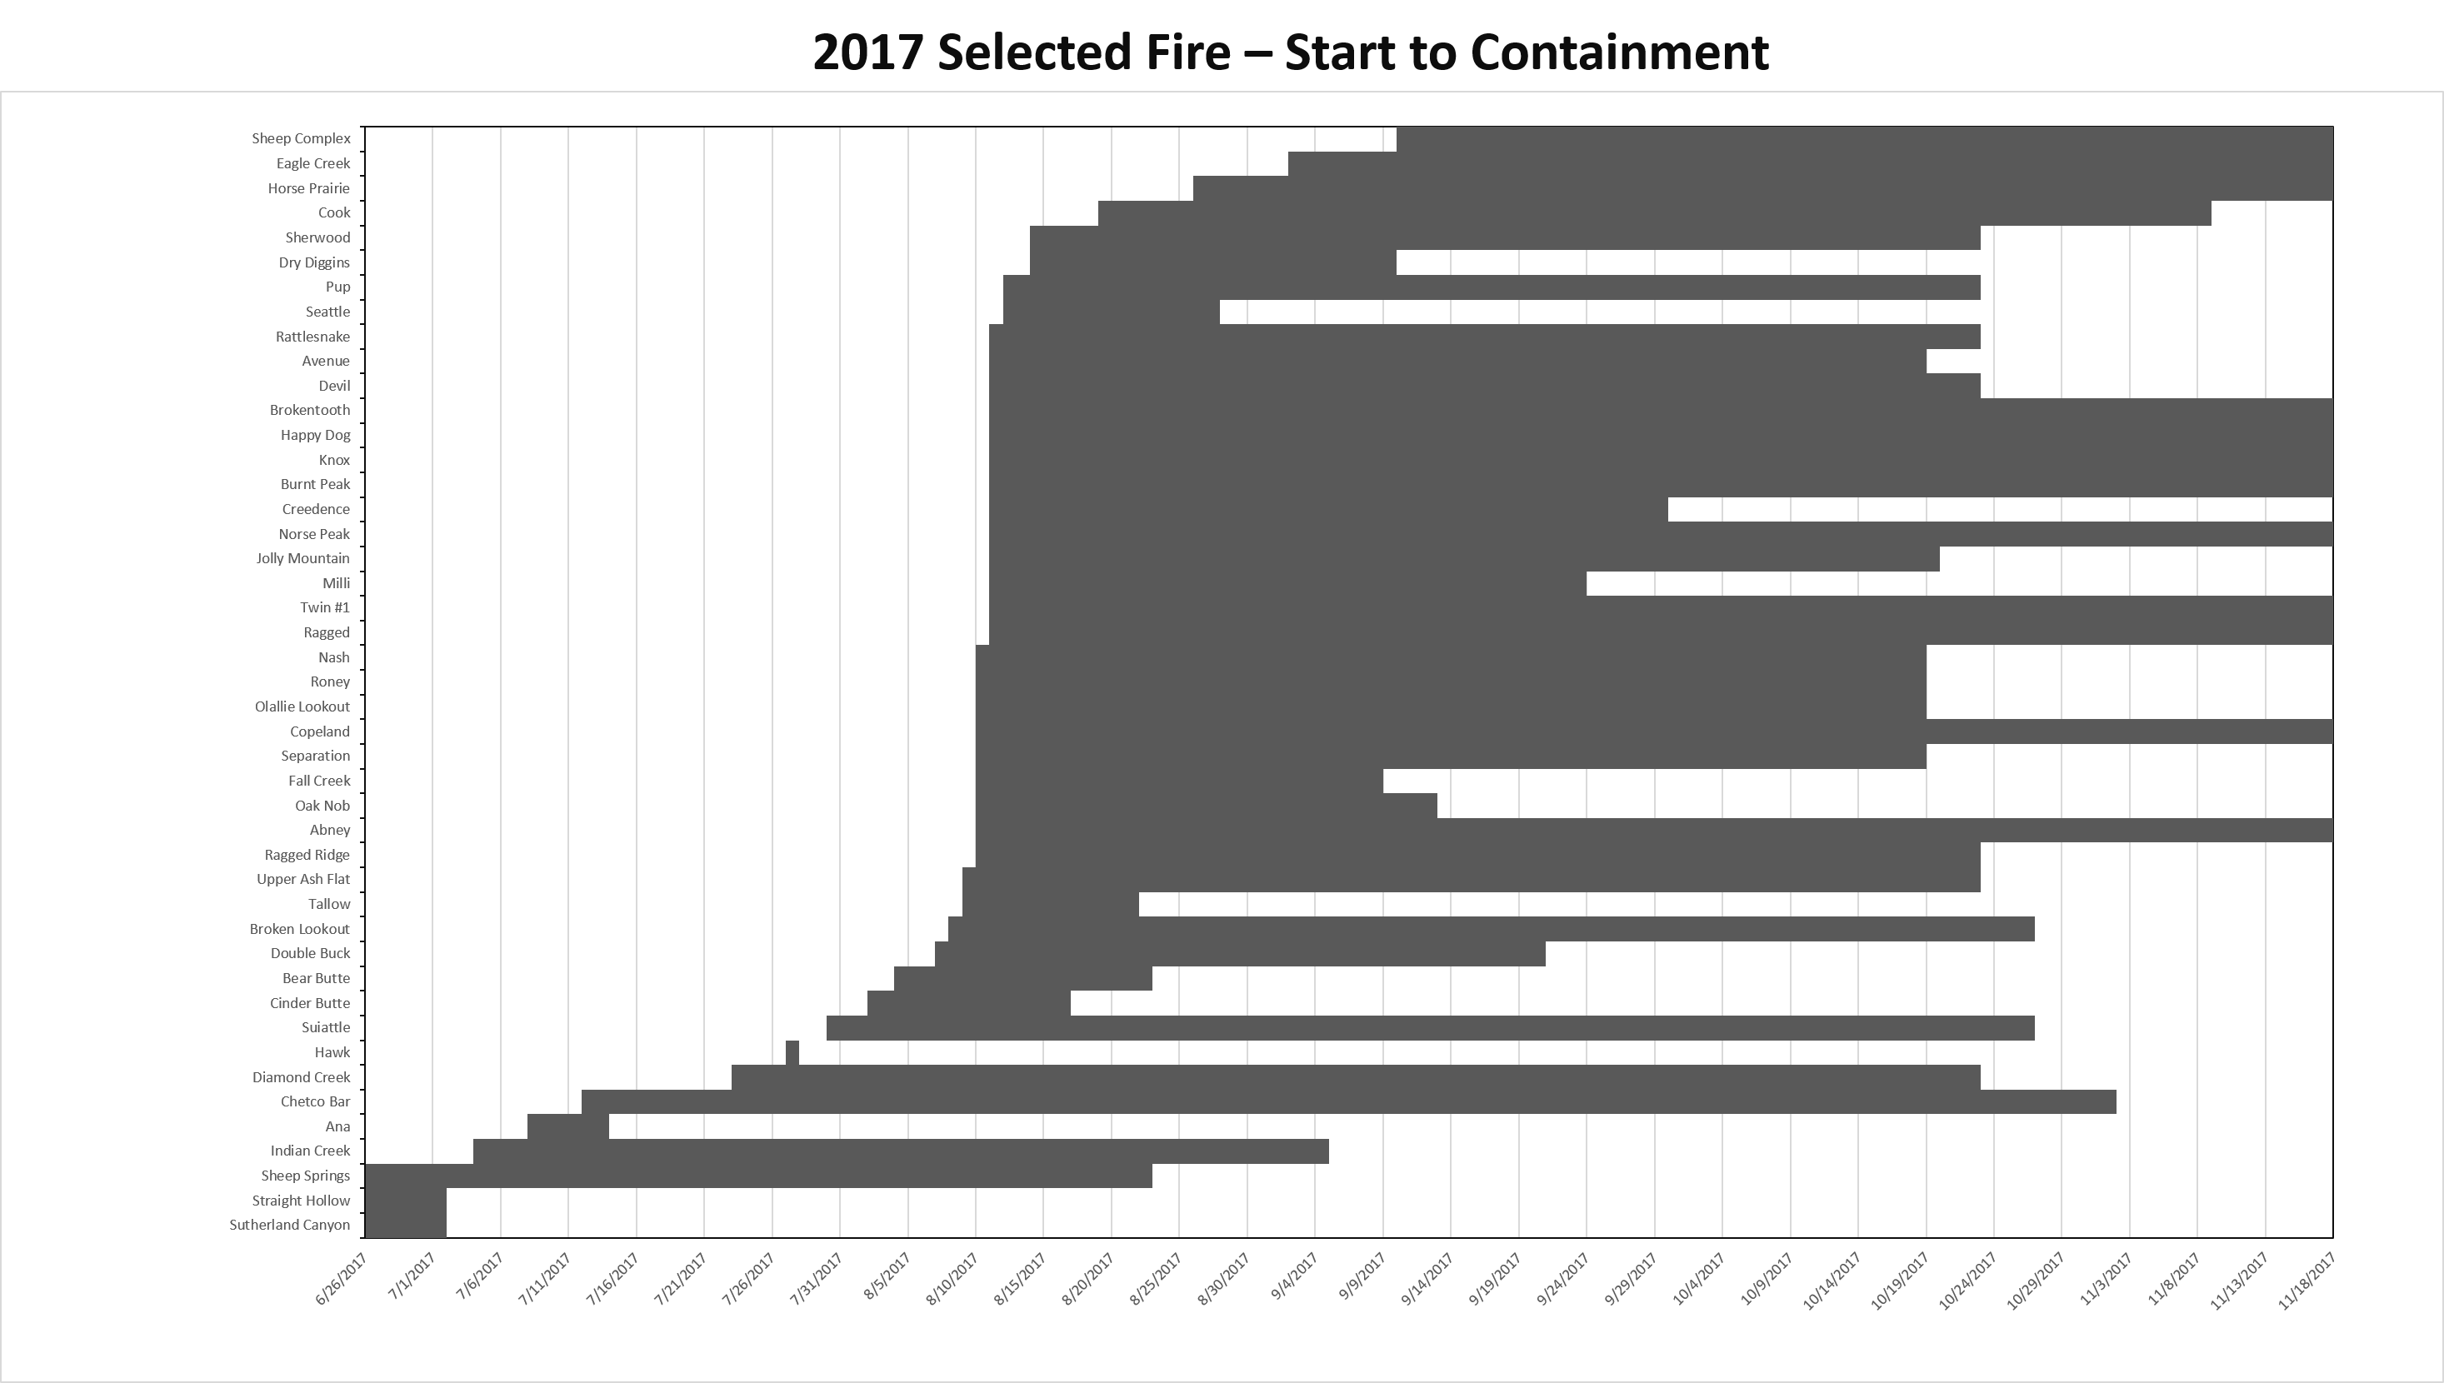

## Large Fire Costs

Everyone has heard how expensive large fires are, which is a source of concern both nationally and regionally. While the Northwest experienced 3,712 wildfires, the 126 large fires resulted in most of the costs. In 2017, the Northwest firefighting agencies collectively spent over $584 million dollars in direct suppression and emergency stabilization costs. That cost does not account for the indirect costs to the agencies for bringing in additional firefighting resources to fill in when the home unit resources were already committed to wildfires. Nor does it account for the costs to businesses and people for lost days due to smoke-related illness, lost business due to smoke or evacuations, or the costs of rebuilding burned infrastructure and homes and restoring damaged resources.

For example, the Cinder Butte Fire lasted roughly 10 days and cost an estimated $4,474,046 to suppress the fire and conduct emergency stabilization of the firelines and repair other suppression-related damage. The Burns District estimated postfire rehabilitation costs for the BLM-managed lands at $4,986,000 for seeding, replacing burned fences, protecting cultural resource sites, and monitoring. Harney County Electric bore additional costs to replace burned powerpoles and lines and homeowners had replacement costs for the four minor structures that burned.

## Preparedness Levels

Preparedness levels indicate the severity of fuel and weather conditions, level of fire activity, and the availability of firefighting resources (Table Y). The Northwest Coordination Group (NWCG) sets the preparedness level for the Northwest while the National Multi-Agency Coordination Group (NMAC) sets the national preparedness level each day throughout the year. As preparedness level increases, more federal and state employees become available to assist in firefighting efforts. In addition, resources from other parts of the country not experiencing wildfires are more likely to be sent where the fires are occurring. For example, during the 2017 fire season in the Northwest, crews, IMTs, and other resources from the eastern United States and Alaska were sent to Oregon and Washington. At higher preparedness levels, the Department of Defense may make military resources available, such as helicopters, large aircraft that can be fitted with temporary retardant tanks, and crews from both the regular army and National Guard.

Often incident commanders are not able to get all the resources they feel they need to manage a given wildfire or complex of wildfires at preparedness levels 4 and 5. Options to deal with this scarcity include altering suppression strategies and tactics and sharing particularly scarce resources with other fires, such as helicopters and type 1 crews.

| National Preparedness Level | Indicators |
| --- | --- |
| PL1 | Geographic areas can accomplish incident management objectives using local resources with little or no national support.  Conditions are not favorable to support significant wildland fire activity in most geographic areas  Resource capability is adequate with little or no mobilization of resources occurring through the National Interagency Coordination Center (NICC)  Potential for emerging significant wildfires is expected to remain minimal |
| PL2 | Active geographic areas are unable to independently accomplish incident management objectives. Resource capability remains stable enough nationally to sustain incident operations and meet objectives in active geographic areas.  Significant wildfire activity is increasing in a few geographic areas  Resources within most geographic areas are adequate to manage the current situation, with light to moderate mobilization of resources through NICC  Potential for emerging significant wildfires is normal to below normal for the time of year |
| PL3 | Mobilization of resources nationally is required to sustain incident management operations in active geographic areas. National priorities established as a necessary measure to address the heavy and persistent demand for shared resources among active geographic areas.  Significant wildfire activity is occurring in multiple geographic areas with IMTs actively engaged.  Mobilization of resources through NICC is moderate to heavy.  Potential for emerging significant wildfires is normal for the time of year |
| PL4 | Shared resources are heavily committed. National mobilization trends affect all geographic areas and regularly occur over larger and larger distances. National priorities govern resources of all types. Heavy demand on inactive/low activity geographic areas to support high activity geographic areas.  Significant wildfire activity is occurring in multiple geographic areas; significant commitment of IMTs.  NICC increasingly engages with geographic area coordination centers in an effort to coordinate and fill orders for available resources.  Potential for significant wildfires emerging in multiple geographic areas indicates that resource demands will continue or increase. |
| PL5 | National mobilization is heavily committed and measures need to be taken to support geographic areas. Active geographic areas must take emergency measures to sustain incident operations.  Full commitment of national resources is on-going  Resource orders are filled at NICC by specifically coordinating requests with geographic areas as resources become available.  Potential for emerging significant wildfires is high and expected to remain high in multiple geographic areas. |

For geographic area PLs, subsititute “subgeographic areas” for “geographic areas”, “geographic” for “national”, and Northwest Coordination Center (NWCC)” for “National Interagency Coordination Center (NICC)”.

On average, the Northwest slowly rises from PL1 to a peak at PL3 or PL4 (average is PL3.6) in mid-August, and then slowly falls back to PL1 by early October. Preparedness level in 2017 rose to PL2 in late June, about two weeks earlier than usual and reached PL3 by mid-July, about one month earlier than typical (Figure X). The Northwest reached PL4 about the same time it normally reaches PL3 and only 8 days later moved to PL5 on August 12, remaining there a record 40 days, until September 21. After that, the Northwest began dropping preparedness levels relatively quickly, returning to PL1 by October 21. For comparison, in 2015, the Northwest moved to PL5 on August 13, but remained there for only 23 days before dropping back to PL4 on September 5 and to PL1 by October 9.

Nationally, the preparedness level reached PL4 on July 9 and PL5 on August 10. The national level remained at PL5 for 39 days, dropping back to PL4 on September 18 and PL1 on October 31. In addition to high activity in the Northwest, the Northern Rockies, Northern California, and the Great Basin had high fire activity with the associated demand for firefighting resources.

## Structures Lost

The Northwest is not known for losing structures in wildfires, but in recent years that has begun to change. Fortunately, it remains rare to lose a large number of structures in a single incident. A total of 112 structures were destroyed in the Northwest, 61 in Oregon and 51 in Washington. Of these, 26 were single residences, 83 were minor structures (sheds, barns, etc.), and 3 were either mixed residential/commercial or nonresidential commercial structures. Twenty-nine of the 126 large fires burned structures. In Oregon, the greatest losses happened on Chetco Bar (6 residences, 24 minor structures); in Washington, the greatest losses happened on the Monument Hill Fire (3 residences, 20 minor structures).

## Evacuations

Large fires in 2017 seemed to have resulted in an unusually high number of evacuations, although this statistic is not tracked. Based on daily incident reports (form ICS-209) 42 of the 126 large fires had some level of evacuation. Evacuation levels can be thought of as a variation Ready, Set, GO! (Table Y).

|  |  |
| --- | --- |
| Evacuation Level | Meaning |
| Level 1 (Ready) | Residents and businesses in the affected area should prepare to leave by packing up clothing and important papers and taking precautionary measures for people with special needs, mobile property, pets, and livestock |
| Level 2 (Set) | Residents and businesses should be ready to leave at any moment and the fire is probably moving towards the area. If a resident or business has not already gathered necessary items and made needed arrangements there might not be time to do so before having to leave. If conditions deteriorate rapidly, emergency services may not have time to send out additional warnings or notices. |
| Level 3 (GO!) | Leave the area immediately. Emergency services may not be able to assist if a person does not leave and entry into Level 3 evacuation areas is usually denied until conditions are safer. |

Six large fires reached only Level 1 evacuation notices and six reached level 2. Thirty-six fires reached Level 3 evacuations and several fires have Level 2 evacuations in some areas and Level 3 in others. On seven of the fires that reached Level 3, the number of people evacuated was not recorded. On the remaining 29 fires, 8,858 people evacuated to friends or family, 512 sheltered in place, and 126 moved to temporary shelters. Chetco Bar Fire had the highest number of evacuations with 5,122 people affected. The next highest was Eagle Creek, with 1,822 people evacuated, including nearly everyone in Cascade Locks, Bridal Veil, and Warrenton.

## Other Season Statistics

* Number of ESF4 activations –
* Number of Conflagration Act activations (Oregon) –
* Number of Fire Service Mobilization Plan activations (Washington) –
* National Guard mobilizations –
* Active duty military mobilizations –

# Preseason: Actions Taken from January through May

## January through March

* Predictive Services issued forecasts and compared past forecasts with actual conditions for snowpack, temperature, and precipitation
* Each local Forest, BLM District, and State Unit conducted training and preseason meetings to prepare for the upcoming fire season.
* The National and Regional Training Centers offered a number of courses to train the fire community for various positions in Operations, Plans, Finance, Logistics, Fire Information, and Resource Advising
* Planning for the August eclipse began in January

## April through May

* Predictive Services continued to issue forecasts and seasonal outlooks for the upcoming fire season. Based on April 1 snowpack and other indicators, it appeared that the upcoming season would be relatively mild.
* Planning continued for the August eclipse with monthly calls gradually becoming weekly calls
* Preparedness reviews occurred on all National Forest and BLM Units to assure that firefighters, equipment, and fire caches were ready.
* Hiring of new and returning seasonal firefighters began

# The 2017 Fire Season