Drought Update – Dry Lake Complex/Turnbo Fire

Current Situation
July 24 is the 90th percentile date for the onset of the monsoons, based on the term file developed for this incident. However, the monsoons have yet to make an appearance. According to the National Weather Service in El Paso, Texas, two conditions need to be met for the monsoons to occur: 1) upper air winds need to shift to predominantly easterly and 2) the Four Corners High pressure system needs to shift either northward into the Great Basin or eastward into Texas. Once these conditions are met, the upper air winds steer moisture from the Gulf of Mexico into New Mexico.
As of July 24, the first condition has occurred but not the second. The Four Corners High continues to block moisture from western New Mexico and eastern Arizona. Monsoonal moisture is flowing into southern and western Arizona around the Four Corners High and into eastern New Mexico. Outflow from thunderstorms in eastern New Mexico combined with some moisture entrained into the circulation around the Four Corners High from western Arizona bring enough moisture into the fire area to trigger afternoon and evening thunderstorms. Although some of these storms are quite wet, they are not widespread enough to be considered monsoonal in nature. The range of fluctuation in minimum relative humidity and dew point temperatures from day-to-day are other indicators that the monsoons have not arrived.
In general, June rainfall was below average for the Southwestern Mountains Climate Division, which includes the Gila Wilderness. July rainfall also appears to be headed for a below average rating. Streamflow levels in the Gila River have been running well below average with record lows for a given date set several times in mid-July. While river levels have been rising recently due to the limited rain that has fallen, they remain well below average (Figure 1).
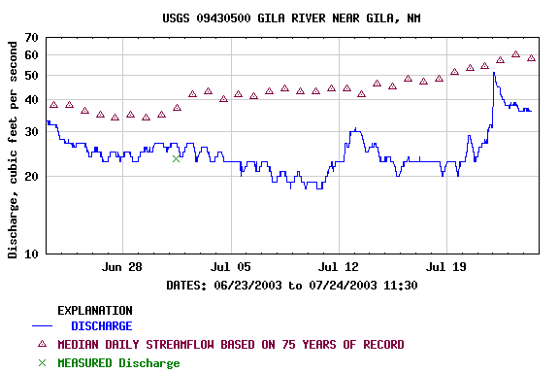
Figure 1. River levels bottomed out about July 9-10 and have risen in response to recent rains.
Several other drought indicators depict deteriorating conditions as well. Ground water monitoring wells show long-term declines in the water table south and east of the fire area. The Palmer Drought Severity Index, which usually shows considerable lag between the values indicating drought and actual drought onset, currently has a declining trend for the Southwestern Mountains climate zone. The July 22 Drought Monitor map (figure 2) shows an increase in the drought level as compared to June and early July.
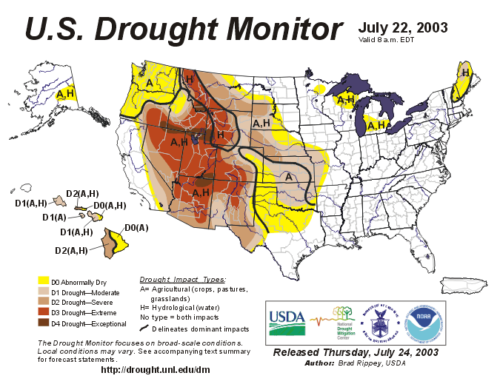
Figure 2. Since early July, conditions in the Southwestern Mountains climate zone have deteriorated to moderate drought (D1) levels.
Water year precipitation through the end of June is 82 percent of normal at Gila Hot Springs and 86 percent of normal at Fort Bayard. About 90 percent of New Mexico has low topsoil moisture as of July 20, whereas normally about 56 percent of the state has low topsoil moisture. The lack of moisture is reflected in the latest departure from average greenness map (figure 3).
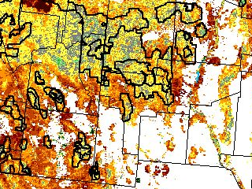
Figure 3. Vegetation in the Gila Wilderness is not as green as average, although in better condition than the area just to the south of the Forest.
Energy Release Component (ERC) data display the relative dryness of conditions as well. Weather data for the Beaverhead RAWS (292001) and a special interest group (SIG) for the manual station (292006) and RAWS (292011) at Gila Center were analyzed in Fire Family Plus to compare the number of days in the various fire danger levels in 2003 with the normal levels (climatology). The results indicate that conditions as represented by both stations are pretty extreme. Since April 1, 71 percent of the days at Beaverhead have been at or above the 90th percentile ERC value and 90 percent of the days at Gila Center (table 1).
Table 1. Number of days normally spent and actually spent in each ERC class from April 1 through July 21 at key stations for the Gila Wilderness.
BEAVERHEAD
 | ERC
 |  |  | 90th percentile | 97th percentile
 | 0-26 | 27-73 | 74-87 | 88+
Normal | 17 days (15%) | 84 days (75%) | 8 days (7%) | 3 days (3%)
2003 | 0 days (0%) | 30 days (29%) | 46 days (44%) | 28 days (27%)
GILA CENTER
 | ERC
 | 0-27 | 28-69 | 70-90 | 91+
Normal | 17 days (15%) | 84 days (75%) | 8 days (7%) | 3 days (3%)
2003 | 0 days (0%) | 10 days (10%) | 40 days (38%) | 54 days (52%)

Outlook
Monsoonal moisture may still enter the area in late July or early August. However, these monsoons would likely be short-lived as rainfall begins to fall off in mid-August. September and October are when the monsoon system typically decays. Since the monsoon season is strong in Mexico, the center of the North American monsoon, the typical pattern should be expected concerning decay of the season.
Climatologists at the Climate Prediction Center expect only limited improvement in the drought situation. Significant easing of water shortages will likely need to wait until next winter at the earliest (figure 4). Signals are too mixed to estimate what the precipitation might be over the next three months, but temperatures are expected to be above average (figure 5). Soils are expected to remain much drier than average through August (figure 6) suggesting that not enough rain is expected to recharge the soil surface. Through October, however, soils are expected to approach average conditions for moisture. This outlook may be a reflection of the normal drying that can be expected in September and October.

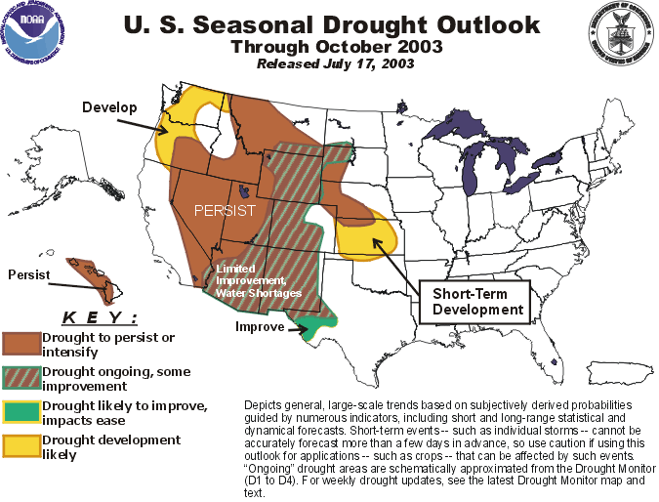
Figure 4. Some moisture should help temporary ease the drought situation in southwestern New Mexico, but major improvement is not expected until after October.

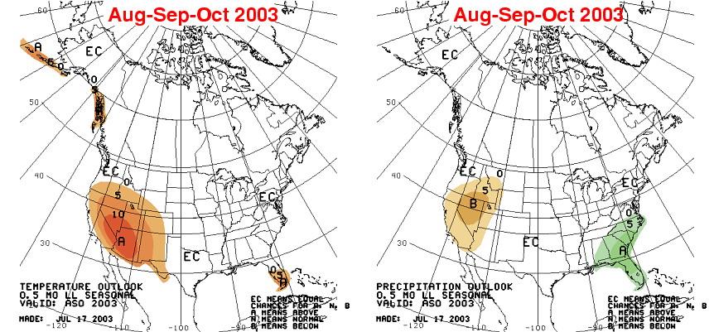
Figure 5. Temperatures are expected to be above average through October, but it is anyone’s guess as to what may happen with precipitation.
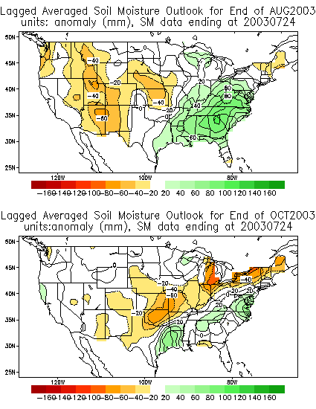
Figure 6. Soil moisture is expected to be well below average in August but approaching normal by October.

Conclusion
The current situation more resembles the extreme weather scenario described in the updated Dry Lake Complex WFIP than the expected weather scenario. The monsoons are late and likely to be short-lived. If any portion of the fires currently considered part of the Dry Lake Complex and the Turnbo Fire ‘survives’ the monsoons, activity could increase in September and the fires burn until sometime in October. Changing day lengths and sun angles will begin to affect the length of the daily burn period and reduce the amount of potential spread even during more active periods, as compared to that seen in June and July.
Through August, the areas that have greened-up with what moisture has fallen will serve as temporary barriers to surface fire spread and slow or steer the fire around them. Junipers are very responsive to moisture, such that live fuel moistures in these species may rise to the point of also serving as a fire spread barrier, particularly the younger, more vigorous trees. Pines (pinyon and ponderosa) tend to be less responsive, such that torching or crowning in groups of this genus may still occur in August, particularly on hotter, drier aspects and where soils are shallow or well-drained.
Beginning sometime in September, lower temperatures will trigger the normal leaf turn and fall in deciduous species. Leaves that fall while still ‘in color’ often require additional drying before they can carry a fire. Leaves that are brown when they fall, may be able to carry fire soon after they drop.

Louisa Evers – LTAN
Great Basin #1 FUMT

