Dry Lake Complex

Long-Term Weather Analysis
This long-term weather analysis is an update to the Stage III WFIP information provided by the first Fire Use Management Team assigned to the Dry Lake Complex. That assessment was prepared in early June and almost one month has passed. This update focuses on long-term analysis and assessment of precipitation patterns, the developing La Nina event, and various drought indicators. It also examines how the season has developed in relation to the long-range fire risk assessment completed on April 20, 2003, for the Southwest geographic area.

Seasonal Precipitation Patterns
July and August are the wettest months in New Mexico with a precipitation minimum in the April through June period. The monsoon wet season is driven by moisture surges from the Gulf of Mexico under southeasterly flow. Orographic and convective uplift combine with the moist air to trigger the development of wet thunderstorms, primarily over the higher terrain. Rarely, tropical storms from the Gulf of California can cause heavy rain and severe flooding in southwestern New Mexico.
As the monsoon season begins, the thunderstorms are mostly dry, gradually becoming wetter. These storms tend to be more localized than general and high intensity, such that much of the precipitation runs off instead of soaking deep into the soil. The upper layers of the soil do receive enough moisture to allow green-up in warm season grasses and some annual grasses. Dead fine fuels on the surface also soak up enough moisture to limit or halt fire spread and fire starts.
Precipitation records from Beaverhead, Bear Wallow, and Gila Center weather stations show similar patterns to the local communities and to the Grant County Soil and Water Conservation District from April 1 through October 31 (figure 1). The April through June period averages considerably less precipitation than the July through October period. Bearwallow is a wetter station than Beaverhead and Gila Center, but also has the shortest record (10 years as opposed to 33 years). The Grant County information covers 135 years.
According to the Southwest Geographic Area assessment, total precipitation for the water year was near 20-year average conditions through April. However, snowpack levels at the mid- and lower elevations was below average, indicating that much of the precipitation fell as rain and that winter temperatures were warmer than average.
Data from Sno-tel sites in the Gila Basin collected by the Natural Resources Conservation Service (NRCS) indicate that the basin has had below normal snowpack and precipitation for the last two water years (table 1). The winter started out warm and dry with snowpack levels in the Gila Basin in well below average through February. Sufficient moisture returned in March to bring snowpack levels up to near normal but warmer weather quickly returned. A warmer than average winter coupled with near average precipitation tends to result in earlier than average green-up and curing.

Table 1. Water year precipitation and snowpack levels for the Gila Basin. The water years runs from October 1 through September 30 such that the 2003 water year began on October 1, 2002 and will end on September 30, 2003.
Gila Basin (Gila National Forest)
Water Year | 1998 |  | 1999 |  | 2000 |  | 2001 |  | 2002 |  | 2003
 | % Normal Snow | % Normal Rain | % Normal Snow | % Normal Rain | % Normal Snow | % Normal Rain | % Normal Snow | % Normal Rain | % Normal Snow | % Normal Rain | % Normal Snow | % Normal Rain
Oct | 123% | 91% | 49% | 134% | 25% | 12% | 272% | 305% | 0% | 30% | 74% | 50%
Nov | 59% | 54% | 84% | 104% | 16% | 5% | 232% | 164% | 19% | 18% | 41% | 32%
Dec | 192% | 191% | 36% | 54% | 29% | 20% | 21% | 19% | 66% | 38% | 77% | 88%
Jan | 35% | 36% | 14% | 13% | 18% | 24% | 105% | 108% | 50% | 24% | 18% | 22%
Feb | 154% | 173% | 5% | 4% | 26% | 10% | 75% | 82% | 31% | 59% | 57% | 64%
Mar | 249% | 185% | 36% | 47% | 134% | 104% | 44% | 54% | 0% | 8% | 97% | 76%
Apr | 224% | 125% | 149% | 134% | 91% | 59% | 182% | 190% | 6% | 16% | 10% | 75%
May |  | 20% |  | 20% |  | 12% |  | 115% |  | 16% |  | 74%
Jun |  | 53% |  | 178% |  | 237% |  | 152% |  | 18% |  | 71%
Jul |  | 140% |  | 168% |  | 68% |  | 114% |  | 30%
Aug |  | 87% |  | 110% |  | 97% |  | 97% |  | 72%
Sep |  | 42% |  | 154% |  | 12% |  | 67% |  | 156%
Data based on last day of month report from Sno-tel sites in the Gila Basin.

Figure 1. For all three stations and Grant County, average precipitation triples in July, compared to June.

Drought Indicators
The various drought indicators offer conflicting evidence on whether this part of New Mexico is in something other than a seasonal drought or not. The objective short-term drought indicators place the southwestern mountains climate division in normal conditions (figure 2). The Palmer Drought Index reading as of 28 June 2003 has a preliminary drought rating of -0.59 (near normal) for the southwestern mountains, requiring only 0.28 inches of precipitation to reach a rating of 0.00. This rating is an improvement over the May rating of -1.18.
The Standardized Precipitation Index (SPI) shows the southwestern mountains division as near normal or moister than normal for this water year and for the last six years. The Grant County Soil and Water Conservation District precipitation records indicate that 2002, 2001, 1999, 1998, and 1996 were average or above average years while 2000 and 1997 were below average years. Lastly, the precipitation anomaly maps indicate that as of 28 June 2003 this area has received normal to well above normal precipitation for the water year, last 28 days, and last 14 days, although the last 7 days have seen below normal precipitation (figure 3).

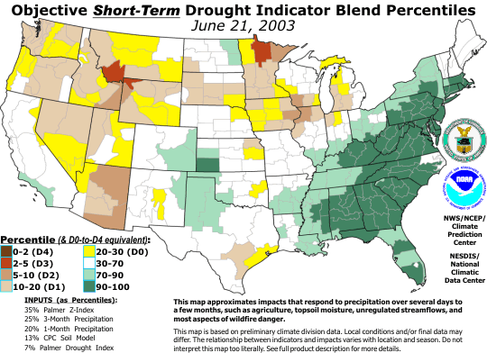
Figure 2. The southwestern mountains climate division falls within the 30-70 percentile range for drought rating.
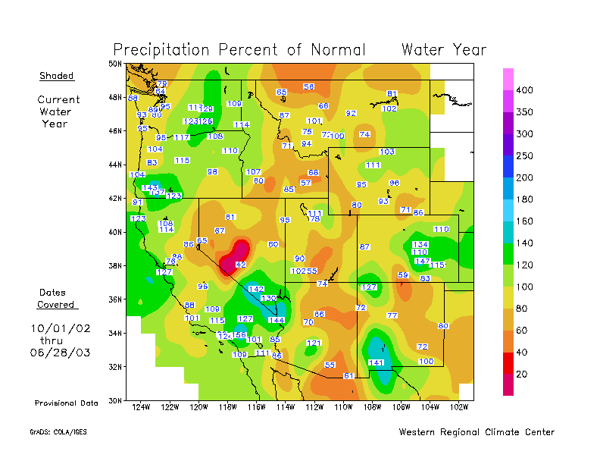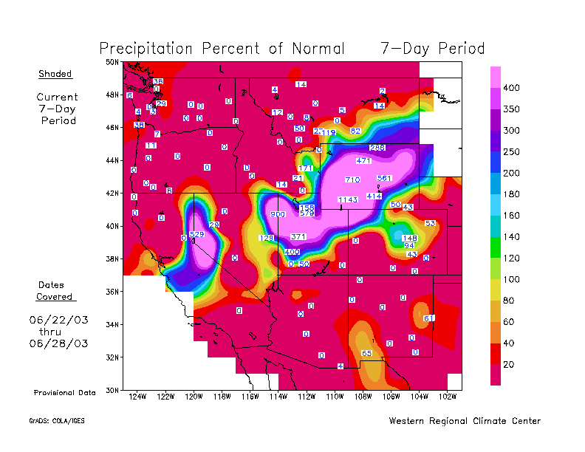
Figure 3. Over the water year, the southwestern mountains have received between 100 and 141 percent of normal precipitation while the period between June 22 and 28 have only seen 65 percent or less.
Providing contrary evidence of the lack of drought are indicators such as the Drought Monitor, soil moisture, vegetation greenness, and energy release component traces for southwestern New Mexico in general and various remote area weather stations (RAWS) in particular. The July 1 Drought Monitor, which also uses several of the indicators that point to no drought, places the southwestern mountains in either abnormally dry (D0) or moderate drought conditions (D1) (figure 4).
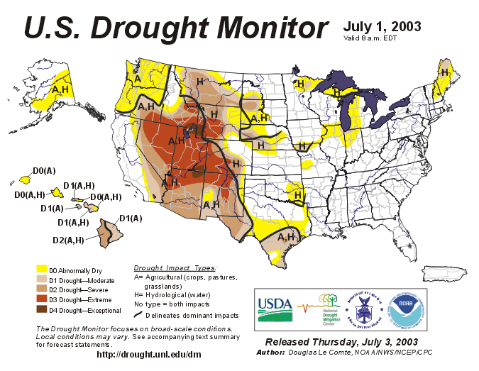
Figure 4. The northern end of the southwestern mountains climate division is abnormally dry while the southern end is in moderate drought. The area of severe drought has been expanding toward the southwestern mountains.

A review of the last 12 weeks of the Drought Monitor indicate that conditions have improved somewhat in this climate division. The April 8 Drought Monitor had the entire climate division in moderate drought. By May 6, the northern part of the climate division improved to abnormally dry. However, conditions deteriorated to the east and west from moderate drought to severe drought (D3). Compared to this time last year, there has been considerable improvement in the drought conditions for southwestern New Mexico (figure 5).
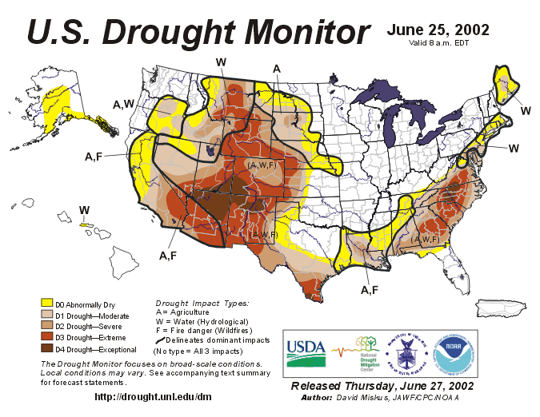
Figure 5. In late June of 2002, most of New Mexico was in extreme to exceptional drought.

The various measures of soil moisture indicate that a soil moisture deficit has been present for some time. Much of this deficit is evidenced through lower than average streamflows, low reservoir levels, and lower than average vegetation greenness for the time of year (figure 6). Soil moisture in the June through September period normal runs between 100 and 200mm. Currently, the deficit is 20 to 40mm. With the exception of June, temperatures for this area have been running above average at least since December 2002. In January, temperatures were well above average. Since many perennial plants are physiologically active when temperatures cross a certain threshold, the high temperatures through the winter may have resulted in many plants actively respiring and using water at a time when they would normally be dormant. Warmer temperatures can also trigger earlier bud break and active growth.
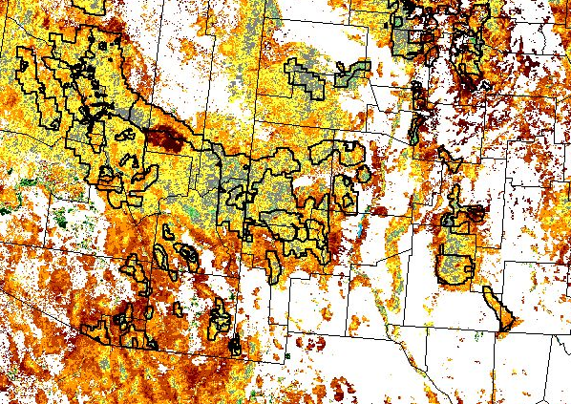
Figure 6. As of 24 June 2003, vegetation in the Gila Wilderness was below average for greenness, although the area in the western tip was of average greenness.

Energy release component (ERC), a measure of seasonal dryness has been tracking well above average for May and June, both for New Mexico in general and for Beaverhead weather station (figure 7). These data also suggest warmer temperatures, earlier than normal green-up, and dry soils all leading to earlier curing of vegetation and drier than average dead fuels. Observer reports from the fires in the complex state that large logs are consuming completely, leaving only ash beds behind. Major drivers in the equations used to compute ERC are large and live fuel moistures. Energy release component values above seasonal norms are strong indicators that live fuel moisture and large woody fuel moistures are also well below seasonal norms.
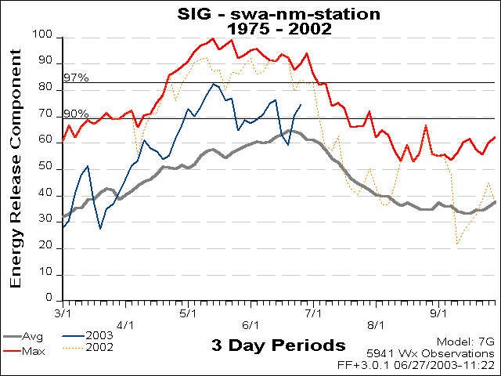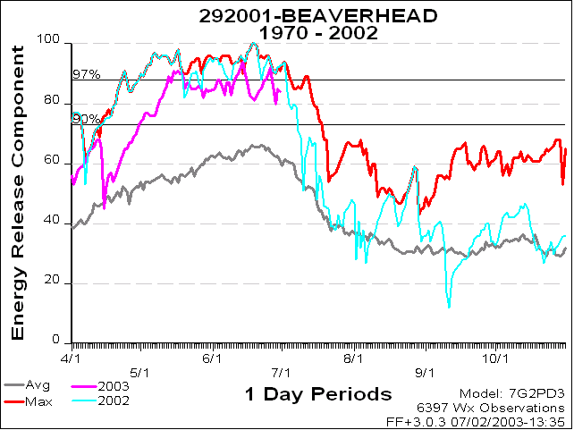
Figure 7. Beaverhead weather station is drier than New Mexico in general and near levels seen in 2002.

The keys in defining the current situation with regard to drought appear to be temperature and long-term soil moisture deficits. As temperatures increase, evapotranspiration in plants increases. High winds can further accelerate evapotranspirational demands. Two factors could be coming into play that current drought indices do not adequately incorporate.
The first is that once air temperature increases above a certain level, woody plants become photosynthetically active. Normally in the winter months, plants are dormant and moisture that falls as rain or snow tends more to provide for groundwater recharge. However, at warm enough temperatures, conifers can begin photosynthesizing in winter. If soils are frozen, the trees are unable to extract the water needed and begin to die, creating red belts. However, if soils are not frozen, the trees begin extracting soil water to support photosynthesis. The available records are not sufficient to determine when and how long conifers may have been photosynthetically active during the winter months. If they were, less water would be available for ground water recharge and runoff into streams, lakes, and reservoirs.
The second factor for which little data is available is wind. As wind speeds increase, evaporation directly from the soil can increase, particularly on warm or hot windy days. Wind increases evapotranspiration demand on warmer days as well, resulting in more extraction of soil water. Wind can also increase sublimation rates for snow. When snow sublimes from a solid to a gas, it is not available for absorption into the soil or run-off.
Various photos indicate that stands within the Gila Wilderness are still overstocked when compared to conditions before 1900. The combination of high tree stocking, warm days in winter, and wind means that more snow is captured by the tree canopies where it is more likely to sublime off rather than melt. Therefore, the demand on soil water is much greater than most drought models may account for. Thus, the conflicting drought indicators suggest that sufficient moisture is being received in the forest relative to climatological norms but the demands on that moisture prevent adequate ground water recharge and reduce streamflows as well as result in earlier timing of moisture deficits sufficient to reduce live woody fuel moisture.

Outlook
The outlook for the July through September period is somewhat mixed. The drought prognosis is for limited improvement in drought conditions (figure 8). This latest forecast is an improvement over the previous forecast, which called for the drought to persist in southwestern New Mexico.
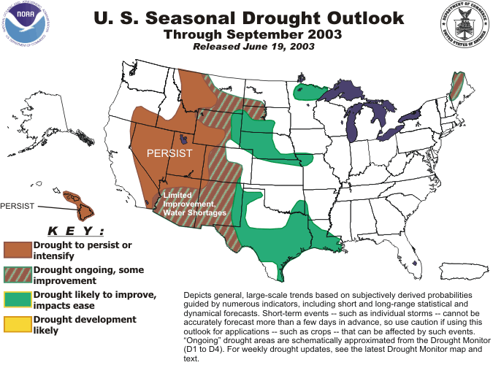
Figure 8. Drought conditions should improve somewhat in southwestern New Mexico, but significant water shortages are expected to persist.
The 30-day forecast for July calls for warmer than average temperatures and equal changes for below-average, above-average, and average precipitation. The 90-day forecast for the July-August-September period calls for both above average temperatures and precipitation (figure 9).
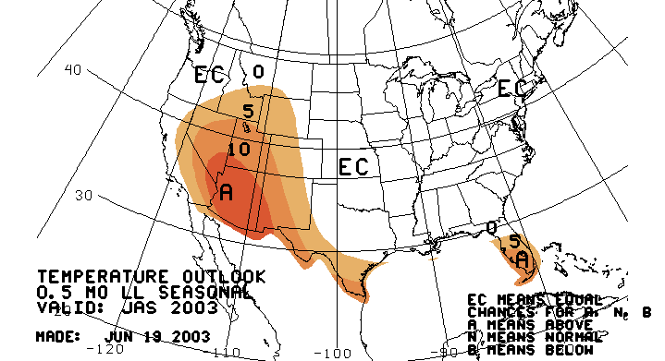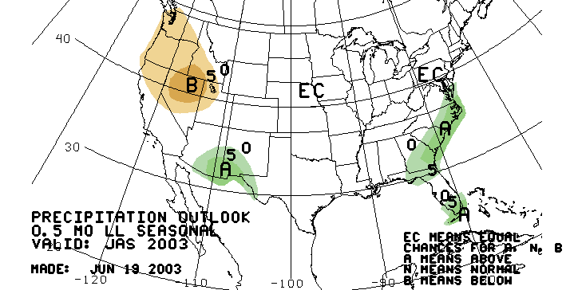
Figure 9. Southwestern New Mexico has a higher chance of above average temperatures than of above average precipitation.
According to the 20 June 2003 ENSO seasonal outlook, although signs of a La Nina episode are weakening, there have been several indicators of a cold event. The monsoon is currently enhanced over Mexico and signs of an enhanced monsoon in Central America have developed. This trend should continue through the summer with a five percent probability of an enhanced monsoon over southwestern New Mexico and southeastern Arizona. Soil moisture conditions, however, are expected to remain in deficit by about 20-40mm through September as of the 28 June 2003 forecast (figure 10).
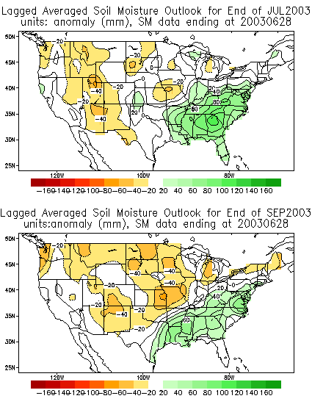
Figure 10. Soil moisture is expected to remain below average for the next 30 to 90 days.
I examined the yearly ERC traces for Beaverhead weather station to determine if there was any trend in ERC values in July and August when May and June were above average. Over the 33-year period used to assess this question, above average May and June ERC values occurred eight times and did not occur at all before 1988. Three times (1988, 1989, 1995) ERC remained above average until sometime in mid-July or mid-August, suggesting late monsoon seasons. Three times ERC dropped to average or below average (1991, 1996, 2000) although a return to above average conditions occurred by mid-July in two of those years suggesting weak and short-lived monsoon seasons. In 1990, ERC dropped to below average on July 5 and remained below average, suggesting an early and strong monsoon season. In 1999 ERC dropped to average levels on June 17 and then below average levels on July 21, also suggesting a strong monsoon season. If these interpretations are correct, it would seem there is a 38 percent chance of higher than average fire danger conditions persisting until at least mid-July and a 38 percent chance that fire danger will fall temporarily and rise to above average levels after mid-July.
Based on long-term records from weather stations in the National Weather Service observer network, the probability of receiving at least 0.3 inches of rain in a single day begin increasing rapidly in late June (figure 11), reaching a maximum of around 12-15 percent in late July. The chances of receiving at least that amount over a 5-day period reaches as high as 60 percent.
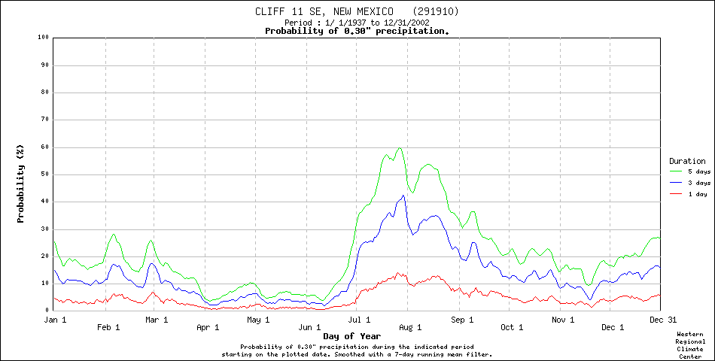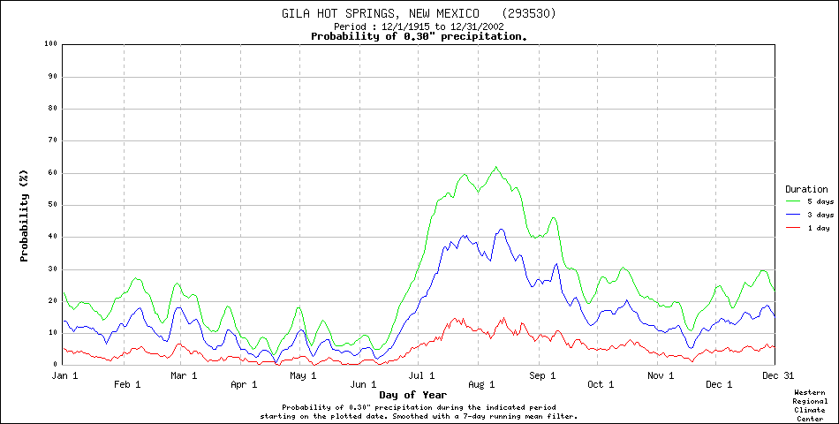
Figure 11. The probability of receiving at least 0.3 inches of precipitation peaks in the period from mid-July to mid-August.

Expected Weather
Under the most probable scenario, southwestern New Mexico should see the onset of monsoons sometime around mid-July. The strong high pressure over the area needs to move north into the Great Basin or east into Texas in order to allow extensive moisture into the area. Most often the onset of the monsoons is sudden and occurs with little warning.
Burning conditions could resemble those experienced in the 1990 season (figure 12). A normal to slightly wetter than normal season is expected. While soils may remain fairly dry, enough moisture should come in to increase live fuel moisture in woody plants and green-up warm-season grasses. Fine dead fuel moistures should also increase as these size classes respond to increases in relative humidity as much as to the direct input of moisture. Large dead fuel moistures may remain low as the short-duration, high intensity thunderstorms typical of the monsoonal season have little effect on large woody fuel moisture.
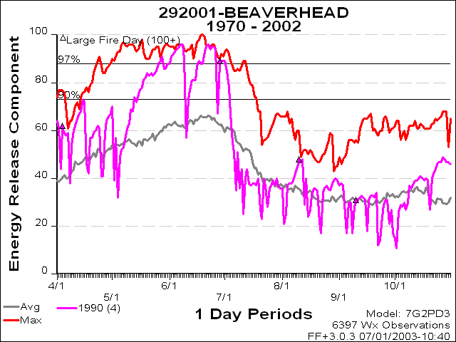
Figure 12. In 1990, ERC levels dropped rather suddenly from well above average values to below and near average values.

Extreme Weather
Under an extreme scenario, the monsoon season is weak and either delayed or short-lived. If the monsoon season is weak and short-lived, conditions could resemble those experienced in 2000 (figure 13). Hot, dry conditions would return by mid-August and persist until October. If the monsoon season is weak and delayed, conditions could resemble those experienced in 1995 (figure 13). Hot, dry conditions would persist until at mid-August and return in September, lasting until sometime in October.
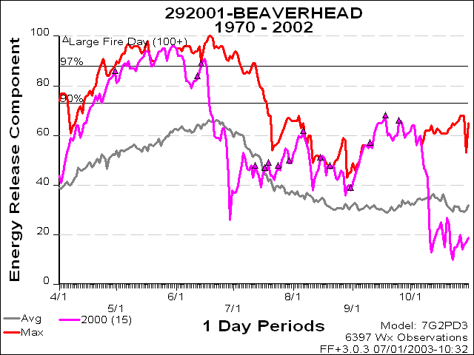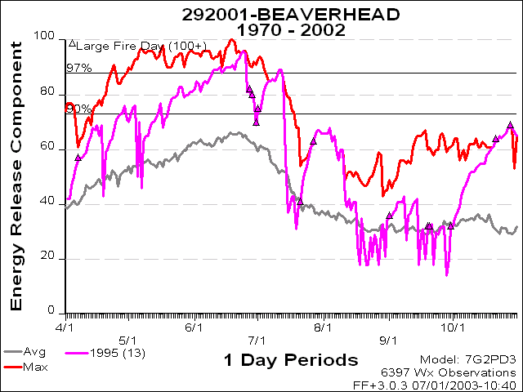
Figure 13. In 2000, it appears the monsoons were weak and short-lived allowing a return to above average conditions by August that persisted until early October while in the ERC pattern in 1995 suggests that a weak monsoon season did not begin until mid-August and was relatively short-lived.

