RERAP Term Files for the Gila Wilderness

The Problem
Neither the Gila National Forest nor Wilderness Ranger District has developed a term file for use by Fire Use Management Teams (FUMTs) in conducting risk assessments using the Rare Event Risk Assessment Process (RERAP) model. Although the Forest and District know that onset of the summer monsoons is the significant fire slowing or fire ending event in the summer, clearly defining monsoon onset in terms useful for analyzing in Fire Family Plus or RERAP has proven elusive.
Individual FUMTs have developed several definitions over the years, usually based on a certain amount of precipitation over a set period of days. However, intense wet thunderstorms may result in rainfall amounts that meet or exceed these definitions, but do not serve to significantly slow or stop fire spread. One reason is that these thunderstorms are often highly localized, hitting at the weather station, but not on the fire. Another is that the rainfall rate can far exceed soil and wood infiltration rates, resulting in most of the water simply running off. Fire spread may decrease for a day or two until the fine fuels dry out, but then can return to or exceed rates seen before the event.
The Southwest Area Coordination Center has defined the onset of monsoons as 5 consecutive days where minimum relative humidity is equal to or greater than 20% followed by several days with minimum relative humidity generally staying above 20% with occasional dips into the upper teens. However, the Coordination Center uses several stations at once over a large area to determine when this criterion is met, not a single station as is typically used for an individual fire. The National Weather Service offices in Arizona typically define the monsoon onset as dew point temperature reaching 54 or 55 degrees or higher and remaining at that level for at least 5 days. However, dew point temperature is not recorded by remote area weather stations (RAWS) nor stored in the weather information management system (WIMS).
The American Southwest lies in the northern edge of the North American monsoon, leading to much variability in the onset and ending of the season and the intensity of the season. This variability is probably why a clear definition has proven elusive. In moister years, a precipitation event definition or relative humidity definition may work well. But, in drier years, these definitions may not work as well. Usually the onset occurs suddenly, with little warning, and is only recognized in retrospect. Two key elements are movement of the Four Corners High out of the area and upper air winds from the southeast that bring in deep layers of moisture from the Gulf of Mexico. Neither of these elements are recorded by any particular weather station, so are not amenable to analysis using the standard tools.

Proposed Solution
In looking over both the weather records and fire danger indices as calculated in Fire Family Plus, the only clear evidence that stood out was the annual energy release component (ERC) trace. I examined annual ERC traces from 1970-2002 for two stations commonly used to represent weather within the Gila Wilderness – Beaverhead RAWS (292001) and Gila Center manual station and RAWS (292006 and 292011, respectively). I constructed a special interest group (SIG) from the Gila Center manual station and RAWS since there was very little overlap in the period of record and doing so allowed me to analyze weather back to 1970.
I selected the 75th percentile ERC value as the best indicator of generally moist conditions that do not promote erratic fire behavior or large spread events in the absence of significant wind. The 75th percentile value for Beaverhead is 57 and for Gila center is 53, including data for 2003 as of July 21. I then used the event locator tool in Fire Family Plus to find those days when ERC dropped below the 75th percentile and stayed there for at least two weeks. The date selected as the onset was the first day that ERC dropped below the 75th percentile value at the beginning of the two-week minimum period. Years in which ERC never reached the 75th percentile were dropped from the analysis. Days examined were June 1 through August 31. According to local experience, the monsoons can begin in late June and peak in early August, usually dieing off completely by early September. I first looked for the onset in July, backing up to June and moving forward to August when no July date matching the definition was found.
In general, the onset of monsoons happens earlier using data from Beaverhead RAWS than if Gila Center is used:
 | Beaverhead |  | Gila Center
Percentile | Number of Days Since April 1 | Date | Number of Days Since April 1 | Date
50th | 100 | July 9 | 109 | July 17
80th | 109 | July 18 | 118 | July 27
90th | 113 | July 22 | 123 | August 2
The earliest date at Beaverhead was June 18 and the latest was August 11. The range at Gila Center was June 25 to August 15.
Given that ERC tends to drop below the 75th percentile later in the year at Gila Center, a lower elevation, ‘hotter’ location, than at Beaverhead, the term file for Beaverhead may be the better choice during normal to wetter years. The term file for Gila Center may be more appropriate during drier years.
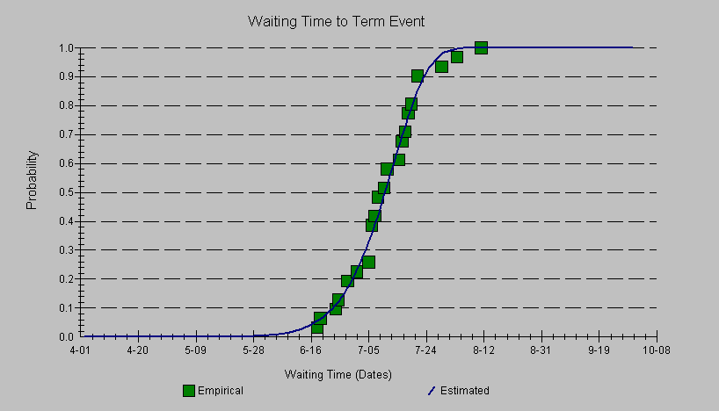
Beaverhead

Gila Center
Louisa Evers – LTAN
Great Basin #1 FUMT

