Smoke Concentrations

Air Quality Rating | 1- hour average PM2.5 Concentrations  (µg/m³) | Visibility Range  (miles)
Good | 0-40 | 10+
Moderate | 41-80 | 6-9
Unhealthy for Sensitive Groups | 81-175 | 3-5
Unhealthy | 176-300 | 1½ - 2½
Very Unhealthy | 301-500 | 1 – 1¼
Hazardous | >500 | ¾ or less

Sample Photos of Different Particulate Concentrations and Visibility from Crater Lake National Park.
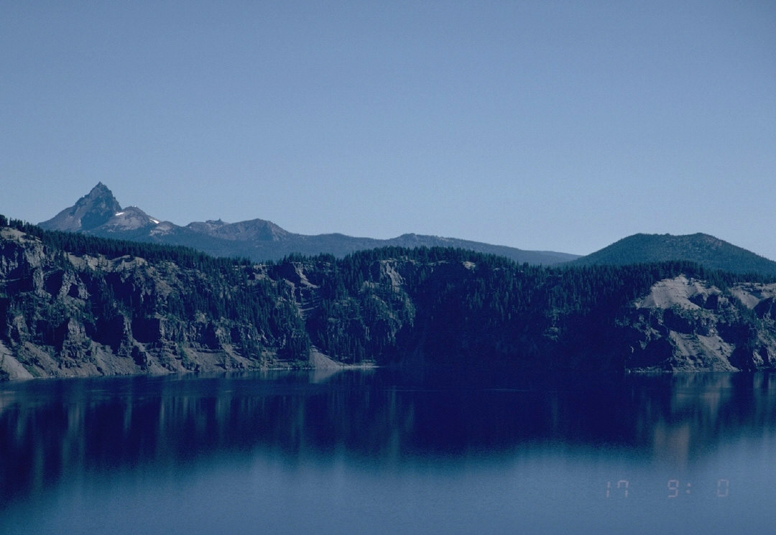
Mt. Theilson
Visible Range = 200 miles. PM2.5 concentrations = 0-1 µg/m³
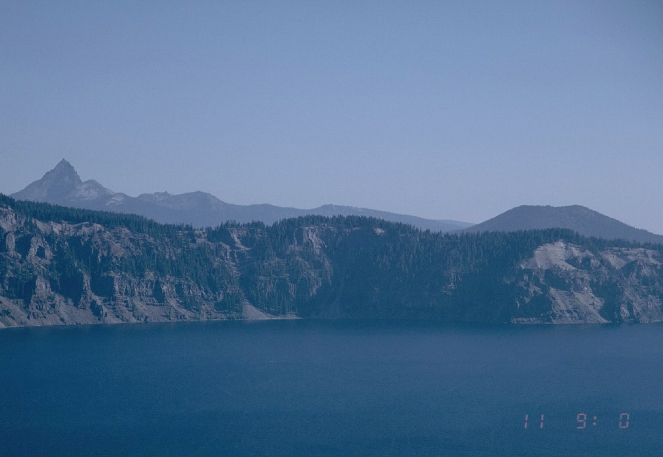
Mt. Theilson
Visible Range = 99 miles, PM2.5 concentrations ~5-10 µg/m³

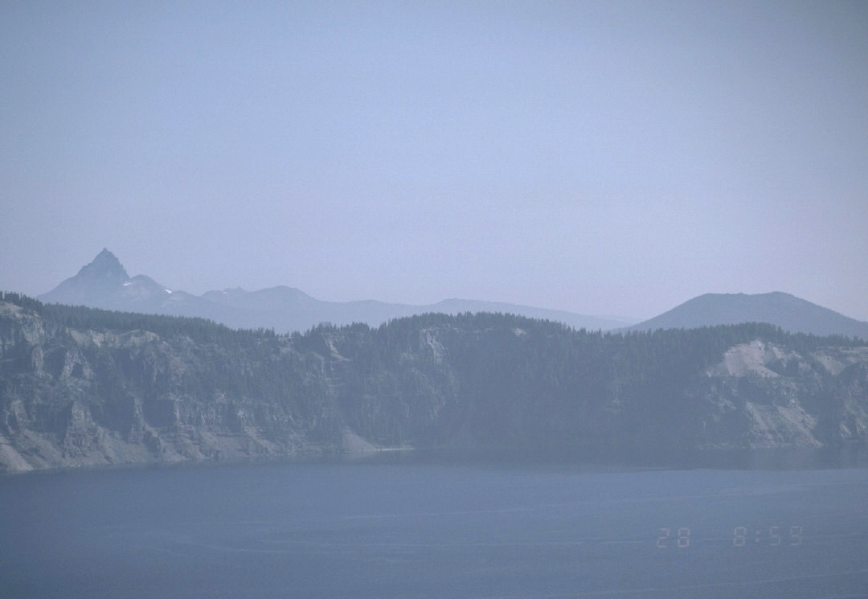
Mt. Theilson
Visible Range = 50 miles, PM2.5 concentrations ~15-20 µg/m³
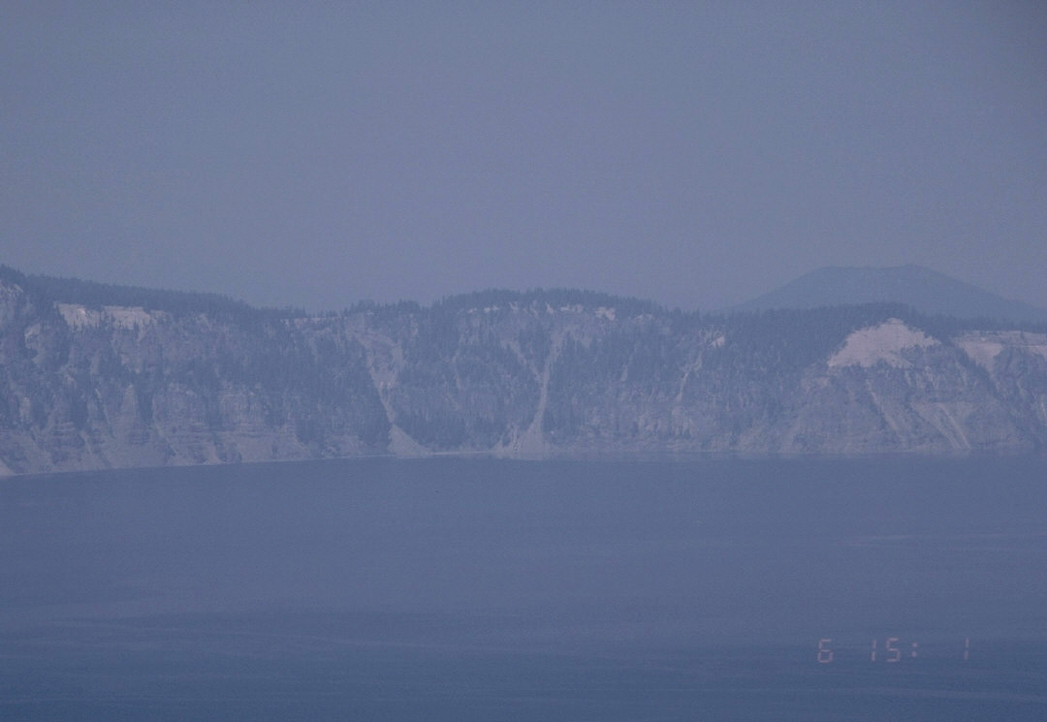
Visible Range = 15 miles, PM concentrations ~20-30 µg/m³

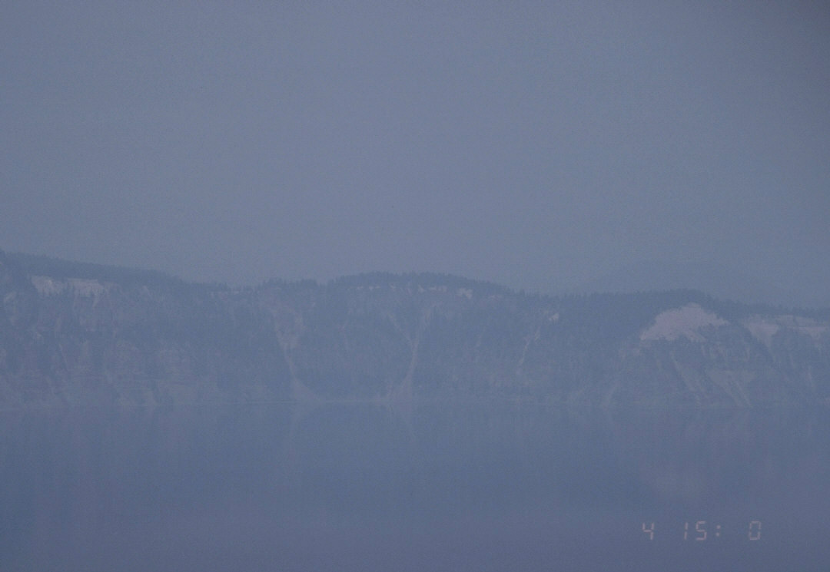
Visible Range = 9 miles, PM2.5 concentrations ~41 µg/m³

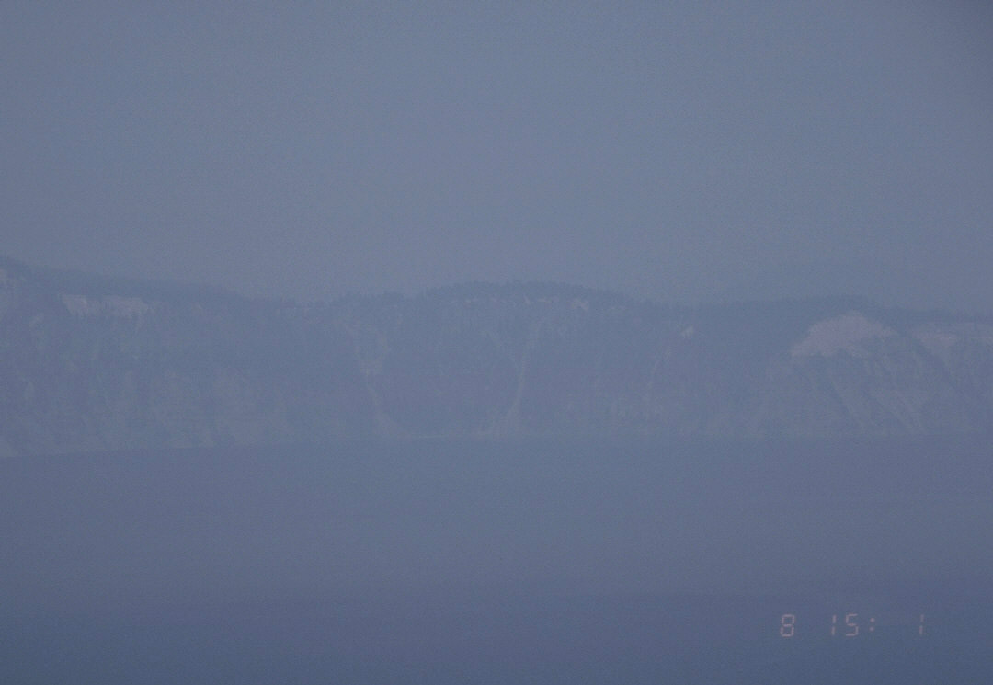
Visible Range = 9 miles, PM2.5 concentrations ~65-80 µg/m³

