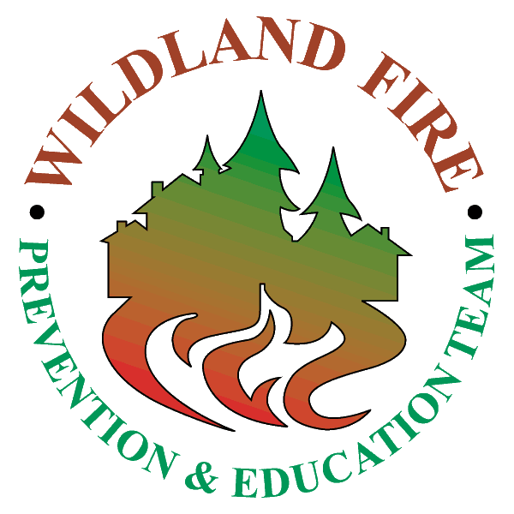
Wildland fire prevention & education teams can help reduce the risk of human-caused fires, educate communities to reduce their risk from wildfires, and work on special fire related events. Their primary role is to supplement and support the wildfire prevention efforts of local personnel and agencies. Teams provide interagency expertise in wildfire prevention, public relations and outreach, fire safety, the role of fire, and developing Firewise/fire adapted communities. They are highly successful at reducing the occurrence of unwanted human-caused wildfires through the use of trained specialists and state-of-the-art communication and education techniques. These interagency teams are available to support any geographic area preceding, during, or after periods of high fire danger or fire activity. The requesting unit may use severity dollars in support of a team or they can be mobilized under a fire code.

PURPOSE OF WILDLAND FIRE PREVENTION & EDUCATION TEAMS
Teams assist the local unit in the prevention of unwanted human-caused wildfires and mitigation of all wildfires. This involves working together to:
- Facilitate community awareness and education in fire prevention and mitigation including prescribed burning and Firewise and Fire Adapted Community methods.
- Promote public and personal responsibility regarding fire prevention and mitigation in the wildland/urban interface.
- Reduce the number of human-caused fires.
- Develop and implement communication plans, which include extensive media campaigns.
- Develop fire prevention and education material for specific targeted audiences. This material is currently used throughout the country by local staff and other national teams.
- Present Fire Safe/Firewise/ Community Programs.
- Improve and/or established relationships with cooperating organizations.
- Provide training for local prevention/education staff.
- Complete fire risk assessments.
- Determine the severity of the situation.
- Coordinate announcement of interagency restrictions and closures.
- Coordinate fire prevention efforts with the public, special target groups, state and local agencies and elected officials.
- Assist Incident Management Teams in accomplishing their objectives in working with the public to develop fire protection plans.

MOBILIZATION OF A TEAM MAY OCCUR WHEN AN UNUSUAL EVENT OR CIRCUMSTANCE WARRANTS OR IS PREDICTED. Examples are:
- severe weather or burning conditions.
- unusually high fire occurrence.
- majority of firefighting resources committed.
- preparedness levels above normal.

BENEFITS OF WILDLAND FIRE PREVENTION EDUCATION TEAMS
- reduce the loss of human life and property.
- reduce resource losses.
- reduce the cost of suppression.
- improve interagency relations.
- reduce the number of unwanted, human-caused wildfires.

ORGANIZATION AND ORDERING: A team normally consists of:
PETL - Fire Prevention Education Team Leader
PETM – Fire Prevention Education Team Member
PIO2 – Public Information Officer Type 2
Other positions and skills may be added to meet host unit’s objectives.

Requests for National Fire Prevention and Education Teams will be placed through established ordering channels in ROSS using an Overhead Group Request and configured according to Chapter 60 of the National Mobilization Guide.

