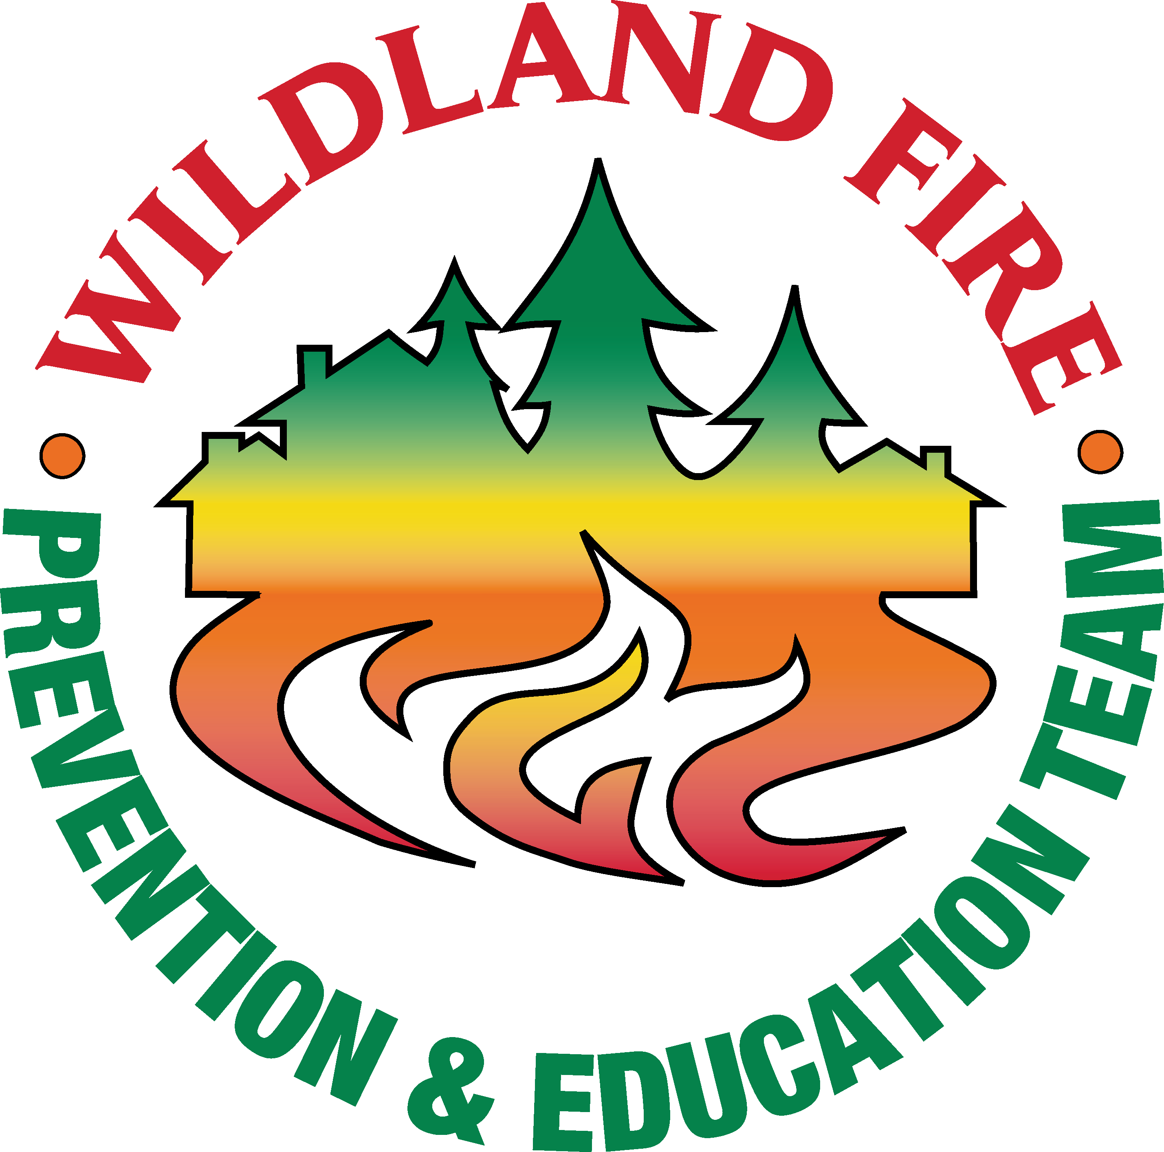 | Transition Plan  Team 1 to Team 2 | June 30, 2014

EXECUTIVE SUMMARY

The National Wildfire Prevention and Education Team (NFPET) was tasked by the Pacific Northwest Wildfire Coordinating Group (PNWCG) to align and leverage a Pacific Northwest (PNW) collective interagency campaign effort throughout Oregon and Washington, communicating prevention messaging through the Northwest Coordination Center (NWCC).

The Team was ordered by the USDA Forest Service and DOI Bureau of Land Management and arrived on June 15, 2014. Drought conditions in the PNW ranging from high to very high and increased fire danger warranted the need for a NFPET. The area has already experienced large wildfires exhibiting mid-to-late summer behavior, such as in the recent Two Bulls fire near Bend, OR.

The Team was tasked to address the issue of centralized messaging. After inventorying existing messaging the Team determined, the best course of action was to centralize messaging through a blog portal within the NWCC website. The blog portal will facilitate networking between cooperators and connect the public with local resources. It will also serve as a viable tool to communicate current conditions, raising public awareness regarding severe drought conditions, critical fuel moisture indices, high fire potential and the their role in the prevention of human-caused fires.

The Team developed short and long-term capacity building strategic plans to assist the Pacific Northwest for use in 2014 and beyond. The plans outline how local prevention work can be accomplished while training and qualifying individuals for prevention team deployment.

A second NFPET will continue the prevention effort through field assists to prioritized areas of Washington and Oregon. The second team, composed of PNW members, will transition in on June 30 for a two-week period.
Prevention Team Approach
The initial approach to address the Delegation of Authority (Appendix A) was to list each objective, describe an initial strategy, and list actions to achieve the strategy. The Team collected and analyzed data to support direction of the assignment and adjusted the operation strategy. Objectives were accomplished through a process of inventorying existing resources, messaging and programing, analyzing content and developing planning components. Appendix B outlines the Team’s methodology. Objectives were accomplished and/or modified based on the results of the inventory process.

Addressing Information Objectives
The delegation focused on ensuring prevention messaging raised public awareness about the severe drought conditions, critical fuel moisture indices, high fire potential and the public’s role in the prevention of human-caused fires. Further, the delegation asked that media markets and contacts be identified.

Methodology for the inventory included in-person and phone interviews, a program-based messaging matrix, website visits, and review of media outreach. It also included discussion with Predictive Services highlighting linkages to well displayed weather and fuels information.

Upon completion of the inventory and analysis, which focused on objectives and outcomes as opposed to titles and programs, it was determined that PNW is effectively reaching many of their sub-geographic areas with fire-adapted community messaging that meets PNWCG objectives. As a result, the decision was made not to create a new campaign, but instead to create a “bucket” that yarded up all existing programming and provided ‘one-stop shopping’ for the public.

Consistent Messaging Objectives
The same process was used to collect existing messaging. A matrix was used to examine materials being used by different agencies/organizations in the PNW. The process revealed messaging fell within the same range of values with all the cooperators using messaging consistent with Firewise mitigation principles and prevention of wildfires consistent with Smokey Bear’s messaging.

A key finding during the inventory process was the pre-season talking points, dated May 9, 2014 sent out by NWCC to cooperating Public Affairs staff. These talking points accomplished PNWCG objective to speak with one voice regarding this year’s conditions.

2014 PNW Fire Season Talking Points, May 9

Drought could signal early, serve fire season
Much of Texas, portions of the Southwest, large parts of the southern plains and Great Basin, and virtually all of Oregon are experiencing moderate to serve droughts this year. Most of California is in an extreme drought. February precipitation provided some improvement, but the drought remains. Without additional rain and snow, these areas could face a severe and earlier-than-normal fire season.

Some relief in Northwest, but large fuels remain dry
For Oregon and Washington, October and November 2013 were warmer and drier than average, delaying the onset of snow accumulation. December was also drier than normal, but much cooler. Snowpack remains well below average over much of Oregon. NE Oregon and most of Washington are at or near average snowpack.

The December 2013 cold snap caused widespread frost-kill that may provide additional dead/dry vegetation to carry wildfire during the summer. Shrubs like Ceanothus may readily ignite and burn at a time of year when they should be flush with spring moisture.

Cooler spring temperatures and much-needed precipitation have brought some relief to the NW, but large fuels remain dry at their core. As summer-like conditions occur, large fuels that are normally slow to dry will rapidly lose their moisture and be ready to burn earlier in the year.

Now is the time to prepare
Weather in the months ahead will ultimately determine the severity of the approaching fire season. Under current conditions, any ignition on a normal, summer-like day- lightning or human-cause-could rapidly become a large, damaging wildfire.

It is not a matter of if, but when, a fire will start in a given location. Preparation is essential to keeping you, your family and firefighters safe. It is critically important that landowners and communities recognize the dangers of living in fire-prone areas. Landowners should act now to make their property defensible, and to make conditions as safe as possible for firefighters who would be called on to protect it.

This means clearing excess brush, trees and grass that fuel high-intensity fires. Deprived of these fuels, fires burn at a lower intensity, are easier and safer for firefighters to contain, and are much less likely to cause damage.

As a result, the Team did not produce press releases and news articles. Public Affairs Officers within PNW have already been effectively communicating 2014 talking points with their local communities and media outlets. Duplication of efforts was not necessary and had the potential to create confusion. Therefore, the prevention team focused on providing linkages between the sources of information and users.

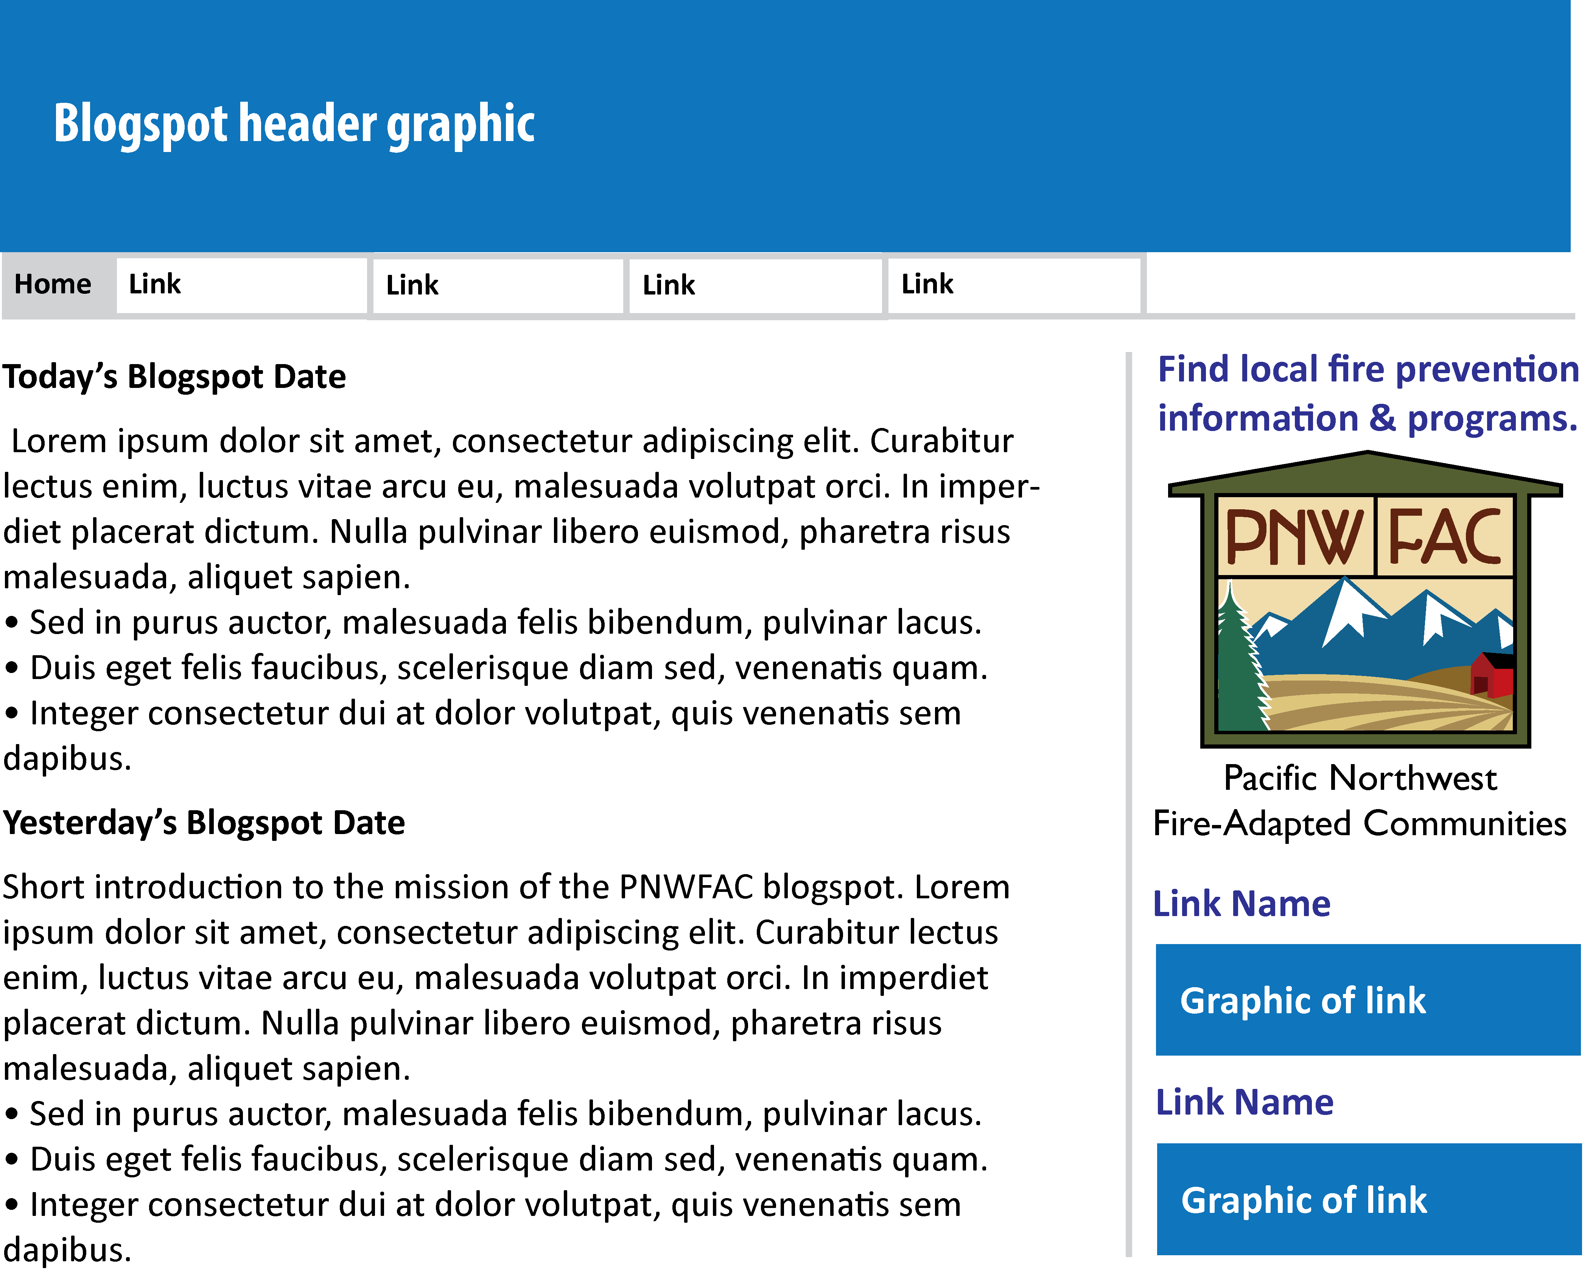
The NWCC media director, Carol Connolly, designed a blog spot for the NWCC. The blog spot will become the central point for PNW fire prevention, education and mitigation information distribution. A unifying brand was designed to signify the PNW effort to work within the umbrella (bucket) of Fire-Adapted Communities (FAC). The symbol on the website/blog spot will serve as the entry portal to prevention information for the PNW and provide linkages to existing local programs.

Building PNW Prevention Capacity
The delegation directed the Team to use PNW resources to supplement team actions, helping to build area capacity. Opportunities to train and mentor PNW prevention and information employees are to be used. Building prevention capacity is considered an immediate need and an opportunity for action to strengthen prevention efforts in the PNW. The Team has received requests for prevention assistance from both Washington and Oregon. At the time of this writing, eight severity requests have been approved for increasing the response capacity in southern Oregon. The ability to deploy trained local prevention teams is a benefit to the PNW.

Training on Current Assignment
Training tasks are welcomed in prevention teams. The Team composition allowed for getting task books signed off on this assignment. It was particularly important to emphasize the training aspects to get individuals qualified to build prevention capacity. Two Team Leader and three Team Member task books were completed and recommended for agency certification.

Addressing Prevention Capacity
There is a need to build the long-term prevention capacity of the PNW. Two distinct elements are identified to address this objective. A review and analysis of existing prevention positions and use is needed. A progressive training and experience program to solve local problems with qualified personnel needs implementation.

Internal Resource Inventory
The first element is for agencies to analyze the current daily prevention capacity in the PNW. The analysis helps provide management with information to make decisions.

Training and Experience
The second element increases prevention capacity by training and utilizing personnel as team leaders and members for prevention team deployment. These individuals are not necessarily prevention personnel in their daily jobs, yet are trained to assist units in the PNW. Team Member (P-310), Team Leader (P-410), and Fire Prevention Education 2 (P-301) training is needed to encourage individuals to the prevention effort.

The strategic plan developed, will help guild this effort. Individuals are used in productive area assignments to reinforce their classroom training. This accomplishes experience through application, working in a prevention team environment, and getting prevention projects done. Task books are completed and the number of team leaders and members available for deployment are increased.

Strategies to Build Long-Term Capacity
A second prevention and education team was ordered from the national rotation to follow the first team, transitioning on June 30. The second team, which is from PNW, will assist field operations in wildfire issues, identifying and prioritizing targets to address in 2014, and expanding partnering resources to help accomplish the mission. The Team is to utilize opportunities to include Team Members or trainees at the local level where possible.

2014 Prevention Strategy
The targets established at this planning level will become the responsibility of local resources once the prevention team leaves. Success is achieved through agency and public cooperation when focused on well-defined issues of concern. Refer to Appendix C for a detailed report “Strategy to Implement Prevention Team Use – 2014.”

Prevention Team Strategy – Four-Year Plan
The current number of qualified team leaders in the PNW is one (six). There are six additional team members and six more team members in trainee status. Discussions are ongoing to determine the level of experience, interest, and availability of the qualified team leaders and members identified in ROSS. For a detailed report on the four year strategy to improve the prevention capacity in the PNW, refer to Appendix D, “Prevention Team Strategy – The Four-Year Plan.”

Support of Fire Restrictions Website
The intent of this objective is to provide information and suggestions to all state and federal agencies. Encourage support and participation in the interagency fire restrictions website (firerestrictions.us)

The website has its origin in Montana. The state effectively maintains the accuracy of the content and has viable user interface. Other regions also have data in the site. Extensive contact with the site developer revealed the potential uses and limitations of the website. The Team identifies the following:
- The value of the site is dependent on agency information, vigilance to maintain the content, and timeliness of postings.
- The initial rollout of the site was limited (soft rollout) and not well advertised.
- Buy-in by agencies is limited and some that were initially involved are no longer participating.
- If the site is to increase credibility, agencies have to see the value. A recommendation is to get the site ready for a widely advertised rollout demonstrating the uses to the public and agency.
- A PNW decision to support the effort and provide a link to the website can be done through the NWCC prevention portal.

Other Initiatives of the Assignment
GIS products were produced to represent fire-cause information by agency and sub-region. The information was gleaned from existing databases maintained in the National Interagency Fire Management Integrated Database. These products are captured electronically and printed as part of Team documentation.

Products were developed in the inventory processes that do not appear in this report. The products are captured electronically and in hard-copy as part of Team documentation.
- Prevention capacity Analysis
- Program Information Matrix
- Weather/Fuels Forecasts
- Fire-cause analysis spreadsheets
- Field visit summaries
- Phone and in-person contact results
- Graphics and developed products

Administration
Administration is an important element of team operation and requires the Team to maintain administrative tasks to provide daily budget information, work in a safe and efficient manner, and maintain documentation of the assignment. Additionally, the team must adhere to local, state, and federal laws, including anti-harassment guidelines. The Team did the following:
- Maintained a daily budget spreadsheet of salary, hotel, per diem, vehicle, supply, transportation, production, and miscellaneous costs.
- Provided the host with periodic snapshots of expenditures in a summary or detailed format.
- Held daily safety briefings and practiced the varied topics resulting in an accident free assignment.
- Team signed off on a Job Hazard Analysis.
- Maintained an aggressive work schedule ensuring completion of objectives while allowing for team freedom to reduce stress and maximize productivity.
- Professional attitudes and interactions with individuals were maintained.
- Documentation of the assignment is recorded electronically and given to the host on a USB drive, as well as a documentation box of paper files and miscellaneous items.

<team composition and picture>

Recommendations:

NWCC Public Affairs Officer
It became clear early in the process that in order to have coordinated geographic area-wide messages and programs, there needs to be a single point of contact responsible for developing seasonal messaging and distributing to partners and cooperators. The position needs to be a full-time employee in the PNW in order to develop and maintain needed relationships and stay abreast of emerging PNW issues and needs. It also became clear that there is a need to advance the NWCC’s social media outreach, which requires someone to update information, foster relationships and respond to public and media inquiries beyond the high-fire activity summer months.

Development of an Evaluation/Feedback Mechanism
One of the primary findings of the interview process was the lack of a feedback mechanism. It was clear there are many programs being implemented throughout the PNW, but there aren’t any set measurements to gauge success and social change. It is this team’s recommendation to work with Pacific Northwest Research social scientists to develop an evaluation/feedback mechanism to measure success and social change.

Follow-up Items
Contact Bob Schumacher, Community Firewise Coordinator – 541 450-6205 – Not available until after July 15.

Appendix A
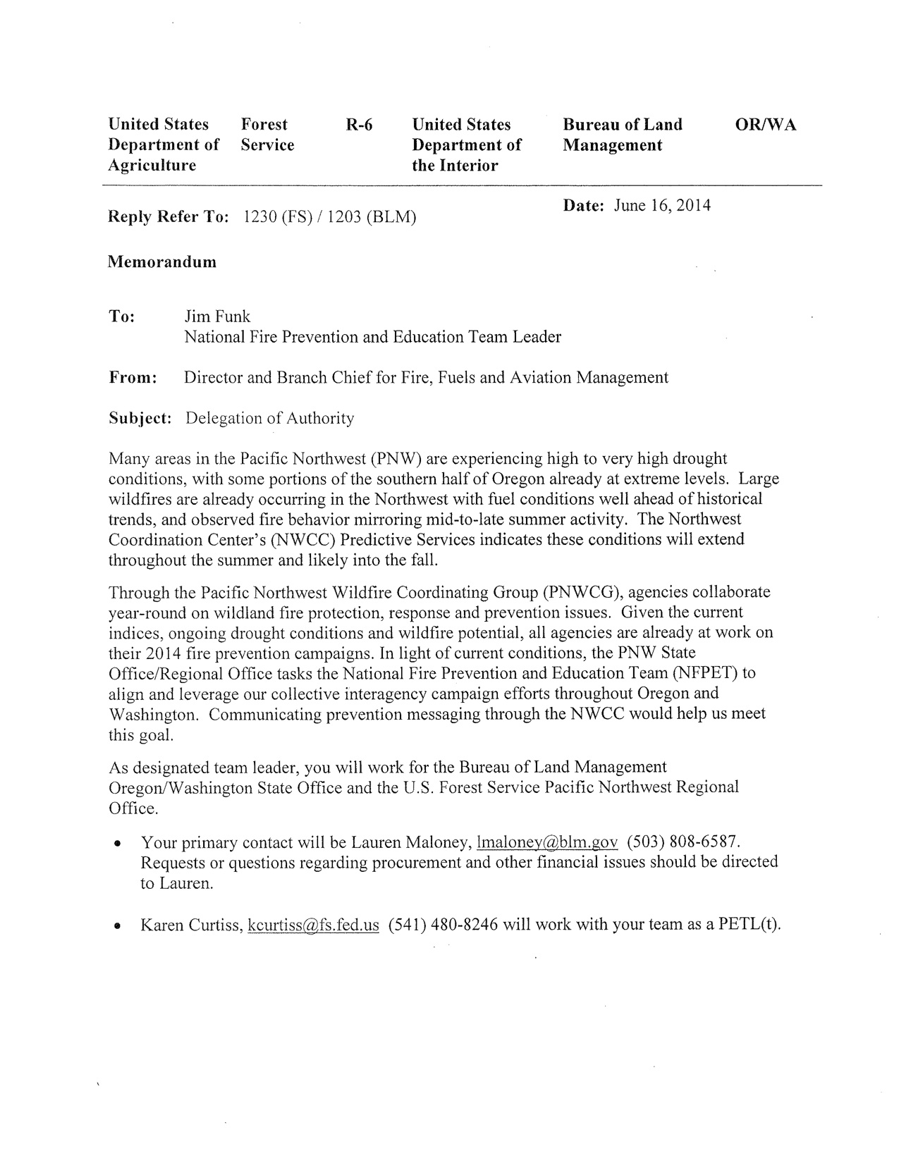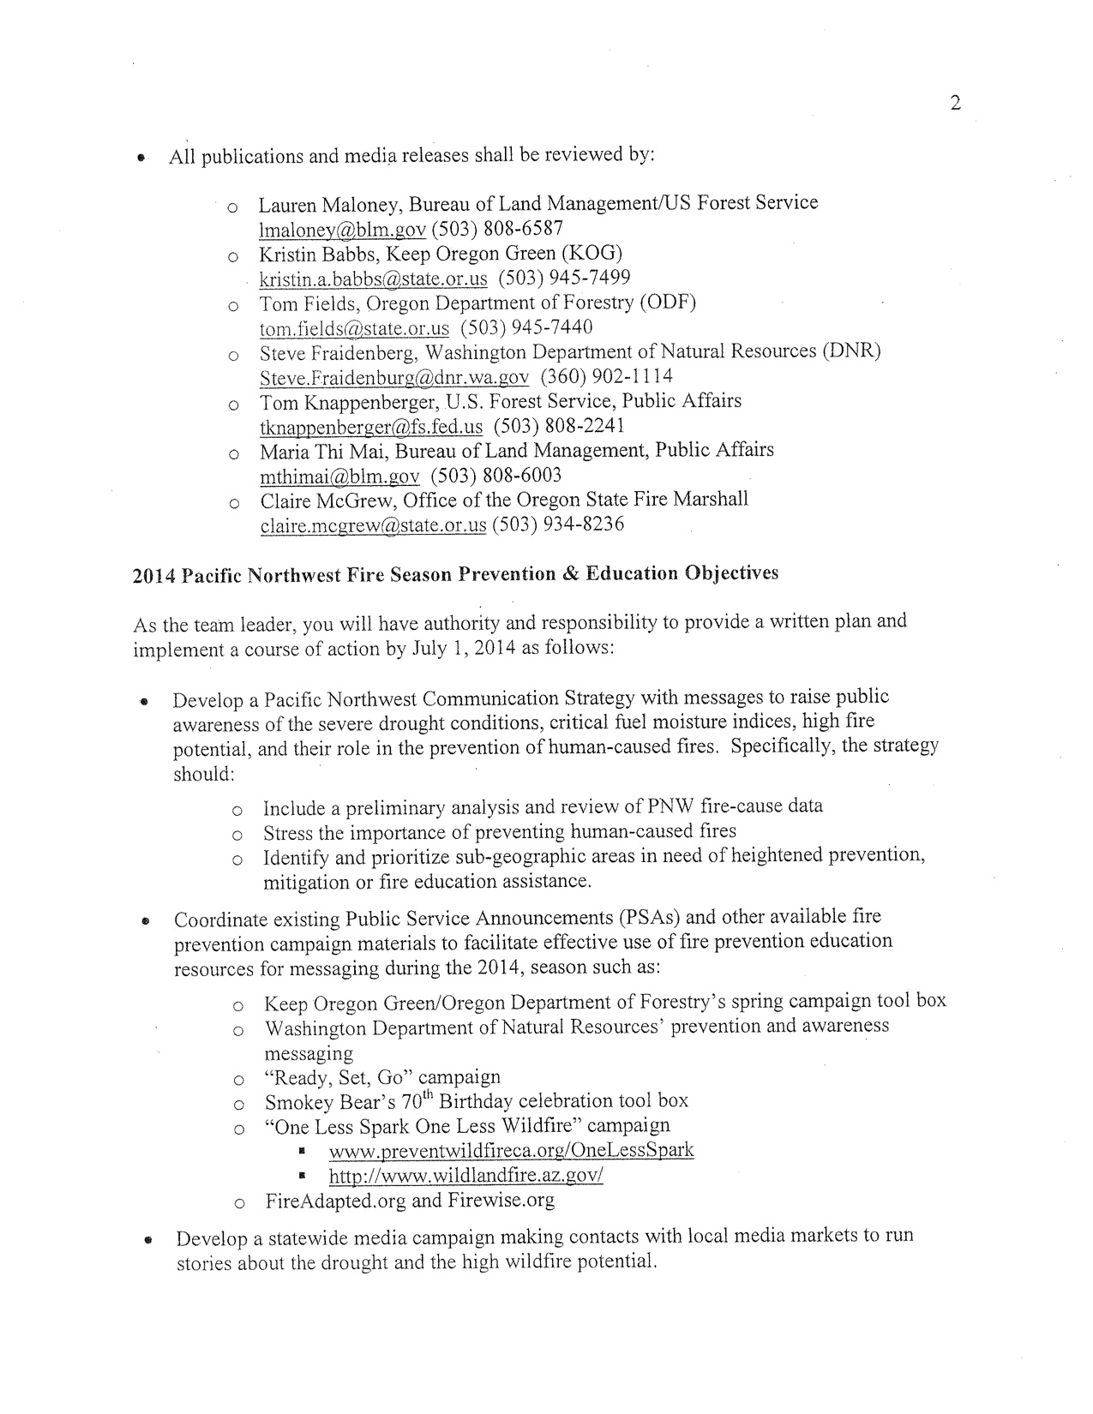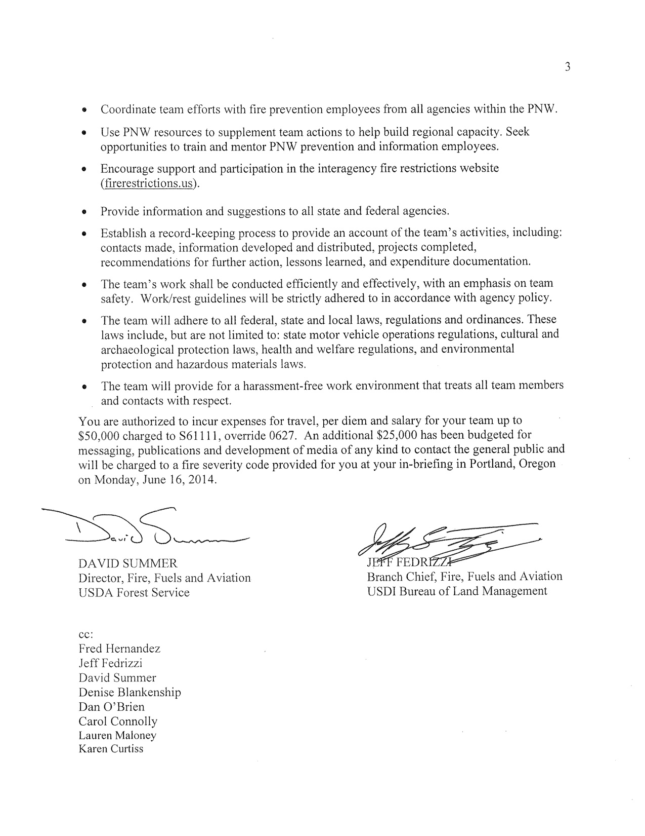
Appendix B

Team Strategy – June 2014
Fire Prevention and Education Team 2014-1 (PNW)

There are three primary elements of the team’s strategy to complete the objective of the assignment. Discovery of information feeds the process to develop needed products and deliverables. The information segment identifies and uses networks and delivery systems to get the messages to intended audiences. The Planning component is the development of the one-year prevention plan and the longer plan to span the next three to five years. The planning component further demonstrates the connection of the efforts in the Pacific Northwest to the Cohesive Strategy.

Discovery:
- Agency capacity – What prevention team resources are trained and available for use to handle local and area prevention missions?
  - Gap analysis of prevention capacity – What is needed in prevention resources to accomplish the long-term vision to manage risk from wildfire in the PNW?
- Programs and contacts – What are the programs/campaigns being used in PNW with associated primary contacts?
  - Examine the messages and delivery mechanisms used by programs.
  - Develop an information matrix to compare messages and delivery.
- Field input – Contact agency cooperators and others to reach out and get needs, input and suggestions.
- Fire-cause analysis at sub-regional level – Attain and analyze more localized fire cause data and represent the information graphically.
- Field visits – Physically visit selected areas to meet with ground personnel. Build information into the discovery process.

Information:
- Develop a list of networks and websites
- Gather current media outreach to look at content and approach to prevention messaging
- Build the story line of weather, fuels, situation
- Develop a composite of information links to be used where appropriate
- Define approval and distribution process for media from prevention teams
- Explore opportunities to use a central site for messaging, useful linkages, and information pages, to include blog spots
- Discuss measurements for tracking prevention trends
- Develop graphic image support including central identifying image and graphics to display drought, weather and fire risk. Provide other support to NWCC and PNWCG as needed

Planning:
- The planning scopes are immediate, 2014, and a three to five year view
- Prevention resources available and strategy to build the area capacity
- Present professional case showing how PNW prevention strategies are directly in line with the Cohesive Strategy objectives
- Present a 2014 prevention strategy for the PNW
- Present a three to five year prevention strategy for the PNW
- Identify and develop additional partnerships
Appendix C

Strategy to Implement Prevention Team Use – 2014

The initial Fire Prevention and Education Team (FPET) is tasked to develop a strategic-level plan to raise wildfire risk awareness, build agency prevention capacity and a synergy of PNW efforts resulting in area approaches to the Fire-Adapted Community concept. The effort is to directly address the objectives of the Cohesive Strategy.

The Team recommends a second FPET follow directly behind the initial team with the team lead arriving one day ahead of the other members. The recommendation is to have the team leader arrive on June 28 in Portland and report for first shift at 0700 June 29. Team overlap will allow the opportunity to shadow for clear delineation of tasks, logistics, and mission. Transition can be completed in one meeting at the closeout/in-briefing on June 30, 2014. The Transition Plan will contain the products, accomplishments, and recommendations of Team 1 and the suggested outline for the assignment of Team 2.

The recommendation for the focus of Team 2 is to assist selected field sub-regions to provide local planning analysis and develop an implementation component.

- Identify two to four prioritized sub-regions in each state (Washington and Oregon).
- Involve as many agency cooperators and local prevention programs as possible.
- Work through the risk/hazard/value analysis on a ‘coarse scale’ to identify specific needs, target accomplishments, and available resources. More detailed analysis can be done as time permits or needs are indicated.
- Recognize the differences in perceptions and assignment of values for each agency, cooperator, and program.
- Identify existing prevention personnel resource capacity and need for additional resources.
- Formulate a prevention plan to address the most urgent issues.
- Define the prevention messages most effective for each objective and identify the availability of materials for distribution.
- Focus on fire-cause analysis and opportunities to manage risk.
- Solicit participation of other local resources to assist in delivery of actions for each objective. Community participation leverages the resources and builds relationships.
- Use local efforts to build agency prevention capacity by giving interested people the opportunity to participate in the process and contribute their talents.
- Explore the opportunity of including the resources of the Citizen Fire Academy, a current community effort in Southwest OR.
- Document the successes and challenges for each sub-region project with the intent of building a good working model to use local prevention teams solving specific issues in future assignments.
- Identify long-term projects where additional prevention will reduce wildfire risk.

Team 2 is to utilize their full team and work with Southwest OR first. A goal is to then develop the working model to determine actions and deliverables. The process can be taken to other locations for implementation. The Team will judge the opportunity to conduct similar operations with two-to-three person teams that respond to priority requests.

Past the assignment of Team 2, local resources will implement the results of the sub-regional planning. Efforts will be aimed at clear and targeted objectives using an expanded prevention resource in a unified assault. A person or team may be needed to coordinate and assist the local units with logistical support and agency coordination.

Appendix D

Prevention Team Strategy
The Four-Year Plan

The Pacific Northwest has identified the need to build internal prevention capacity through increasing the number of qualified prevention team leaders (PETL) and members (PETM). Both training opportunities and assignment experience are needed to build the prevention capacity.

The increased prevention resource has the potential to address local issues, address specific fire causes, and assist agencies and programs with implementing actions to manage wildfire risk. The plan for 2014 focuses effort on assisting prioritized sub-regions to implement plans targeted at specific issues.

Following is a plan for the next three years that incorporates training and prevention team use to build the capacity of PNW resources to address future needs:

2015
Conduct P-301 (Fire Prevention Education 2) training regionally in January or February. If the timelines prohibit, offer the P-301 course in Fall 2015. Place people in the training that are interested in pursuing a prevention path. There would be a benefit to include students from each sub-region. The course is designed to develop solutions for specific local issues. A broad variety of prevention challenges helps identify the depth. Changing social behavior, community engagement, and measuring outcomes are the three main topics of the course. Issue solutions are the outcomes of the course. The training order may be altered based on agency interest and commitment of individuals

From the course, identify and prioritize issues that the PNWCG through its Communication, Prevention and Investigation working team, deems the most relevant and beneficial to address. In the spring following the course offering, assign teams to work on the identified projects. Develop and demonstrate measurements of prevention efforts.

Results for this stage are for individuals to gain skills in prevention approaches and to demonstrate putting the training into action. An intended result is to add professionalism to the prevention structure; encouraging individual participation and program support from administrators.

2016
Conduct P-410 (Prevention Education Team Leader) training in January or February. The course is designed to train existing team members as leaders. Additional leader capacity is needed to manage teams in local and area assignments.
Develop and use the mini-team assignment concept. Local teams on local assignments give trainees experience and confidence being part of a team and accomplishing beneficial objectives. Focus can be on current or emerging issues. If needed, the teams can support ongoing efforts. Building prevention success stories helps establish the credibility of the prevention program and helps draw in addition partners that see the value of managing wildfire risk.

2017
Conduct a P-310 (Prevention Education Team Member) training in January or February. The course is designed to train interested individuals as prevention team members. As prevention efforts are demonstrated to be more effective, more people will be interested in looking at the prevention track. Individuals are encouraged to attain crossover skills of prevention, suppression, and law enforcement. Team member composition draws on specific skill sets to address specific issues. A law enforcement person can be added to a team. If there is additional knowledge of how a team functions, the skill set is enhanced.

Incorporate demonstrated FPET value into risk reduction and fire suppression strategies where applicable. Broaden the team use to be involved in all-hazard assignments, strategic planning, and community support.

