**Kansas Interagency Wildfire Council  
Wildfire Prevention Action Plan**

## A report from the 2012 Kansas Wildland Fire Prevention and Education Team

Presented on September 7, 2012

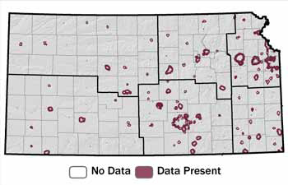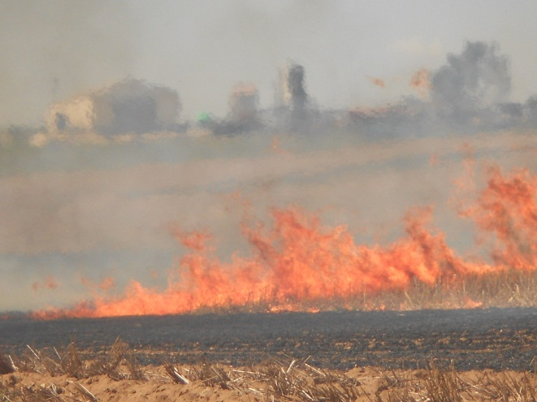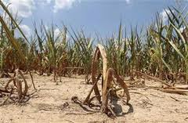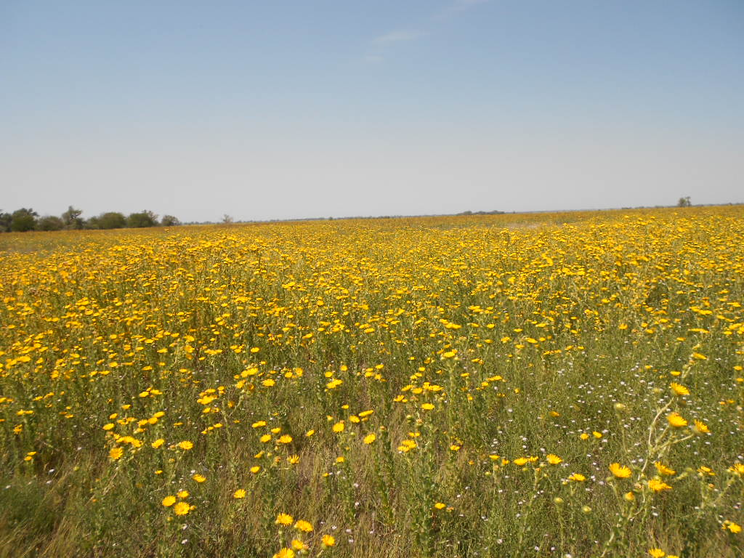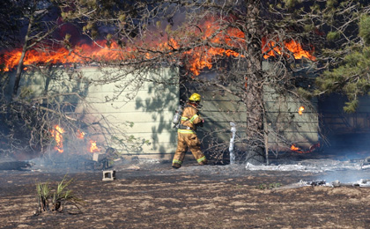

Contents

Executive Summary 1

Introduction 2

Objectives 3

Partner Wildfire Prevention Assessments 4

Fort Riley 4

Bureau of Indian Affairs – Northeast Kansas 6

U.S. Fish and Wildlife Service (USFWS) 9

FORCe (Fire Operations Resource Coordination) 11

Kansas Forest Service 13

Strategies 14

Short-Term Strategy 14

Short-term action 14

Long-Term Strategy 15

Long-Term actions 15

Measuring the Kansas prevention effort 16

Measures 16

Communication Plan 18

Purpose and Objectives 18

Strategies 19

Barriers 20

Ambassadors 20

Channels of Communication 20

Issue – Debris Burning 21

Audiences 21

Sources of Information 21

Messaging 21

Issue – Controlled Burning 22

Audiences 22

Sources of Information 22

Messaging 22

Issue – Field Equipment 25

Audiences 25

Sources of Information 25

Messaging 25

Issue - Drought 27

Audiences 27

Sources of Information 27

General Talking Points on Drought 27

Drought Resources 28

Drought Campaign Ideas 29

Drought Related Wildfire Prevention Messaging -- How The Public Can Help 29

Issue – Wildland Urban Interface 31

Audiences 31

Sources of Information 31

Messaging 31

Issue - Arson 33

Audiences 33

Messaging 33

Website flowchart 34

High Profile Events 35

Recommendations 36

Appendix A 37

NETWORK BUILDING INSTRUCTIONS 37

Appendix B 38

Google Access Instructions for Kansas Wildland Fire Prevention & Education Account 38

# Executive Summary

Kansas experienced extreme fire behavior in 2012, with more than 41,000 acres burned and 26 structures lost from wildfire by the end of August. A **national fire prevention and education team** was requested by the Kansas Interagency Wildfire Council on August 23rd to provide expertise and guidance for interagency outreach efforts for wildfire prevention, with the ultimate goal to reduce human-caused fires. The team was charged with developing a statewide fire prevention plan, conducting a preliminary assessment of the state’s wildfire problem, identifying agencies and/or individuals that could form a lasting prevention partnership and creating prevention messages and materials to address different types of wildfire causes in Kansas. This Action Plan is a result of those efforts and is a guide for future wildfire prevention efforts in Kansas.

# Introduction

Kansas experienced a unique and extreme level of wildfire activity in the summer of 2012 compared to previous years. Drought conditions made the landscape particularly vulnerable to the ignition and spread of fire. This lack of moisture, coupled with warm, dry and windy weather, resulted in record low fuel moistures and increased the potential of extreme fire behavior.

Kansas Forest Service officials estimated that more than 41,000 acres burned across the state from a timespan of January through August, making it one of the worst years for wildfire on record. These fires burned hotter and were more difficult to control making suppression by firefighters more dangerous.

Making matters worse was the fact that these wildfires resulted in greater property loss than in previous years. According to the Kansas Forest Service, there were 26 structures lost due to wildfire that summer through the end of August. Compared to the fact that no structures were reported lost over the previous seven summers, and the severity of the situation was clear. In addition to structural losses, burned hay fields were considered property losses since the likelihood of regrowth was low due to extreme drought conditions.

Many counties across the state had burn bans in place or were not issuing burn permits because of these extreme conditions. Where restrictions were not in place, it was recommended that citizens delay any outdoor burning until the area received a significant amount of rainfall.

According to the National Weather Service, much of Kansas experienced extreme or exceptional drought conditions. Light rain showers did little to ease the drought or reduce the threat of wildfire.

As a result of the severe conditions, a **national fire prevention and education team** was requested by the Kansas Interagency Wildfire Council (KIWC) on August 23rd to provide expertise and guidance for interagency outreach efforts for wildfire prevention - with the ultimate goal being to reduce human-caused fires. This Team was comprised of a national multi-agency group of wildfire prevention specialists established to raise awareness of the severe threat of wildfire the state was experiencing due to the drought conditions. The Team arrived in Manhattan, Kansas on August 27th to begin a two week assignment to fulfill the objectives set forth by the KIWC.

# Objectives

The objectives for the Team were outlined by the Kansas Interagency Wildfire Council in a Delegation of Authority signed on August 27th and included:

1. Developing an Interagency and Statewide Fire Prevention Plan or Guide
2. Identify, from data provided by cooperating agencies, a preliminary assessment of the fire issue in Kansas (what is the primary concern related to unwanted fire starts).
3. Create a message(s) to address those Human causes that were identified in Objective #2.
4. Identify agencies and/or individuals that could/should form a lasting prevention partnership.
5. Develop a Statewide communication plan for seasonal messaging for use by the partnership mentioned in Objective #4.
6. Create prevention messages to address different types of communities in Kansas (Urban/Rural)
7. Through the Kansas Forest Service, disseminate appropriate suppression strategies and mop up issues associated with current environmental conditions and share “Lessons Learned” with Volunteer Fire Departments statewide.
8. Identify high profile events in the State and determine ones the team can attend, such as the State Fair.

# Partner Wildfire Prevention Assessments

The assessment process objective was to listen to partnering agencies to better understand their perceptions of wildfire issues. Partners were asked to elaborate on their current situation and highest wildfire concerns; then provide best solutions to the issue. Conversations often led to open discussions helping to carve a path forward for prevention efforts in Kansas.

## Fort Riley

#### Fire occurrence

Fort Riley has a frequent fire occurrence due to the nature of activity on base from both training and recreation activities. Wildfires can happen anytime depending on conditions and use.

Fire causes  
The top three fire causes on base are munitions, recreation, and children, with munitions being the number one cause.

#### Property location, distribution and jurisdiction

Fort Riley military installation is 101,000 acres in size and is located West of Manhattan, KS. The majority of land on post is used for munitions training and has large impact and training areas on the north side of the base. The south side of the base is primarily housing and amenities as well as providing some recreation areas for hunting, biking, and OHV use. There is a new area near the marina that will be utilized for camping. Fort Riley Fire Department (FRFD) is responsible for fire suppression on the base.

#### Partnerships of note

One of the biggest partnerships with Fort Riley is with the Kansas State Forest Service. This is a well-established relationship that involves cooperative efforts for fire suppression, prescribed burning and wildfire prevention/education.

On the west side border of the base is Milford State Park. Fort Riley Fire Department expressed interest in forming a partnership with the Kansas Department of Wildlife Parks and Tourism (KDWPT); however the partnership has not materialized. They would like to develop this partnership to be informed of prescribed burning and suppression but also to communicate the same fire prevention message. The partnership could become a place for KDWPT to obtain fire training and PPE for their firefighters.

There is an organization called Fort Riley Outdoorsman Group or FROG. This is a group whose purpose is to coordinate outdoor activities on base. It is felt the organization will be an effective partner in distributing fire prevention messages to outdoor recreationists. This partnership has the potential to reach the two fire causes that the FRFD is concerned about - Children and Recreation.

#### Perception of wildfire issues from agency and public perspectives

The general perception is people in the area of Fort Riley do not recognize there is a wildfire problem in the area. FRFD expressed concern regarding the lack of awareness that the public has about the drought. They have requested a better drought map that might explain the severity of this year’s fire danger.

#### Current prevention actions

FRFD has a prevention education program in place. Range control is on patrol during training activities to help minimize wildfire starts as well as fire spread.

Recreationists/hunters are urged to check in on *i*-Sportsman (<http://www.isportsman.net>) when they come onto base. When they check in, an alert will pop up informing the recreationists of the high fire danger urging them to be safe with fire.

The FRFD is partnering with the local juvenile fire setters program with the intent to expand to a regional program.

#### What is working or has worked to reduce threat of wildfire

Range control is the most effective with helping to patrol and reduce the amount of fires caused by munitions. *i*-Sportsman is working to an extent but only if the recreationists are signing in to the system.

#### Best solution ideas going forward

Better educate the public on the fire danger and drought using local networks, such as FROG, to promote awareness.

#### Central idea theme suggestions:

FRFD is willing to work with any theme that is approved by the Kansas Interagency Wildfire Counsel (KIWC).

#### Current needs:

FRFD would like to continue to develop the KIWC and work with the new messages created by the Kansas Wildfire Prevention and Education Team. FRFD would also like to obtain a good drought map that better explains this year’s drought condition compared to years past.

## Bureau of Indian Affairs – Northeast Kansas

#### Fire occurrence

Fire occurrence in and around the Indian lands is primarily from equipment use and debris/residue burning. Most of the occurrence is from the non-Indian population during farming and ranching activities. Fires from improperly maintained equipment, usually bearing failure, sparks from mowers hitting rocks, and vehicles parking on flashy fuels are major sources of fire starts. The fuel types are almost entirely grasslands with wooded riparian elements.

Escaped fires from controlled burns to reduce crop residue or grass management are also a prevalent fire cause. Indications are that a number of individuals participate in burning activities with limited training, equipment, or experience. There is a significant fire occurrence from newly developed “ranchettes” in the southern portion of the area. Jackson County is the county of greatest concern. The county is 50-60% hay or pasture land with frequent use of controlled burns.

There is considerably less fire activity on the north portion of the area due to weather and fuel differences. The southern area is much drier with flashy fuels and more fire-use activity. Estimates from the agency were an average of six fires on the north end versus 50-60 in the south.

#### Property location, distribution, and jurisdiction

The lands of the Horton Agency include the properties of the Iowa Tribe, Sac & Fox Nation, Kickapoo Tribe, and the Prairie Band Potawatomi Nation. A unique factor of these lands is the interspersed pattern of ownership due to allocation, fracturing, trust lands, and non-Indian private land ownerships. The area is approximately 85 miles north to south.

The BIA jurisdiction issues are complicated and go well beyond the scope of this document; however it is our understanding that agency jurisdiction is on tribal and government lands with no jurisdiction on non-Indian private lands within the boundaries of the reservation.

There is also a dynamic of control on lessees farming and ranching under contract with the agency on Indian lands. The agency communicates with the lessees on restrictions and actions.

The tribal FD is in the center of the Prairie Band Potawatomi Reservation. Land to the west of the FD tends to be larger agricultural ownership blocks with a high use of controlled fire. There are numerous scattered residences in the western half of the Reservation. The eastern half of the Reservation contains five development clusters of homes. Properties tend to be smaller. Fewer wildfires occur in the eastern half of the Reservation. There are several small “ranchettes” in the southern area of the Reservation. Some fires come from this area. Landowner experience with controlled burning and debris may contribute to fires occurring in this area.

#### Detail of note

There are three tribal fire departments. They are the Iowa, Kickapoo, and Prairie Band Potawatomi fire departments. Outside partnerships are not well defined. There are a number of potential partners that would be very beneficial to this area. An example is the machinery and farm supply dealers. Garnering support of this partner group could help relay messaging to ranchers using equipment and doing control burns without infringing on jurisdictional boundaries.

Four Communities At Risk (CAR) are identified as Mayetta, Powhatten, Reserve, and White Cloud according to the Federal Register, 2001. Only Mayetta is in Jackson County with the other three north of Horton. The CAR is a broad area including rural lands around the town center. The designation is indicative of the topography, fuel type, residence structure type, and activity along with other factors.

Conservation Reserve Program grounds adjacent to residence properties were expressed as a concern. Burning times had deadlines and occasionally the timing was not the safest. Material in the yard of homeowners may be combustible and could carry the fire to the residence.

#### Perception of wildfire issues from agency and public perspective

Similar to other findings, there is awareness that wildfire is present, yet the threat level is not great. As a whole, the northern portion is not concerned about wildfire. In the southern portion, there is a sense of urgency to address the wildfire problem. Fire departments and agency personnel seem to have an elevated concern for wildfire in comparison to the general public. The difference is due to information availability and experience with wildfire.

#### Current prevention actions

As part of prevention team documentation, a file of the Horton Agency Wildfire Prevention Plan, Communications Plan and Implementation Plan has been established.

Elder Care Centers are excellent places to have messaging and information. Programs are held at the centers. Thought is that visual and brief messaging would be the most effective.

Current efforts are focused on signage, prevention program delivery, personal contacts, and use of a burn-permit program. Prevention information utilizes exhibits and community centers and other gathering places such as health facilities. Prescribed fire is broadly used to reduce fuels and implement mitigation objectives.

A recommendation is that the electronic message board at the casino could be used to get prevention messages to the public. Contacts need to state the case of benefit to the citizens and tribal community.

#### Central idea theme suggestions

BIA is willing to work with any theme that is approved by the Kansas Interagency Wildfire Counsel (KIWC).

#### Suggested ideas going forward

Resulting from the assessment is a series of ideas from desired actions, suggested approaches, and long-term ideas. Both short and long-term ideas are blended in the following list.

* Meet with the Potawatomi fire department to discuss fire cause issues and dissemination of information.
* Schedule an appearance on the noon farm and market show at the Hiawatha radio station.
* Produce a checklist of equipment use safety tips to be used in a variety of ways including a flyer to send to lessees and to distribute to local farm supply businesses.
* Produce the equipment use safety tips information in a small sticker version to be affixed on the inside of machinery cab windows as a safety reminder.
* Contact Roberta Spencer, NRCS in Jackson County to provide information for an upcoming Livestock Meeting in Kansas City on September 11.
* Contact John Deere to encourage an Awareness and Safety Day where they can promote maintenance products and equipment while also providing safety information to prevent wildfires coming from equipment.
* Contact the Holton and Jackson county fire departments to get a sense of their wildfire issues and to garner support to distribute information.
* Develop a prevention strategy specifically targeting the ranchette developments in the southern portion of the protection area.
* Create a video demonstrating how easily fire starts in prairie grass in extreme conditions and how fast it spreads. The video can be distributed on YouTube.
* October Prevention Week would be an excellent opportunity to distribute information on wildfire and safety information on equipment and control fire use.
* Utilize the RFD TV cable channel to get messages to rural citizens.
* Work to improve the relationships with agencies and fire departments, both paid and volunteer.

## U.S. Fish and Wildlife Service (USFWS)

#### Fire occurrence

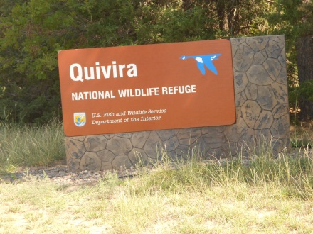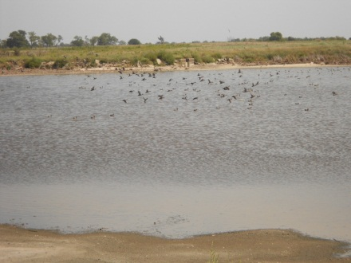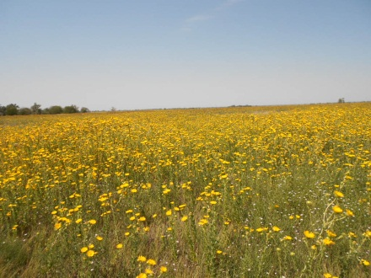

This assessment encompasses more than USFWS lands. One of the main impacts of USFWS on prevention of controlled burns is through their Private Lands section that deals directly with private landowners and assists with field burns. Fire occurrence around USFWS lands is primarily from escaped controlled burns adjacent to the property. Fires due to equipment use also result in a high percentage of occurrences.

During the spring season the fires are generally human-caused (controlled burn escapes and equipment fires). In the fall there is little to no controlled fire use by the public; therefore the incidence of lightning fires is a higher percentage. Higher fire occurrence around USFWS properties is near the Foot Hills property with 12-13 per year. An unusual fire cause is one set at antler shed to more easily locate the antlers.

#### Property location, distribution, and jurisdiction

There are four properties in Kansas; Flint Hills NWR (18, 500 acres) near Hartford, Marais de Cygnes NWR (7,500 acres) at Pleasanton in eastern Kansas, Quivira NWR (22,135 acres) in the south central portion of the state, and the Kirwin NWR in north central Kansas (10,778 acres) at Kirwin.

In addition to jurisdiction of the refuges, the Private Lands section assists landowners with funding and execution of wildlife practices including controlled burning. This is an important connection with the public and may have significant outreach in the prevention effort.

#### Detail of note

USFWS does prescribed burns throughout the year. As a general rule, private burning is in the spring. The agency has numerous large groups of users and excellent networks.

Bill Waln also serves as a contact for the NPS. There are numerous historical sites, two small park properties and the larger Tall Grass Prairie National Park south of Manhattan, KS with a 10,000 acre tract.

#### Perception of wildfire issues from agency and public perspective

The eastern portion of the state tends to take a less cautious attitude toward the threat of wildfire. In the west fires are a recognized, serious threat due to much drier fuels and weather patterns.

Fire departments seem disengaged from agency cooperation and information in some areas. Fire departments are initial attack in most areas and play vital roles around government properties.

#### Current prevention actions

There are opportunities to place prevention materials at the USFWS facilities. Most of the current emphasis is informing and training individuals in controlled burning tactics and techniques. There is the Prescribed Fire Council within the Kansas Grazing Lands Coalition. The group conducts numerous fire trainings with an attendance averaging about 20 individuals per training. Emphasis is on safe burning practices.

The Partners for Fish and Wildlife (PFW) program is the USFWS’s private lands restoration program. This program works with private landowners to restore and enhance habitat that benefits high priority Federal trust species. Several landscape level conservation partnerships have been developed with the help of the PFW program. These community-based partnerships are effective at providing habitat for high-priority fish and wildlife species, but also maintain sustainable agricultural communities and rural lifestyles. The PFW program is also active in the state’s Prescribed Fire Council and sponsors workshops on safe controlled burning techniques and offers cost share assistance to landowners for controlled burning projects.

Michael Disney is the State Private Lands Coordinator for the PFW program based in Manhattan, KS.

#### Suggested ideas going forward

This assessment brought out a very interesting dynamic of prescribed fire in the state and revealed enormous opportunities to assist in the prevention effort:

* The Private Lands section may be able to focus attention on landowners and managers of leases in areas of most concern to the state. Through an analysis of fire occurrence, the section can target areas to improve the education and communication with public individuals doing controlled burning. Through their assistance programs and USFWS trainings, the incidence in a particular area can be reduced.
* Because the USFWS impacts the private ownership base throughout the state, the agencies’ impact in information distribution and personal contact is a potentially enormous factor in prevention for Kansas. There are opportunities to target wildfire occurrence around partnering agency lands.

## FORCe (Fire Operations Resource Coordination)

***Fire occurrence***

The northern end of the Hutchinson area is of concern especially as it relates to equipment and escaped debris fires. Many of their wildfires result from backyard burners burning vegetative debris and/or trash left unattended.

The southwest counties of the area are where most of the escaped controlled burns occur. These are farmers burning their fields to clear away residual vegetation following harvest or burning to clear away woody vegetation, such as eastern red cedar.

The region typically experiences about two major fires each year. The largest significant fire occurred in 2005 and burned 5,000 acres.

#### Property location, distribution, and jurisdiction

The FORCe group consists of 19 counties Homeland Security region in south-central Kansas. The counties include Barber, Barton, Butler, Cowley, Comanche, Edwards, Harper, Harvey, Kingman, Kiowa, Marion, McPherson, Pawnee, Pratt, Reno, Rice, Sedgwick, Stafford, Sumner and the combined population of nearly 1 million citizens of Kansas.

#### Detail of note

FORCe is comprised of fire officials and data from a 19-county Homeland Security region in south-central Kansas.

The goal is to improve communication between several departments and respond quickly to a disaster without having to wait on the arrival of state or federal aid.

The FORCe includes a comprehensive database system, so fire officials know the amount of personnel and equipment available from each county. If disaster strikes, officials can call a 1-800 number to request help, and the FORCe system helps disperse aid from other counties.

***Perception of wildfire issues from agency and public perspective***

Fire departments and agency personnel seem to have an elevated concern for wildfire in comparison to landowners and residents. The difference is due to information availability and experience with wildfire.

***Current prevention actions***

There are no official prevention actions conducted by FORCe leaving those activities to partners such as KFS and KSU Extension. They are aware of the Firewise program and recognize the program has greater potential for their area.

***Suggested ideas going forward***

Utilize the members of the FORCe network to feed wildfire prevention messages to their respective audiences. The coordinator for the group is Darren Gorhing, Battalion Chief of Hutchinson Fire Department. Bill Guy, EMA Director for Reno County, suggested prevention members work closely with county Extension Agents, Farmers Coops., VFD’s, and local Home Owner Associations. Mr. Guy agreed to provide a link to the KIWC centralized website so their visitors would have direct access.

## Kansas Forest Service

#### Fire occurrence

Kansas Forest Service (KFS) perception of the fire causes in the state are in line with all other reports. Escaped control burns and equipment use were the leading issues. Equipment issues are usually not a problem because when the equipment is used, there is low occurrence of fire. This year the equipment use in summer has been an issue.

#### Property location, distribution, and jurisdiction

KFS property is not a relevant factor in the occurrence of wildfire. Jurisdiction of wildfire is statutorily assigned to the agency. Fire departments have the first line defense on wildfire. KFS is brought in occasionally on large fires and extended attack to supplement the fire department efforts, yet their suppression resources are very limited. The agency provides overhead and other support to the suppression efforts.

#### Details of note

The agency currently requests fire departments to report large fires to the agency. Compliance is scattered and limited. A single reporting system that had the support of the fire departments would help the agency promote the fire significance and perhaps add funding.

The Fire Marshal’s Office collects fire run data of fire departments. A department returning to the same fire for a series of days would have to log each individual day as a different run. There is a way where the data can be retrieved to combine the runs in a single incident. Other ways to provide meaningful data may be found.

#### Perception of wildfire issues

Agency perception is that landowner awareness is low. Similar to the comments of other agencies, there is more fear of wildfire in the west than in the east. Smoke and fire is a common sight and a sense of immunity exists.

#### Current prevention actions

The agency conducts Smokey Bear programs, distributes products, and does classroom visits to promote wildfire prevention. KFS has a Firewise program and personnel participate in control burn workshops with partnering agencies.

#### Suggested ideas going forward

The agency plays a major support role in Kansas’s wildfire by conducting programs to furnish equipment, provide education, and engage communities toward safer fire activities.

* Progress toward accurate and timely fire reporting that is not time and cost limiting to fire departments. Utilize the improved data to better represent the true wildfire picture in the state.
* Increase the partnerships with communities and groups to help inform the public and garner support for forestry and wildfire programs.
* Help educate the public in the benefits from safe controlled burn programs.

# Strategies

At this stage of prevention efforts in Kansas, the objective is to inform the public and partners about the extreme conditions in the state. A further objective is to increase the partnerships and their support in information dissemination. Potential partners are invited to the group with no expectation other than for their support to reduce human-caused fires and to be a willing conduit of information to their clients, members and users.

This strategy envisions a large network of contacts receiving periodic messages from a central source (KIWC) on a wide variety of topics throughout the year. KIWC welcomes topics from any of the partners that address reducing human-caused fires and related topics. The concept is to build prevention capacity through information and education. An expectation is that as recipients become more informed, there is a greater likelihood for interaction and open communications among the broad spectrum of people and interests to discuss and participate in wildfire prevention actions.

## Short-Term Strategy

The following steps are suggested to implement a prevention awareness effort in Kansas:

### Short-term action

Submit a press release about KIWC. The article recognizes the current wildfire situation, bringing in a FPET, assessing situation, developing central messaging and networking through a variety of sources to increase the awareness of wildfire in Kansas. The release also addresses the issue of landowner misunderstanding concerning the drought condition even with the occurrence of recent rainfall. The release uses the information provided by KIWC about the unusual conditions and property loss in the current weather pattern. The release makes the case for why the prevention effort is being made. (*This element of the short-term action was accomplished by the KS FPET*.)

* Develop central message to the satisfaction of Council members. The message is an overarching message that all agencies and partners can support and promote. The message is best with fewer words, encourages participation to action rather than a directive, and is inclusive of agency, residents and citizens.
* Develop a list of personal responsibility actions that individuals can do to help prevent human-caused wildfire and tie the message to the central theme.
* Each agency lists and contacts networks available to them for the purpose of garnering support and commitment to distribute the central message and related fire information.
* Develop a procedure for each agency and partner group to take action in promoting and supporting the central theme. A result is that agencies and end-users deliver the central message in the unique language for that group. (See Appendix xxx for Network Building Instructions).
* Establish measures for KIWC and programs. The measures are important for the agency to quantifiably capture the success of the prevention effort. Examples are provided to demonstrate how the effort can be visually captured. Selected measures tie into the current strategy. Through experience, changed direction and discussion, other measures can be selected over time to accurately depict the prevention accomplishments.
* Assess the impact of specific fire causes and wildfire, and develop an action plan to address the problems. Local resources are established to work with the media to further define the situation and explain the issue in detail. Use media to provide broad coverage of the cause and solutions.
* Explore the expansion of the current KFS website or develop a fire information website to provide a one-stop-shop for information on wildfire and what individuals can do to assist in the effort. A dedicated site is needed to refer people to get the best and latest information on wildfire and the prevention effort. The site should emphasize KIWC, its partners and the resources available to the state in wildfire prevention.

## Long-Term Strategy

Strategy development is designed to be a sustainable approach to increase the awareness of Kansas residents to the current extreme drought conditions and unusual wildfire potential in the state; as well as a continuous stream of information to help landowners understand the issues of wildfire in Kansas.

Landowners appear to be aware that wildfire exists; yet there is little public conversation of the issue. Smoke columns are common across the landscape from controlled residue burning. Recognizing a smoke column as a wildfire would be difficult at a distance until the size became unusually large or public attention was drawn to the incident. Wildfire threat does not seem to be a frequent occurrence; therefore citizen inaction is common.

Awareness messaging is a first and logical step at this time. Building partnerships, networks, and getting a variety of messages before the public is an important beginning.

### Long-Term actions

#### Development of a Prevention Action Plan

This KIWC Wildfire Prevention Action Plan document is a suggested roadmap for future prevention efforts. It includes assessments of the fire causes and fire patterns of agencies, VFDs, and communities, these strategies, a communications plan on common issues, and toolbox including prevention materials as source material for implementation.

## Measuring the Kansas prevention effort

A set of measurements is recommended to judge the effectiveness of the program effort. The measures reflect how the population is responding to the effort of the prevention program and strategy. The following measures are suggested as a starting point to track progress. Each measure can be graphed with data that is relatively easy to obtain.

A distinction is made between what the agencies do to promote prevention and how the general population is responding to the effort. The following measures are a reflection of how the population is participating in the prevention effort. Groups showing support and willingness to help disseminate information are positive signs of partnership participation. Initial effort of the Council contributed to the success, yet the real accomplishment is measured in other’s willingness to act.

### Measures

#### Partner Development –

Show the number of partner groups or agencies that join in the commitment to distribute the central message and work with the Council to help prevent human-caused fires. Currently the Council members are the only ones in the loop. As each agency adds groups, the number of groups will grow rapidly at first and taper off after a period of time as the groups reach saturation. A graphed curve will demonstrate the progress of the unified agency effort to expand the reach of support.

#### Network Expansion –

Track the number of recipients receiving information through the partnerships formed through the Council. This measure is directly related to Partnership Development in that greater number of partners increases the total population of individuals receiving information. The idea is that group action leads to more citizens getting the information about wildfire. Strong partnership development supported by consistent and informative messaging will lead to a more informed and aware public.

#### VFD Reporting –

Track the number of VFDs that consistently report wildfire and support the effort to distribute the central message to their local public. Kansas Forest Service states that the VFD is the initial attack for wildfire suppression. The reporting of wildfire is essential to accurately depict the depth of the situation. The Fire Marshal’s Office is the collector of VFD reporting data. There is hesitation on the part of the VFD to report for a variety of valid reasons.

The Council can commit to understanding the hesitation to report and address the barriers that exist. Accurate reporting is important to understanding the extent of wildfire threat in the state and can be used to request additional funding for suppression efforts. KFS will expand the firefighter training to include suppression tactics during extreme conditions. This is support for the Fire Marshal’s Office, yet is essential to all aspects of the Council operations.

# Communication Plan

A well-executed, coordinated effort utilizing consistent messaging stands the greatest opportunity to successfully raise awareness of the threat that wildfires pose to Kansans. With this in mind, it is important for all members of the Council to use the following communications strategies and key messages in cooperation. All members pushing the same information, messages and graphics from one source (i.e. KIWC) will, over time, establish a reliable, ‘go-to’ source for the public by building trust through creditability.

The intent of this communication plan is for any KIWC partner agency, prevention team member, technician, public information officer, or web manager to utilize this information for public outreach. It could be used for press releases, web pages, or informational brochures.

Ideally, the following issues and their respective messages should be used in connection to the central theme of **“Wildfire Prevention Needs Our Attention”**. However, they can also be used in stand-alone fashion. Regardless, only the information that is pertinent to local outreach efforts should be used.

A sample of prevention materials is provided as a toolbox on USB drive available from Kansas Forest Service as well as the Kansas Wildland Fire Prevention & Education Team Google account (see Appendix for access instructions). It includes ‘ready to use’ items that were created using the central theme or can easily be modified as themes change. It also includes examples of items from other prevention campaigns that can be adapted for Kansas’ use.

## Purpose and Objectives

The specific purpose of this communication plan is to guide fire prevention/education efforts, with the ultimate goal being to reduce the number of human-caused fires in Kansas by:

1. Informing residents, landowners, partner agencies, visitors, local officials and fire departments of wildfire danger with coordinated and centralized themes and sources.
2. Increasing public awareness of human-caused fires with the intent to encourage individuals to take an active role in reducing the occurrence of human-caused wildfires.
3. Providing information on how homeowners can protect their homes and communities from wildfires.
4. Educating the public on fire causes and sources, including debris burning, controlled burning, equipment use, arson, etc.
5. Improving the media’s understanding and coverage of wildfire prevention efforts and suppression operations.

## Strategies

* Use the central theme “**Wildfire Prevention Needs Our Attention”** on all products to raise awareness of the threat of wildfire while also making prevention the responsibility of everyone working together – landowners, WUI residents, campers, partner agencies, etc.
* Develop ‘go-to’ information website for quick, easy, and reliable information about wildfire in Kansas (see Website flowchart). This KIWC site would provide accurate and timely information about:
  + Current fire danger/activity
  + Burn ban info (link to DEM map); county contact links
  + Fire weather information
    - Spot forecast (link)
    - Drought monitor (link)
    - Area precipitation deficit map (link)
  + Safety tips and best management practices for debris and field burning
  + Fire prevention messages
  + Prevention toolbox/materials for partners
  + Contact info
  + Training for VFDs (materials, videos)
* Attend events and fairs targeting issue respective audiences (see High Profile Events)
  + Conduct or assist with community presentations, public meetings and assist partners with fire prevention programs.
  + Coordinate current centralized themes and messages with partners and cooperating agencies.
  + Develop monthly calendar and task lists with identified project leader and time frames for completion (distribute to partners).
  + Share records from presentations and meetings including items discussed, sign-up sheets/email addresses, FAQs and unanswered questions.
* Prepare and distribute press releases pertaining to issues.
  + Localize when possible
  + Provide partners with talking points so everyone is promoting the same messages.
  + Follow-up directly with reporters who typical write on ag/conservation oriented material.
  + Track response for coverage effectiveness

## Barriers

* An engrained public perception that wildfire is not a problem in Kansas.
* Lack of timely and thorough reporting of wildfires by Volunteer Fire Departments
* Lack of clarified roles by partner agencies
* Constraints on resources (time, money)
* Improved and sustained weather pattern resulting in low fire activity over an extended period of time

## Ambassadors

This communication plan should be used by any and all members of KIWC and their associated partner networks. They are the Ambassadors who will carry the messages forward. They include:

Horton Agency, BIA

Hutchinson Community College Fire Science

Hutchinson Fire Department/FORCe

Kansas Department of Health and Environment

Kansas Department of Transportation

Kansas Department of Wildlife, Parks & Tourism

Kansas Division of Emergency Management

Kansas Forest Service

Kansas Highway Patrol

NRCS

Kansas State Fire Marshall's Office

KSAFC

KSFFA

KSU - State Climatologist

National Park Service

National Weather Service

Potawatomi Tribal Fire Department

Pueblo Interagency Dispatch Center

The Nature Conservancy

US Army, Ft. Riley

US Fish and Wildlife Service

US Forest Service

## Channels of Communication

This is a list of recognized channels of communications for Ambassadors to feed prevention information to. The list can be expanded to include other channels as they are identified.

Volunteer Fire Departments

Fire Departments

Extension Agents

Farmers Coops.

Home Owner Associations

Kansas State University Extension

Kansas Grazing Lands Coalition

Kansas Prescribed Fire Council

US Army Corps of Engineers

Fort Riley Outdoorsman Group (FROG)

Kansas Livestock Association

Farm Services Agency

Farm Equipment and Supply Dealers

## Issue – Debris Burning

*Text borrowed and modified from Texas A&M Forest Service*

<http://texasforestservice.tamu.edu/uploadedFiles/FRP/UWI/debris_burning_tips.pdf>

Careless debris burning is a major cause of wildfires in Kansas. Everyone needs to cooperate and exercise extreme caution with all potential sources of wildfire ignition, if senseless and potentially deadly wildfires are to be avoided.

### Audiences

* Landowners
* Fire Departments

### Sources of Information

* Website
* Kansastag.gov burn ban information page  
  <http://www.kansastag.gov/>
* County information – phone number/website

### Messaging

#### Safety tips for debris burning

* Know all state and local fire restrictions.
* Avoid burning trash, leaves and brush on dry, windy days.
* Check to see if weather changes are expected. Postpone outdoor burning if shifts in wind direction, high winds or wind gusts are forecast.
* Before doing any burning, establish wide control lines down to bare mineral soil at least five feet wide around any burn barrels and even wider around brush piles and other piled debris to be burned. The larger the debris pile, the wider the control line that is needed to ensure that burning materials won’t be blown or roll off the pile into vegetation outside the line.
* Stay with all outdoor fires, until they are completely out.
* Keep water and hand tools ready in case your fire should attempt to spread.
* Burn household trash only in a burn barrel or other trash container equipped with a screen or metal grid to keep burning material contained.
* Never attempt to burn aerosol cans; heated cans will explode. Flying metal may cause injuries and the explosion may scatter burning material into nearby vegetation and cause a wildfire.
* Stay abreast of wildfire danger levels and heed warnings and bans on outdoor burning.

#### Alternatives to Burning

* Bag leaves and give them to waste management
* Create a compost and re-use
* Cover piles with tarp and burn later after significant rainfall occurs

## Issue – Controlled Burning

Text borrowed and modified from Missouri DNR

<http://www.dnr.mo.gov/pubs/pub2253.pdf>

The use of prescribed burning in managing agricultural lands is a common practice. If properly conducted, it can be an economical and efficient method for removing crop residue after harvest, minimizing pests and weeds, and stimulating plant growth. Landowners need to recognize safe field burning practices to minimize the threat of escaped prescribed fire.

### Audiences

* 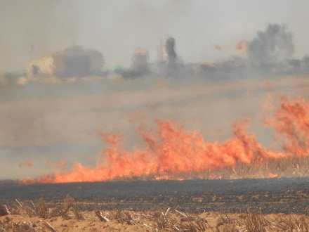Landowners
* Fire Departments
* Property Managers/Contractors
* Agencies
* Cooperating Partners

### Sources of Information

* Website
* K-State Extension - <http://www.agronomy.ksu.edu/extension/>  
  Prescribed Burning Safety - <http://www.ksre.ksu.edu/library/crpsl2/l565.pdf>  
  Prescribed Burning Planning and Conducting - <http://www.ksre.ksu.edu/library/crpsl2/L664.pdf>
* Kansas Smoke Management – Fire Management Practices  
  <http://www.ksfire.org/~/doc3983.ashx>
* Kansas Prescribed Burn Associations  
  <https://sites.google.com/site/ksgrazinglandscoalition/kansas-prescribed-fire-council/kansas-prescribed-burn-associations>
* Kansastag.gov burn ban information page  
  <http://www.kansastag.gov/>
* County information – phone number/website

### Messaging

#### Safety tips for field burning

##### **Safety and Good Stewardship**

It is important to be a good steward and avoid situations that can endanger the public.

Safety - Identify potential hazard areas such as roads, residences and electric lines. It is most desirable to burn with the wind blowing away from the road. Personal safety is also important. Proper clothing made of wool or cotton is necessary, covering the body, arms and legs. A cap, gloves and boots are also recommended for worker safety.

Notification - For safety, it is recommended that before a burn is conducted, neighbors, the local fire department and the Department of Natural Resources’ regional offices should be notified. In cases of burning near public roadways, the local sheriff’s office should be contacted. This can prevent misunderstandings, unnecessary fire calls and poor public relations.

Communication - Ensure proper communication equipment is available for burn crew members to communicate with each other and with local emergency responders if needed.

##### **Wildfire Prevention Tips**

* Know all state and local fire restrictions.
* Notify your neighbors as a courtesy prior to burning.
* Postpone the burn if unsure of the fuel and weather conditions
* Have adequate resources and equipment available to prevent escaped fires.
* Consider smoke management to avoid unsafe roads and air quality conditions.
* Use the best knowledge and tactics for the situation.

##### **Best Management Practices**

Safe burning begins with proper preparation. Use these best management tips to prevent potential problems:

* Allow the field several days of drying time for a more effective burn and reduced smoldering.
* Do not burn to the ends of the field. Setting boundaries, “back burning” and keeping the fire off of fence rows will prevent out-of-control burns.
* Disking fields after harvest can reduce the need for residue burning.
* Watch for favorable weather conditions and safe wind speeds. Wind speeds of 5 to 15 mph, steady from a desirable direction are preferred.
* Be aware of drought-like conditions and any bans on burning that may be in place.

##### **Smoke and Air Quality**

* The airborne particles in smoke are microscopic in size and can present serious health problems. Short-term exposure to particles in smoke can aggravate existing conditions such as lung disease, acute bronchitis and asthma.
* Some groups of people are more susceptible to smoke:
* Children are because their respiratory systems are often not fully developed.
* Older adults can be especially if they have heart or lung diseases.

###### Environmental effects of smoke:

* Visibility can be reduced due to the presence of smoke in the air.
* Fine particles in smoke can be transported long distances and deposited on water, land and property causing nuisance and affecting such things as acidity and nutrients.
* The Clean Air Act requires the EPA to set national standards for the particulate matter that can be found in smoke. Elevated particulate matter concentrations make it more difficult to attain national air quality standards.

## Issue – Field Equipment

Text borrowed and modified from Wisconsin DNR

<http://dnr.wi.gov/topic/wildlifehabitat/documents/HayEmergencyGuidelines.pdf>

Field equipment is a significant cause of accidental human-caused fires. Landowners can reduce the chances of causing a wildfire by taking simple precautions to ensure that their equipment does not cause a spark.

### Audiences

* Landowners
* Property Managers/Contractors
* Fire Departments

### Sources of Information

* Website
* K-State Extension - <http://www.agronomy.ksu.edu/extension/>
* Farm equipment manufacturers
* Farm equipment dealers
* Farmers Coops.
* Ranch and Grassland Associations

### Messaging

#### Safety tips for field equipment

* Get an early start. Mowing and harvesting operations should be conducted during the morning hours. After 12 noon, temperatures rise, humidity drops, and winds increase – prime wildfire conditions.
* Keep equipment clean and free of debris. Use an air compressor to blow all dust off machinery. Clean belly pans before you head out.
* Inspect equipment to make sure there aren't any parts rubbing or bearings going out that could cause friction and create a spark.
* Make sure spark arresters are in place as required and in proper working order.
* Repair fluid leaks immediately.
* Take frequent breaks to give bearings a chance to cool down and to check for debris trapped near heat sources and clear it away.
* Park on bare ground when fueling equipment. Use recommended fuels and do not ‘top off’ fuel tanks.
* Hot exhaust pipes and mufflers can easily start fires that you may not see until it’s too late!
* When bailing hay, remove any loose hay trapped around rollers – the friction can build up heat and start a fire.
* Take the wind into consideration when harvesting crops.  If a fire did start from equipment, it would be better to have it burn in the cut material where it will do less damage and be easier to suppress than in your standing crop. Working into the unharvested crop and the wind will also help keep air filters and equipment a bit cleaner since the crop dust and debris will blow into the already harvested area. This may mean that it will take longer to harvest the field, but you've reduced the risk and minimized the amount of damage that may occur to you, your equipment, and the crop.
* Make certain exhaust systems including manifolds, mufflers and turbochargers, are free of leaks and in good working order. Avoid parking hot machinery on or near dry grass or other dry vegetation.
* Follow instructions when installing and operating farm machinery and follow maintenance schedules including cleaning of chaff, dust, and other combustible materials.
* Keep appropriate fully charged fire extinguishers on tractors, combines, and near all farm machinery.
* Welders, grinders, and cutting torches should only be used in clean areas at least 35 feet away from any flammable and combustible materials. Welding curtains should be used to minimize the spread of sparks.

## Issue - Drought

### Audiences

* Public
* Landowners
* Partners
* Agency Cooperators
* Fire Departments

### Sources of Information

* Website
* Kansastag.gov burn ban information page  
  <http://www.kansastag.gov/>
* Governors Drought information web page  
  <http://governor.ks.gov/kansas-drought-resources>
* [www.weather.gov](http://www.weather.gov)
* County information – phone number/website

### General Talking Points on Drought

#### Weather

* The culprit behind the dry weather pattern is a high pressure system that limited moisture flow into the area.
* A small amount of precipitation is not expected to end the drought in the drier areas of the region.
* A change in weather pattern that brings multiple and spaced out rain events is what is needed to ease the effects of the drought.
* However, critical weather associated with a change in weather pattern could increase the possibility of gusty winds and low relative humidity’s as it approaches.

#### Fuels

* Drought conditions have dried out all fuel classes and humidity values have been below average which leads to above normal fire behavior.
* Extreme fire behavior can exist when two conditions are present:
  + Long-term drying of fuels (present)
  + Daily fire weather conditions that reflect low humidity, higher temps, and high winds (predicted)
* Unusually high flame lengths and deep burning conditions have been observed.
* Due to long-term drying fuels, critical fire weather thresholds which are normally used may be reached at more benign weather conditions.

#### Fire Occurrence

* This section would need to be updated with data with current conditions. Summer 2012 example included:
  + Major causes of wildfire include escaped debris or field burning and sparks from field equipment, such as brush mowers and hay balers
  + Since March, Kansas Forest Service officials have estimated that more than 41,000 acres have burned across the state, making it one of the worst years for wildfire on record.
  + Last week alone there were seven fires resulting in over 8,000 acres burned.
  + There have been 26 structures lost due to wildfire so far this summer, compared to no structures reported lost over the past summers.

#### Drought Impacts & Fire

* Drought has a direct impact on vegetation and down woody material (fuels).
* Drought places stress on vegetation through reduced moisture availability resulting in a corresponding reduction in the moisture content of the vegetation.
* There is an inverse relationship between fuel moisture content and the availability of a fuel to ignite and burn.
* As fuel moisture content decreases, fuel availability for ignition and burning increases.
* With drought, this process has taken place over an extended period of time, resulting in an increased amount of available fuels for combustion in a wildfire.
* Along with increased fuel availability come the potential for increased fire intensities and difficulties of control.
* The weather on top of the drier fuels could produce problematic fire behavior, with higher difficulties of control, requiring additional resources for effective containment of wildfires.

*Source: Southern Area Fire Risk Assessment, Fall 2007*

### Drought Resources

* US Drought Monitor:   
  <http://www.drought.unl.edu/>
* NOAA Drought Information Center:   
  <http://www.drought.noaa.gov/>
* NOAA Drought Termination Center: <http://lwf.ncdc.noaa.gov/oa/climate/research/drought/drought.html>
* Rocky Mountain Area Coordination Center:   
  <http://gacc.nifc.gov/rmcc/>

### Drought Campaign Ideas

1. In a Drought, Keep Fire Out!
2. I’m Concerned About Drought
3. Know Before You Go Without H2O
4. Thirsty?…So Are Our Fields & Forests
5. Living with Drought
6. When in a Drought, Tap into Fire Prevention
7. Smokey Can’t Cry You a River
8. In a Drought, Wildfires Move Fast
9. Smokey’s Water Bucket is Only Half Full
10. Be Fire Safe, Not Sorry
11. Drought + Wildfires = Disaster
12. Conserve Water, to Conserve Our Fields & Forests

### Drought Related Wildfire Prevention Messaging -- How The Public Can Help

Residents are advised to use extreme caution with fire over the next few months.

#### Campfires:

The public should consider the risk of campfires when camping. The current drought conditions have increased the potential for campfires to escape. Therefore, burning restrictions may be in effect.

The dry weather conditions have set the stage for wildfires to occur outside of the typical fire season. Even if we get a bit of rain, one dry, sunny afternoon can dry out fuels again. This means Kansans will have to take extra precautions. Any source of ignition can cause a fire that will quickly get out of control.

* Keep campfires to a minimum
* Stay with your campfire. Put it out before you leave, even for a short hike! If the wind picks up, it can ignite even the smallest ember that could reach dry ground fuels and start a wildfire.
* Fires should be contained in designated fire rings and grills within the developed recreation areas.
* Use gas and propane grills, lanterns, and stoves with care.
* Don’t throw cigarette butts out the car window or onto the ground. Use an ashtray.
* Look for signs, or ask your host agency (e.g. state park office), if any campfire restrictions are in effect.

#### Fire Danger Remains High Due to Drought

* Obey water restrictions at home and work.
* Call 911 to report a wildfire immediately. Practice an evacuation plan with your family.
* Protect your home. Visit [www.firewise.org](http://www.firewise.org) or contact your local fire department.

#### Fires May be Banned Due to Wildfire Danger

* Check with your county government, fire department or local agencies for fire restrictions or bans.
* Warn others that they can be held responsible for suppressions costs if their fire gets out of control.
* Learn alternatives to debris burning and campfires until fire danger levels decrease.

## Issue – Wildland Urban Interface

### Audiences

* Homeowners and landowners in the wildland urban interface
* Fire Departments

### Sources of Information

* Website
* KFS Firewise  
  <http://www.kansasforests.org/fire/wui/index.shtml>
* National Firewise Program  
  <http://firewise.org/>
* Fire Adapted Communities  
  <http://fireadapted.org/>
* Kansastag.gov burn ban information page  
  <http://www.kansastag.gov/>
* County information – phone number/website

### Messaging

* Urban wildland interface wildfires cause economic loss and other hardships to homeowners and communities.
* Defensible space around homes and outbuildings is important; visit [www.Firewise.org](http://www.Firewise.org) for tips on improving structure survivability.
* Defensible space improves fire fighter safety and reduces cost to fire departments and local governments.
* Residents can increase their chances of their homes surviving a wildfire by planning ahead (having defensible space around their homes, having an evacuation plan, etc.).
* Residents should be prepared protect their personal property, livestock and pets in the event a wildfire threatens their community. Visit Ready, Set, Go (<http://www.wildlandfirersg.org/>) for more information.
* Wildfire can strike home if you have not taken some steps to protect your house and property. The actions and precautions listed below are designed to help you prepare your home and lessen the threat of wildfire damage to you and your property.

1. LPG tanks should be far enough away from buildings for valves to be shut off in case of fire. Keep area around the tank clear of flammable vegetation.
2. Store gasoline in an approved safety can away from occupied buildings.
3. All combustibles such as firewood, wooden picnic tables, boats, stacked lumber, etc. should be kept away from structures.
4. Clear roof surfaces and gutters regularly to avoid build-up of flammable materials such as leaves and other debris.
5. Remove branches from trees to a height of 15 feet or more.
6. In rural areas, clear a fuel break of at least 3 times the fuel length around all structures.
7. Have fire tools handy such as: ladder long enough to reach your roof, shovel, rake, and a bucket or two for water.
8. Place connected garden hoses at all sides of your home for emergency use.
9. Assure that you and your family know all emergency exits from your home and neighborhood.

In addition:

* Know if there is or is not a burning ban in place for your town, city, or county
* If you burn, clear a large area on the ground of any combustible material, such as grass, leaves, and scrap wood, burn only what you want to burn.
* Do not leave your burn pile unattended and have a hose at the ready.

## Issue - Arson

### Audiences

* Public
* Landowners
* Partners
* Fire Departments

### Messaging

#### Put the heat on arsonists

* Communities working together can impact the reduction of arson fires. Arsonists are few in number, yet create significant threats to the community.
* Pay attention to any suspicious fire activity and report it immediately to local law enforcement.
* Simple tips can pay off during an investigation such as a license plate number or description of the individual.
* Arson is a crime! Penalties can be up to xx years imprisonment and a fine up to $xxxxx (Kansas law reference).
* A person commits the offense of arson if they start a fire, regardless of whether the fire continues after ignition, or causes an explosion with intent to destroy or damage property, structures, vegetation, vehicles, or endanger the life of some individual or the safety of the property of another.
* The Kansas Interagency Wildfire Council asks that you report suspicious activities at or near a wildfire or a vehicle leaving the scene of a wildfire by calling 1-8xx-xxxx.

## Website flowchart

Examples:

<http://www.utahfireinfo.gov/>

<http://burnsafetn.org/>

<http://www.kglc.org/>

## High Profile Events

* Kansas State Fair
  + Sept. 7-16
  + Hutchinson; Kansas State Fairgrounds
  + <https://www.kansasstatefair.com/>
* Kansas Society of Range Management
  + Oct. 25, 2012
  + Great Bend; Kansas Wetlands Education Center
  + <http://ks.rangelands.org/Pdf/2012fallmeeting.pdf>
* Kansas Prescribed Fire Council Annual Meeting
  + Sept. 26, 2012
  + <https://sites.google.com/site/ksgrazinglandscoalition/kansas-prescribed-fire-council>
* East Kansas Grazing School
  + Sept. 12-13
  + Emporia; Lyon County Fair Grounds
  + <http://www.kansasruralcenter.org/calendar.html#EKGS>
* Kansas Grazing Lands Coalition
  + Sept. 16, 2012
  + Great Bend; Kansas Wetlands Education Center
  + <https://sites.google.com/site/ksgrazinglandscoalition/about-us/past-activities/current-events/kssrmsectionfallmeetingoctober25>
* Harvest Days
  + Sept. 15, 2012
  + Overland Park; Deanna Rose Children's Farmstead
  + <http://www.opkansas.org/Events/Harvest-Day>
* Cornstock – Anderson County Corn Festival
  + Sept. 22, 2012
  + Garnett
  + <https://accornfest.com/>
* 33rd Annual Apple Festival
  + Oct. 7, 2012
  + Topeka
  + <http://www.topeka.org/>
* Hays Daily News Home & Garden Show
  + March 9-10 2013
  + Hays; Hays Mall
  + <http://www.shophaysmall.com/>
* Lincoln County Fair
  + July 26-27, 2013
  + Sylvan Grove
  + <http://www.lincolncoks.com/LincolnCountyFairBoard/tabid/11341/Default.aspx>

# Recommendations

* Develop a “brand” or central message for the Kansas Interagency Wildfire Council’s Fire Prevention Program. This message will be an overarching message that all agencies and partners can support and promote. The message is best with fewer words, encourages participation to action rather than a directive, and is inclusive of agency, residents and citizens. It should also include personal responsibility actions that individuals can do to help prevent human-caused wildfire and tie the message to the central theme.
* Design a website that will be used by the Council for all prevention materials. Explore the expansion of the current KFS website or develop a fire information website to provide a one-stop-shop for information on wildfire and what individuals can do to assist in the effort. A dedicated site is needed to refer people to get the best and latest information on wildfire and the prevention effort. The site should emphasize the Council, its partners and the resources available to the state in wildfire prevention.
* Expand networks of information from Council members to their clientele, customers, etc. Each agency should list and contact networks available to them for the purpose of garnering support and commitment to distribute the central message and related fire information. A result is that agencies and end-users deliver the central message in the unique language for that group.
* Track prevention efforts through measurements that the Council can use to quantifiably capture the success of the prevention effort. Selected measures should tie into the current strategy. Through experience, changed direction and discussion, other measures can be selected over time to accurately depict the prevention accomplishments.

# Appendix A

## NETWORK BUILDING INSTRUCTIONS

#### Objectives:

To establish a broad base of agencies, groups, and individuals that can quickly disseminate wildfire prevention information through email distribution and other forms of messaging. The intent is to have a low-cost/no-cost system of distribution with minimal time commitment at any level.

Each agency has unique sets of clientele and user groups. Each user group interprets a message in slightly different terms. Recipients are often members of more than one group. The result is the recipient hearing the same theme in a variety of ways and with different interpretations. For example, a hunter interprets the message of ‘wildfire costs everyone’ as a loss of habitat while a watershed specialist might think of water quality loss.

#### Action Needed:

Each agency and group provides a channel of information to its users through a networking system. The Kansas Interagency Wildfire Council provides information for distribution. Any participant can have input into topics or messages. Each level in the chain is responsible for forwarding the information to the next level with the opportunity to add messaging relevant to their users.

#### The specific steps to building networks are as follows:

* Each participating agency develops a list of the key user groups and network partners.
* Each group is contacted and asked to support the efforts to reduce human-caused fires and to assist by forwarding provided information to their users.
* Use the central theme and banner if deemed appropriate.
* Refine the message to more directly communicate with your users if needed.
* Ask each participating level if they will do the same to expand the message distribution.
* Initially, ask for an estimate of distribution volume to gauge the overall impact of the network outreach.
* Use whatever networking medium you are comfortable with to get messages to your users.
* Each group attempt to avoid duplication of users. A potential barrier to success is a person being on every list and getting bombarded excessively with the same email. There will be a “take me off all the lists” reaction.

Kansas needs to focus attention on the threats of wildfire on our communities. Participation in this network building initiative will help reach thousands of citizens with timely information that may save lives, property loss, and our treasured natural resources.

# Appendix B

## Google Access Instructions for Kansas Wildland Fire Prevention & Education Account

* Go to <https://www.google.com/>
* Click on the “Sign in” button
* Enter username and password
  + Username: KSwildfireprevention
  + Password: SmokeyBear
* To access toolbox materials, click on “Drive” in the toolbar at the top of the page.
* Click on the “Toolbox” folder