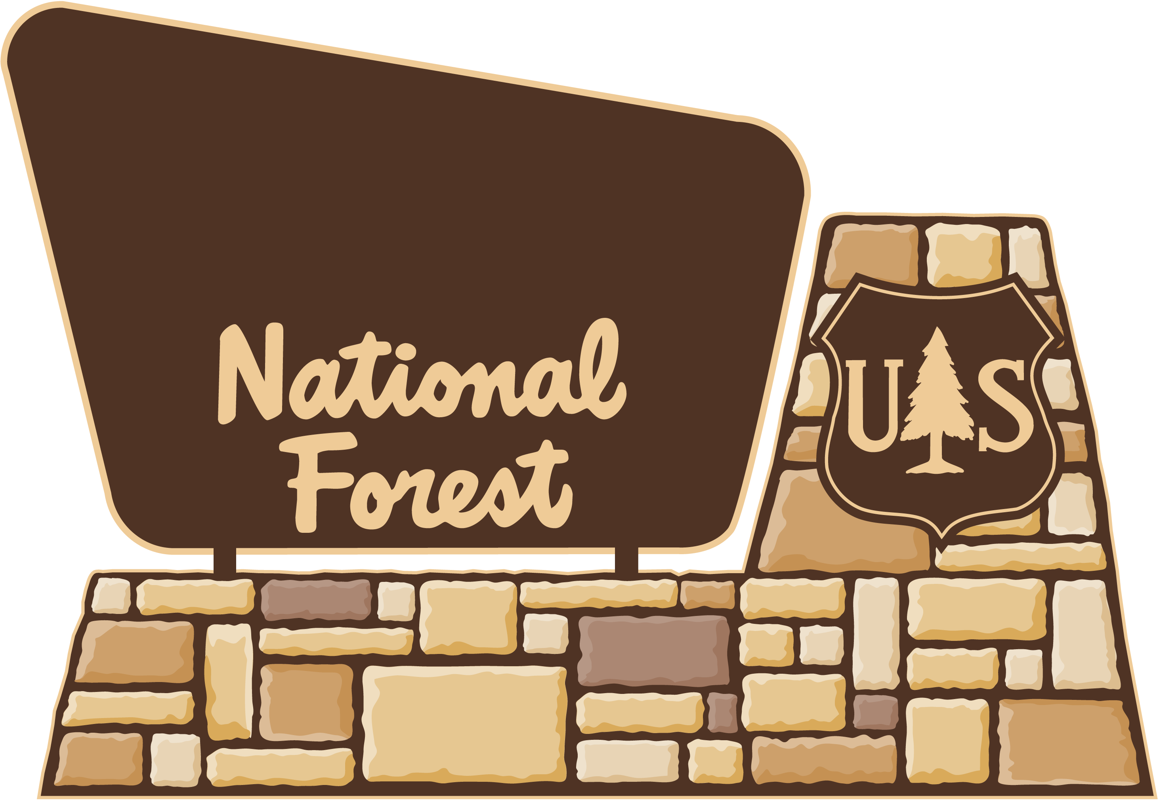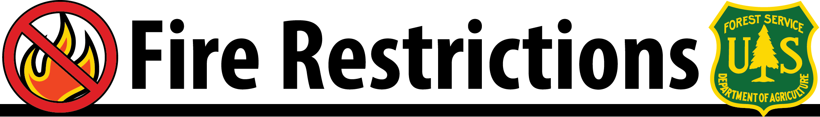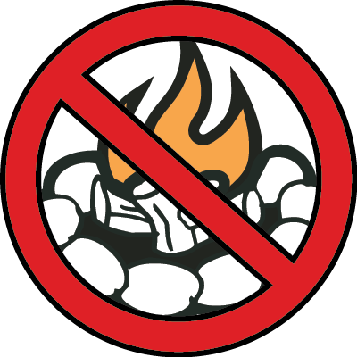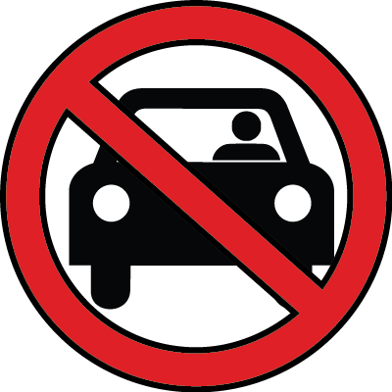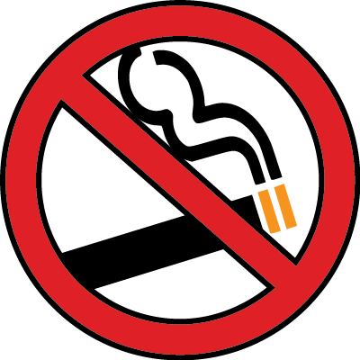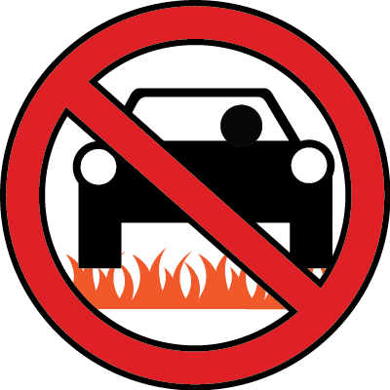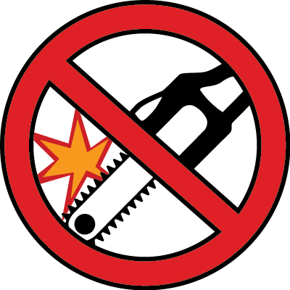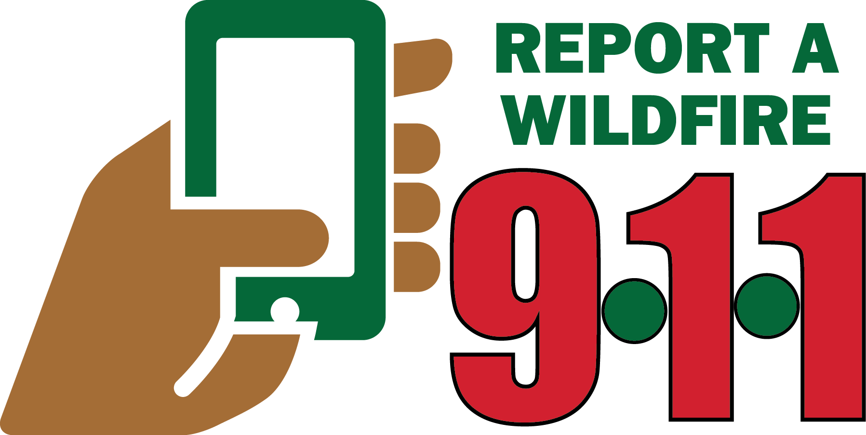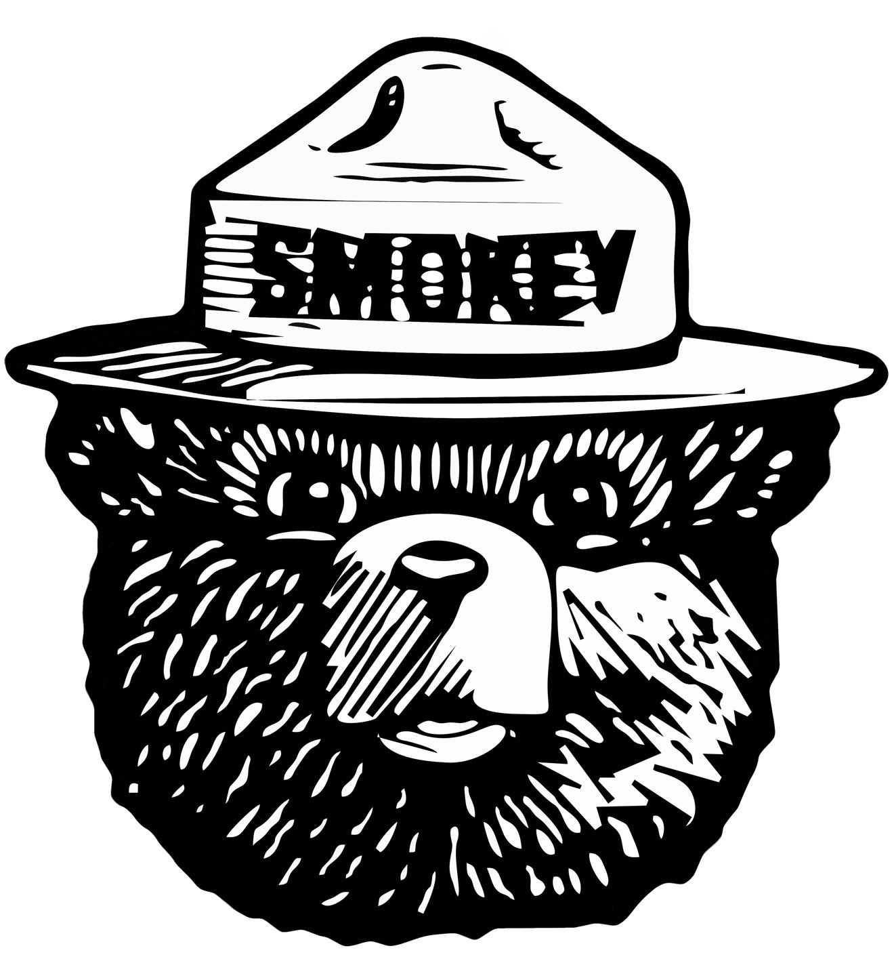

**Name of National Forest**

Street Address  
City, State, Zip Code  
Phone Number

www.fs.usda.gov/nameofforestwebsite

For more information on public-use restrictions, contact your local Forest Service office or our websites: **http://www.fs.usda.gov/nameofforest**

**Insert Name of National Forest Here**

**Beginning _______, due to high fire danger, the following are prohibited:**

**PROHIBITED: Campfires and charcoal briquette fires**

unless they are in a fire pit surrounded by dirt, rock or a commercial ring, and in a cleared area. Liquefied and bottled gas portable cooking stoves are allowed. Wood stoves are allowed with a 5 foot or longer chimney and a ¼ inch mesh spark arresting screen.

* A tool that can serve as a shovel and one gallon of water is required (except at campgrounds with camp hosts on site).
* The area must be cleared of all flammable material within a radius of 3 feet from the edge of the fire pit.
* Fire pits must be free of overhanging material.
* Campfires must be attended at all times, and completely extinguished prior to leaving.

**PROHIBITED: Vehicle travel on closed or blocked forest roads**

This includes roads closed or blocked by earthen berms, logs, boulders, barriers, barricades and gates. Off-road and off-trail travel to access firewood as allowed under firewood permit is exempt.

**PROHIBITED: Smoking**

Except within an enclosed vehicle, building, developed recreation site, or cleared area.

**PROHIBITED: Use of a chainsaw between**

**1 pm and 8 pm**

Chain saw operation is allowed between 8 pm and 1 pm, and saw operators must have an axe, shovel, and fire extinguisher, and remain in the area for a one hour fire watch after saw operations cease.

**PROHIBITED: Vehicle travel off forest roads and trails**

Travel is not permitted on roads that are not cleared of standing grass and other flammable material.

**ONLY YOU**

**CAN PREVENT**

**WILDFIRES**