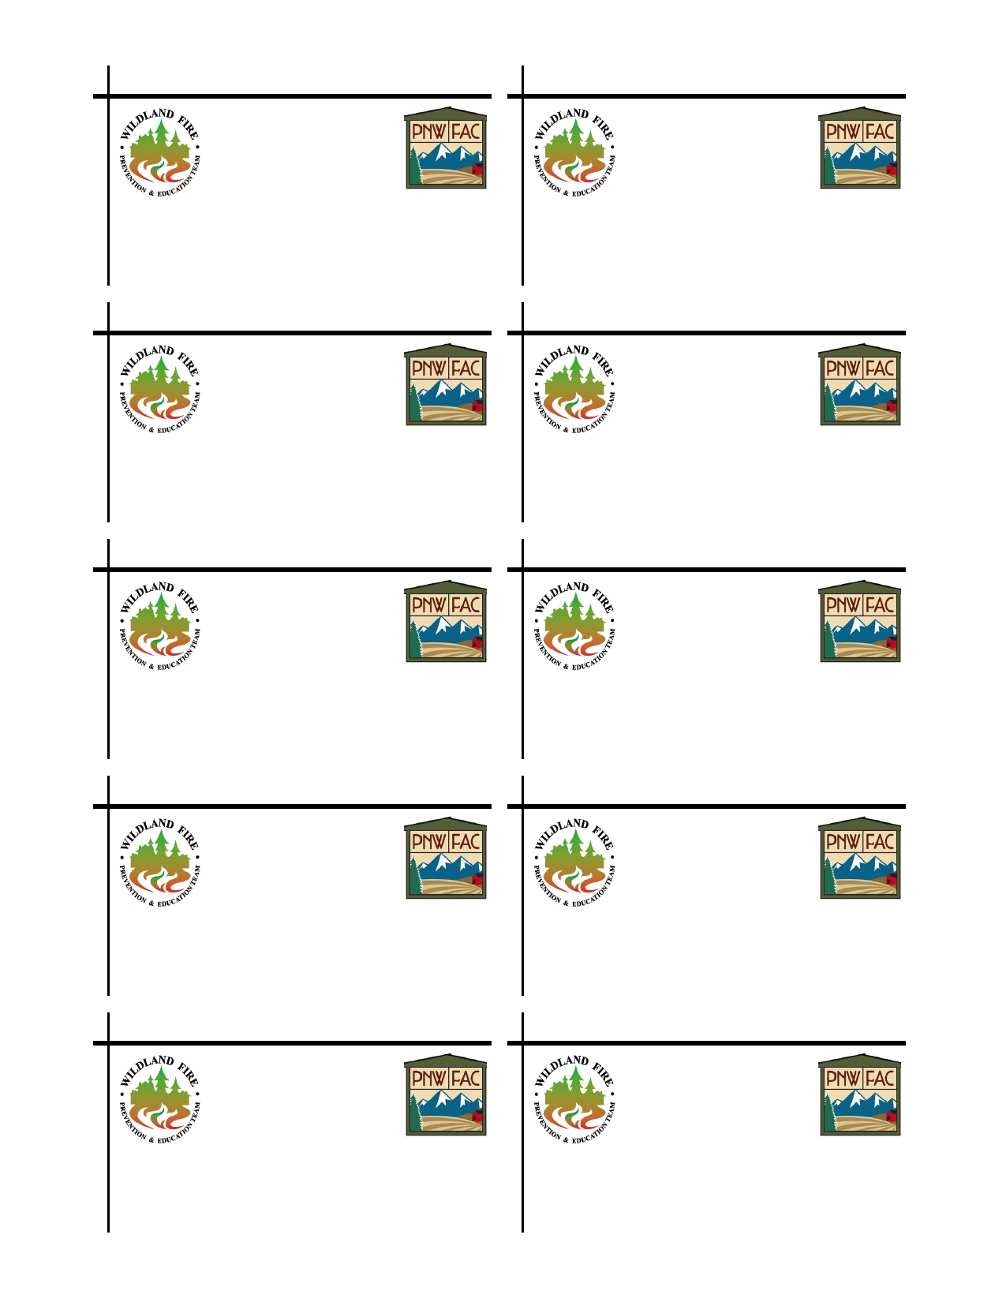Supporting Pacific Northwest Fire Adaptive Communities Supporting Pacific Northwest Fire Adaptive Communities

Meg Cicciarella Meg Cicciarella
Fire Prevention Team Member Fire Prevention Team Member

AK Division of Forestry Phone: 907-235-4041 AK Division of Forestry Phone: 907-235-4041 42499 Sterling Hwy. Cell: 907-299-8102 42499 Sterling Hwy. Cell: 907-299-8102
Soldotna, AK 99669 megcicciarella1@gmail.com Soldotna, AK 99669 megcicciarella1@gmail.com

Supporting Pacific Northwest Fire Adaptive Communities Supporting Pacific Northwest Fire Adaptive Communities

Meg Cicciarella Meg Cicciarella
Fire Prevention Team Member Fire Prevention Team Member

AK Division of Forestry Phone: 907-235-4041 AK Division of Forestry Phone: 907-235-4041 42499 Sterling Hwy. Cell: 907-299-8102 42499 Sterling Hwy. Cell: 907-299-8102
Soldotna, AK 99669 megcicciarella1@gmail.com Soldotna, AK 99669 megcicciarella1@gmail.com

Supporting Pacific Northwest Fire Adaptive Communities Supporting Pacific Northwest Fire Adaptive Communities

Meg Cicciarella Meg Cicciarella
Fire Prevention Team Member Fire Prevention Team Member

AK Division of Forestry Phone: 907-235-4041 AK Division of Forestry Phone: 907-235-4041 42499 Sterling Hwy. Cell: 907-299-8102 42499 Sterling Hwy. Cell: 907-299-8102
Soldotna, AK 99669 megcicciarella1@gmail.com Soldotna, AK 99669 megcicciarella1@gmail.com

Supporting Pacific Northwest Fire Adaptive Communities Supporting Pacific Northwest Fire Adaptive Communities

Meg Cicciarella Meg Cicciarella
Fire Prevention Team Member Fire Prevention Team Member

AK Division of Forestry Phone: 907-235-4041 AK Division of Forestry Phone: 907-235-4041 42499 Sterling Hwy. Cell: 907-299-8102 42499 Sterling Hwy. Cell: 907-299-8102
Soldotna, AK 99669 megcicciarella1@gmail.com Soldotna, AK 99669 megcicciarella1@gmail.com

Supporting Pacific Northwest Fire Adaptive Communities Supporting Pacific Northwest Fire Adaptive Communities

Meg Cicciarella Meg Cicciarella
Fire Prevention Team Member Fire Prevention Team Member

AK Division of Forestry Phone: 907-235-4041 AK Division of Forestry Phone: 907-235-4041 42499 Sterling Hwy. Cell: 907-299-8102 42499 Sterling Hwy. Cell: 907-299-8102
Soldotna, AK 99669 megcicciarella1@gmail.com Soldotna, AK 99669 megcicciarella1@gmail.com

