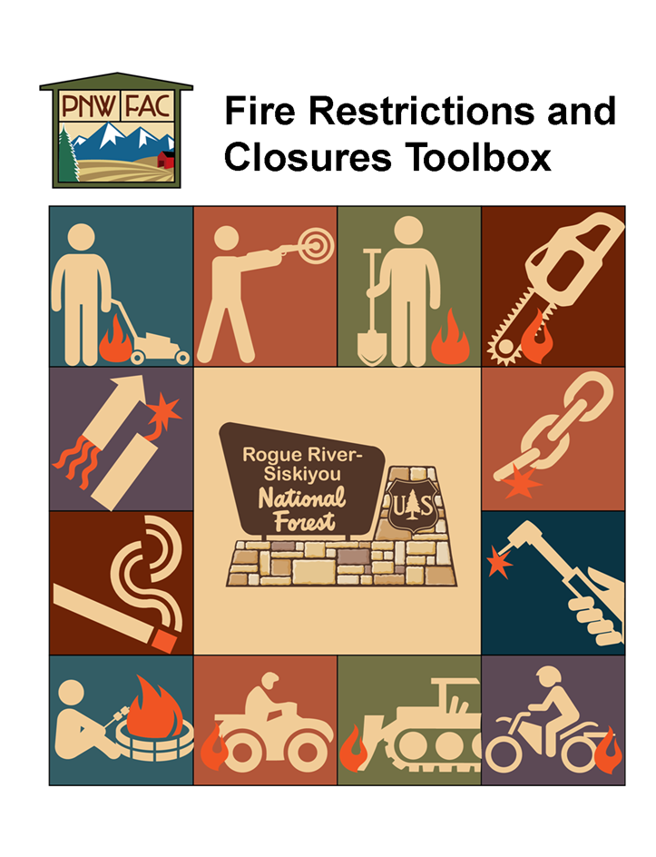
DRAFT – AUGUST 2015

Table of Contents
1. Background 1
2. Purpose and Need 1
3. Audience 2
4. Interagency Coordination 2
5. Authority 2
6. Public Use Restrictions 3
8. Roles and Responsibilities 6
9. “Trigger Points” for Fire Restrictions, Closures and Rescinding Orders 7
10. Progression of Stages 7
Four Stages of Fire Restrictions 8
11. Developing an Order 9
Development Steps 10
Communication Plan 11
Coordination with Others 12
12. Logistical and Implementation Considerations 12
Logistical Considerations 12
Entry/Activity Permits 13
General Recreation Use 14
Agreements, Contracts, Leases and Permits 14
Agreements 15
Contracting and Acquisition Management 15
Permitted Livestock Grazing 15
Oil, Gas and Minerals 16
Recreation and Heritage Special Uses 16
Lands Special Uses 17
Timber 17

Appendix A - Sample Communication Product 18
Appendix B - Forest Service Handbook and Manual, 36 CFR 261 Regulations, 16 USC 551 and 18 USC 3559, 3571 49
Appendix C - RSF Exempted Designated Recreational Areas 64
Appendix D - Industrial Fire Precaution Levels 67
Appendix E - Roles and Responsibilities 68
Appendix F - Restriction and Closure Decision Checklist, Actions and Questions 74
Appendix G - Pre-Approved and Sample Order Templates 81
Appendix H - Size, Scope, and Time Considerations For Restrictions/Closures 93
Appendix I – Sample Media Releases: Radio PSAs, Media Taglines, Talking Points 95
Appendix J – Sample Posters / Flyers / Handouts 112
Appendix K – Sample Routing Form and Contact List 128
Appendix L - Coordination with Others 131
Appendix M - Entry/Activity Permit Process and Sample Permit and Sticker 132
Appendix N - Signing 135
Appendix O - Fire restrictions and/or closures and the National Recreation Reservation Service 136
Appendix P – Sample Letters 137
Sample Letter for Agreement Notification 137
Sample Letter for Stage III 138
Sample Letter for Oil and Gas Lessees 139
Fire Restriction Levels and Fire Precaution Needs for Oil and Gas Operations 142

Background
This guide has been developed to provide information on roles, tasks and responsibilities for the stages of the Public Use Restrictions (PURs) process: initial recommendation, pre-implementation and decision-making, implementation and rescission.
Public Use Restrictions are management measures taken to reduce the risk of human-caused wildfire ignitions. Their implementation is driven by a combination of: the current number of human-caused wildfires; fire causes; current and predicted weather; fuel moisture; the current and predicted wildfire situation; and availability of suppression resources. Based on an assessment of these factors, fire officials make recommendations to limit activities in high risk areas in order to reduce the potential for new human-caused fires. The focus is on restricting activities, while allowing the activities in less fire-prone or hazardous areas, where possible. The restrictions can include (but are not limited to): reductions in where and when campfires can be established; use of other open flame devices; limitations on the types of roads that can be used; locations and limitations for smoking; and/or limitations to exclusions of open flame/internal combustion devices such as welding, off highway vehicles (OHVs), chainsaws, etc.
Public Use Restrictions may be implemented broadly or can focus on specific geographic areas. For example hazardous fuels in a project area in the Wildland Urban Interface (WUI) may lead to temporary PURs, while a high-use recreation area with a history of human-caused fires may lead to seasonal PURs enacted annually. Public Use Restrictions are implemented when conditions dictate and may not occur every year. Additional areas with extreme fire potential may have permanent fire use restrictions. While this guide can help with implementing these types of restrictions, the main intent is to provide direction and guidance at the forest-district level for large-scale restrictions driven by seasonal risk weather and other pertinent conditions.

Purpose and Need
This section will help users understand the importance applying an established process or the toolbox concept, so as to promote efficiency/consistency when considering fire restrictions and/or closures. To legally develop and enforce forest fire restrictions and/or closures, this toolbox is provided to assist the line officers in developing and implementing the fire restrictions and/or closures.
The purpose of this document is to:
- Develop guidance for the Rogue River-Siskiyou National Forest to address fire restrictions and closures.
- Provide a framework that provides consistency for fire restrictions and closures.
- Define the degree of discretion that Forest Service line officers have to develop and implement fire restrictions and closures.
- Facilitate strong interagency and intra-regional coordination and communication.
- Assist with effective communication planning (Appendix A) and wide-spread notification.
- Focus attention on public education relative to fire restrictions and closures.
- Support enforcement of restrictions and closures, as needed.
“Consistency” in process and messaging will encourage public acceptance, understanding and compliance with restrictions and closures. Clear communication with the public, forest users, partners, other agencies and our own employees will all strengthen future relationships.
The material in this toolbox should be reviewed and refined after each fire season.

Audience
The principal audience for this toolbox is Forest Service line officers and their staffs so they can more efficiently develop orders, implement restrictions and closures, while helping forest users understand the rationale and effects of these strategic management actions.

Interagency Coordination
Cooperating federal, state, and local agencies will also benefit from a common process for fire restrictions and closures, especially when jurisdictional boundaries interface or co-mingle based on land ownerships. National direction is to coordinate with cooperating agencies so as to develop common terminology, criteria and processes, whenever possible. It is the responsibility of each level of government to work with their cooperative counterparts – with the greatest level of interaction expected at the District and District Ranger level. Where adjoining forests share a boundary, their coordination to align restrictions and timelines will greatly enhance the process.

Authority
Fire restriction and closure orders are authorized by the Code of Federal Regulations (CFR) (Appendix B) and the references listed below.
Restrictions
- 36 CFR 261, Subpart B
Closures
  - 36 CFR 261.52(e)—Going into or being upon an area
Restrictions and Closures
- 16 U.S.C. §551; 18 U.S.C. §3559; and 18 U.S.C. §3571—Violations and penalties
- 36 CFR 261.51 – Prohibitions and Posting requirements
- FSH 1909.15, 31.1b - Categorical exclusion for restriction and closure orders: Category 1, of categories established by the Chief, where no case file or decision memo is required
- FSH 2709.11, 31.23(1) - Special Uses - Temporary fee adjustments
- FSH 5109.18, 52 - Fire restrictions and closures
- FSH 5309.11, 32 - Issuing orders under Title 36, CFR, Part 261, Subpart B
- FSH 5309.11, 33 – Renewals and Termination of order
- FSM 1231.3 - Acting Authority
- FSM 5304.31-33 - Authorities and Responsibilities

Public Use Restrictions
Southwest Oregon uses two systems to reduce wildfire risk on forested lands. Public Use Restrictions are aimed at the general public, recreationalists and forest visitors. These restrictions limit activities in order to reduce human-caused fires, especially in more hazardous areas. Regulated activities can include: smoking, driving vehicles off of road systems, building campfires, use of internal combustion engines, welding or cutting torches. Restrictions are put in place using a Forest Supervisor’s Order, and are directly tied to the CFRs. Public Use Restrictions should be based on current and expected conditions, rising risk and the potential for human-caused wildfires. As conditions change, PURs can be increased, lowered or rescinded. In extreme cases, closures may occur.

Exceptions
Exceptions appear commonly in the system of PURs and may include a list of sites that are excluded from the order. Excluded sites should be included with the order and, if possible, a map of the site(s) provided. Sites may also be included or excluded for special circumstances such as potable water, toilet, construction or other issue not related to the above. While exemptions may be perceived to add flexibility or additional options to restricted/limited activities, they can also be a source of confusion, inconsistency and/or detail that challenges the public’s ability to clearly comprehend the orders intent. (Appendix C)

Exemptions
Exemptions should be managed and mitigated according to risks and benefits. The restrictions/orders need to progressively focus on those members of the public and activities over which there is the least amount of active control. This will frequently mean that activities of the public should be restricted long before activities occurring under contract or permit are restricted or reach the same level of restriction. The rationale used by authorized officers for granting or denying exemptions should be documented in writing. Exemptions will be authorized through an entry/activity permit.
Based on the type and extent of risk documented, the Fire Staff Officer can recommend one or all of the following public use restrictions.

Campfire Restrictions
Campfire restrictions limit the ability of a recreational user to build, maintain, attend or use a campfire, stove fire (including a charcoal fire) in developed or dispersed sites managed by the relevant agency. Exceptions need to be identified by facility/campground name.
- Dispersed – campfires are prohibited in undeveloped or dispersed areas.
- Developed – campfires are prohibited in all dispersed and developed sites managed by the agency/agencies implementing the restrictions.
- Developed with no campground host – campfires are prohibited in dispersed sites described above and in developed sites without a full-time campground host.

Smoking
Where smoking is considered an ignition risk, it may be prohibited. General language in Forest Service (FS) PURs/closure orders limits smoking to within an enclosed vehicle or building, a designated campground, while in a boat floating in the water, or while standing in the water.
Example: Forest Service language also includes the provision: “while stopped in an area at least three feet in diameter that is cleared of all flammable material.”

Motorized Vehicle Travel
Travel limitations may be implemented in stages, as risk rises leading to additional PURs, or not at all. General language for travel includes:
Example: Operating any type of motor vehicle off National Forest System Roads, except when operating in compliance with travel management rule and the Motor Vehicle Use Map (MVUM) pursuant to 36 CFR § 261.13 and 36 CFR §261.56.

OHV Travel
Off-highway vehicle (OHV) travel is also part of the motorized vehicle public use restrictions. Decisions need to be made about which areas are closed and which areas may remain open to use. These areas should be described by name and/or geographically (i.e. trail numbers). Exceptions have generally been for the OHV play areas and certain trails.

Parking
In addition to travel, PURs may address where vehicles may be parked either temporarily during the day or overnight. Typical language addresses the parking site conditions or provides a distance from roadway limit, such as:
Example: Possessing or using a motor vehicle on National Forest System roads, except when parking in an area devoid of vegetation within 10 feet of the roadway; and except for parking overnight in Forest Service developed campgrounds and trailheads.

Equipment or Other Operations
Based on an evaluation of risk and casual fire factors, the Fire Staff Officer may recommend use restrictions for equipment and operations not regulated by the Industrial Fire Precaution Level System. Here specific types of equipment, mandatory fire precautions and/or the time of day that equipment/activities could be engaged. These types of restrictions address:
- Use of explosives
- Operating a chainsaw, generator or equipment powered by an internal combustion engine
- Welding or operating an acetylene or other torch with open flame

Wilderness
Wilderness PURs will require notification and coordination between the Umpqua NF, Fremont-Winema NF, Klamath NF, Oregon Department of Forestry, as well as other partners who may need to know such as BLM, DFPA, EFPA and user groups. Implementing PURs within the wilderness may include the following:
- No campfires
- No Smoking (smoking is prohibited away from a motor vehicle, except or while stopped in an area at least three feet in diameter that is barren or cleared of all flammable material.
- Gas Fuel Stoves Only – no open fires or biomass stoves
PURs will be posted at all trailheads by Fire Prevention Technicians, Fire Prevention Officers (FPOs), Field/Wilderness Rangers and Recreation Technicians.

Enforceable fire restrictions and emergency closures can reduce the possibility of human-caused wildfires occurring during periods of seasonal drought, when wildfires can cause seriously threaten life, property and resources.

- Industrial Fire Precaution Level (IFPL)
The second system used to reduce wildfire on forested lands are Industrial Fire Precaution Levels (IFPLs). In the Pacific Northwest, this system applies to woods workers and other industrial forest users. IFPLs regulate all spark-emitting devices used during contracted or permitted activities on federal, state and private lands. Industrial Operations are those that require a contract (timber sales, road maintenance, trail maintenance, silvicultural operations, fuel reduction, firewood gathering, etc.) and in so signing the contract agree to abide by the IFPL provisions. On national forest lands these restrictions are typically applied April 1 – October 31 so as to align with the drought laden months of greatest fire risk. The intent of the system is to prevent large fires. (See Appendix D for a description of the four IFPL levels and their intent.)
To the extent possible, like Industrial use restriction between agencies should be coordinated and implemented similarly for the same fire Danger Rating Areas. Some industrial restrictions are unique by agency and based on different guidelines (statutes, rules, policy), sometimes with different philosophies. Finding the middle ground and coordinating implementation/notification processes between partners is the preferred operational standard for public benefit.
The IFPL system does allow for waivers of IFPL restrictions when localized conditions depart from broader geographic criteria. The basic principal is that the Agency will not be assuming additional risk by granting a waiver. Waiver guidelines were prepared and agreed to by members of the Pacific Northwest Wildfire Coordinating Group (PNWCG).

Roles and Responsibilities
Smooth and successful implementation of PURs and IFPLs requires a coordinated effort between staff officers, law enforcement, public affairs, and fire, prevention and recreation personnel. Another group, often called the “front-liners” are also a valuable link to public information and may include campground hosts, volunteers, administrative staff and others serving at the Forest-public interface. (See Appendix E for a contact list with roles and responsibilities defined.)

It is essential that each program area update the names and contact information listed annually.

Timelines
Successful implementation of PURs begins early in the season with the development of maps, diagrams, exhibits, resource lists and document templates and continues through the fire season with careful monitoring of fire cause trends and weather patterns. Fire staff will be prepared to communicate the potential for PURs as early as possible to line officers, fire management, law enforcement, and PURs implementation staff (public affairs, front-liners, prevention, recreation, law enforcement and fire) to create a smooth and efficient move into the restrictions and to allow sufficient time to inform agency staff and public of the changes. The following timeline shows an example of a typical fire season that includes public use restrictions.
April May June July August September October November
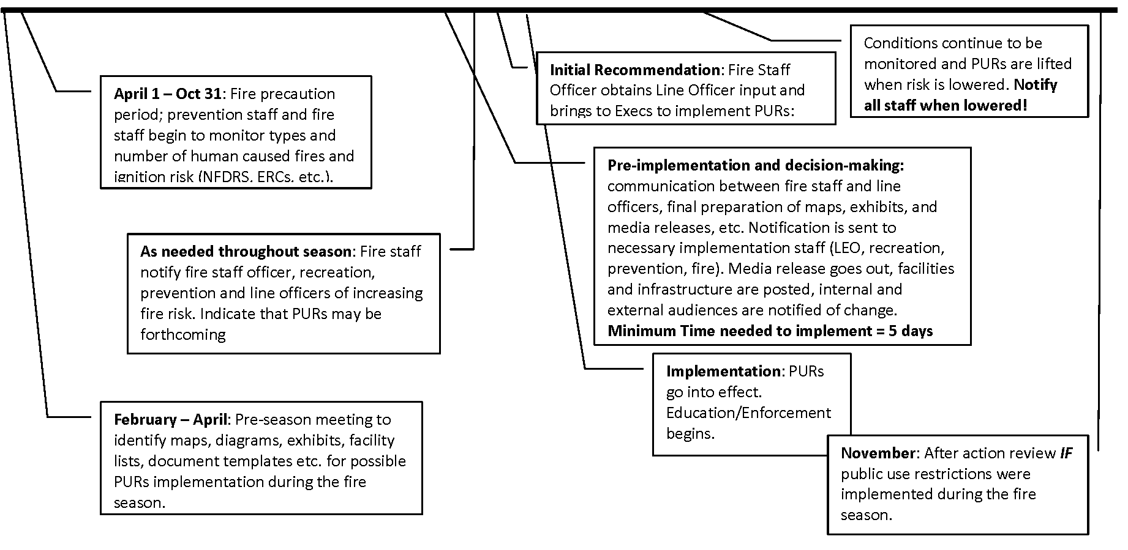

“Trigger Points” for Fire Restrictions, Closures and Rescinding Orders

This section includes five criteria that should be used when considering restrictions/closures. The first criterion is quantitative and based on weather and burning conditions. The remaining four are more subjective and allow for broad discretion by the line officers and fire staff officers considering local conditions and issues. (See Appendix F for questions to consider when contemplating fire restrictions/closures.)
- Energy Release Component (ERC) and ten-day ERC forecast. Medford Interagency Communication Center posts daily ERC data under the “Fire Intelligence, Daily Intelligence Report” tabs. (See http://www.ormic.org/intel/intelreport.shtml.)
- Risk to firefighters and public safety
- Ongoing fire activity (number and size of fires) and suppression resource availability, including Incident Management Teams
- Social, political and economic impacts
- Increase/decrease in recreation use

Rescinding Fire Restrictions and Closures
Enacting restrictions relies on a gradual drying and therefore the use of the ERC data facilitates consistency; however rescinding restrictions will usually occur rapidly reflecting the onset of wetting seasonal rainfall. Thus, the use of ERC data may not prove to be as effective when considering rescinding restrictions. Traditionally, fire and prevention staff will continue to monitor conditions and will make a recommendation to rescind the public use restrictions to the Fire Staff Officer when the risk decreases. The Fire Staff Officer will coordinate with appropriate agency executives or line officers to approve the reduction or removal of restrictions.
The Line Officer who signed the order is responsible for rescinding or modifying their restriction/closure orders. (See Appendix B for Forest Service Handbook direction for terminating an order.) Decisions to change, continue, or remove restrictions/closures are long term in nature. It is important to avoid making changes when there is a likelihood that the restriction/closure will need to be re-imposed in the foreseeable future.
Once an order is rescinded, fire staff and law enforcement will cooperatively communicate with agency counterparts and the internal staff. The public affairs office will notify the general public through websites, social media and media releases. District Rangers/FMOs will also notify their fire, recreation and resources personnel, with outreach to front-liners, campground hosts, and community partners. Applicable signs and flyers will be removed from campgrounds and facilities, completing the reduction or rescission process for the PURs.

Progression of Stages
The progression from “no restrictions” to “restrictions” to “partial closure” to “full closure” should be viewed as a continuum with multiple stages. As fire danger and/or fire preparedness levels change, the line officer evaluates human-caused fire risks and weighs those risks to the potential costs and benefits of imposing varying degrees of restrictions and/or closures.
Each potential stage of restriction involves the implementation of progressively more limiting restrictions. Restrictions are cumulative in nature—so that Stage II continues to implement Stage I restrictions, while Stages III and IV closures continue to implement all Stage I and II restrictions, as appropriate. Within each progressive stage, the line officer has the option of adding exemptions to the restrictions and/or closures that are appropriate for the circumstances and that will best meet the fire restriction or closure objectives.
This ability to move between and within the restriction stages provides a continuum of choices for implementing the appropriate restrictions/closures over a variable geographic area.

Four Stages of Fire Restrictions
The following general definitions will help line officers determine what “stage” of restriction/closure is appropriate. The four recommended stages are:
Stage I (restriction) – The first stage occurs when there is an increasing fire danger and/or an increasing preparedness level, and the risks of keeping the forest open to all activities begins to be outweighed by the risks inherent in doing so. Stage I imposes restrictions aimed at preventing the start of wildfires based on human activities that are known to be high risk, specifically smoking, campfires, and fireworks.

Definition: No smoking outside of vehicles, or buildings. No open campfires outside of developed sites. No fireworks.

Recommended Symbols:

Stage II (restriction) – As the risks increase, the Line Officer/Agency Administrator may choose to move to Stage II. This stage intensifies the restrictions from Stage I by focusing on activities that, although normally managed under permit or contract, have a relatively high risk of causing a fire start.

Restrictions under Stage II will affect forest users and will have additional economic impacts to
contractors, permittees, and others. Therefore, the decision to move to Stage II will involve a risk/benefit assessment, as well as, consideration of economic and social impacts.

Definition: In addition to Stage 1 restrictions, Stage II may add prohibitions for explosives, chainsaw or other internal combustion engines (possibly during certain hours), welding, and using a motor vehicle off forest development roads. This stage also requires approved spark arresters.

Recommended Symbols:

Stage III (closure) – Stage III is the closure of specific areas of the forest. This stage is selected when the ability to mitigate risks using Stage I or II restrictions is no longer viable. The social, economic, and political impacts of implementing a partial closure at this point are outweighed by the benefits associated with virtually eliminating the potential for human- caused fire starts.

Definition: Partial forest closure, with very few exceptions (as detailed in the closure order).

Recommended Symbols:

Stage IV (closure) – Stage IV is full closure. This stage is selected when the ability to manage risks using Stage III closures is no longer viable. The social, economic, and political impacts of implementing a full closure at this point are outweighed by the benefits associated with virtually eliminating the potential for human-caused fire starts.

Definition: Full forest closures, with very few exceptions (as detailed in the closure order).

Recommended Symbols:

Developing an Order
This section contains information needed to develop an enforceable restriction or closure order. Development includes steps to follow, communication planning and coordination with others.
Because of the emergency nature of fire restrictions or closures, some steps in the process may be shortened or delayed. For example, the case file or administrative record may be completed after the order has been issued, as long as all the factors needed for the record are considered and can be documented. Sample order templates are contained in Appendix G of this toolbox.
Within each restriction and/or closure order, exemptions are limited to only those listed in 36 CFR 261.50(e), (see Appendix B). No other exemptions may be authorized. See Appendix H for suggestions on time, size and scope.
The Office of the General Counsel (OGC) has rendered the opinion that an “Acting Forest Supervisor” may sign a Forest Order, as long as this authority has not been eliminated in the letter of delegation. Also, anyone authorized by the District Ranger may sign an entry/activity permit.

Development Steps
The following steps outline the sequence of actions to follow when developing an order and planning for fire restrictions and/or closures.
When using the pre-approved forest order template (see Appendix G):

- Condition Monitoring
Fire staff and prevention personnel are responsible for monitoring current and expected fire conditions; identifying increasing risk of human ignitions and human-caused fires; and documenting increasing weather-related factors for increased fire risk. Staff will also track activated PURs and fire conditions of neighboring forests/agencies, as well as large events such as fairs, festivals, or official gatherings. These factors in combination can also trigger the implementation of public use restrictions.
It is valuable that fire staff share rising trends and perceived risk with the Fire Staff/Deputy Fire Staff Officers prior to the need for actual public use restrictions. Early and frequent discussion facilitates non-urgent communication between fire staff officers and agency executives, line officers and cooperators. Timely conversations with cooperative fire agencies and partners in land management equally lead to smooth management transitions and coordinated PUR decisions. Discussions can include the extent of potential PURs; trends and actions taken by neighboring agencies, and the appropriate level of PURs to address the current risks.
- Initial Recommendation
Following notification of rising trends and increased risk, prevention and fire staff can make a recommendation to move into public use restrictions. The Fire Staff Officers take these recommendations to the appropriate executives or line officers for discussion and approval. Communication regarding realistic implementation timelines is critical to ensure all public affairs, fire, law enforcement, contracting, timber, and recreation staff, as well as front-liners have appropriate time to notify internal and external audiences about the PURs.
- Pre-implementation and Decision-making
There are several steps that must be completed to effectively implement public use restrictions. While some steps may be running concurrently, decision-makers must allow a minimum of five working days - from the time the decision is made, to implement public use restrictions and the date the PURs become effective. This allows time for visitors who may already be camped (for example) in a potentially disallowed area, to be informed and to relocate to a site without restrictions.
During this step, Fire Staff Officers are working with agency executives and line officers to create the required legal orders, and informational document. Signing then follows by the appropriate agency personnel. The date of actual PURs implementation needs to take into account five working days of preparation and notification prior to the effective date. Where possible and as conditions allow, managers should avoid implementing PUR on a Friday or a weekend. Ideal dates for media notifications and field compliance are Thursday and Monday.
During the week before PURs are implemented, law enforcement, public affairs, fire and recreation personnel work together to inform internal and external audiences about the PURs. Actions and outreach should include:
- Posting all relevant campgrounds, facilities and infrastructure
- Media products with relevant documentation are drafted and released
(See Appendices I and J for examples)
- Maps and exhibits are sent out
- Appropriate agency personnel are provided with talking points, handouts, posters
(See Appendix J for examples)
Contact numbers for questions and additional information are established
Without this week to provide appropriate notifications, enforcement and compliance becomes impossible, thereby rendering the PURs ineffective.
- Implementation
Implementation of PURs is tied to the date documented on the signed legal order. This order identifies the enforceable restrictions and behaviors expected of people visiting the National Forest lands as described by the order. These actions/activities will remain in effect and enforceable until; conditions change requiring amendment of the order, the risk of wildfire continues to increase resulting in a stricter order, or the order is lifted
If not using the pre-approved order, you must also do the following:
- The unit submits the draft order to the Fire Staff/Deputy Fire Staff Officers.
- The Fire Staff/Deputy Fire Staff Officers facilitates the review of the draft order and sends copies to:

  - Patrol Captain/on-site LEI personnel

  - Forest staffs, as appropriate.

- The Fire Staff/Deputy Fire Staff Officers and the unit discuss comments to clarify and resolve any differences.
The unit will have the appropriate Line Officer/Agency Administrator sign, post and distribute the order (36 CFR 261.51). (See Appendix K for Sample Forest Order Routing Form and Contact List)

Communication Plan
Communication planning involves making decisions about program goals and objectives, identifying key audiences, and determining strategies to achieve overall program objectives. Although each situation calls for specifically tailored elements, the overall approach is similar. Common steps include:
- Defining program goals and objectives
- Determining where to invest time, energy, and talent
- Preparing action plans to achieve specific objectives
- Determining the communication necessary to achieve understanding and commitment
- Securing agreement among all key people on who and what needs to be committed to the effort
Internal and external communication should be addressed in the plan.
(See the sample Forest communication plan in Appendix A for assistance with the development of a forest communication plan.)

Coordination with Others
Coordination is fundamental to compliance and support of fire restrictions and/or closures. Before implementing fire restrictions and/or closures, forest personnel need to develop a list of contacts to consult with, or be notified of, the impending restrictions or closures. The scope and extent of the restriction or closure will indicate how much coordination is necessary. A checklist of agencies and interests to consider contacting is found in Appendix L.
Permittees should be contacted and informed of mitigation measures they may use to obtain an exemption from the restrictions/closures, and provided instructions on how to obtain an entry/activity permit.

Logistical and Implementation Considerations
This section contains information concerning logistical considerations, entry/activity permits, recreation use, agreements, contracts, grazing permits, mining operations, special use permits and timber contracts. In dealing with our permittees, contractors, lessees, etc., inform them early- on of those mitigation measures that could be required during a fire restriction and/or closure.
This could be accomplished through the pre-work meeting, operating plan, at the time of contract award, Plan of Operations, the Memorandum of Understanding (MOU), the Annual Operating Instructions (AOI), development of the fire plan or any other opportunity the line officer has when meeting with these permittees.

Logistical Considerations
The following list includes logistical considerations to incorporate for restrictions and/or closures:
  - Continuation and enhancement of the fire prevention program and its integration into ongoing restrictions/closures
  - Identify roles for key people responsible for the implementation
  - Timing of implementation
  - Enforcement:
    - Road blocks or traffic stops
    - Methods and locations
    - Coordination and strategy with state and local road authorities:
      - Additional personnel needs, including law enforcement and FPO’s
      - Patrol scheduling
      - Clear signage, i.e., site open or closed
  - Front-liner considerations: backup support, training, and adequate information
  - Plan for soliciting and mobilizing external resources, such as volunteer groups and special interest groups.

Entry/Activity Permits
An entry/activity permit is required for any person(s) allowed an exemption to the restrictions and/or closures enacted by the specific forest order, including access for landowners, allowing for continued operations by permit holders, contractors, etc. A hard copy permit will be issued to all people/businesses allowed an exemption, as well as a vehicle sticker for those needing repeated access. A suggested process for issuing entry/activity permits is available in Appendix M and a consistent regional entry/activity permit format is also available in Appendix M.
Most entry/activity permits will be issued to landowners needing access to their property. An example would be repair to a domestic water line that requires welding in an area that is under a Stage II restriction. Although the permittee holds a special-use permit that allows the continued occupancy of National Forest System lands, welding is prohibited under the Stage II restriction. The special-use permittee would, at the discretion of the authorized officer, need to obtain an entry/activity permit that gives specific authorization to weld, with any necessary additional mitigation.
Proactive notification to holders and/or contractors should specify what restrictions or closures are in place, the appropriate Forest Service contact, and the process for issuance of an entry/activity permit.

An entry/activity permit needs to be tailored to the particular use and/or need. The permit needs to be as specific as is possible and reasonable. The entry/activity permit must:
  - Define who is authorized to use the permit
  - Outline the times that the permitted activity may take place
  - Identify the roads or areas they are allowed to travel on
  - Identify what activity is allowed and
  - Identify where the activity may take place
Requests for entry into a closed area need to be carefully considered, not only for the holder’s safety, but for firefighter safety should an evacuation situation arise. The non-emergency nature and value of the work needs to be weighed.
It is imperative that all entry/activity permits and activities be coordinated with law enforcement, permit administrators, other affected land management agencies and landowners, as needed.

General Recreation Use
Guidelines for all stages of fire restrictions and/or closures are described below:
  - Fire restriction or closure notices need to be posted and maintained along entry points to the unit, each trailhead, each developed recreation site and in each concentrated use area. (See Appendix J and N for consistent signing examples)
  - Activate and infuse social media outlets currently used by the Rogue River-Siskiyou National Forest (RSF) and cooperators.
  - All local visitor contact points need to be notified, including local convenience stores, local sporting goods stores, visitor centers, chamber of commerce offices, and other local sites where visitors stop for supplies or information. Copies of fire restrictions or closures need to be available.
  - The National Recreation Reservation Service (www.reserveamerica.com) needs to be contacted to have notices of the fire restrictions posted for those campgrounds/cabins/areas listed on the reservation system. This is the responsibility of each permit administrator. (See Appendix O)
  - Increased patrols should be considered.

Agreements, Contracts, Leases and Permits
There should be no distinction between the various types of permits (i.e. outfitter/guiding, communications sites, grazing, resorts, ski areas). A permit is simply an authorization in writing by the Authorized Officer that allows for an activity or use. Any restrictions and/or closures should relate directly to actions or decisions taken in reference to the authorized permit in the form of various mitigation measures decided upon and required by the Authorizing Officer.
Sample letters may be found in Appendix P.
The following Stage I and Stage II restriction guidelines apply to all categories. (Note: see additional specific direction for “minerals” and “timber.”)

Stage I Restrictions
Notify the appropriate audiences. No entry/activity permit is required, if operating under the terms and conditions of the authorization, operating plan and the Stage I restrictions.

Stage II Restrictions
If the restrictions specifically affect cooperator’s operations, notify them of the restrictions, and the possibility of future closure. If there is an opportunity to mitigate some or all of the restriction, this is the appropriate time to notify them of those requirements. Mitigation can be incorporated into annual operating plans, and would then be authorized through an entry/activity permit
With a Stage II restriction, no entry/activity permit is required if operating under the terms and conditions of the authorization, annual operating plan and the Stage II restrictions.

Agreements

Stage III and IV Closures:
- For all Stage III and IV closures under special orders that close an area to entry and include closure to entry by cooperators, the Forest Supervisor shall ensure that cooperators are notified that a fire closure has been put into effect and that they are provided with a copy of the order.
- Enclosed in Appendix P is a sample memo for agreements specialists to prepare to be sent to cooperators (and a copy filed in the official agreements folder) when a closure is put into effect that may restrict their otherwise authorized activities.
- Verbal notification by the Principal Contact listed in the Agreement may precede the written notification, and will be followed up in writing as soon as practicable.

Contracting and Acquisition Management

Stage III and IV Closures:
- Notification should be through normal contract administration channels by the contracting officer’s representative (COR) or the contracting officer (CO). A copy of the order will be provided to each COR and/or CO so they can provide a copy to each contractor.
- Contractors may submit a request for equitable adjustment/time extension if a restriction or closure affects contract performance. The Contracting Officer is the only person with authority under the contract to negotiate equitable adjustment/time extension on a contract.
- If a contractor has a need to do emergency project work within the closure area, the contractor needs to request a waiver under the Fire Protection and Suppression Clause of the contract, and an entry/activity permit needs to be issued.

Permitted Livestock Grazing

Stage III and IV Closures:
During discussions with the special-use permit Administrator, the District Ranger should inform the permittee of any mitigation measures that could be required during a fire restriction and/or closure.
- The permit holder should be contacted in writing. A personal contact prior to sending the letter is recommended.
- With a Stage III or IV closure, an entry/activity permit will be required for the permittee or his/her employees to enter the allotment.

Oil, Gas and Minerals

Requirements—Locatable Minerals
All Stages: Laws and regulations governing administration of minerals operations require that activities necessary for continuance of ongoing production be allowed to continue. Some requirements may be imposed to mitigate activities that present specific risks.

Stage III and IV Closures:
  - Under forest orders that close an area to entry, including entry by operators with approved plans of operations, the authorized officer should notify the operators that a closure has been put into effect and their operations may be restricted.
  - If a holder of an approved Plan of Operation needs to continue operations, and has adequate fire prevention and control measures incorporated within the approved plan, they need to obtain an entry and activity permit. The entry and activity permit can include necessary mitigation measures.

Requirements—Leasable Minerals
All Stages: Laws and regulations governing administration of oil and gas operations require that activities necessary for continuance of ongoing production be allowed to continue. Some requirements may be imposed to mitigate activities that present specific risks. (See Appendix P)
Stage III and IV Closures: Operators conducting activities under a lease or application for permit to drill (APD) need to obtain an entry and activity permit to continue operations. Some new activities not associated with ongoing production may be prohibited for up to 60 days, consistent with 43 CFR 3101.1-2 (Surface rights).

Requirements—Saleable Minerals
Stage III and IV Closures: Work may continue if authorized by the Line Officer, and mitigation measures approved. An entry/activity permit would be required.

Recreation and Heritage Special Uses
Stage III and IV Closures:
Proactive notification to authorized users when a closure is pending is advisable. Providing appropriate Forest Service contact names and numbers to permittees is essential.
The District FMO/Duty Officer should notify special-use authorization holders, as appropriate, that an area/forest closure has been put into effect.
An entry/activity permit would be required for the permittee or his/her employees to operate. The entry/activity permit may be granted, with mitigation measures approved by the authorized officer. Customers of the permit holder must also abide by the mitigation measures. Prior to approval of the entry/activity permit, the terms and conditions of the permit will be carefully reviewed and explained to the permittee.
Any upcoming recreation events should be reviewed to determine the Forest’s ability to accommodate them based on varied circumstances.

Lands Special Uses

Stage III or IV Closures:
  - Proactive notification to authorized users when a closure is pending is advisable. Providing Forest Service contact names and numbers to permittees is essential.
  - The District Ranger/Forest Supervisor should notify special-use authorization holders, as appropriate, that a closure has been put into effect.
  - When there is a need for emergency access and/or repairs under a Stage III or IV closure, the holder will need to obtain an entry/activity permit. The permit allows for emergency work, and can contain extensive fire protection measures for the proposed action.

Timber
There are two avenues under IFPLs for interrupting or delaying purchaser’s operations in response to increased fire danger. The following options would likely be executed under extreme conditions or in addition to the IFPLs:
- The purchaser agrees to interrupt or delay operations upon the written request of the contracting officer based upon the Emergency Fire Precautions found in C(T)(P)7.22# of the 2400-6(T) and 2400-3(T)(P) provisions of the contract. Sole remedy to the contractor is addressed in the FS-2400-6(T) and 2400-3(T)(P) contracts in B(T)(P)8.21 - Contract Term Adjustment.

- The Forest Supervisor or Regional Forester issues an order under 36 CFR 261.50, limiting or prohibiting specified activities. The direct link to the FS-2400-6(T) and 2400- 3(T)(P) contracts of such an order is Provision B(T)(P)6.01 - Statutory Compliance.

The CO(s) must be notified when an order is being prepared and must be provided with a copy of the signed order as soon as it is available. The CO(s) or their designee will call purchasers with active sales to notify them of the order and when it will take effect. The CO(s) will follow up with a letter from the appropriate line officer, including a copy of the order. The same process will be followed when an order is either rescinded or replaced by a new order.

Appendix A - Sample Communication Product

Rogue River-Siskiyou National Forest
FIRE RESTRICTIONS/CLOSURES INCIDENT
INFORMATION PLAN 2015

Objectives
Key objectives are to distribute complete, accurate information to the public, cooperators, elected officials, stakeholders and internal audiences through a variety of traditional and new media and to maximize fire prevention and education opportunities when appropriate.

See local 2015 SW OR PIO list for county & local fire department contacts. [Need to obtain lists]
For incidents on the Rogue River-Siskiyou National Forest, Public Affairs Officer Virginia Gibbons, or the Acting, will serve as the primary contact.

Primary Agency Contacts:
POSITION | CONTACT | OFFICE PHONE | CELL PHONE | EMAIL
PIO-Coos Bay PAO | Megan Harper | 541-751-4353 | 541-290-3780 | m1harper@blm.gov
PIO – Medford  District BLM (Acting PAO) | Don Ferguson | 541-618-2220 | 541-778-2679 | ferguson.don1@gmail.com
PIO –Medford District BLM Rec Planner | Jeanne Klein | 541-471-6614 | 541-261-3124 | jklein@blm.gov
PIO – Rogue River-Siskiyou NF, Public Affairs Officer | Virginia Gibbons | 541-618-2113 | 541-690-6681 | vgibbons@fs.fed.us
PIO-Rogue River-Siskiyou NF, Public Affairs Specialist | Chamise Kramer | 541-618-2051 | 541-261-5609 | chamisekramer@fs.fed.us
PIO-Klamath NF, Public Affairs Officer | Kerry Greene | 530-841-4485 |  | kggreene@fs.fed.us

Refer phone calls from the public or media to:

Rogue River-Siskiyou NF
Virginia Gibbons (PIO1), Public Affairs Officer, 541.618.2113(O) or 541.690.6681(C)
Chamise Kramer (PIOT), Public Affairs Specialist, 541.618.2051 or 541.261.5609 (C)

R6 Neighboring Forest PAOs
Fremont-Winema:
Brian Reublinger, Forest PIO, 541.947.6243

Umpqua NF:
Cheryl Caplan, Forest PAO 541.957.3270 (O) or 541.530.0173 (C)
Lucero Hernandez, Public Affairs Specialist 541.957.3411

R5 Neighboring Forest PAOs
Klamath NF:
Joshua Veal, Acting Forest PAO, 530.841.4485 or 530.905.3584
Kerri Greene, Forest PAO, 530.841.4485

BLM
Don Ferguson (PIO1), BLM Acting PAO, 541.618.2220 or 541.778.2679 (C) or Jeanne Klein (PIO1-T), BLM Outdoor Recreation Planner, 541.618-2274 (O) or 541.608.9113(C)

General Protocols & Considerations
Qualified Public Affairs Officers and Incident Information Officers are authorized to conduct interviews with national media during emergency incidents such as wildland fire but the interview should remain focused on the particular incident. National media requests for information regarding policy or other issues not related to the particular incident must be approved by the FS Washington Office. The Forest PAO, or Acting, will coordinate approval through Jennifer Jones, Public Affair Specialist at NIFC (208) 631-0406. The Northwest Coordination Center is located in Portland and all fire information should be cc’d to the center. The center is included on the forest media mailing list: NWCCMedia@gmail.com or cconnoll@blm.gov. Carol Connolly coordinates the media desk.

In non-emergency situations, USDA Washington Office approval is required prior to conducting any national media interview; the Forest PAO will coordinate approval through the R6 Media Liaison (503) 808-2241.

The FS is the lead agency for Emergency Support Function #4: Firefighting (ESF4), the identified link in the National Response Framework between the Federal Emergency Management Agency (FEMA) and the wildland and structural fire communities. Consequently, the FS Washington Office is often contacted by FEMA, USDA, and other departments and agencies for information about both Federal and non-Federal fires of interest to the news media, elected officials, and senior FS and USDA leadership. When a high-profile fire, Federal or non-Federal, occurs, notification will be made to Kaari Carpenter, National Fire Desk Program Manager for FS Washington Office Fire and Aviation Management or Jennifer Jones, Public Affairs Specialist for FS Washington Office Fire and Aviation Management at the National Interagency Fire Center (NIFC). Kaari can be reached at her desk at (202) 205-1450, on her mobile at (202) 809-2838, or by email at kaaricarpenter@fs.fed.us Jennifer can be reached at her desk at (208) 387-5437, on her mobile at (208) 631-0406, or by email at jejones@fs.fed.us
The White House, USDA, and Chief of the Forest Service will require frequent updates from incidents with media and political potential. PIOs should be ready to establish and prioritize an information stream to the WO with the eastern time zone in mind. It may be necessary to assign one or two individuals to this task. Please contact Kaari Carpenter in the WO or Jennifer Jones at NIFC with questions or to establish this information feed.

Website/Social Media Information
Both the Forest and the Medford Interagency Communications Center (MICC) have Twitter accounts to facilitate timely dissemination of information. The Forest account is managed by Virginia Gibbons and Chamise Kramer, and the MICC account by center manager Gary Moberly (541) 618-2510. Forest twitter account is @RRSNF and is managed by the PAO/acting Forest PIO. Please consult with PAO/PIO to determine who will post to the twitter account during incidents.

The Northwest Coordination Center also hosts a blog during the summer. We have the NWCC on our forest media mailing lists. NWCCMedia@gmail.com

We encourage the posting of information to the Southwest Oregon District ODF fire blog (www.swofire.com) Coordinate with the Forest PAO or Contact Brian Ballou at (541) 621.4156 or bballou@odf.state.or.us for access.

Internal Information
Fire restriction and closure announcements should be distributed to the Rogue River-Siskiyou Forest “all employee group email list” FS-pdl r6 rrs employees in Outlook Directory. This will ensure information is received by each Ranger District, the Supervisors Office, Grants Pass Interagency Office, Medford Interagency Dispatch Office, and J. Herbert Stone Nursery. The Forest Public Affairs Officer will facilitate distribution to the Rogue River-Siskiyou all employee list as needed. To facilitate distribution to BLM employees, courtesy copy Don Ferguson and Megan Harper (ferguson.don1@gmail.com and m1harper@blm.gov) in the email to the FS all employee list.

Agency PAO Contacts

Name & Address | Phone/ Cell / Fax | E-mail
Jim Whittington, Public Affairs Officer  BLM Medford District  3040 Biddle Road  Medford, OR 97504 | O 541-618-2424  C 541-261-0424  F 541- 618-2400 or  Fax Fire Dispatch  541-618-2515 | jwhittin@blm.gov
Megan Harper , Public Affairs Officer  BLM Coos Bay District  1300 Airport Lane  North Bend, OR 97459 | O 541- 756-0100  C 541-290-3780  F 541-751-4303 | m1harper@blm.gov
Brian Ballou, Information Officer  Oregon Department of Forestry,  SW OR District  5286 Table Rock Road  Central Point, OR 97502 | O 541-665-0662  C 541-621-4156  F 541- 776-6184 | bballou@odf.state.or.us
Kyle Reed, Public Information Officer  Douglas Forest Protective Association  1758 NE Airport Rd.  Roseburg, OR 97470 | O 541-672-6507 x136  C 541-580-2789  F 541-440-3434 | kreed@odf.state.or.us
John Flannigan  Coos Forest Protective Association  63612 Fifth Road  Coos Bay, OR 97420 | O 541-267-3161 | jflannigan@odf.state.or.us
Erica Hupp, Public Affairs Officer,  Fremont-Winema National Forests  2819 Dahlia Street  Klamath Falls, OR 97601 | O 541-883-6715  C 541-891-9013  F 541-885-3452 | ehupp@fs.fed.us
Cheryl Caplan, Public Affairs Officer  Umpqua National Forest  2900 NW Stewart Parkway  Roseburg, OR 97470 | O 541-957-3270  C 541- 530-0173  F 541- 957-3495 | ccaplan@fs.fed.us
Kerry Greene, Public Affairs Officer  Klamath National Forest  1711 S. Main St.  Yreka, CA 96097 | O 530-841-4485  C  F 530-841-4571 | kggreene@fs.fed.us
Bridget Lettin, Public Affairs Officer (Arrives 6/1)  Peggi Lawrence, Public Affairs Specialist  Six Rivers National Forest  1330 Bayshore Way  Eureka, CA 95501 | O 707-441-3673  O 707-441-3595  F 707-442-9242 | plawrence@fs.fed.us
David Lane, Deputy Administrator—Information and Education Division  Oregon Department of Fish & Wildlife | O 503 947-6013  C 503 302-5495 | david.w.lane@state.or.us
Joan Jewett  Regional Office, U.S. Fish & Wildlife  Phil Carroll  Oregon Office US Fish & Wildlife  2600 SE 98th Ave. Suite 100  Portland, OR 97266 | O 503 231-6211  O 503 231-6954  F 503 231-6195 | Joan_Jewett@fws.gov
Jim Buck or Chad Stuart  Army Corps of Engineers  Rogue Basin Project | O 541-878-2255  F 541 878-3588 | Jim.A.Buck@usace.army.mil
Gary Leaming, ODOT Project Information  Oregon Department of Transportation  Rogue Valley office  White City ODOT Office  100 Antelope Road | O 541- 774-6388  C 541-621-3074 | Gary.W.Leaming@odot.state.or.us
Suzie Brady-Public Affairs Officer  Cal Fire (CA Dept. of Forestry & Fire Protection)  Yreka, California  Daniel Berlant-Public Affairs Officer  Cal Fire (CA Dept. of Forestry & Fire Protection)  State level, Sacramento | O 530-842-3516  C 530-598-2622  O 916- 651-3473 | suzanne.brady@fire.ca.gov  daniel.berlant@fire.ca.gov
Ann Seltzer  City of Ashland – Communications/Web Master  Margueritte Hickman  City of Ashland  Division Chief/Fire Marshall  EOC Contact list manager | O 541 552-2106  F 541-488-5311  O 541-552-2229  F 541-488-5318 | ann@ashland.or.us  hickmanm@ashland.or.us
Vicki Snitzler, Park Superintendent  Greg Funderburk – FMO  National Park Service  Oregon Caves National Monument  19000 Caves Highway  Cave Junction, OR 97523 | O 541-592-2100 x2222  F 541-592-3981  O 541-594-3062 | vicki_snitzler@nps.gov  Greg_Funderburk@nps.gov
Marsha McCabe, Public Affairs Officer  Greg Funderburk – FMO  National Park Service  Crater Lake National Park  P.O. Box 7  Crater Lake, OR 97604 | O 541-594-3091  O 541-594-3062  F 541-594-3004/ 3010 | Marsha_McCabe@nps.gov  Greg_Funderburk@nps.gov
Michael Campbell , Teddi Duling -  BLM Public Affairs  OR/WA State Office  333 SW 1st Ave.  Portland, OR 97208 | O 503-808-6031  C 503-367-7089  F 503-808-6333 | michael_campbell@blm.gov  teddi_duling@or.blm.gov
Vacant – Public Affairs, Media Liaison  USFS Pacific Northwest Regional Office  1220 SW 3rd Ave.  Portland, OR 97208 | O 503-808-2241  C  F 503-808- 2229

The following media contact list could be condensed depending on the fire restriction/closure location/interest.

Media Contact List (5/2014)
ROGUE VALLEY MEDIA

MEDIA OUTLET | ADDRESS | CONTACT | PHONE/FAX/ CELL | E-MAIL
Print
Associated Press | P.O. Box 1468 Grants Pass, OR 97526 | Jeff Barnard  Environmental Reporter | P 541-476-1722  F 541-474-1573  C 541-285-7404 | jbarnard@ap.org  apportland@ap.org (as a back-up)
Medford Mail Tribune | P.O. Box 1108 Medford, OR 97501 |  | P 541 776-4477  F 541-776-4376 | news@mailtribune.com
Grants Pass Daily Courier | PO Box 1468 Grants Pass, OR  97528-0330 | Dennis Roler, Editor | P 541-474-3823  F 541-474-3824 | news@thedailycourier.com
Ashland Daily Tidings | 1661 Siskiyou Blvd.  Ashland, OR 97520 |  | P 541-482-3456  F 541-482-3688 | news@dailytidings.com
Capital Press | *Derivative of the East Oregonian Publishing Co. |  | P 503-364-4431  F 503-370-4383 | newsroom@capitalpress.com
SOTIA News ‘N Notes – industry publication |  |  | P 541-773-5329  F 541-773-3663 | foresluco@qwestoffice.net
Applegater  (Every other month)  Focus Applegate  Watershed Area | c/o Applegate Valley Community Newspaper Inc.  181 Upper Applegate Rd.  PMD 308 Jacksonville,  OR 97530 | J.D. Rogers | P 541- 846-7736  F N/A | gater@applegater.org
Upper Rogue  Independent | PO Box 900  Eagle Point, OR  97524 | Nancy Leonard  Editor | P 541 826-7700  F 541-826-1340 | editor@urindependent.com
Rogue River Press | 211 Pine St.  Suite D  Rogue River, OR 97537 | Teresa Pearson | P 541-582-1707  F 541-582-0201 | rrpress@rogueriverpress.com
Illinois Valley News | PO Box 1370  Cave Junction OR 97523 | Dan Mancuso  Editor | P 541-592-2541  F 541-592-4330 | dan@illinois-valley-news.com
Siskiyou Daily News | 309 S. Broadway  Yreka, CA 96097 |  | P 530-842-5777  F 530-842-6787 | editor@siskiyoudaily.com
Pioneer Press (formerly known as Klamath Courier) | P.O. Box 400  Fort Jones, CA  96032 | Daniel Webster  Publisher/Editor | P 530- 468-5355  F 530-468-5356 | pioneerp@sisqtel.net
Television
KTVL Channel 10  CBS | P.O. Box 10  1440 Rossanley Dr.  Medford, OR 97501 | Vacant  News Director | P 541-773-7378  F 541-245-5705  (Newsroom) | ktvl@ktvl.com
KOBI Channel 5  NBC | 125 South Fir  Medford, OR 97501 | Julie Akins  News Director | P 541-779-5555  F 541 779-5018  (Newsroom) | newsrelease@kobi5.com
KDRV Channel 12  ABC | 1090 Knutson Ave.  Medford, OR 97501 | Charlotte Duren  Assignment Editor | P 541-779-9755  F 541-776-0659 | newsdesk@kdrv.com
KSYS Channel  8 (educational) | P.O. Box 4688  Medford, OR 97501 | Jessey Riley  Production Manager | P 541-779-0808  F 541-779-2178 | jriley@soptv.org
Radio
KSOR / KSJK Radio  (Jefferson Public Radio) | 1250 Siskiyou Blvd.  Ashland, OR 97520 |  | P 541 552-6301  F 541-552-8565 | jprinfo@sou.edu
KDOV Radio | 1236 Disk Dr.  Suite E  Medford, OR 97501 | Jim McCoy | P 541 776-5368  F 541 842-4334 | newsroom@thedove.us  Prefer email, not fax
KYJC (AM)  KFMJ (FM) | 511 Rossanley Dr.  Medford, OR  97501 |  | P 541-772-0322  F 541-772-4233 | traffic@opusradio.com
KRWQ / KMED / KZZE / KOOL 103 / KISS 107 Radio | 3624 Avion Dr.  Medford, OR 97504 | Susu Mahood  General Mgr.  Larry Neal  Program Dir. | P 541-261-6346  F 541-858-5416 | larryneal@bicoastalmedia.com
KBOY / KTMT / KAKT / KCMX Radio | 1438 Rossanley Dr.  Medford, OR 97501 | Casey  Baker | P 541-779-1550  F 541-776-2360 | news@radiomedford.com
KCNA / KEZX / KROG / KRTA / KRVC Radio | 511 Rossanley Dr.  Medford, OR 97501 |  | P 541-772-0322  F 541-772-4233 | traffic@opusradio.com
KAJO/KLDR  Radio | 888 Rogue R. Hwy  Grants Pass, OR  97527 | Chuck Benson | 541-476-6608 | news@kajo.com

SOUTH COAST MEDIA

MEDIA OUTLET | ADDRESS | CONTACT | PHONE/FAX/  CELL | E-MAIL
Print
The World Newspaper | PO Box 1840  Coos Bay, OR  97420 | Jim Casey | P 541-269-1222  F 541-269-5071 | news@theworldlink.com  Published: Daily
Curry Coastal Pilot Newspaper |  | Scott Graves - Editor  Steve Cadle | P 541-469-3123  F 541-469-4679 | news@currypilot.com  sgraves@currypilot.com  published: Weds, Sat.
Curry County Reporter Newspaper |  | Joel Summer | P 541-247-6643  F 541-247-6644 | joel@currycountyreporter.com  rmacko@currycountyreporter.com  Published: Wednesday
Daily Triplicate | PO Box 277  Crescent City, CA 95531 |  | P 707-464-2141  F 707-464-5102 | news@triplicate.com
The Coquille Valley Sentinel Newspaper |  |  | P 541-396-3191  F 541-396-3624 | coquillevalleysentinel@mycomspan.com
Western World Newspaper |  | Amy Moss Strong, Steve McCasland | P 541-347-2423  F 541-347-2424 | astrong@theworldlink.com
Myrtle Point Herald Newspaper |  | Mary Schamehom | P 541-572-2717  F 541-572-2828 | mpherald@harborside.com
Port Orford News Newspaper |  | Matt Hall | P 541-332-6397  No fax | portorfordnews@gmail.com
Port Orford Today |  | Evan and Valerie Kramer | P 541-332-6565  F 541-332-6565 | valerie@mydfz.com, evan@mydfz.com
Radio
KGBR-FM Radio  (92.7) |  | Dale St. Marie | P 541-247-7211  F 541-247-4155 | info@kgbr.com
KURY-FM Radio (95.3) |  | Kevin Bane | P 541-469-2111  1- 800-628-7438  F 541-469-6397 | kevin@kuryradio.com
BiCoastal Media | KBDN-FM (96.5) Bandon;  KACW-FM (107/3) CB/NB; KBBR-AM; KOOS-FM (94.9) CB/NB, KHSN-AM (1230) /CB/N  KSHR-FM (97.3) KWR0-AM Coquille | News  PSAs | P 541-267-2121  F 541-267-5229 | george@bicoastalmedia.com

Other Regional Media

MEDIA OUTLET | ADDRESS | CONTACT | PHONE/FAX/  CELL | E-MAIL
Klamath Falls, OR
Herald and News | 1301 Esplanade  Klamath Falls, OR 97601 |  | P 800-875-0982  P 541-885-4410  F 541-885-4456 | news@heraldandnews.com
KDRV (KDKF) Channel 12 ABC | 231 East Main St.  Klamath Falls, OR  97601 |  | P 541-883-3131  F 541-883-8931 | newsdesk@kdrv.com
KOTI Channel 2  NBC | 222 South 6th St.  Klamath Falls, OR 97601 | Lyle Ahrens  Regional Reporter | P 541-882-2222  C 541-892-1049  F 541-883-7664 | lahrens@koti2.com
KAGO AM & FM / KLAD / KYSF / KKJX Radio | 4509 South 6th St.  Suite 201  Klamath Falls, OR 97601 | Melody Kirk  News Director | P 541-882-8833  F 541-882-8836 | melody.kirk@nnbproduction.com
KFLS / KKRB / KIX96  Sunny 107 Radio  The Eagle 104.7 | 1338 Oregon Ave.  Klamath Falls, OR 97601 | Ryan Brown  News Director | P 541-882-4656  F 541-884-2845 | ryan@klamathradio.com
Roseburg, OR
The News-Review | 345 NE Winchester  P.O. Box 1248  Roseburg, OR 97470 |  | P 541-672-3321  F 541-957-4270 | newsdesk@nrtoday.com
KPIC-TV (CBS) | P.O. Box 1345  Roseburg, OR  97470 | Dan Bain | P 541 673-4551  F 541 672-4482 | nwnews@kpic.com
KEZI-TV (ABC) | 1425 W. Harvard  Roseburg, OR  97470 | Rebecca Little | P 541-440-0009  C 541-580-4195  F 541-677-9133 | rebeccalittle@kezi.com
KMTR-TV (NBC) | 1004 SE Stephens  Roseburg.,OR  97470 |  | P 541-672-9852  F 541 440-6750 | newsdesk@kmtr.com
Brook Communications  KQEN-AM, KRSB-FM 103.1, KKMX Kiss FM 104.5, KAVJ Cool FM 101.1 | 1455 W. Harvard  Roseburg, OR 97470 | Kyle Bailey | P 541-672-6641  F 541-673-7598 | news@bciradio.com
KGVR-AM 700 | P.O. Box 1598  Winston, OR  97496 |  | P 541- 679-8185  F 541-679-6456 | info@kgrv700.net
Eugene, OR
Eugene Register Guard Newspaper | P.O. Box 10188  Eugene, OR 97440-2188 | Dave Baker  Managing Editor  Chris Frisella  News Editor | P 541-485-1234  F 541-683-7631 | rgnews@registerguard.com
KEZI-TV  (ABC) |  |  | P 541-485-5611  F 541-343-9664 | newsdesk@kezi.com
KVAL-TV  (CBS) |  |  | P 541-685-5825 | kvalnews@kval.com
KMTR-TV  (NBC) |  |  |  | newsdesk@kmtr.com
Portland, OR
Oregon Public Broadcasting | 7140 SW Macadam  Portland, OR 97219 | Amelia Templeton,  Environmental Reporter | P 541-779-0808 x222  C 503-752-2388 | atempleton@opb.org  NWNDnews@gmail.com
Northwest Cable News | 1501 SW Jefferson  Portland, OR 97201 |  | P 503-226-5615  F 503-226-5616 | nwnews@nwcn.com
Oregonian | 1320 SW Broadway  Portland, OR 97201 | Scott Learn | P 503-294-7657  F 503-294-5159 | newsroom@oregonian.com
Portland Tribune | 6605 S.E. Lake Road  Portland, OR 97222 |  | P 503-226-6397  F 503-546-0727 | tribnews@portlandtribune.com
AP (wire service) |  |  | P 503-228-2169  F 503-228-5514 | apportland@ap.or
UPI (wire service) |  |  |  | newsroom@upi.com
Salem, OR
Statesman Journal | P.O. Box 13009  Salem, OR 97309 | Don Currie, news editor | P 503-399-6611  P 800-556-3975  F 503-399-6706 | newsroom@statesmanjournal.com

Chambers of Commerce:

City | Phone / Fax | Email
Ashland  Medford  Grants Pass  Jacksonville  Cave Junction  Brookings  Gold Beach  Coos Bay  Coquille  Myrtle Point  Bandon | O 541 488-5495 / F 482-2350  O 541 779-4847 / F 776-4808  O 541 476-7717 / F 476-9574  O 541 899-8118 / F 899-4462  O 541 592-3326 / F 592-4075  O 541 469-3181 / F 469-4094  O 541 247-0923 / F 247-4394  O 541 266-0868 / F 267-6704  O 541 396-3414 / F 824-0138?  O 541 572-5200 / F 572-3838  O 541 347-9616 / F 347-7006 | sandra@ashlandchamber.com  business@medfordchamber.com  gpcoc@grantspasschamber.org  cmartin@grantspasschamber.org  sue@grantspasschamber.org  lbradley@grantspasschamber.org  adyer@grantspasschamber.org  chamber@jacksonvilleoregon.org  ivchamberofcommerce@cavenet.com  les@brookingsor.com  info@goldbeachchamber.com  kathy@oregonsbayarea.org  ?  bigredcruiser61@yahoo.com  inforequest@mycomspan.com

Trap-line Locations
The following are potential trap line locations for posting fire restriction/closure news releases, orders, and/or posters. Consult with local PAO and/or line officer for additional sites.

Siskiyou Mountains Ranger District (FS) / Ashland Resource Area (BLM)
Ashland Area Trap Line  Plaza – Information Booth  Safeway  Market of Choice  Albertsons  Bi-Mart | Applegate Area Trap Line  McKee Store  Star Ranger Station  Ruch Store  Applegate Store  Applegate Fire District #9 and kiosks at other fire stations as appropriate
Wild Rivers Ranger District (FS) / Grants Pass Resource Area (BLM)
Grants Pass Area Trap Line  Visitor Center  Grants Pass Interagency Office | Merlin/Galice Area Trap Line  Smullen Visitor Center  Galice Resort  Grave Creek Boat Ramp  Ray’s Shop Smart Grocery Store
Illinois Valley/Cave Junction Area Trap Line  Post Office  Wild Rivers Ranger Station  Illinois Valley Visitor Center  Ray’s Shop Smart Grocery Store  Select Market | Additional Locations  Selma - Community Center  Wonder - Wonder Store  Kerby - Kerbyville Museum  O’Brien - Gas Station  Takilma – Dome School  Wolf Creek/Sunny Valley/Hugo
High Cascades Ranger District (FS) / Butte Falls Resource Area (BLM)
Prospect Area Trap Line  Post Office  Prospect Ranger Station  Union Creek Resort | Butte Falls Area Trap Line  Post Office  Butte Falls Ranger Station  Fish Lake Resort
Gold Beach Ranger District (FS) / BLM Coos Bay District
Brookings Area Trap Line  Crissey Field Visitor Center  Post Office  Fred Meyers Market  Rays Food Place  Rite Aid | Gold Beach Area Trap Line  Gold Beach Ranger Station / Visitor Center  Jerry’s Rogue Jets  Post Office  City Hall  McKays Grocery Store  Rays Food Place  Biscuit Building-Gold Beach Books  Coffee Dock at the Cannery Building
Agness Area Trap Line
Cougar Lane Store
Old Agness Store

Powers Ranger District (FS) / BLM Coos Bay District _
Powers Area Trap Line  Ranger Station  Powers Market  Post Office  Abbotts Mini Mart  City Hall  Powers Volunteer Fire Department | Myrtle Point Area Trap Line  Safeway Grocery Store  McKays Grocery Store  Hometown Hardware  City Hall  Fire Department
Port Orford Area Trap Line  Ray’s Food Place  Post Office | Coos Bay / North Bend Area Trap Line  Coos Bay Public Library  North Bend Public Library  Coos Bay Visitor Center  North Bend Visitor Center

LAW ENFORCEMENT/EMERGENCY MANAGEMENT

Name & Address | Phone & Fax | E-mail
Craig Zanni  Sheriff  Coos County  Courthouse  Coquille, OR 97423 | O 541-396-7800  F 541-396-5935 | coosso@co.coos.or.us
Michael Murphy  Coos County  Emergency Services Manager  250 N. Baxter  Coquille, OR 97423 | O 541-396-7990 | mmurphy@co.coos.or.us
John Bishop  Sheriff  Curry County  29808 Colvin St.  Gold Beach, OR 97444 | O 541-247-3243  F 541-247-6893 | bishopj@co.curry.or.us
Don Kendall  Department Coordinator  Curry County Emergency Services  94235 Moore Street  Gold Beach, OR 97444 | O 541-247-3208  F 541-247-2705 | kendalld@co.curry.or.us
Mike Winters  Sheriff  Jackson County  5179 Crater Lake Hwy  Central Point, OR 97502  Andrea Carlson – PIO | O 541-774-6800  F 541-776-7768  O 541-864-8801 | winterms@jacksoncounty.org  carlsoak@jacksoncounty.org
Sara Rubrecht  Emergency Manager  Jackson County  5179 Crater Lake Hwy  Central Point, OR 97502 | O 541-774-6790  C 541-218-7140 | rubrecsn@jacksoncounty.org
Gil Gilbertson  Sheriff  Josephine County  1901 NE F St.  Grants Pass, OR 97526 | O 541-474-5123  F 541-474-5114 | jocosheriff@joshephine.or.us
Jessica Schwarz  Josephine County Emergency Management  1901 NE F St  Grants Pass, OR 97526 | O 541-474-5300  C 541-295-7831  F 541-474-5302 | jschwarz@co.josephine.or.us
Frank Skrah  Klamath County Sheriff  3300 Vandenberg Rd.  Klamath Falls, OR 97601 | O 541-883-5130  F 541- 883-4271 | fskrah@klamathcounty.org
George Buckingham  Klamath Co. Emergency Mgmt  5170 Summers Ln.  Klamath Falls, OR 97601 | O 541-851-3741  F 541-885-7182 | gbuckingham@co.klamath.or.us
Jon Lopey  Sheriff  Siskiyou County  305 Butte Street  Yreka, CA 96097 | O 530-842-8300  F 541-842-8356  O 530-841-2900 (dispatch) | jon.lopey@co.sisqjustice.ca.us
Ron Quigley  Siskiyou Co.  Office of Emergency Services  806 S. Main St.  Yreka, CA 96097 | O 530-841-2155 | sisqoes@co.siskiyou.ca.us
Dean Wilson  Sheriff  Del Norte County  650 5th Street  Crescent City, CA 95531 | O 707-464-4191  F 707-465-6527 | sheriff@co.del-norte.ca.us
Cindy Henderson  Emergency Services Mgr.  Del Norte County  981 H Street, Suite 240  Crescent City, CA 95531 | O 707-465-0430 x376  F 707-465-0350 | chenderson@co.del-norte.ca.us
John Hanlin  Sheriff  Douglas County  1036 SE Douglas Ave.  Roseburg, OR 97470 | O 541-440-4450  F 541-440-4470 | jwhanlin@co.douglas.or.us
Wayne Stinson  Emergency Manager  Douglas County  1036 SE Douglas Ave.  Roseburg, OR 97470 | O 541-440-4448 | wastinso@co.douglas.or.us
Capt. Andy Heider  Oregon State Police  SW Oregon Region HQ  3620 Gateway St.  Springfield, OR 97477 | O 541-726-2536 x269  Central Pt. Command 541-776-6236  Coos Bay Command 541-888-2677  Grants Pass Worksite 541-955-6370 | andy.heider@state.or.us  kelly.collins@state.or.us  steve.smartt@state.or.us  jeff.proulx@state.or.us
California Highway Patrol  Northern Division Office  2585 Sonoma St.  Redding, CA 96001 | Yreka Office 530-841-6006  Crescent City Office 707-464-3117
Amy Thuren  Exec. Director  American Red Cross  Southern Oregon Chapter  Medford, OR | O 541-779-3775 x305 | amy.thuren@redcross.org

Fire Centers

Name & Address | Phone & Fax | E-mail
Medford Interagency  Communication Center Center Manager :  Gary Moberly | O 541 618-2510  F 541-618-2515  After Hours:  (541) 776-7114 | gmoberly@fs.fed.us  Dispatch email:  ormicc@gmail.com
NW Coordination Center (NWCC)  Jeree Mills/Carol Connolly, Media Managers | O 503-808-2764  F 503-808-2750 | cconnoll@blm.gov  ornwc@dms.nwcg.gov

COUNTY ELECTED OFFICIALS LIST 2013
(Revised 6/12/2013)
Oregon Counties
Address | Phone and Fax | Commissioners
Coos County Board of Commissioners  250 N. Baxter  Coquille, OR 97423  www.co.coos.or.us | O 541-396-7535  F 541-396-1010 | John Sweet jsweet@co.coos.or.us  Melissa Cribbins mcribbins@co.coos.or.us  Robert “Bob” Main bmain@co.coos.or.us
Curry County Board of Commissioners  Location: 29821 Ellensburg Ave.  Curry County Courthouse  Mailing: P. O. Box 746  Gold Beach, OR 97444  www.co.curry.or.us | O 541-247-3296  F 541-247-2718 | Thomas Huxley  David Brock Smith SmithD@co.curry.or.us  Susan Brown – Chair BrownS@co.curry.or.us  E-mail: commissioners@co.curry.or.us
Douglas County Board of Commissioners  1036 S.E. Douglas Street  Roseburg, OR 97470  www.co.douglas.or.us | O 541-440-4201  F 541-440-4391 | Susan Morgan  Tim Freeman  Chris Boice
Klamath County Board of Commissioners  305 Main Street  Klamath Falls, OR 97601  www.klamathcounty.org | O 541-883-5100  F 541-883-5163 | Tom Mallams—Chair  Kelley Minty Morris  Jim Bellet  E-mail: bocc@klamathcounty.org - Note to please distribute to each Commissioner
Jackson County Board of Commissioners  10 South Oakdale, Room 200  Medford, OR 97501  www.co.jackson.or.us | O 541-774-6116  F 541-774-6705 | Doug Breidenthal BreideDP@jacksoncounty.org  Rick Dyer  DyerRR@jacksoncounty.org  Colleen Roberts RobertCL@jacksoncounty.org
Josephine County Board of Commissioners  500 NW Sixth Street  Grants Pass, OR 97526  www.co.josephine.or.us | O 541-474-5221  F 541-474-5105 | Simon Hare  share@co.josephine.or.us  Cherryl Walker cwalker@co.josephine.or.us  Keith Heck  kheck@co.josephine.or.us  bcc@co.josephine.or.us

California Counties

Address | Phone and Fax | Supervisors
Del Norte County Board of Supervisors  981 H Street, Suite 200  Crescent City, CA 95531  www.co.del-norte.ca.us | O 707-464-7204  F 707-464-1165 | Roger Gitlin-District 1  rgitlin@co.del-norte.ca.us  Martha McClure-District 2  mmcclure@co.del-norte.ca.us  Chris Howard-District 3  choward@co.del-norte.ca.us  Gerry Hemmingsen – District 4  ghemmingsen@co.del-norte.ca.us  David Finigan – District 5 – Chair  dfinigan@co.del-norte.ca.us
Siskiyou County Board of Supervisors  Location: 1311 4th Street  Mailing: P. O. Box 750  Yreka, CA 96097  www.co.siskiyou.ca.us | O 530-842-8005  F 530-842-8093 | Brandon Criss, Dist. 1—530-859-5548  bcriss@co.siskiyou.ca.us  Ed Valenzuela, Dist. 2—530-926-1733 dist2sup@sbcglobal.net  Michael Kobseff, Dist. 3—530-918-9128  mkobseff@co.siskiyou.ca.us  Grace Bennett, Dist. 4—530-842-4037  gbennett@co.siskiyou.ca.us  Ray A. Haupt, Dist. 5—530-925-0444  rhaupt@co.siskiyou.ca.us

Other County Links

Address | Phone and Fax | Supervisors
Association of Oregon Counties:  1201 Court St NE Suite 300,  Salem, OR 97301  Mailing: P.O. Box 12729  Salem, OR 97309-0729  http://www.aocweb.org | O 503-585-8351  F 503-373-7876 | Gary Thompson, President  gthompson@co.sherman.or.us
Association of O&C Counties:  16289 Highway 101, S., Suite A  Brookings, OR 97415  http://www.oandccounties.com/info.htm | O 541-412-1624  F 541-412-8325 | Rocky McVay, Executive Director  rocky@bluepac.com
California State Association of Counties:  1100 K Street, Suite 101  Sacramento, CA 95814-3932  http://www.counties.org/ | O 916-327-7500  F 916–441-5507 | Vito Chiesa, President  contact@counties.org
National Association of Counties:  25 Massachusetts Avenue, NW  Suite 500  Washington, DC 20001  http://www.naco.org/ | O 202-393-6226 | Karen McRunnel, Executive Assistant to CEO  202-942-4238
National Forest Counties & Schools Coalition:  Mailing: P.O. Box 8551, Red Bluff, CA 96080  http://www.forestco.net | O 530-527-0666  F 530-529-4120 | Bob Douglas, Executive Director  forestco@forestco.net

Congressional Delegation List 2015
Rogue River-Siskiyou National Forest / Medford BLM District
Revised 05/04/2015

Oregon

Address | Phone and Fax | Staffer
Senator Jeff Merkley  10 South Bartlett Street, Suite 201  Medford, OR 97501  1250 One World Trade Center, Suite 1400  121 S.W. Salmon Street  Portland, OR 97204  313 Hart Senate Office Building  Washington, D.C. 20510-3704 | O 541-608-9102  F 541-608-1049  O 503-326-3386  O 202-224-3753 | Amy Amrhein, Field Representative, Medford, OR  amy_amrhein@merkley.senate.gov  Jessica Stevens, State Director, jessica_stevens@merkley.senate.gov  Jeremiah Baumann, Chief of Staff  jeremiah_baumann@merkley.senate.gov
Senator Ron Wyden  The Federal Courthouse, Room 118  310 W 6th Street  Medford, OR 97501-2768  911 N.E. 11th, Suite 630  Portland, OR 97232  2D-230 Dirksen Senate Office Building  Washington, D.C. 20510 | O 541-858-5122  F 541-858-5126  O 503-326-7525  O 202-224-5244 | Molly McCarthy-Skundrick,  Field Representative, Medford, OR  molly_mccarthy@wyden.senate.gov  Mary Gautreaux, Natural Resource Representative/Deputy State Director mary_gautreaux@wyden.senate.gov  Michele Miranda, Senior Policy Advisor for Natural Resources michele_miranda@wyden.senate.gov
Representative Greg Walden  14 N. Central Ave., Suite 112  Medford, OR 97501  2182 Rayburn House Office Building  Washington, D.C. 20515-3702 | O 541-776-4646  F 541- 779-0204  O 202-225-6730 | Troy Ferguson, Field Representative troy.ferguson@mail.house.gov  Riley Bushue, Southern Oregon Director riley.bushue@mail.house.gov  Thomas Griffin, Natural Resources Representative Thomas.griffin@mail.house.gov
Representative Peter DeFazio  612 SE Jackson Street, Room 9  Roseburg, OR 97470  125 Center, Suite 350  Coos Bay, OR 97420  405 East 8th Avenue, Suite 2030  Eugene, OR 97401  2134 Rayburn House Office Building  Washington, D.C. 20515-3704 | O 541-440-3523  F 541-440-3525  O 541-269-2609  F 541-269-5760  O 541-465-6732  F 541-465-6458  Phone: 202-225-6416 | Chris Conroy  Field Rep Douglas and Josephine Cos.  chris.conroy@mail.house.gov  Kathy Erickson  Field Representative Coos and Curry Cos  kathy.erickson@mail.house.gov  Nick Batz, District Director  Nick.Batz@mail.house.gov  Kristie Greco Johnson, Chief of Staff, kristie.grecojohnson@mail.house.gov

California

Address | Phone and Fax | Staffer
Sen. Barbara Boxer | Sacto 916-448-2787  DC 202-224-3553 | Julissa Delgado, Field Representative
Sen. Dianne Feinstein | SF 415-393-0707  DC 202-224-3841
Rep. Doug LaMalfa | Redding 530-223-5898  DC 202-225-3076 | Erin Marie Ryan  Field Rep - Redding  erinmarie.ryan@mail.house.gov
Rep. Jared Huffman | Eureka 707-407-3585  DC 202-225-5161 | Stephanie Owens  Field Rep - Eureka  Stephanie.owens@mail.house.gov

Appendix B - Forest Service Handbook and Manual, 36 CFR 261 Regulations, 16 USC 551 and 18 USC 3559, 3571

FOREST SERVICE MANUAL

FSM 1200 – ORGANIZATION
CHAPTER 1230- DELEGATIONS OF AUTHORITY AND RESPONSBILITY
Amendment No. 1200-2013-1
Effective Date: December 18, 2013

1231.3 - Acting Authority. Heads of organizational units are frequently not available for periods of time. Positions also become vacant. In either event, the responsible officer shall designate, in writing, an individual to act for, or as, the unit head. The designation of an "acting" must include the duration of the assignment.

Employees designated as "actings" automatically assume and have the power to exercise all the authority delegated to the officer for whom they are acting, unless the written designation specifically limits the exercise of certain authorities. For example, a Line Officer designating an "acting" may be specifically prohibited from allowing an "acting" to exercise a particular authority.

[The Office of the General Counsel (OGC) has rendered the opinion that an “Acting Forest Supervisor” may sign a Forest Order, as long as this authority has not been eliminated in the letter of delegation. Also, anyone authorized by the District Ranger may sign an entry/activity permit].

1231.31 - Continuing Acting Authority. A unit head may designate an employee to act on a continuing basis but only when the unit head is absent. For example, the Chief annually designates the Deputy Chiefs to serve as "Acting Chief" on a monthly rotation basis when the Chief and Associate Chief are not available. Position descriptions of employees who are expected to routinely act in the absence of a unit head generally reflect this authority and responsibility also.

FOREST SERVICE HANDBOOK

FSH 1909.15 - ENVIRONMENTAL POLICY AND PROCEDURES HANDBOOK CHAPTER 30 - CATEGORICAL EXCLUSION FROM DOCUMENTATION
Amendment No. 1909.15-2014-1
Effective Date: May 28, 2014

31.1 - General. A proposed action may be categorically excluded from further analysis and documentation in an EIS or EA only if there are no extraordinary circumstances related to the proposed action and if:
(1)The proposed action is within one of the categories established by the Secretary at 7 CFR part 1b.3; or
(2)The proposed action is within a category listed in sections 220.6 (d)
and (e). (36 CFR 220.6(a))

FOREST SERVICE HANDBOOK

FSH 2709.11 - SPECIAL USES HANDBOOK CHAPTER 30 – FEE DETERMINATION

Amendment No. 2709.11-2008-1
Effective Date: September 17, 2008

31.23 - Temporary Fee Adjustments
1. Non-Use. The authorized Forest Service officer may place a use authorization in a non-use status when such action is necessary for the protection of the interest of the United States, or when circumstances beyond the holder's control deny the holder the use of the authorization. Placing an authorization in non-use status fully waives fees for that period. The holder may not use the area for the use authorized during the non-use period; however, the holder must maintain the premises and improvements in a satisfactory condition.

FOREST SERVICE HANDBOOK

FSH 5109.18 - WILDLAND FIRE PREVENTION HANDBOOK
CHAPTER 50 - WILDLAND FIRE PREVENTION ENFORCEMENT AND FIRE INVESTIGATION
Amendment No. 5109.18-99-1
Effective Date: June 10, 1999
52 - FIRE RESTRICTIONS AND CLOSURES. Ensure that plans are developed, for implementation at appropriate times by order on local units, for restrictions on the use of open fires and other causal agents and for closures of National Forest System lands due to fire danger. See Title 36, Code of Federal Regulations, part 261, subpart B for specific prohibitions.

Coordinate with Law Enforcement and Investigations Staff and Office of Communications personnel in the preparation and public notification for an order and implementation plan. All special orders must be reviewed by Law Enforcement and Investigations personnel prior to approval (FSM 5304.31a and 5304.33a).

52.1 - Fire Restriction Orders. Line officers above the District Ranger level issue orders for restricting activities on National Forest System lands. When a unit determines the need to order and implement the fire restriction plan, ensure close coordination with cooperators and other functional areas within the Forest Service, especially law enforcement personnel. Base the issuance of orders for these restrictions on:
- Live fuel moistures.
- Burning indexes.
- Drought indexes.
- Draw down levels.

52.2 - Emergency Forest Area Closures. An emergency closure of National Forest System lands for any reason can be extremely sensitive. Prior to the actual need for an emergency closure, develop a plan for emergency forest area closures. The final decision to implement an emergency closure is implemented by order from a line officer above the District Ranger level, in most cases the Forest Supervisor. Orders for area closures should be based on extreme fire danger, and area closures must be coordinated with law enforcement and cooperating fire and law enforcement agencies.
- Implement closures only under the most severe conditions.
- Allow closures to remain in effect for the shortest possible time.
- Implement closures with the concurrence of cooperators and local political jurisdictions.

52.3 - Posting. Display each prohibition contained in a restriction and/or closure order in a manner to reasonably bring the prohibitions to the attention of the public (36 CFR 261.51). Implementation should include feedback from communications and law enforcement personnel.

FOREST SERVICE MANUAL

FSM 5300 - LAW ENFORCEMENT
Amendment No. 5300-2008-1
Effective Date: January 24, 2008
5304.31 - Regional Foresters

5304.31a – Authority. Issue orders and regulations, after review and concurrence by the Special Agent in Charge, and the U.S. Department of Agriculture Office of the General Counsel as appropriate, pursuant to Title 36, Code of Federal Regulations, Part 261, Subparts B and C.

5304.31b - Responsibility. It is the responsibility of Regional Foresters to fulfill administrative support requirements in accordance with yearly support agreements (FSM
5304.21, para. 1c).

5304.32 - Station Directors, Area Directors, and Institute Director. It is the responsibility of the Station Directors, Area Director, and Institute Director or their actings to ensure that any allegations of illegal acts that meet the criteria in FSM 5304.21, paragraph 3b, when committed by any employee, are immediately reported in writing to the Washington Office, Director of Law Enforcement and Investigations (FSM 5320.43).

5304.33 – Forest Supervisors

5304.33a - Authority. Issue orders, after review and concurrence by appropriate Law Enforcement and Investigations patrol captain and if appropriate, the U.S. Department of Agriculture Office of the General Counsel, pursuant to Title 36, Code of Federal Regulations, Part 261, Subpart B.

FOREST SERVICE HANDBOOK

FSH 5309.11 – LAW ENFORCEMENT HANDBOOK CHAPTER 30 - VIOLATIONS
Amendment 5309.11-2008-2
Effective Date: March 7, 2008

32 - ISSUING ORDERS UNDER TITLE 36, CODE OF FEDERAL REGULATIONS, PART 261, SUBPART B
32.1 - Scope of Orders
Orders issued under the authority provided in Title 36, CFR, sections 261.50(a) and (b) are for the purpose of closing or restricting an area or National Forest System road or trail in which the Chief, each regional forester, each station director, the Administrator of the Lake Tahoe Basin Management Unit, and each forest supervisor has jurisdiction. These sections require the signature of the named line officer; therefore neither deputies nor actings should sign orders. Where the line officer position is vacant or exigencies exist, coordinate designation or delegation needs with the Office of the General Counsel.

Prohibitions contained within 36 CFR Part 261, Subpart B orders may not prohibit more than what is specified in the cited regulation. They may however be less restrictive, by either dropping a restriction or making an exception. Exercise care when changing wording to assure that the prohibition is not being made more restrictive and to avoid changing the concept or purpose of the basic prohibition. Assistance in modifying such prohibitions may be requested from the Office of the General Counsel.

32.11 - Exemptions
An order may exempt any of the following persons from any of the prohibitions contained in the order:
1. Persons with a permit specifically authorizing the otherwise prohibited act or omission.
2. Owners or lessees of land in the area.
3. Residents in the area.
4. Any Federal, State, or local officer, or member of an organized rescue or firefighting force in the performance of an official duty.
5. Persons engaged in a business, trade, or occupation in the area.
6. Any other person meeting exemption requirements specified in the order.

32.2 - Legality of Orders
Each order must be drafted properly so that it can withstand legal challenge. Violation of a regional or forest order constitutes a criminal offense and has the potential result of placing a citizen in jail; specific justification and documentation must support each order. To ensure that
future orders can withstand court challenges, an order review process should be implemented by the originating unit that will involve forest resource staff, law enforcement personnel, and the Office of the General Counsel.

33- RENEWALS AND TERMINATION OF EXISTING ORDERS

The issuing line officer shall review each issued order annually to determine if there is a continuing need for the prohibition or exemptions listed in the order, and that the order is not in conflict with other issued orders or current regulations under 36 CFR Part 261, Subpart A.

If an order is to be terminated, the affected staff shall prepare a Termination of Order. This document must declare the prohibition is removed on a specific date and must be executed and dated by the line officer position that issued the original order. See exhibit 01 for an example of a termination of an order. The Termination of Order must be attached to the original order and included in the case file. The complete case file must be maintained for at least 3 years after the date the original order is rescinded.

If an order has expired under its own terms, the appropriate staff officer shall be responsible for:
1. Determining if there is a need for continuance of the order.
2. Proposing necessary revisions.
3. Submitting the revised order to the line officer for approval following the checklist.
4. Ensuring a complete and properly executed revised order is included in the case file.
5. Ensuring that revised orders are reflected in agency records and public information signs, etc., and ensuring all forest officers are notified and provided a copy.

Existing orders should be reviewed promptly after expiration to ensure the need for each order remains. If the order remains necessary, the forest or region should ensure that the documentation identified in the policy for newly proposed orders already exists or is prepared for the existing order to ensure it is defensible and an administrative record exists that supports the order.

Regional and forest law enforcement plans (FSM 5310) may establish protocol deviating from the above review process for recurring orders that must be renewed on a periodic basis. Once such a protocol is established and approved, orders may be renewed without a comprehensive review. However, even with this streamlined process, it is recommended the responsible line officer execute and date a justification memo addressing the continuing need for the order and establishing new effective dates. The memo should then be included in the case file.

- – Exhibit 01
Example of Termination of an Order

TERMINATION ORDER
_______ NATIONAL FOREST

Pursuant to Title 36 CFR 261.50(a) and/or (b), the prohibition(s) listed in Order Number

___________________applicable to the __________________, dated ___________, and signed by

___________________ is (are) hereby terminated.

Date: __________________ By _____________________________

36 CFR 261 Regulations

TITLE 36 -- PARKS, FORESTS, AND PUBLIC PROPERTY
CHAPTER II -- FOREST SERVICE, DEPARTMENT OF AGRICULTURE PART 261 – PROHIBITIONS
SUBPART A -- GENERAL PROHIBITIONS (2015)
§ 261.1 Scope.
a) The prohibitions in this part apply, except as otherwise provided, when:
(1) An act or omission occurs in the National Forest System or on a National Forest System road or trail.
(2) An act or omission affects, threatens, or endangers property of the United States administered by the Forest Service.
(3) An act or omission affects, threatens, or endangers a person using, or engaged in the protection, improvement or administration of the National Forest System or a National Forest System road or trail.
(4) An act or omission occurs within the designated boundaries of a component of the National Wild and Scenic Rivers System.
(b) Nothing in this part shall preclude activities as authorized by the Wilderness Act of 1964 or the U.S. Mining Laws Act of 1872 as amended.
(c) Unless an offense set out in this part specifies that intent is required, intent is not an element of any offense under this part.
(d) None of these prohibitions apply to any person engaged in fire suppression actions.

§ 261.1a Special use authorizations, contracts and operating plans.
The Chief, each Regional Forester, each Forest Supervisor, and each District Ranger or equivalent officer may issue special-use authorizations, award contracts, or approve operating plans authorizing the occupancy or use of a road, trail, area, river, lake, or other part of the National Forest System in accordance with authority which is delegated elsewhere in this chapter or in the Forest Service Manual. These Forest Officers may permit in the authorizing document or approved plan an act or omission that would otherwise be a violation of a subpart A or subpart C regulation or a subpart B order. In authorizing such uses, the Forest Officer may place such conditions on the authorization as that officer considers necessary for the protection or administration of the National Forest System, or for the promotion of public health, safety, or welfare.

§ 261.1b Penalty.
Any violation of the prohibitions of this part (261) shall be punished by a fine of not more than $500 or imprisonment for not more than six months or both pursuant to title 16 U.S.C., section 551, unless otherwise provided.

§ 261.2 Definitions.
The following definitions apply to this part:
Administrative unit. A National Forest, a National Grassland, a purchase unit, a land utilization project, Columbia River Gorge National Scenic Area, Land Between the Lakes, Lake Tahoe Basin Management Unit, Midewin National Tallgrass Prairie, or other comparable unit of the National Forest System.
Archaeological resource means any material remains of prehistoric or historic human life or activities which are of archaeological interest and are at least 50 years of age, and the physical site, location, or context in which they are found.
Area. A discrete, specifically delineated space that is smaller, and in most cases much smaller, than a Ranger District.
Campfire means a fire, not within any building, mobile home or living accommodation mounted on a motor vehicle, which is used for cooking, personal warmth, lighting, ceremonial, or esthetic purposes. Fire includes campfire.
Camping means the temporary use of National Forest System lands for the purpose of overnight occupancy without a permanently-fixed structure.
Camping equipment means the personal property used in or suitable for camping, and includes any vehicle used for transportation and all equipment in possession of a person camping. Food and beverage are not considered camping equipment.
Cave means any naturally occurring void, cavity, recess, or system of interconnected passages beneath the surface of the earth or within a cliff or ledge and which is large enough to permit a person to enter, whether the entrance is excavated or naturally formed. Such term shall include any natural pit, sinkhole, or other opening which is an extensive of a cave entrance.
Cave resources mean any materials or substances occurring in caves including, but not limited to, biotic, cultural, mineralogic, paleontologic, geologic, and hydrologic resources.
Commercial use or activity -- any use or activity on National Forest System lands (a) where an entry or participation fee is charged, or (b) where the primary purpose is the sale of a good or service, and in either case, regardless of whether the use or activity is intended to produce a profit.
Damaging means to injure, mutilate, deface, destroy, cut, chop, girdle, dig, excavate, kill or in any way harm or disturb.
Developed recreation site means an area which has been improved or developed for recreation. Distribution of printed material -- disseminating, posting, affixing, or erecting printed material as defined in this section.
Forest officer means an employee of the Forest Service.
Forest road or trail. A road or trail wholly or partly within or adjacent to and serving the National Forest System that the Forest Service determines is necessary for the protection, administration, and utilization of the National Forest System and the use and development of its resources.
Historical resource means any structural, architectural, archaeological, artifactual or other material remains of past human life or activities which are of historical interest and are at least 50 years of age, and the physical site, location, or context in which they are found.
Indian tribe means any Indian or Alaska Native tribe, band, nation, pueblo, village, or other community that is included on a list published by the Secretary of the Interior under section 104 of the Federally Recognized Indian Tribe List Act of 1994 (25 U.S.C. 479a–1).
Motorized equipment means any machine activated by a nonliving power source except small battery-powered hand carried devices such as flashlights, shavers, Geiger counters, and cameras.
Motor vehicle means any vehicle which is self-propelled, other than:
(1) A vehicle operated on rails; and
(2) Any wheelchair or mobility device, including one that is battery-powered, that is designed solely for use by a mobility-impaired person for locomotion and that is suitable for use in an indoor pedestrian area.
National Forest System includes all national forest lands and waters reserved or withdrawn from the public domain of the United States, national forest lands and waters acquired through purchase, exchange, donation, or other means, national grasslands and land utilization projects and waters administered under title III of the Bankhead-Jones Farm Tenant Act (50 Stat. 525, 7 U.S.C. 1010–1012), and other lands, waters, or interests therein acquired under the Wild and Scenic River Act (16 U.S.C. 1271–1287) or National Trails System Act (16 U.S.C. 1241–1249).
National Forest System road means a forest road other than a road which has been authorized by a legally documented right-of-way held by a State, county, or other local public road authority.
National Forest System trail means a forest trail other than a trail which has been authorized by a legally documented right-of-way held by a State, county, or other local public road authority. National Forest wilderness means those parts of the National Forest System which were designated units of the National Wilderness Preservation System by the Wilderness Act of September 3, 1964, and such other areas of the National Forest System as are added to the wilderness system by act of Congress.
Operating plan means the following documents, providing that the document has been issued or approved by the Forest Service: A plan of operations as provided for in 36 CFR part 228, subparts A and D, and 36 CFR part 292, subparts C and G; a supplemental plan of operations as provided for in 36 CFR part 228, subpart A, and 36 CFR part 292, subpart G; an operating plan as provided for in 36 CFR part 228, subpart C, and 36 CFR part 292, subpart G; an amended operating plan and a reclamation plan as provided for in 36 CFR part 292, subpart G; a surface use plan of operations as provided for in 36 CFR part 228, subpart E; a supplemental surface use plan of operations as provided for in 36 CFR part 228, subpart E; a permit as provided for in 36 CFR 251.15; and an operating plan and a letter of authorization as provided for in 36 CFR part 292, subpart D.
Paleontological resource means any evidence of fossilized remains of multicellular invertebrate and vertebrate animals and multicellular plants, including imprints thereof. Organic remains primarily collected for use as fuel such as coal and oil are Paleontological Resources, but are excluded from the prohibitions under the rule.
Person means natural person, corporation, company, partnership, trust, firm, or association of persons.
Permission means oral authorization by a forest officer.
Permit means authorization in writing by a forest officer.
Prehistoric resource means any structural, architectural, archaeological, artifactual or other material remains of past human life or activity generally prior to the advent of written records and of anthropological interest, and the physical site, location, or context in which they are found.
Prescribed fire means a planned and intentionally lit fire allowed to burn within the requirements of Federal or State laws, regulations, or permits.
Primitive areas are those areas within the National Forest System classified as Primitive on the effective date of the Wilderness Act, September 3, 1964.
Printed material -- any written and/or graphic material including but not limited to pamphlets, brochures, photographs, graphics, signs, and posters.
Publicly nude means nude in any place where a person may be observed by another person. Any person is nude if the person has failed to cover the rectal area, pubic area or genitals. A female person is also nude if she has failed to cover both breasts below a point immediately above the top of the areola. Each such covering must be fully opaque. No person under the age of 10 years shall be considered publicly nude.
Recreation fee means a standard amenity recreation fee, an expanded amenity recreation fee, or a special recreation permit fee as defined in section 802(8) of the Federal Lands Recreation Enhancement Act (16 U.S.C. 6801(8)).
Residence. Any structure or shelter, whether temporary or permanent, including, but not limited to, buildings, buses, cabins, campers, houses, leantos, mills, mobile homes, motor homes, pole barns, recreational vehicles, sheds, shops, tents and trailers, which is being used, capable of being used, or designed to be used, in whole or in part, full or part-time, as living or sleeping quarters by any person, including a guard or watchman.
Special-use authorization means a permit, term permit, lease or easement which allows occupancy, or use rights or privileges of National Forest System land.
State means any State, the Commonwealth of Puerto Rico, and the District of Columbia.
State law means the law of any State in whose exterior boundaries an act or omission occurs regardless of whether State law is otherwise applicable.
Stove fire means a campfire built inside an enclosed stove or grill, a portable brazier, or a pressurized liquid or gas stove, including a space-heating device.
Traditional and cultural purpose means, with respect to a definable use, area, or practice, that it is identified by an Indian tribe as traditional or cultural because of its long-established significance or ceremonial nature for the Indian tribe.
Unauthorized livestock means any cattle, sheep, goat, hog, or equine not defined as a wild free-roaming horse or burro by § 222.20(b)(13), which is not authorized by permit to be upon the land on which the livestock is located and which is not related to use authorized by a grazing permit; provided, that noncommercial pack and saddle stock used by recreationists, travelers, other Forest visitors for occasional trips, as well as livestock to be trailed over an established driveway when there is no overnight stop on Forest Service administered land do not fall under this definition.
Vehicle means any device in, upon, or by which any person or property is or may be transported, including any frame, chassis, or body of any motor vehicle, except devices used exclusively upon stationary rails or tracks..
Volunteer or hosted enrollee means any person, not a Forest Service employee, officially participating in a Forest Service human resource program as authorized by an act of Congress and identified to accomplish one or more of the following objectives: provide skills training; education; useful work; develop understanding of ecological systems and conservation of natural resources; build cultural and communication bridges between various socioeconomic groups; and further the administration, development, and management of National Forest resources, forest research, and State and Private Forest activities.
Wild free-roaming horses and burros mean all unbranded and unclaimed horses and burros and their progeny that have used lands of the National Forest System on or after December 15, 1971, or do hereafter use these lands as all or part of their habitat, but does not include any horse or burro introduced onto National Forest System lands on or after December 15, 1971, by accident, negligence, or willful disregard of private ownership. Unbranded, claimed horses and burros, where the claim is found to be erroneous, are also considered as wild and free-roaming if they meet the criteria above.

16 U.S.C. §551; 18 U.S.C. §3559, 3571

TITLE 16. CONSERVATION
CHAPTER 3. FORESTS; FOREST SERVICE; REFORESTATION; MANAGEMENT GENERAL PROVISIONS
16 USCS § 551 (2015)
§ 551. Protection of national forests; rules and regulations

The Secretary of Agriculture shall make provisions for the protection against destruction by fire and depredations upon the public forests and national forests which may have been set aside or which may be hereafter set aside under the provisions of section 471 of this title, and which may be continued; and he may make such rules and regulations and establish such service as will insure the objects of such reservations, namely, to regulate their occupancy and use and to preserve the forests thereon from destruction; and any violation of the provisions of this section, sections 473 to 478 and 479 to 482 of this title or such rules and regulations shall be punished by a fine of not more than $500 or imprisonment for not more than six months, or both. Any person charged with the violation of such rules and regulations may be tried and sentenced by any United States magistrate judge specially designated for that purpose by the court by which he was appointed, in the same manner and subject to the same conditions as provided for in section 3401(b) to (e) of title 18.

TITLE 18. CRIMES AND CRIMINAL PROCEDURE PART II. CRIMINAL PROCEDURE
CHAPTER 227. SENTENCES SUBCHAPTER A. GENERAL PROVISIONS 18 USCS § 3559 (2015)
§ 3559. Sentencing classification of offenses

(a) Classification.-An offense that is not specifically classified by a letter grade in the section defining it, is classified if the maximum term of imprisonment authorized is-
(1) life imprisonment, or if the maximum penalty is death, as a Class A felony;
(2) twenty-five years or more, as a Class B felony;
(3) less than twenty-five years but ten or more years, as a Class C felony;
(4) less than ten years but five or more years, as a Class D felony;
(5) less than five years but more than one year, as a Class E felony;
(6) one year or less but more than six months, as a Class A misdemeanor;
(7) six months or less but more than thirty days, as a Class B misdemeanor;
(8) thirty days or less but more than five days, as a Class C misdemeanor; or
(9) five days or less, or if no imprisonment is authorized, as an infraction.

(b) Effect of Classification.-Except as provided in subsection (c), an offense classified under subsection (a) carries all the incidents assigned to the applicable letter designation, except that the maximum term of imprisonment is the term authorized by the law describing the offense.
(c) Imprisonment of Certain Violent Felons.-
(1) Mandatory life imprisonment.-Notwithstanding any other provision of law, a person who is convicted in a court of the United States of a serious violent felony shall be sentenced to life imprisonment if-
(A) the person has been convicted (and those convictions have become final) on separate prior occasions in a court of the United States or of a State of-
(i) 2 or more serious violent felonies; or
(ii) one or more serious violent felonies and one or more serious drug offenses; and
(B) each serious violent felony or serious drug offense used as a basis for sentencing under this subsection, other than the first, was committed after the defendant's conviction of the preceding serious violent felony or serious drug offense.
(2) Definitions.-For purposes of this subsection-
(B) the term "arson" means an offense that has as its elements maliciously damaging or destroying any building, inhabited structure, vehicle, vessel, or real property by means of fire or an explosive;
(D) the term "firearms use" means an offense that has as its elements those described in section 924(c) or 929(a), if the firearm was brandished, discharged, or otherwise used as a weapon and the crime of violence or drug trafficking crime during and relation to which the firearm was used was subject to prosecution in a court of the United States or a court of a State, or both;
(F) the term "serious violent felony" means-
(i) a Federal or State offense, by whatever designation and wherever committed, consisting of murder (as described in section 1111); manslaughter other than involuntary manslaughter (as described in section 1112); assault with intent to commit murder (as described in section 113(a)); assault with intent to commit rape; aggravated sexual abuse and sexual abuse (as described in sections 2241 and 2242); abusive sexual contact (as described in sections 2244(a)(1) and (a)(2)); kidnapping; aircraft piracy (as described in section 46502 of Title 49); robbery (as described in section 2111, 2113, or 2118); carjacking (as described in section 2119); extortion; arson; firearms use; firearms possession (as described in section 924(c)); or attempt, conspiracy, or solicitation to commit any of the above offenses; and
(ii) any other offense punishable by a maximum term of imprisonment of 10 years or more that has as an element the use, attempted use, or threatened use of physical force against the person of another or that, by its nature, involves a substantial risk that physical force against the person of another may be used in the course of committing the offense;
(G) the term "State" means a State of the United States, the District of Columbia, and a commonwealth, territory, or possession of the United States; and
(3) Nonqualifying felonies.-
(B) Arson in certain cases.-Arson shall not serve as a basis for sentencing under this subsection if the defendant establishes by clear and convincing evidence that-
(i) the offense posed no threat to human life; and
(ii) the defendant reasonably believed the offense posed no threat to human life.
(7) Resentencing upon overturning of prior conviction.-If the conviction for a serious violent felony or serious drug offense that was a basis for sentencing under this subsection is found, pursuant to any appropriate State or Federal procedure, to be unconstitutional or is vitiated on the explicit basis of innocence, or if the convicted person is pardoned on the explicit basis of innocence, the person serving a sentence imposed under this subsection shall be resentenced to any sentence that was available at the time of the original sentencing.

TITLE 18. CRIMES AND CRIMINAL PROCEDURE PART II. CRIMINAL PROCEDURE
CHAPTER 227. SENTENCES SUBCHAPTER C. FINES
18 USCS § 3571 (2015)

§ 3571. Sentence of Fine

(a) In General.-A defendant who has been found guilty of an offense may be sentenced to pay a fine.
(b) Fines for Individuals.-Except as provided in subsection (e) of this section, an individual who has been found guilty of an offense may be fined not more than the greatest of-
(1) the amount specified in the law setting forth the offense;
(2) the applicable amount under subsection (d) of this section;
(3) for a felony, not more than $250,000;
(4) for a misdemeanor resulting in death, not more than $250,000;
(5) for a Class A misdemeanor that does not result in death, not more than $100,000;
(6) for a Class B or C misdemeanor that does not result in death, not more than $5,000; or
(7) for an infraction, not more than $5,000.
(c) Fines for Organizations.-Except as provided in subsection (e) of this section, an organization that has been found guilty of an offense may be fined not more than the greatest of-
(1) the amount specified in the law setting forth the offense;
(2) the applicable amount under subsection (d) of this section;
(3) for a felony, not more than $500,000;
(4) for a misdemeanor resulting in death, not more than $500,000;
(5) for a Class A misdemeanor that does not result in death, not more than $200,000;
(6) for a Class B or C misdemeanor that does not result in death, not more than $10,000; and
(7) for an infraction, not more than $10,000.
(d) Alternative Fine Based on Gain or Loss.-If any person derives pecuniary gain from the offense, or if the offense results in pecuniary loss to a person other than the defendant, the defendant may be fined not more than the greater of twice the gross gain or twice the gross loss, unless imposition of a fine under this subsection would unduly complicate or prolong the sentencing process.
(e) Special Rule for Lower Fine Specified in Substantive Provision.-If a law setting forth an offense specifies no fine or a fine that is lower than the fine otherwise applicable under this section and such law, by specific reference, exempts the offense from the applicability of the fine otherwise applicable under this section, the defendant may not be fined more than the amount specified in the law setting forth the offense.

Appendix C - RSF Exempted Designated Recreational Areas

ROGUE RIVER- SISKIYOU NATIONAL FOREST

Campfires Allowed in Established Fire Rings
Updated May 2015

CAMPGROUND/CABIN/AREA | RANGER DISTRICT
Farewell Bend Campground | HIGH CASCADES
Union Creek Campground | HIGH CASCADES
Union Creek Resort | HIGH CASCADES
Natural Bridge Campground | HIGH CASCADES
Union Rogue Baptist Camp | HIGH CASCADES
Abbott Creek Campground | HIGH CASCADES
Jim Creek Campground | HIGH CASCADES
Woodruff OHV Staging Area | HIGH CASCADES
River Bridge Campground | HIGH CASCADES
Mill Creek Campground | HIGH CASCADES
Imnaha Cabin | HIGH CASCADES
Imnaha Campground | HIGH CASCADES
South Fork Campground | HIGH CASCADES
Lodgepole Cabin | HIGH CASCADES
Whiskey Springs Campground | HIGH CASCADES
Fourbit Campground | HIGH CASCADES
Willow Prairie Horse Camp | HIGH CASCADES
Fish Lake Resort | HIGH CASCADES
Fish Lake Campground | HIGH CASCADES
Doe Point Campground | HIGH CASCADES
North Fork Campground | HIGH CASCADES
Big Elk Cabin | HIGH CASCADES
Latgawa Methodist Camp | HIGH CASCADES
Daley Creek Campground | HIGH CASCADES
Beaver Dam Campground | HIGH CASCADES
Squaw Lakes Campground | SISKIYOU MOUNTAINS
Watkins Campground | SISKIYOU MOUNTAINS
Jackson Campground | SISKIYOU MOUNTAINS
Beaver Sulfur Campground | SISKIYOU MOUNTAINS
Carberry Campground | SISKIYOU MOUNTAINS
Hart-Tish Campground | SISKIYOU MOUNTAINS
Flumet Flat Campground | SISKIYOU MOUNTAINS
McKee Bridge Day Use Area | SISKIYOU MOUNTAINS
Sam Brown Campground/Day Use Area | WILD RIVERS
Sam Brown Horse Camp | WILD RIVERS
Spalding Pond Campground | WILD RIVERS
Chinquapin Group Camp | WILD RIVERS
Grayback Campground/Day Use Area | WILD RIVERS
Josephine Campground | WILD RIVERS
Bolan Lake Campground | WILD RIVERS
River Bench Campground | WILD RIVERS
Store Gulch Campground | WILD RIVERS
Six Mile Campground | WILD RIVERS
Little Falls Campground | WILD RIVERS
Quosatana Creek Campground | GOLD BEACH
Ludlum House | GOLD BEACH
Ludlum Campground | GOLD BEACH
Foster Bar Campground | GOLD BEACH
Lobster Creek Campground | GOLD BEACH
Myrtle Grove Campground | POWERS
Buck Creek Campground | POWERS
Laird Lake Campground | POWERS
Daphne Grove Campground | POWERS
Island Campground | POWERS
Sru Lake Campground | POWERS
Eden Valley Campground | POWERS
Sunshine Bar Campground | POWERS
Rock Creek Campground | POWERS
Butler Bar Campground | POWERS

Appendix D - Industrial Fire Precaution Levels

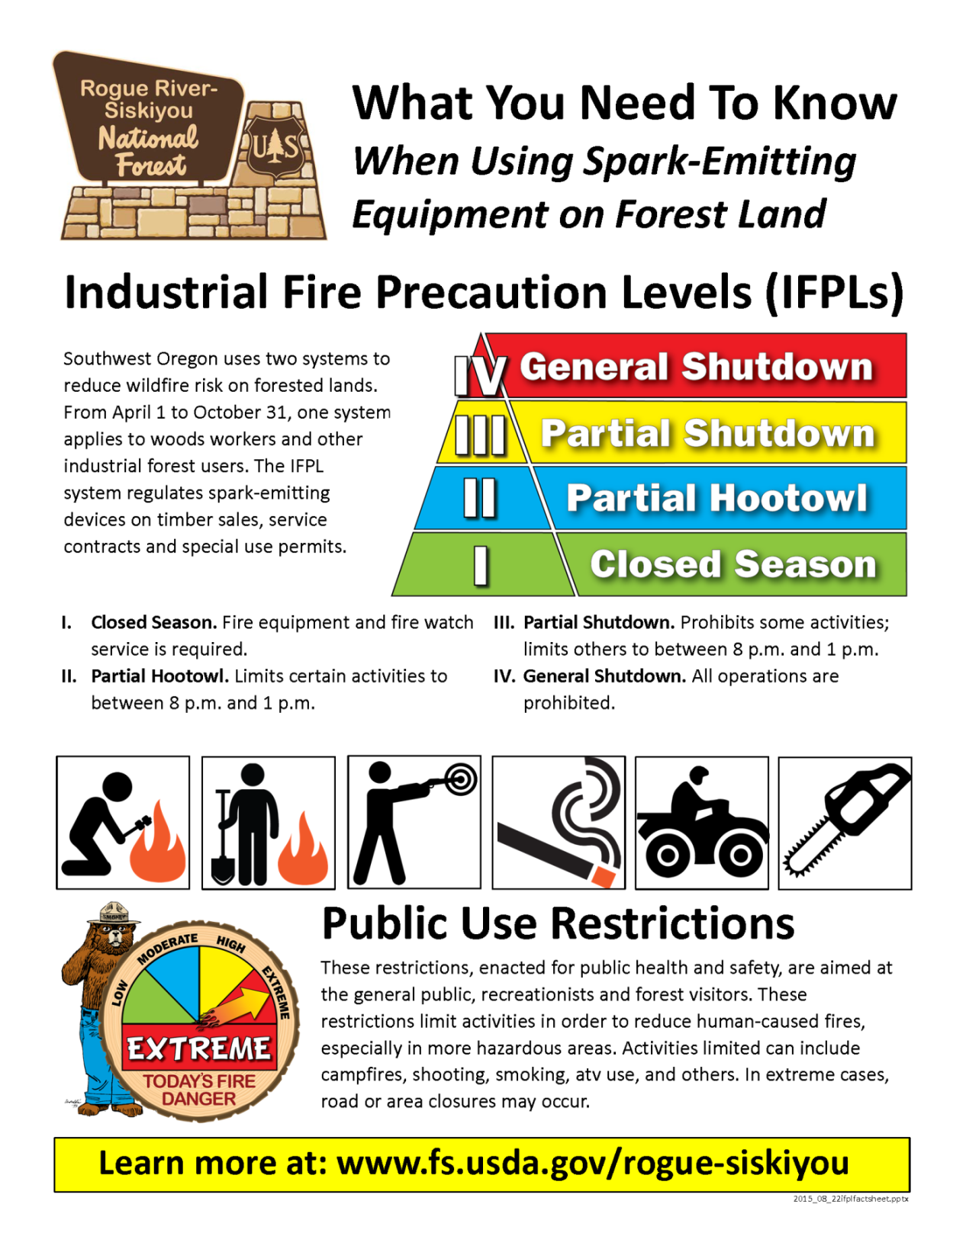

Appendix E - Roles and Responsibilities

Roles and Responsibilities Contacts

The following staff should participate in the implementation of PURs if enacted. These employees may have roles in the development of the orders, maps, exhibits, media releases and in the outreach and education (posting, employee meetings, etc.) step of PURs implementation. These employees should also receive emails from the Forest fire staff regarding rising risk and increasing fire conditions.

Note: This list should be updated annually at the pre-season meeting and adjusted as
needed throughout the season.

Fire/Prevention Personnel and Staff
Name | Phone / Email | Role/Responsibility
Larry Pingel  High Cascades  District FMO | 541-560-3408  lpingel@fs.fed.us | Documenting weather/fuels related fire conditions and rising trends. Documenting human fire cause trends. Sharing information/ recommendations with Fire Staff Officer & Line Officers and providing early notification of rising conditions and potential for PURs. Also documenting decreasing conditions to rescind PURs.
Rob Marshall  Siskiyou Mountains  District FMO | rwmarshall@fs.fed.us | Documenting weather/fuels related fire conditions and rising trends. Documenting human fire cause trends. Sharing information/ recommendations with Fire Staff Officer & Line Officers and providing early notification of rising conditions and potential for PURs. Also documenting decreasing conditions to rescind PURs.
Brandon Coville  Wild Rivers  (Acting) District FMO | bcoville@fs.fed.us | Documenting weather/fuels related fire conditions and rising trends. Documenting human fire cause trends. Sharing information/ recommendations with Fire Staff Officer & Line Officers and providing early notification of rising conditions and potential for PURs. Also documenting decreasing conditions to rescind PURs.
Monty Edwards  Gold Beach/Powers  Zone FMO | 541-247-3699  montyedwards@ fs.fed.us | Documenting weather/fuels related fire conditions and rising trends. Documenting human fire cause trends. Sharing information/ recommendations with Fire Staff Officer & Line Officers and providing early notification of rising conditions and potential for PURs. Also documenting decreasing conditions to rescind PURs.
Sarah Uvodich  High Cascades | 541-560-3424  sarahuvodich@ fs.fed.us | Prevention Technician. Patrol area of responsibility and makes public contacts. Report human caused fire trends. Posting PUR signs and taking them down. Monitor compliance and work closely with LEOs.
AJ Panks  Siskiyou Mountains | apanks@fs.fed.us | Prevention Technician. Patrol area of responsibility and makes public contacts. Report human caused fire trends. Posting PUR signs and taking them down. Monitor compliance and work closely with LEO’s.
Shelly Steiner  Wild Rivers | srsteiner@fs.fed.us | Prevention Technician. Patrol area of responsibility and makes public contacts. Report human caused fire trends. Posting PUR signs and taking them down. Monitor compliance and work closely with LEO’s.
Patrick Bunten  Gold Beach | 541-247-3666  patrickbunten@ fs.fed.us | Prevention Technician. Patrol area of responsibility and makes public contacts. Report human caused fire trends. Posting PUR signs and taking them down. Monitor compliance and work closely with LEO’s.
Powers |  | Prevention Technician. Patrol area of responsibility and makes public contacts. Report human caused fire trends. Posting PUR signs and taking them down. Monitor compliance and work closely with LEO’s.

Law Enforcement Staff/County LEO Cooperators
Name | Phone / Email | Role/Responsibility
Javier Masiel  Patrol Captain | 541-618-2152  jmasiel@fs.fed.us | Coordinating and working with Fire Staff Officer for specific PURs to include reference checking for legality. Coordinating with Administrative Officer and Forest Supervisor (or acting) for signature. Providing copies to the Public Affairs Officer. Monitoring and enforcing PURs.
Debra Globig  Administrative Officer | 541-618-2040  dglobig@fs.fed.us | Assigns Forest Order number. Prepares transmittal and routing and records official order into documentation binder. Sends order for signature.
Douglas Potter  Law Enforcement Officer  High Cascades | 541-560-3410  dmpotter@fs.fed.us | Assists with patrol, education and enforcement.
Charles Mayer  Law Enforcement Officer  Siskiyou Mountains  S |  | Assists with patrol, education and enforcement.
Sean Thomas (?) |  | Assists with patrol, education and enforcement.
MikeFakier (?) |  | Assists with patrol, education and enforcement.
Jackson and Josephine County Sheriff Deputies |  | Partner for monitoring and enforcing PURs. Law Enforcement will be in contact with them to insure information is shared with them
Oregon State Police | 503-375-3555  Osp.ncc@state.or.us | Partner for monitoring and enforcing PURs. Northern Command Center Dispatch (Salem).

Public Affairs Staff/Front-liners
Name | Phone / Email | Role/Responsibility
Virginia Gibbons  Supervisor’s Office | 541-618-2113  vgibbons@fs.fed.us | Creating media releases, developing talking points, securing and updating external media relations, internal RSF notifications and website and social media postings
Chamise Kramer  Supervisor’s Office | 541-618-2051  chamisekramer@  fs.fed.us | Creating media releases, developing talking points, securing and updating external media relations, internal RSF notifications and website and social media postings
Frontliners  High Cascades | Prospect  541-560-3400  Butte Falls  541-865-2700 | Front Desk – responsible for taking in-coming public inquiries. Works off of talking points to filter information requests. Assistance with internal notifications. Posts orders and media releases.
Frontliners  Siskiyou Mountains | Star  541-899-3800 | Front Desk – responsible for taking in-coming public inquiries. Works off of talking points to filter information requests. Assistance with internal notifications. Posts orders and media releases.
Frontliners  Wild Rivers | GPIO  541-471-6500  Cave Junction  541-592-4000 | Front Desk – responsible for taking in-coming public inquiries. Works off of talking points to filter information requests. Assistance with internal notifications. Posts orders and media releases.
Frontliners  Gold Beach | Gold Beach  541-247-3600 | Front Desk – responsible for taking in-coming public inquiries. Works off of talking points to filter information requests. Assistance with internal notifications. Posts orders and media releases.
Frontliners  Powers | Agness  541-439-6200 | Front Desk – responsible for taking in-coming public inquiries. Works off of talking points to filter information requests. Assistance with internal notifications. Posts orders and media releases.
Medford Interagency Supervisor’s Office | Medford  541-618-2200 | Front Desk – responsible for taking in-coming public inquiries. Works off of talking points to filter information requests. Assistance with internal notifications. Posts orders and media releases.
Medford Interagency Communication Center | Medford  541-618-2510 | MICC– posts orders and media releases to MICC website. Informs MICC staff of changes. Radio communication to field units.

Recreation Staff

Name | Phone / Email | Role/Responsibility
 |  | Posting campgrounds as needed; helping with posting Deschutes Resource Area recreation sites; patrol and monitoring compliance
 |  | Lead Field Ranger. Posting PURs signs and assignments to Field Rangers for posting, education and enforcement
 |  | Rec/Field Ranger Lead for_____. Posting PURs signs and assignments to
 |  | Field Rangers for posting, education and enforcement
 |  | Rec Lead for. Posting PURs signs and making assignments to field rangers and other rec staff for posting, education, enforcement.

Information Sharing Process:
As noted above, posting in the field, websites, social media and news releases are the core of the formal information dissemination. In addition, contacts in the field are essential to gain compliance by personal contact and informing. The 24-hour phone line is maintained year-round to help clarify and maintain currency on any changing conditions.

1-800-267-3126 - Recommend adding PURs information to recording. Listen to CO line at 1-800-523-4737.
PURs Email Notification List

This list could include other employees, partners, agencies, organizations, businesses, special use permit holders, Guides and Outfitters, not already listed in this document

Name/Organization | Contact Name | Email or Phone Number

Appendix F - Restriction and Closure Decision Checklist, Actions and Questions

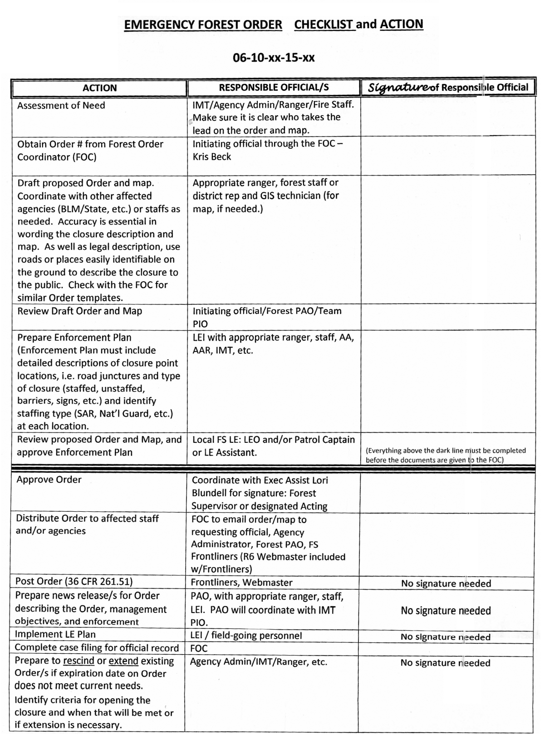

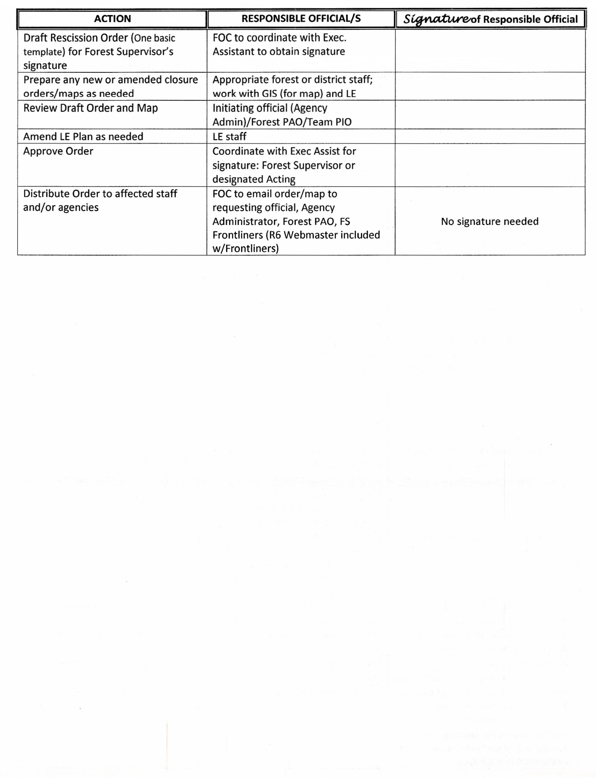

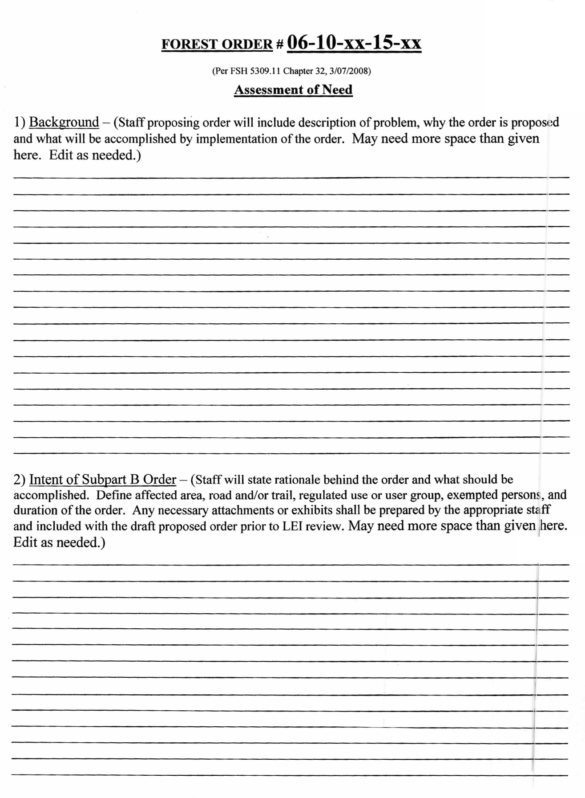

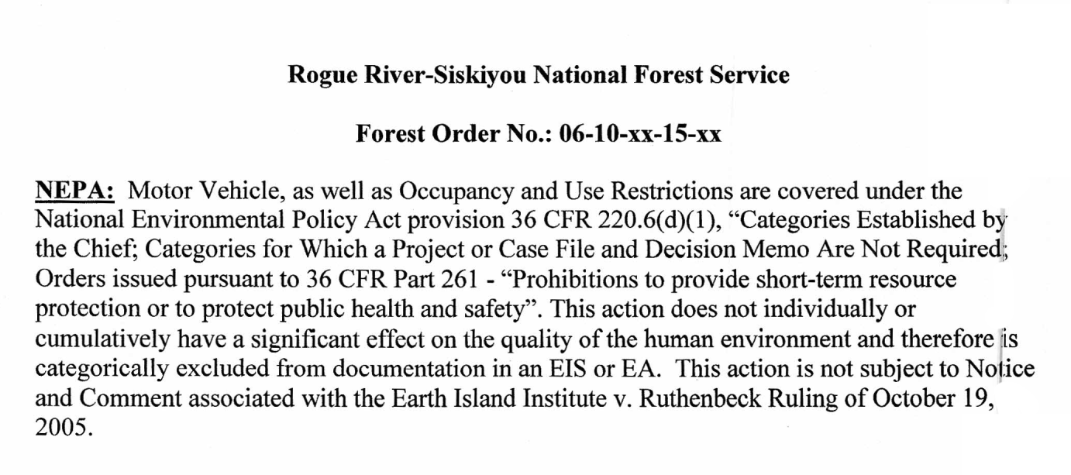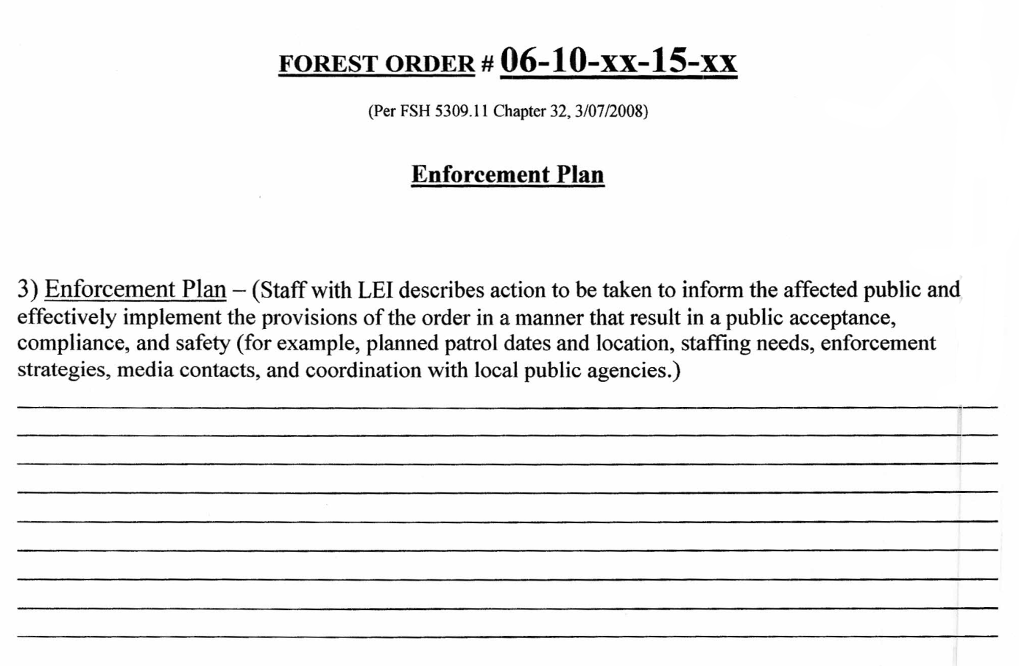

Following are some of the questions to be considered when contemplating a fire restriction and/or closure. The factors that form the basis for the decision should be documented in the “assessment of needs” (Administrative Record), which should be maintained at the forest level.

What is at risk?
    - Public safety
    - Public and private property
    - Natural resources

What are you trying to achieve?
    - Reduced human-caused starts
    - Public and firefighter safety
    - Are there other ways of achieving your objectives?

Are adequate fire resources available?
    - Is there the ability to effectively handle initial attack?
    - Are there enough engines, air tankers, helicopters, crews, etc., available?
    - Are there enough Type I and II teams available?

What is the predicted weather for the next several weeks?
    - Will there be high winds of long-term duration?
    - Will there be low relative humidity during day, and poor nighttime recovery?
    - What are the expected temperatures (maximum/minimum); will there be minimum nighttime temperatures higher than 50o F?
    - What are the lightning predictions?

What is the daily fire occurrence situation?
    - Are there multiple starts?
    - Are fire occurrences and associated control problems increasing or decreasing?
    - Are the daily fire starts more attributable to human cause or lightning/natural causes?

Is an increase/decrease in recreational visitor days, i.e., holidays and special events, expected?

What are the socio-economic considerations?
    - Will there be direct and cumulative impacts on rural economies, tourism and authorized permittees?
    - Has the right message been given to the public and other stakeholders to establish groundwork for restrictions/closure?
    - Is it possible to minimize effects on the local community and users, while achieving desired objectives?
    - What is the urban/wildland-interface complexity?
    - What is the public desire for recreation opportunities and events?

What actions are being taken by surrounding land managers, and local or state authorities?

What are the standards and guidelines contained in the forest plan for the affected area?
    - Are there research natural areas or other special interest areas that may be affected?
    - Are there wilderness or wild and scenic rivers that may be affected?

What is the workload associated with restrictions and closures?
    - Will the workload associated with fire closures compete with fire management?
    - Are personnel available to send notification letters to and do follow up actions with permittees, private landowners, contractors, etc., particularly as restriction levels increase?
    - Are personnel available to assist some users, such as outfitter/guides, who may ask for assistance in moving their operations to areas of lower or no restrictions?
    - Will refunds or fee reductions be appropriate for reservations, and certain uses and contracts?
    - Are personnel available to provide public information and post the order on the ground and on the web?
    - Is there adequate personnel for patrol and enforcement?

Will the restriction/closure be enforceable?
    - Is law enforcement involved early in the consideration of a restriction or closure?
    - Will entry/activity permits be issued, and, if so, in what situations and under what conditions?
    - Is consistent and highly visible signage available?
    - Is there a common goal with state, local and adjacent national forest units?

Are there preparations for the next stage, whether that would be a higher stage restriction/closure or rescission of an order?

Appendix G - Pre-Approved and Sample Order Templates

These could be pre-approved or changed to samples

Order Number:

ORDER
STAGE I FIRE RESTRICTIONS
NATIONAL FOREST

Pursuant to 36 CFR § 261.50(a), the following acts are prohibited on all National Forest System lands within the National Forest, in the State of (“the restricted area”). The restricted area is depicted on the attached map, hereby incorporated into this Order as Exhibit A.

- Building, maintaining, attending or using a fire, campfire or stove fire, except within a developed recreation site. 36 CFR § 261.52(a)
- Smoking, except within an enclosed vehicle or building, a developed recreation site, or while stopped in an area at least three feet in diameter that is barren or cleared of all flammable material. 35 CFR §261.52(d).
- Possessing, discharging or using any kind of firework or other pyrotechnic device. 36 CFR §261.52(f).

Pursuant to 36 CFR § 261.50(e), the following persons [choose appropriate “persons” below]
are exempt from this order:

- Persons with a permit that authorizes actions specifically prohibited by this closure order.
- Any Federal, State or Local Officer or member of an organized rescue or firefighting force in the performance of an official duty.
- Lessees or permittees within the restricted area are exempt from prohibition 1 above, provided such fires are within their residence.

These restrictions are being implemented for public safety and because of extreme fire hazard conditions on federal lands.

This order becomes effective at (time, date, year)_ , and will remain in force until rescinded or until , 2003, whichever occurs first.
Done at ___________________, State, this _____ day of_________________, ____.

______________________________

[FOREST SUPERVISOR’S NAME]
Forest Supervisor
National Forest

Violation of these regulations is punishable as a Class B misdemeanor, by a fine of not more than $5000 for an individual or $10,000 for an organization, or imprisonment for not more than six (6) months or both. 16 USC § 551, and 18 USC §§ 3559 and 3571.

Order Number:

ORDER
STAGE II FIRE RESTRICTIONS
NATIONAL FOREST

Pursuant to 36 CFR § 261.50(a), the following acts are prohibited on all National Forest System lands within the National Forest, in the State of (“the restricted area”). The restricted area is depicted on the attached map, hereby incorporated into this Order as Exhibit A.

- Building maintaining, attending, or using a fire, campfire or stove fire. 36 CFR 261.52(a).
- Smoking, except within an enclosed vehicle or building. 36 CFR 261.52(c).
- Possessing, discharging or using any kind of firework or other pyrotechnic device. 36 CFR 261.52(f).
- Using an explosive. 36 CFR 261.52(b).
- Operating a chainsaw or other equipment powered by an internal combustion engine is prohibited from 1:00 p.m. to 1:00 a.m. 36 CFR 261.52(h).
- Operating or using any internal or external combustion engine without a spark arresting device properly installed, maintained and in effective working order meeting either:
  - Department of Agriculture, Forest Service Standard 5100-1a; or
  - Appropriate Society of Automotive Engineers (SAE recommended practice J335(b) and J350(a). 36 CFR § 261.52(j)
7. Welding, or operating an acetylene or other torch with open flame. 36 CFR 261.52(i).
- Possess or use a motor vehicle off National Forest System Roads. 36 CFR 261.56 Except when parking in an area devoid of vegetation within 10 feet of the roadway; and except for parking overnight in developed campgrounds and at trailheads.
- Violating any state law concerning burning, fires, or which is for the purpose of preventing or restricting the spread of fire. 36 CFR § 261.52(k).

(Reference specific state statute)

Pursuant to 36 CFR § 261.50(e), the following persons [choose appropriate “persons”] are exempt from this order:

1. Persons with a permit that authorizes actions specifically prohibited by this closure order.
2. Persons in a developed recreation site using a fire fueled solely by liquid petroleum or LPG fuels.
- Any Federal, State, or local officer, or member of an organized rescue or firefighting force in the performance of an official duty.
- Lessees or permittees within the restricted area are exempt from prohibition 1 above, provided such fires are within their residence.

This order becomes effective at (time), (date), (year), and will remain in force until rescinded or until (time), (date), (year), whichever occurs first.
Done at ___________________, State, this _____ day of_________________, ____.

______________________________

[FOREST SUPERVISOR’S NAME]
Forest Supervisor
National Forest

Violation of these regulations is punishable as a Class B misdemeanor, by a fine of not more than $5000 for an individual or $10,000 for an organization, or imprisonment for not more than six (6) months or both. 16 USC § 551, and 18 USC §§ 3559 and 3571.

Order Number:

ORDER
EMERGENCY AREA FIRE CLOSURE (STAGE III)
NATIONAL FOREST

Pursuant to 36 CFR § 261.50(a), and 36 CFR § 261.50(b), the following acts are prohibited
within the specific area boundary within the _National Forest, in the State of
(“the restricted area”). The specific restricted area is depicted on the attached map, hereby incorporated into this Order as Exhibit A.

1. Going into or being upon the restricted area. 36 CFR § 261.52(e)

Pursuant to 36 CFR § 261.50(e), the following persons [choose appropriate “persons” below]
are exempt from this closure order:

- Persons with a permit that authorizes actions specifically prohibited by this closure order.
- Any Federal, State or Local Officer or member of an organized rescue or firefighting force in the performance of an official duty.

[Short and succinct reason for closure.]

This order becomes effective at (time), (date), (year), and will remain in force until rescinded or until (time), (date), (year), whichever occurs first.
Done at ___________________, State, this _____ day of_________________, ____.

______________________________

[FOREST SUPERVISOR’S NAME]
Forest Supervisor
National Forest

Violation of these regulations is punishable as a Class B misdemeanor, by a fine of not more than $5000 for an individual or $10,000 for an organization, or imprisonment for not more than six (6) months or both. 16 USC § 551, and 18 USC §§ 3559 and 3571.

Order Number:

ORDER
EMERGENCY FIRE CLOSURE (STAGE IV)
NATIONAL FOREST

Pursuant to 36 CFR § 261.50(a), and 36 CFR § 261.50(b), the following acts are prohibited on all National Forest System lands within the National Forest, in the State of
(“the restricted area”). The restricted area is depicted on the attached map, hereby incorporated into this Order as Exhibit A.

1. Going into or being upon the restricted area. 36 CFR § 261.52(e)

Pursuant to 36 CFR § 261.50(e), the following persons [choose appropriate “persons” below]
are exempt from this closure order:

- Persons with a permit that authorizes actions specifically prohibited by this closure order.
- Any Federal, State or Local Officer or member of an organized rescue or firefighting force in the performance of an official duty.

[Short and succinct reason for closure.]

This order becomes effective at _(time, date, year) , and will remain in force until rescinded or until , 2003, whichever occurs first.
Done at ___________________, State, this _____ day of_________________, ____.

______________________________

[FOREST SUPERVISOR’S NAME]
Forest Supervisor
National Forest

Violation of these regulations is punishable as a Class B misdemeanor, by a fine of not more than $5000 for an individual or $10,000 for an organization, or imprisonment for not more than six (6) months or both. 16 USC § 551, and 18 USC §§ 3559 and 3571.

SAMPLE
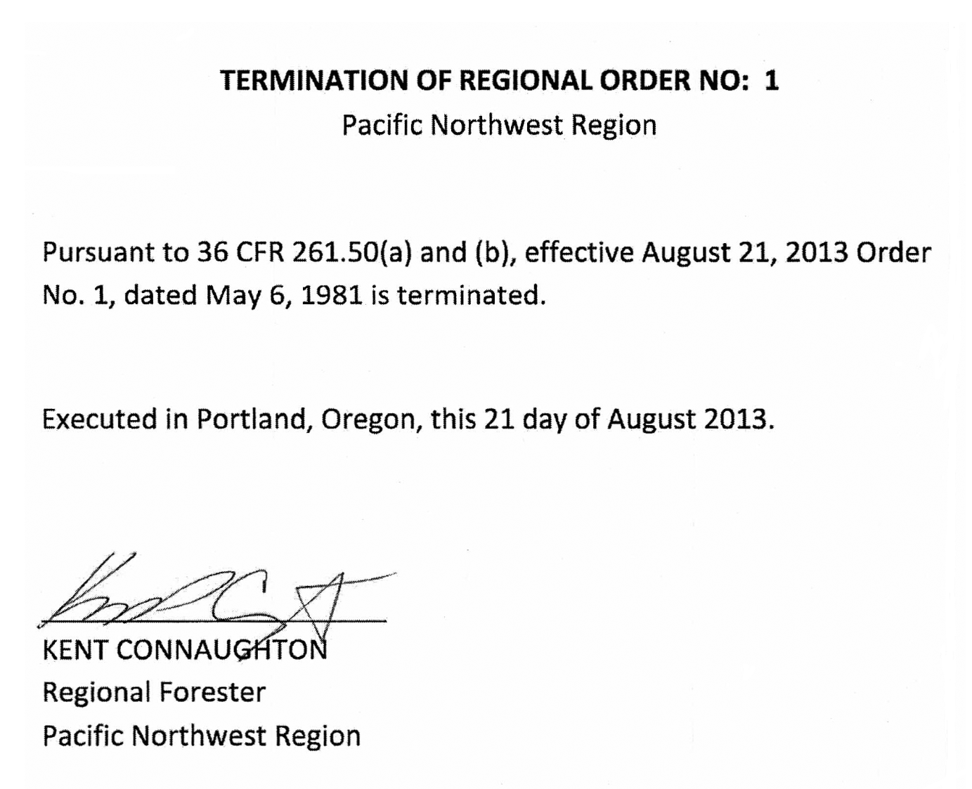
SAMPLE
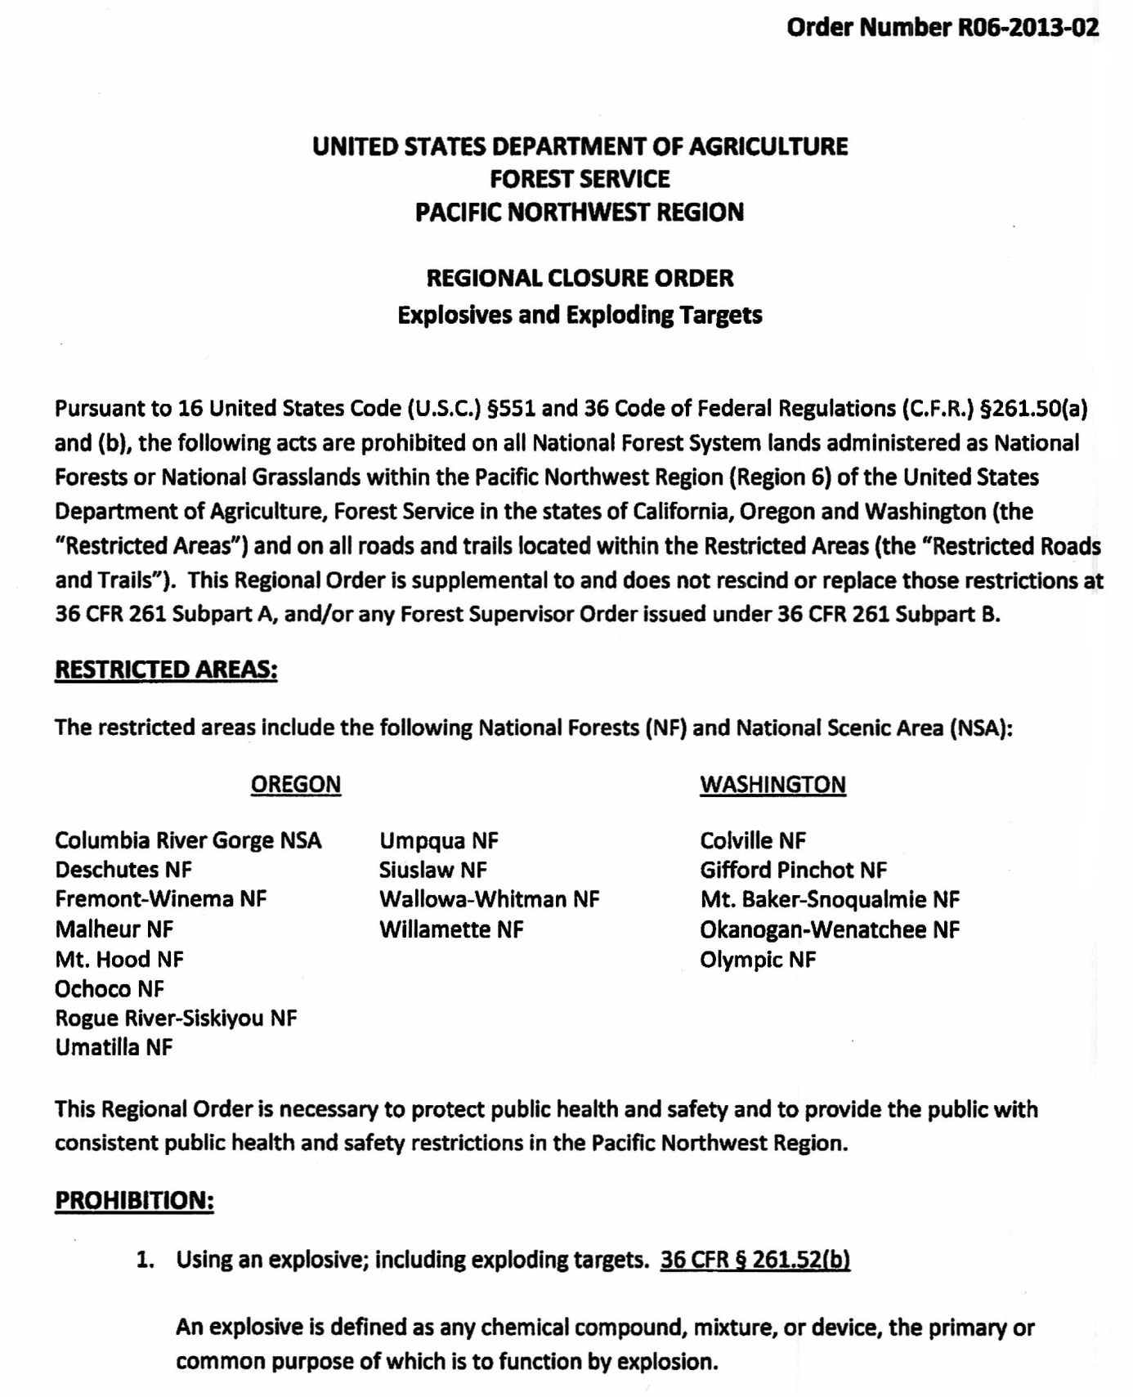

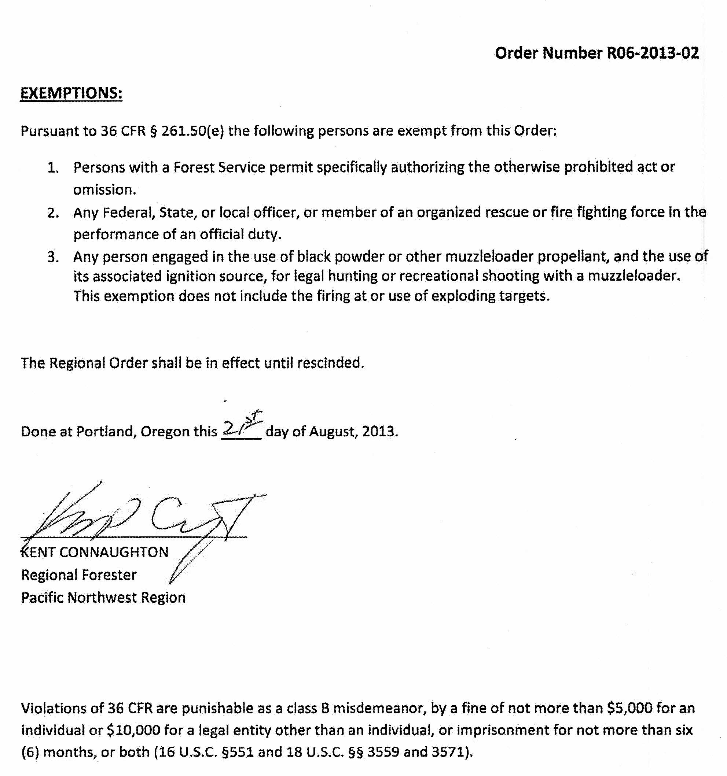

SAMPLE
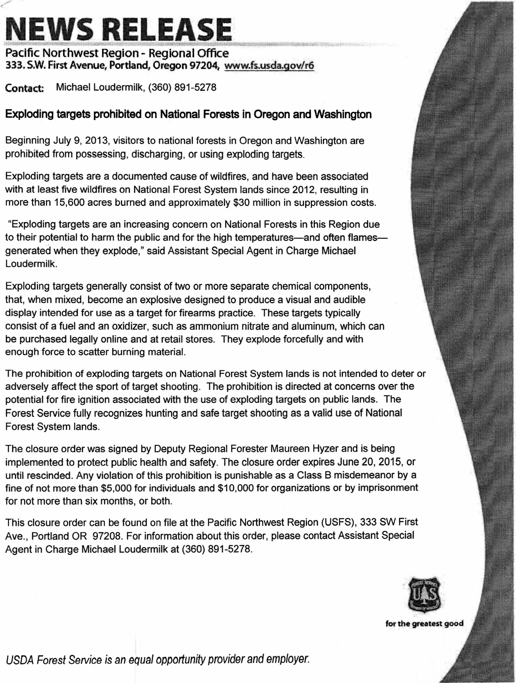
SAMPLE
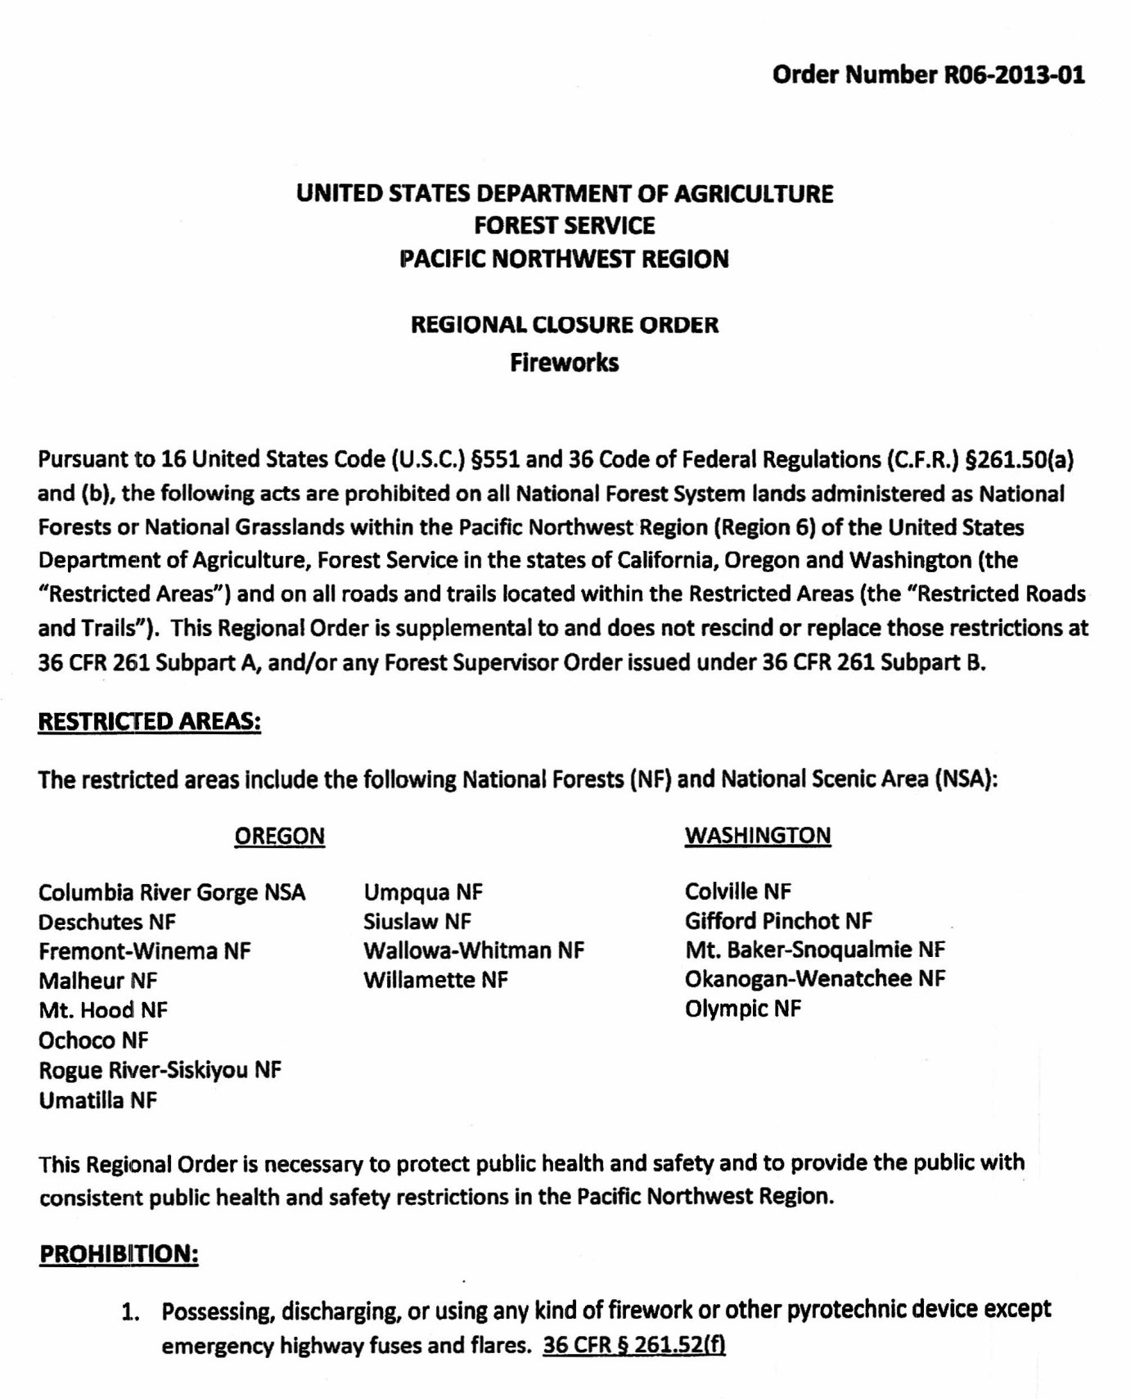

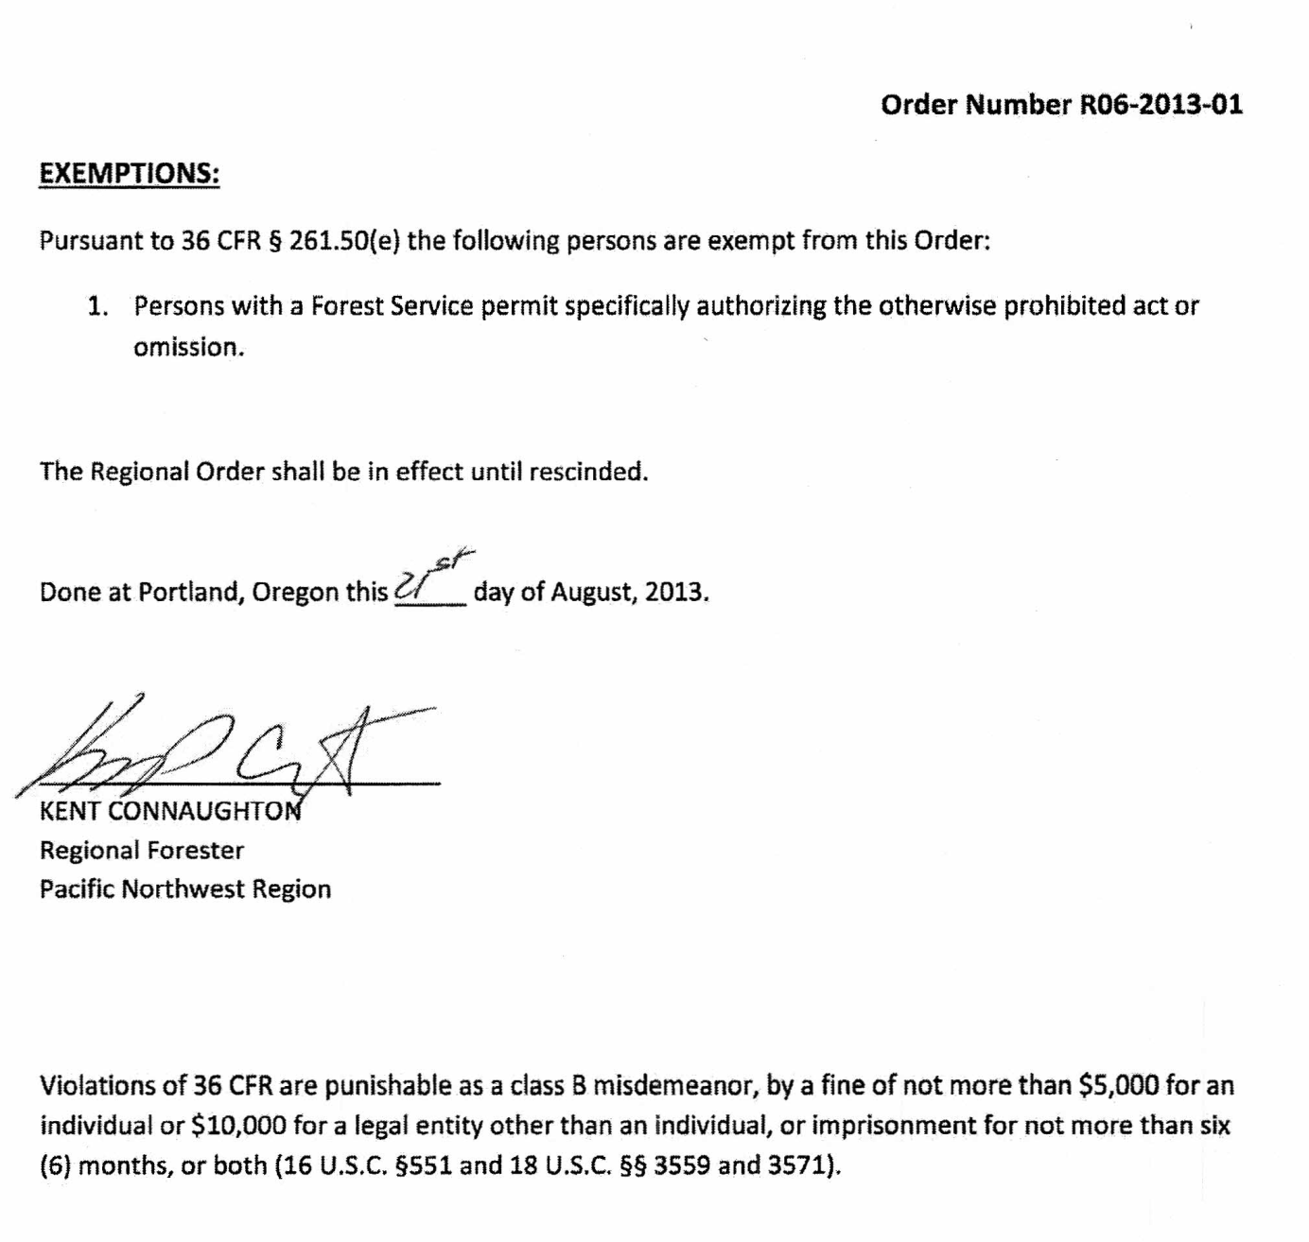

Appendix H - Size, Scope, and Time Considerations For Restrictions/Closures

        - Size and Scope of Restrictions and Closures
Restrictions or closure orders should be implemented on the smallest geographic scale to affect the fewest number of people which will meet the need for and objectives of the restriction/closure. This balancing of benefits and costs is based on carefully defining the need for the restrictions; the risks faced by the forest; the potential benefits of the restriction/closure; and the cost to the public, permit holders, and contractors, as well as the cost of implementation.

Special Considerations

Tribal treaty rights must be considered. Also, every order must consider the right of access to private property and other outstanding private property rights.

Identifiable Area Boundaries

For ease of implementation and interagency coordination, an order should be designed to cover an easily identifiable, logical geographic area. This may be a ranger district, a watershed, or an area bounded by specified roads or topographic features.

All closure orders should be accompanied by a high-quality map clearly delineating the boundaries of the closure in such a manner that the public can readily locate those boundaries on the ground. As enforcement is a key component of every order, the boundaries must be designed to facilitate compliance enforcement.

Multiple-area Restrictions

Various stages might be in effect in more than one geographic area across the landscape. However, before making the decision to implement more than one stage at a time on the landscape, there needs to be careful consideration of the potential for confusion and for potential effects on the public and forest users.

Small geographic extent orders could be used when needed specifically for public or firefighter safety. An example would be to close the area within and around a wildfire, including the greatest estimated five-day extent of burned area.

Options to Consider

Options to a closure may include the following to allow certain recreation activities: Allow day use only.
Allow day use only at developed recreation sites.

Allow overnight use in wilderness, parking at designated trailheads. Allow overnight use only in developed campgrounds.
Allow overnight use only in developed campgrounds with full-time hosts. Allow day/overnight use in specified areas that are easy to patrol and monitor. Allow use only in developed sites along county/state highways.

        - Length of Time
Restriction or closure orders should only be considered with regard to long-term risks. It is important to avoid the appearance of constantly changing the stage of restrictions. Once a decision is reached that an order is appropriate, that order needs to remain in place until the danger has clearly passed. A short-term change in weather may give the appearance that the risk has passed, but, if followed by a warm dry trend, the risks could again accelerate. While it is not prudent to impose more severe restrictions than are warranted, the evaluation of risk should be made over an extended timeframe.

When a specified level of restrictions is no longer needed based on the risk assessment, and evaluation indicates that the danger has passed for the foreseeable future, the restrictions may be relaxed to a lower stage by implementing a new, supplemental, or modified order. In many instances, it will be more appropriate to phase out of restriction stages, rather than immediately dropping to the lowest non-restriction level.

All orders need to have a “sunset” provision, whereby the order will terminate.

Appendix I – Sample Media Releases: Radio PSAs, Media Taglines, Talking Points

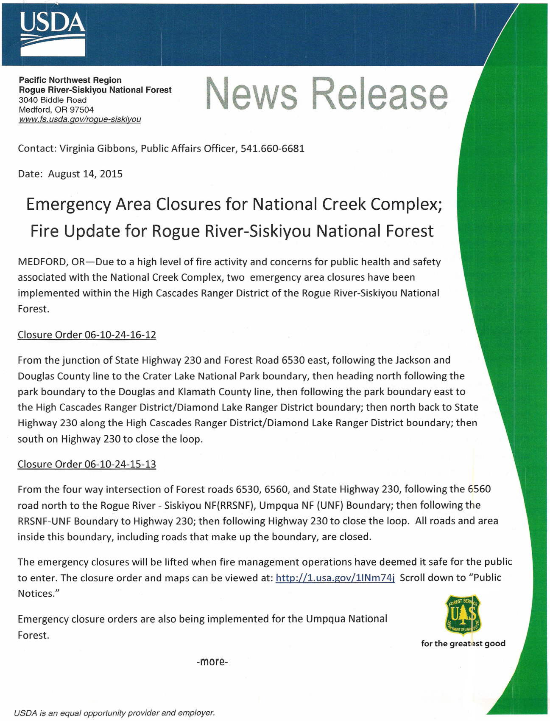
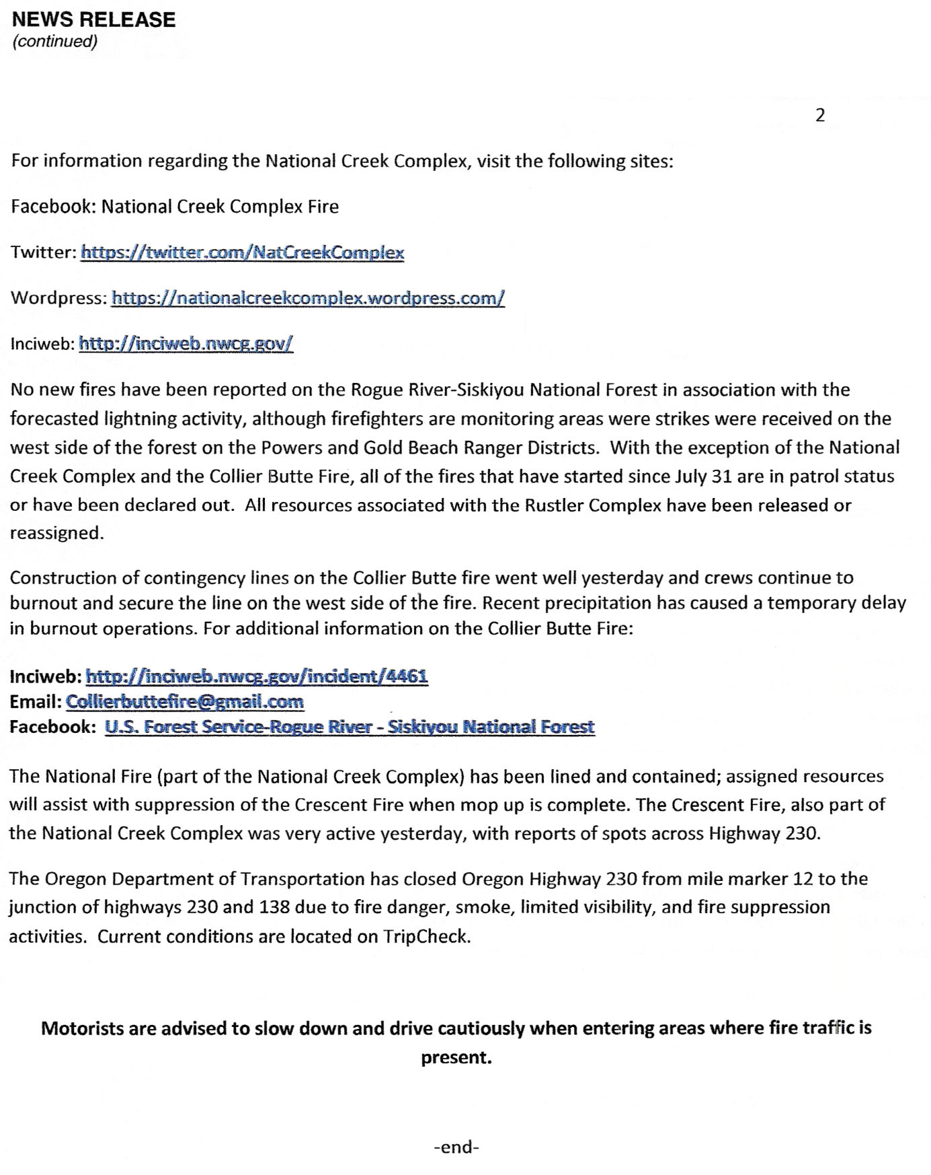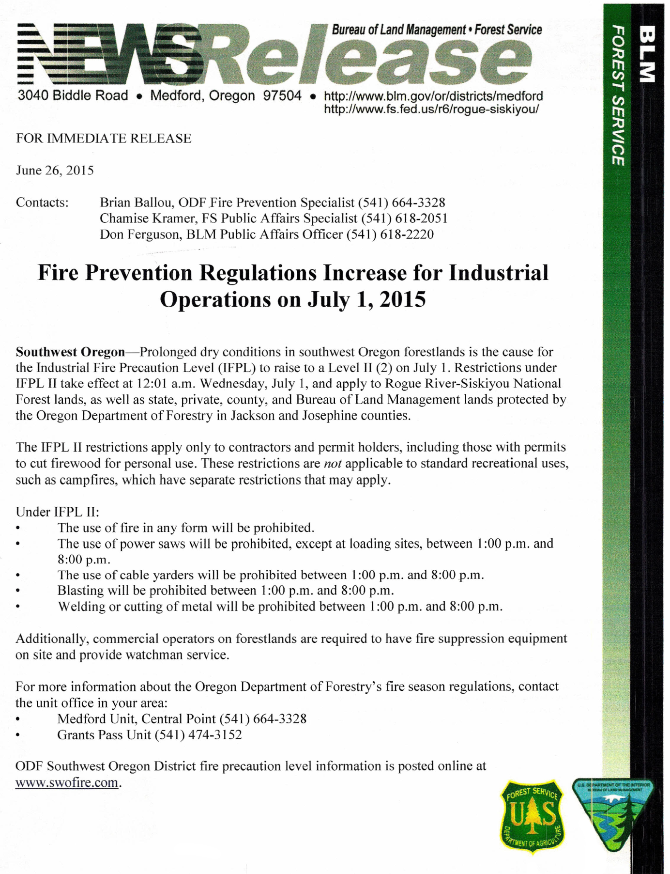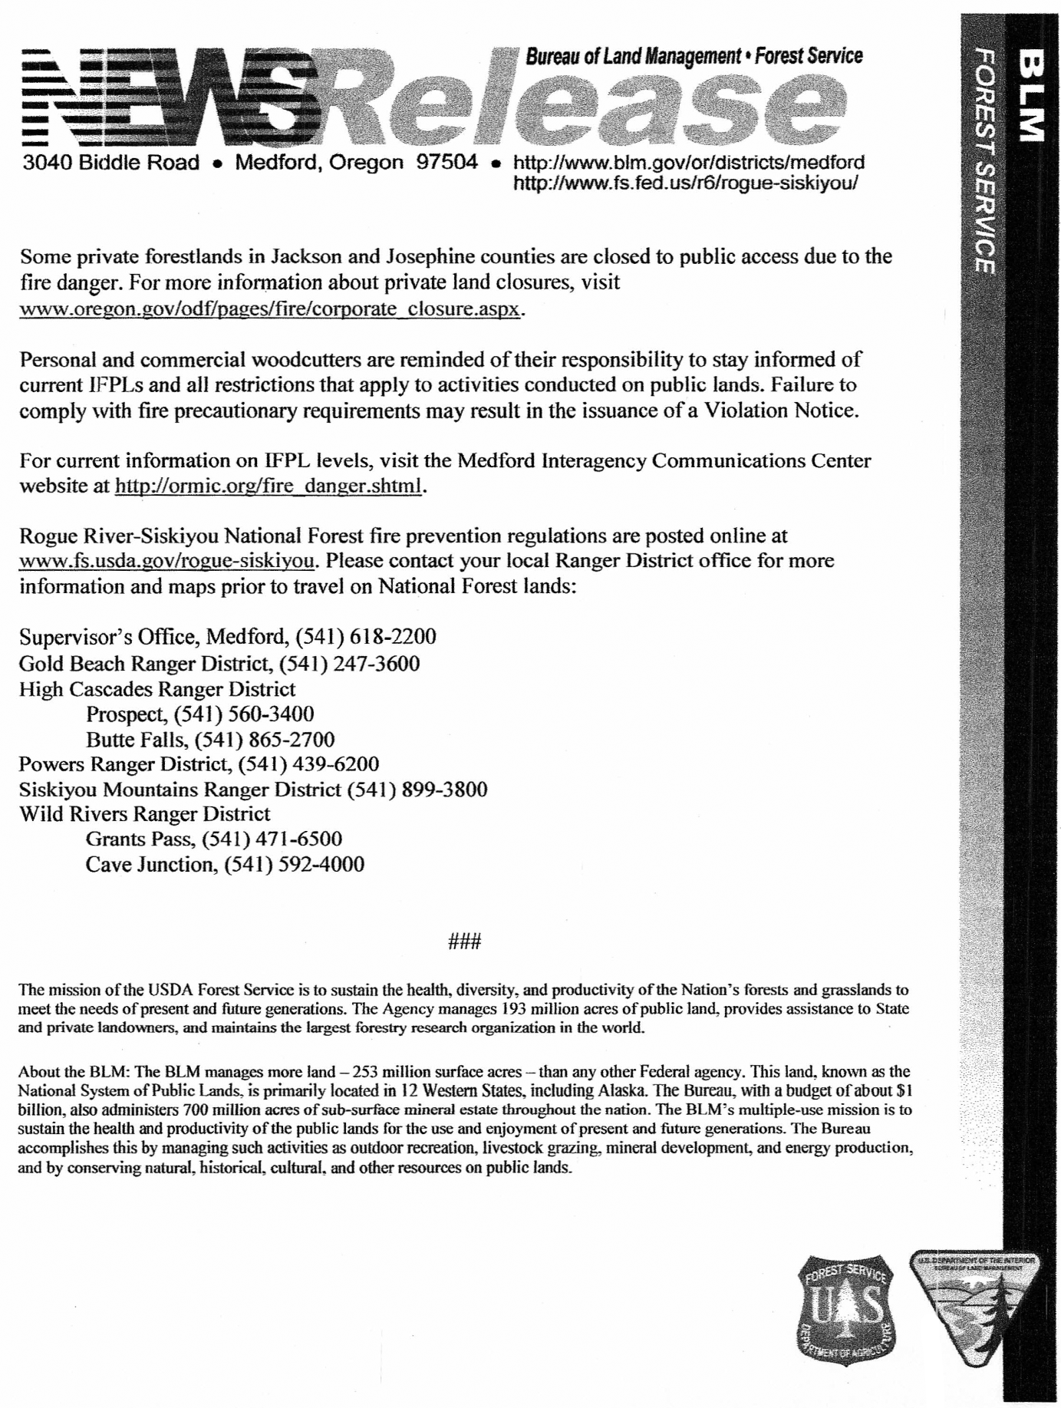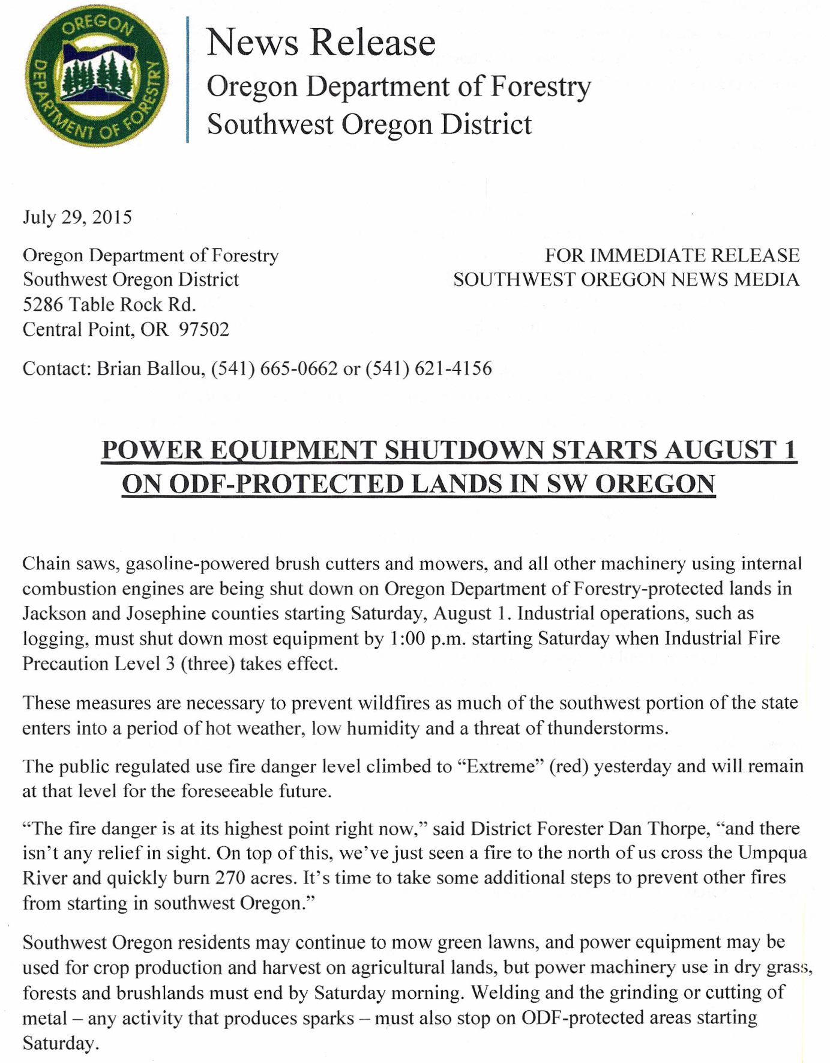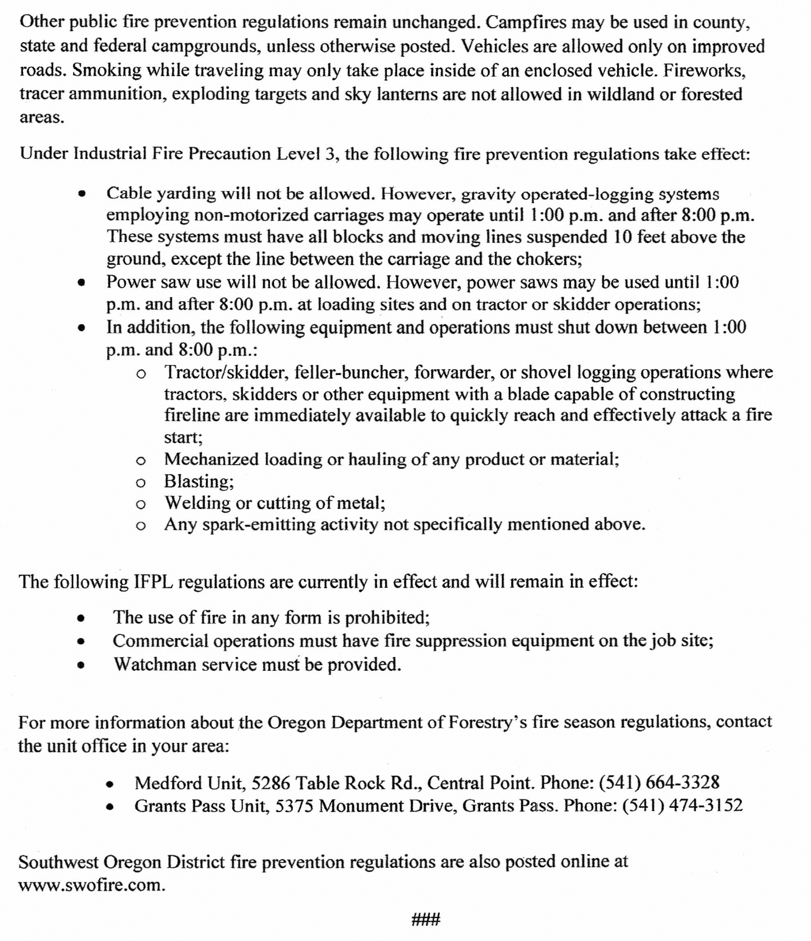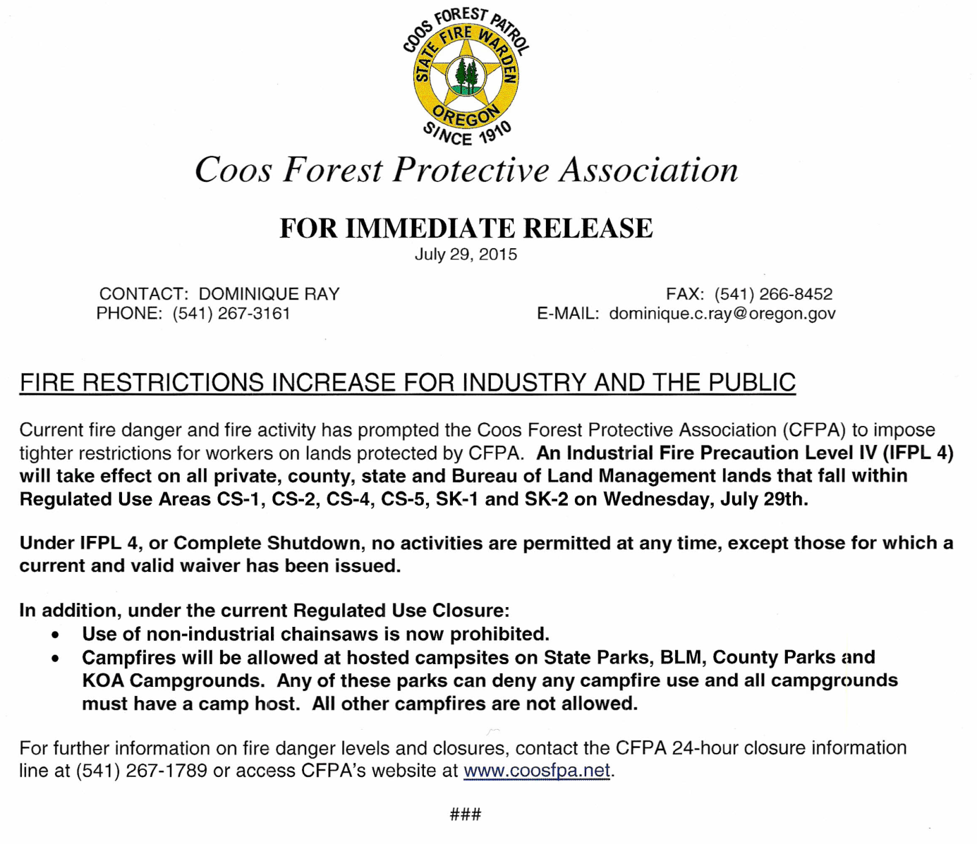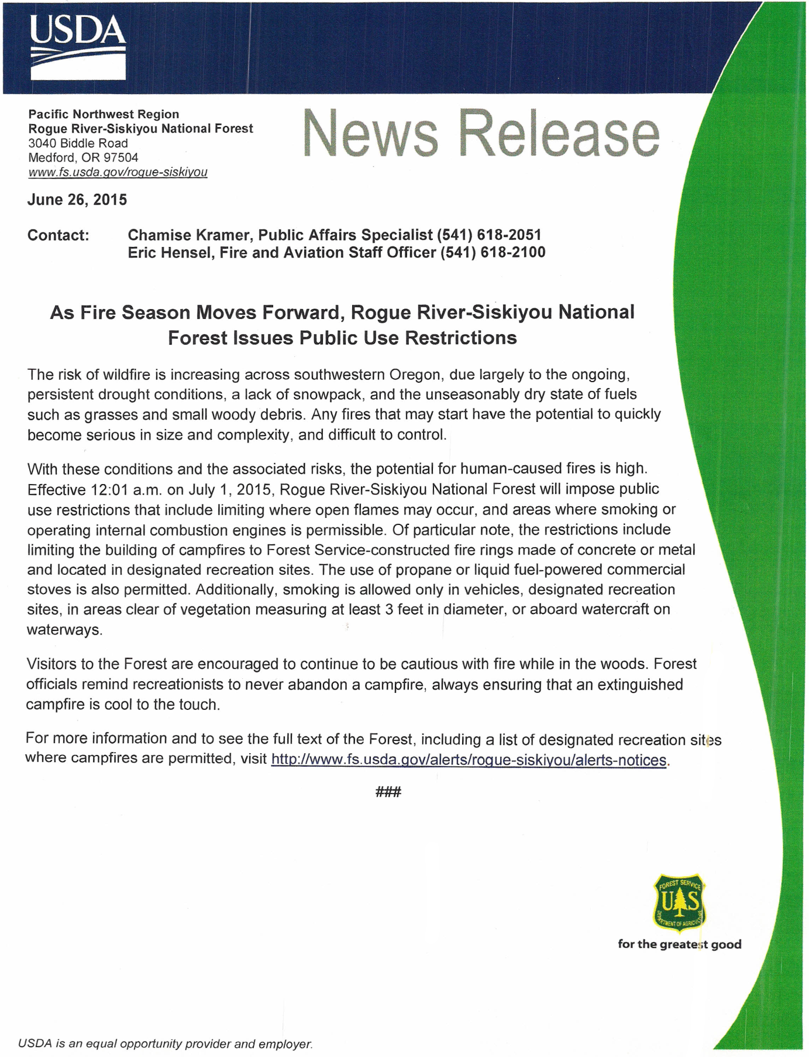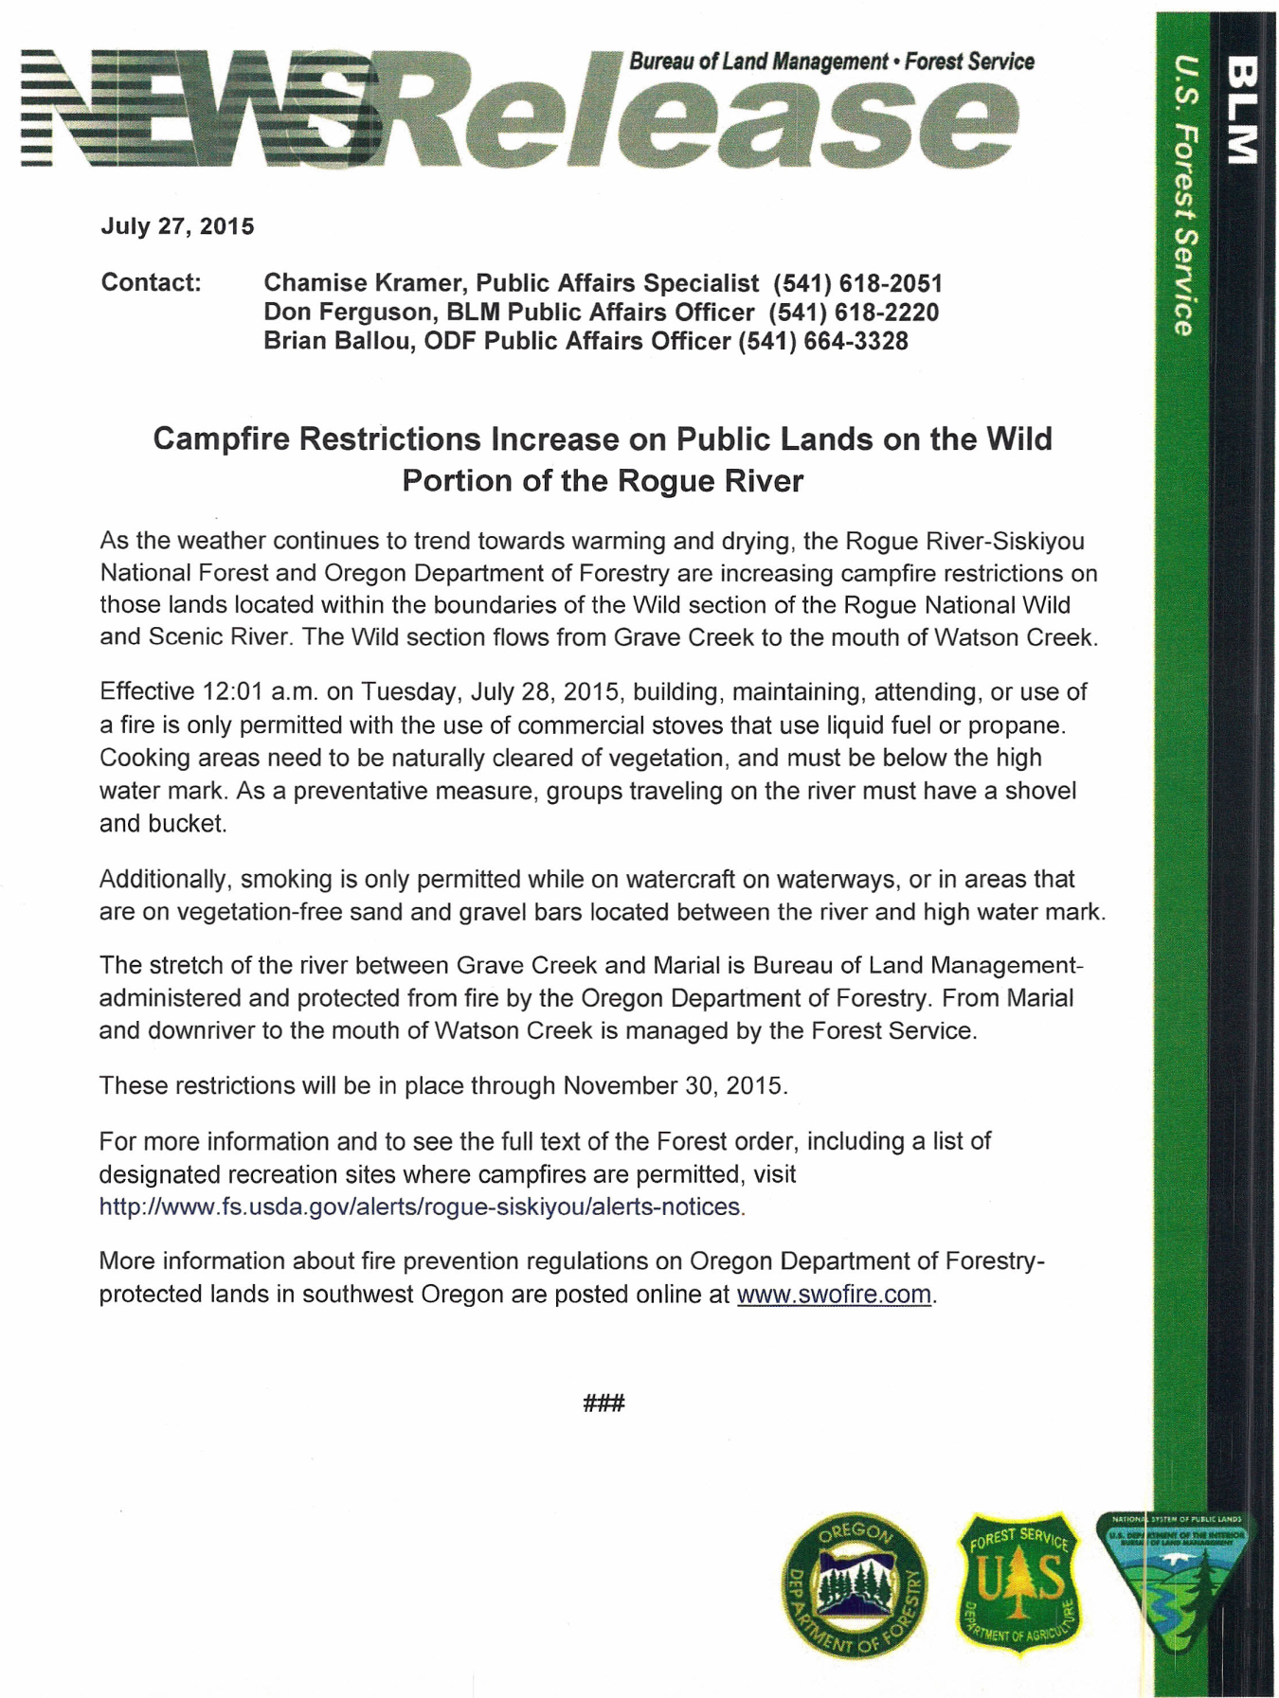

Fire Danger Talking Points
The Pacific Northwest is facing an active and potentially dangerous period of fire season. As summer progresses, hot, dry weather and lightning over already dry fuels dramatically increases the likelihood for severe, fast-moving fires. We are considering further fire prevention measures due to fire danger and high recreational activity.

Every year lightning-caused fires place a heavy demand on our firefighting resources, and put our firefighters, our wildlands, and our communities at risk. Fires caused through carelessness or negligence only increase the threat to life and livelihood, and place an even greater burden on already busy firefighters. In an active fire season, we need our firefighters available and ready to respond to the most critical wildfires. Every fire that’s prevented helps firefighters remain available, rested, and safe.

As always, our highest priority remains firefighter and public safety. Help us achieve this goal. Help our firefighters. Please be careful with fire.

How do we tell the public about the fire danger?
Education about fire prevention on public lands is a priority, and extra effort is now being made to inform our visitors. We want to raise the level of awareness and fire safe behavior by increasing the consistency, visibility and persistence of our prevention messages.

We increase the number of public contacts in the field and add to our fire prevention presence by adding personnel into the regular mix of engines, crews, field, and wilderness rangers. These personal contacts, along with local, regional, and national fire prevention messaging work together to educate and inform the visitors to public lands.

Why are public use restrictions put in place?
Forest, BLM and Oregon Department of Forestry officials utilize public use restrictions as a way to improve firefighter and public safety - they don’t implement public use restrictions to ruin someone’s camping experience. Every year lightning-caused fires already place a heavy demand on our firefighting resources, and put our wildlands, our firefighters, and our communities at risk.
Additional fires caused through carelessness or negligence only increase the threat to life and livelihood, and place an even greater burden on already busy firefighters.

Why didn’t the ___________ National Forest go into public use restrictions?
In all cases, the decision to go into public use restrictions is not taken lightly. Forest Service, BLM and Oregon Department of Forestry officials look at the number of human caused starts, the time since the last rainfall, the amount of available resources and the dryness of the vegetation. Early predictions for the drying trend have been holding true this summer and what we’re seeing is that, [INSERT FOREST SPECIFIC INFORMATION] lands are very dry right now. The Rogue River-Siskiyou National Forest is also very dry, and its neighbor(s) to the east (__________) is already in Public Use Restrictions.

On the other hand, the Rogue River Siskiyou National Forest received fairly heavy rain in areas just a short time ago, keeping the forest just a little bit greener. In fact, fire danger indices on the Forest are more at 10 year averages, not extremes. The Rogue River Siskiyou National Forest will continue to monitor conditions and will implement public use restrictions on the forest if conditions continue to decline. Abandoned campfires are still the leading cause of human-caused wildfires on public land.

However, the current numbers of abandoned campfires on the Rogue River Siskiyou National Forest are not high, and most of the current large fires are lightning-caused. The fuel types on the Rogue River Siskiyou National Forest also vary from those on the [INSERT FOREST SPECIFIC INFORMATION]. Right now, on the Rogue River Siskiyou, the more forested environment, the larger downed wood and heavy fuel moistures are average right now. The snow pack in the ____________________ has contributed to these large fuel moistures staying higher longer this year.

When will the public use restrictions be lifted?
Forest Service, BLM and Oregon Department of Forestry officials and fire staff use the same factors to identify when conditions have improved to the point that they feel comfortable lifting public use restrictions. They will continue to monitor weather, vegetation and the fire situation, and will wait until conditions recover, primarily through measurable precipitation, before they lift these restrictions. Firefighter and public safety always takes priority in these considerations.

Will you be closing roads?
Right now, Forest Service, BLM and Oregon Department of Forestry officials have made the decision to keep roads open (unless they are currently closed under the existing travel management decision). If conditions continue to decline, we may look at restricting access on the types of roads that have vegetation down the middle. There have been cases where dry vegetation gets caught under a vehicle and has started a wildfire. We will notify the public if we get to the point that closing roads is an option.

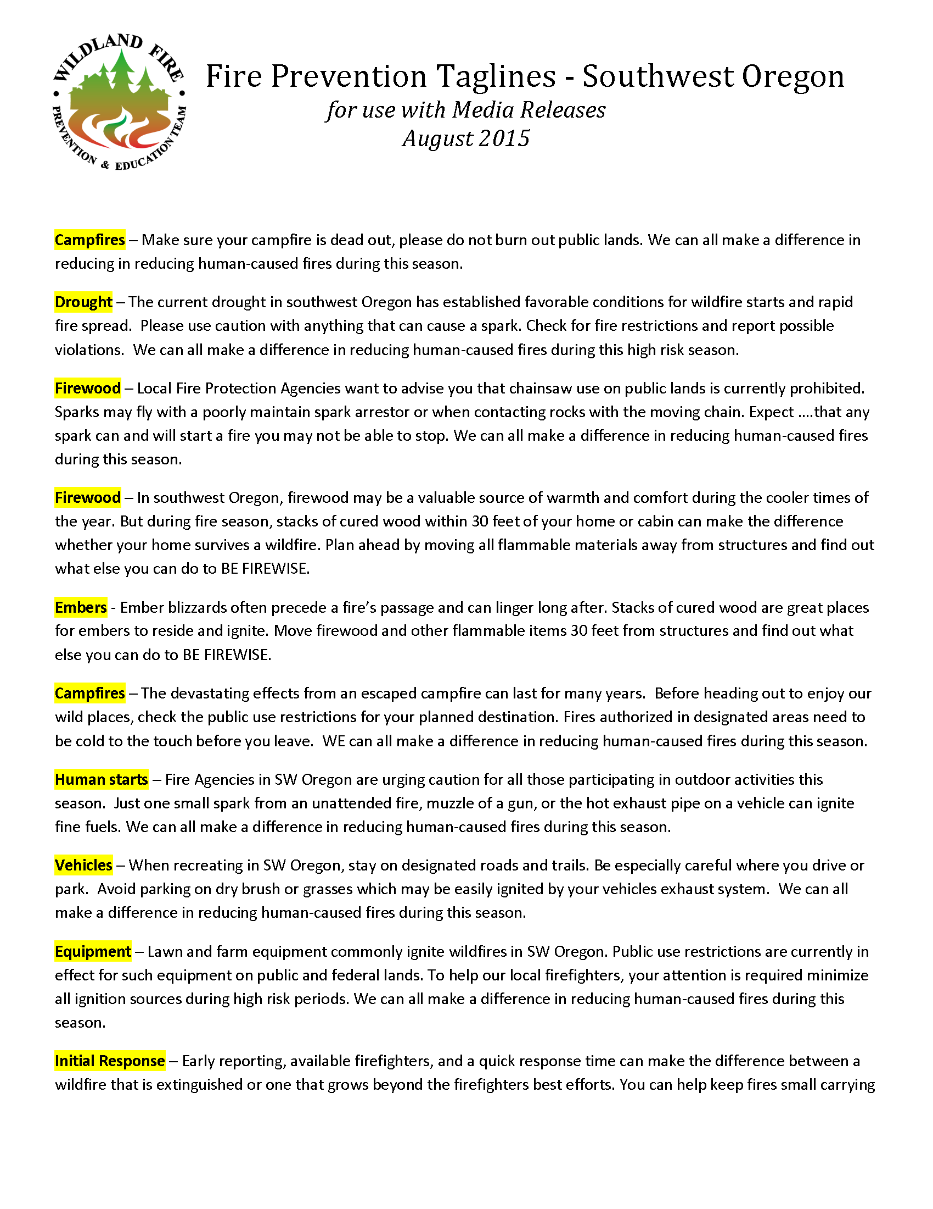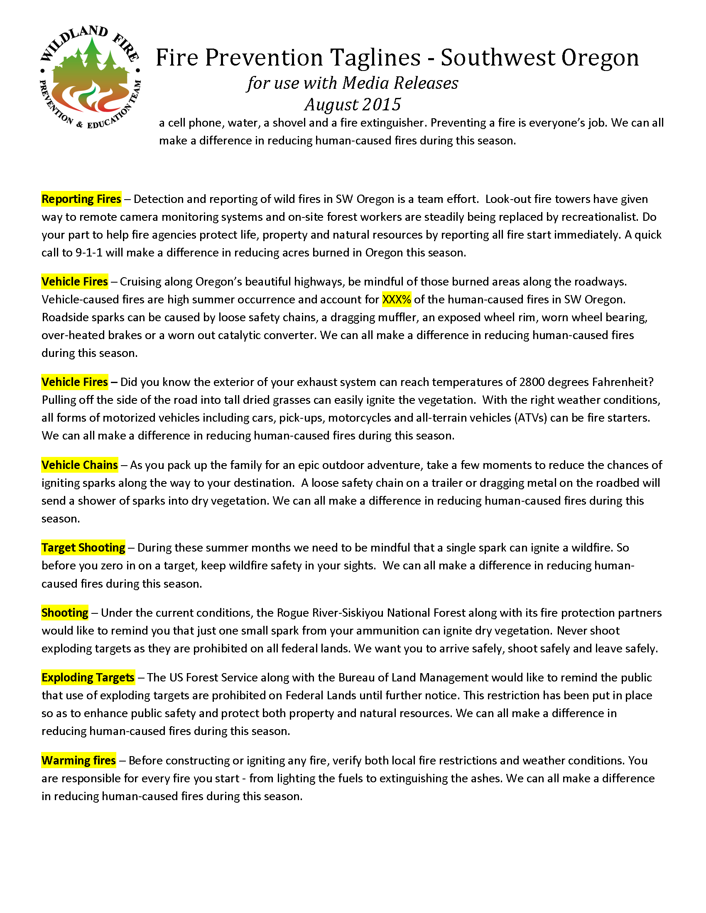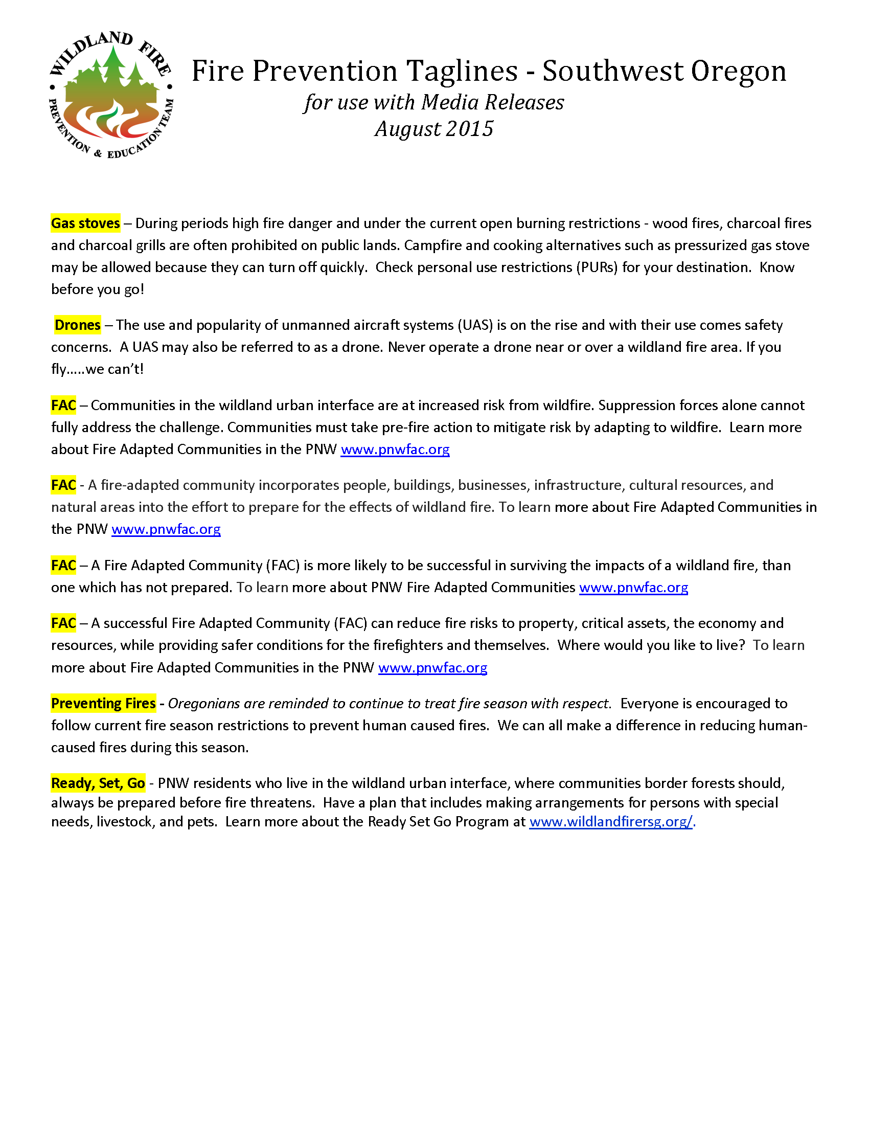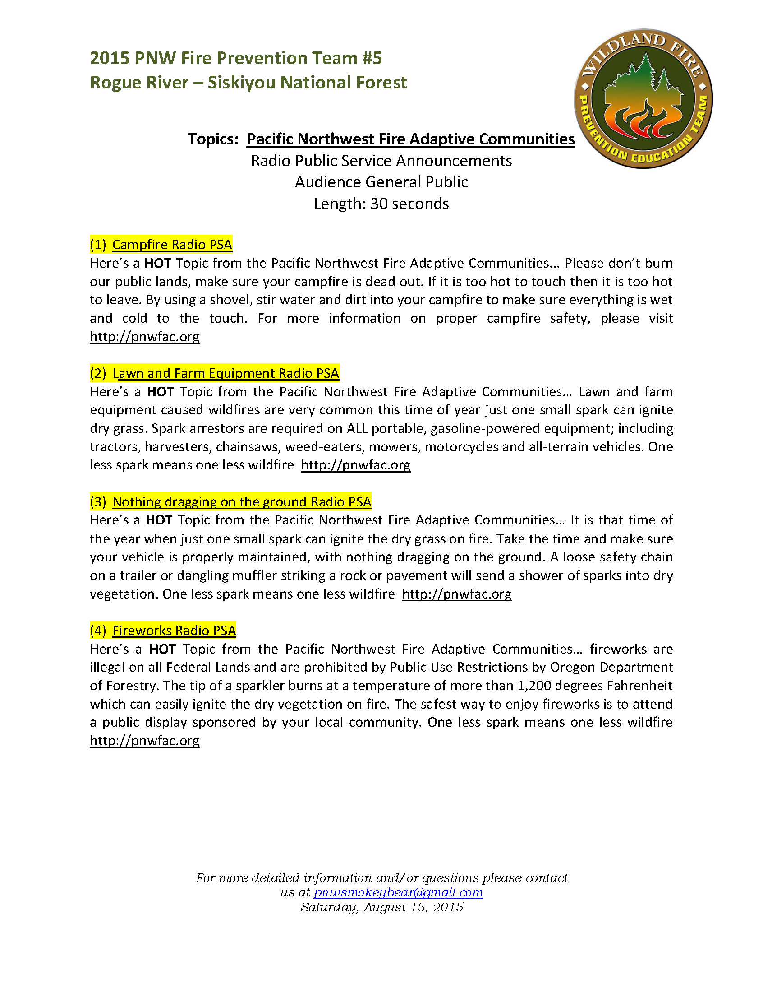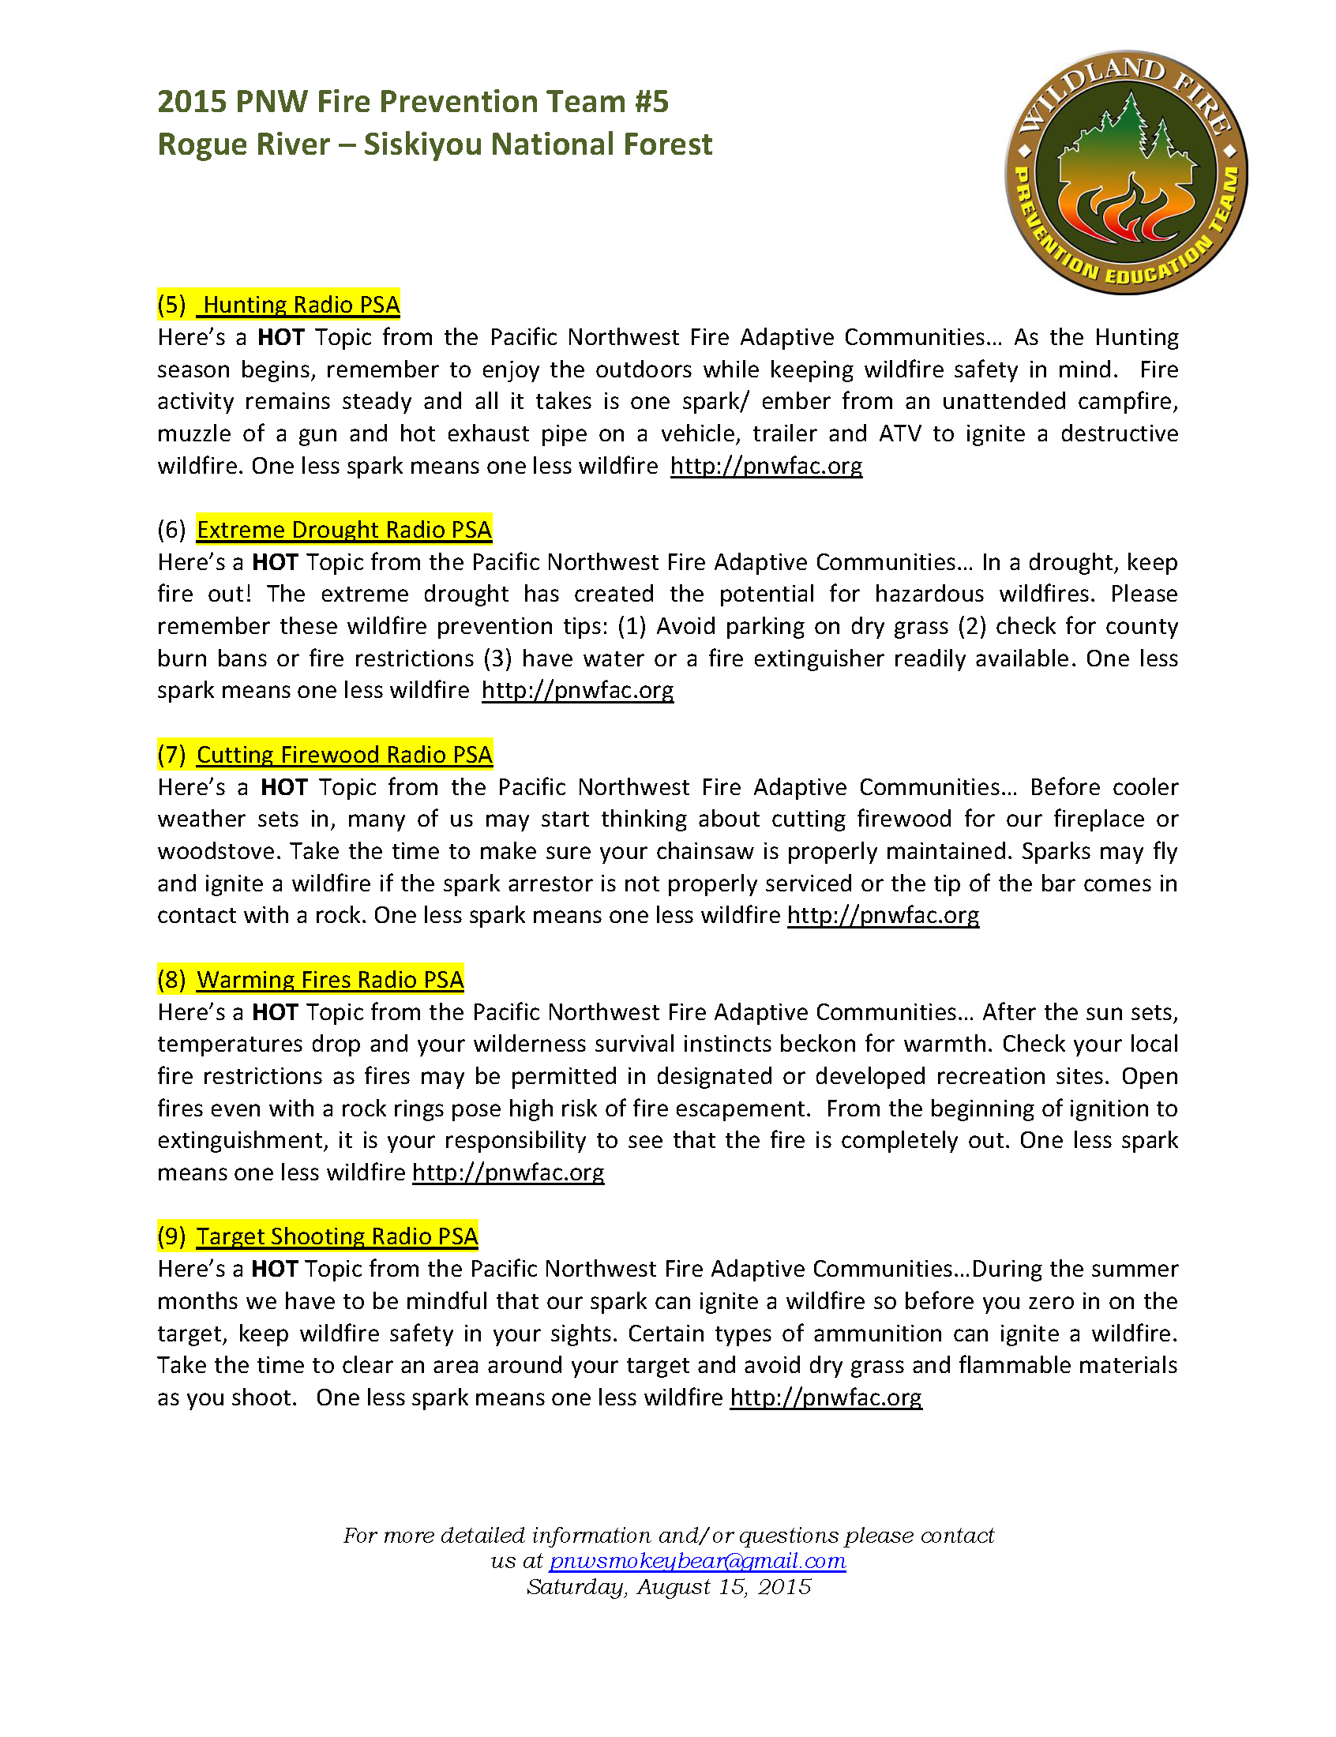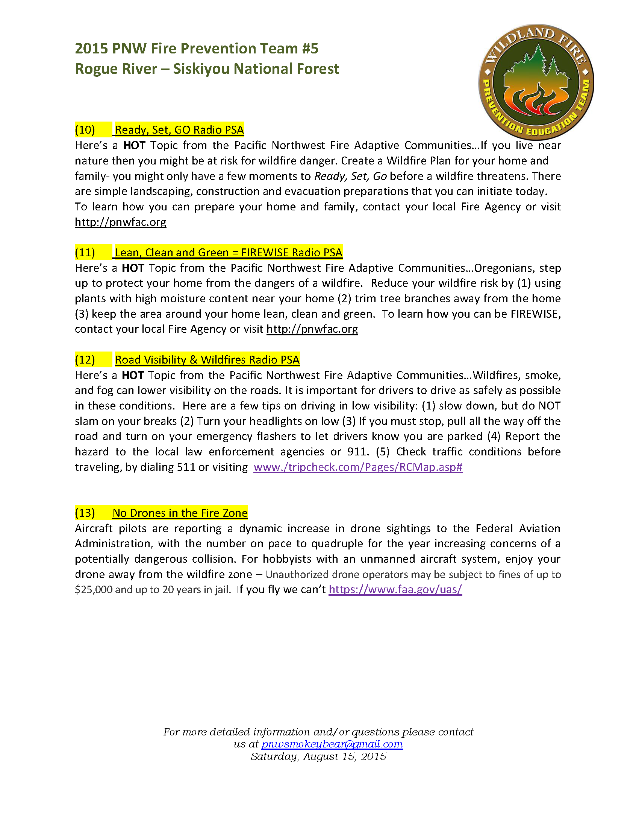

Appendix J – Sample Posters / Flyers / Handouts

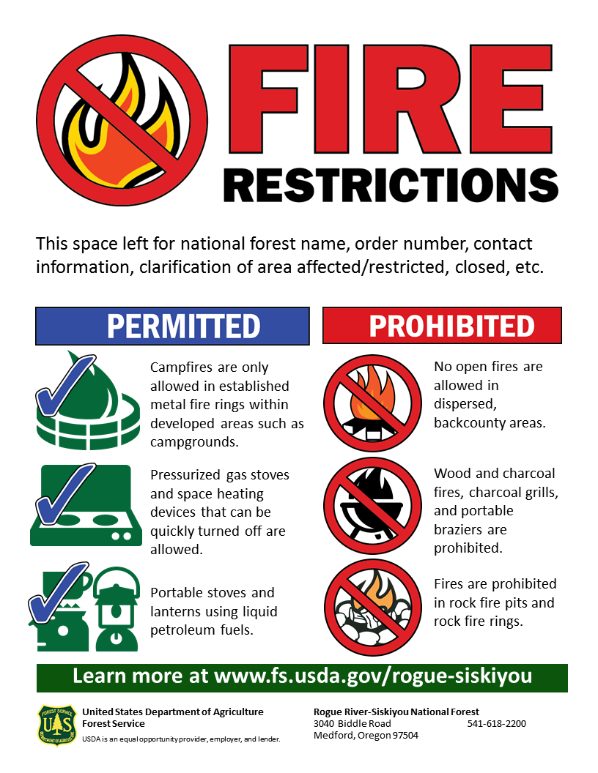
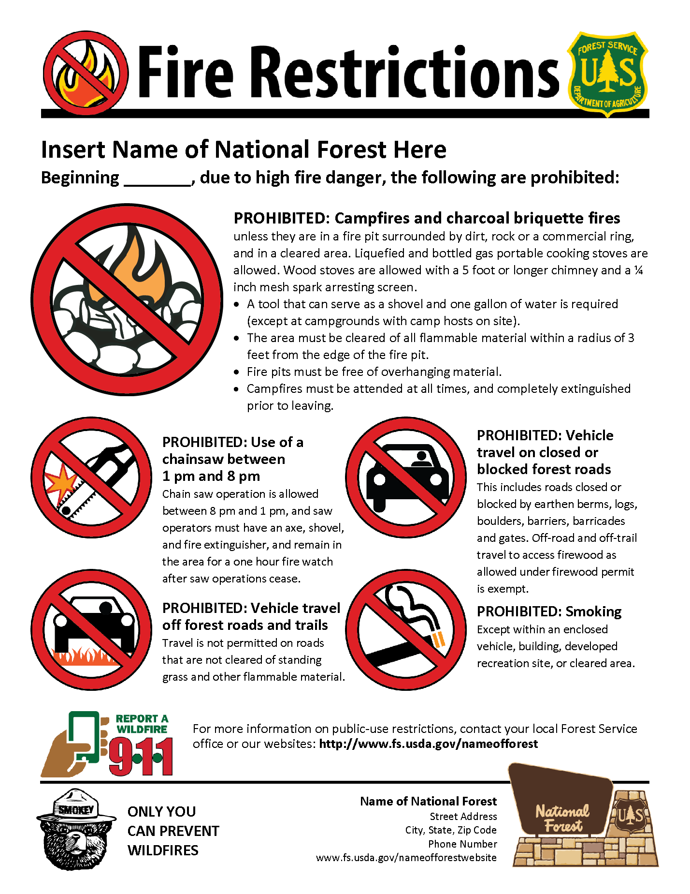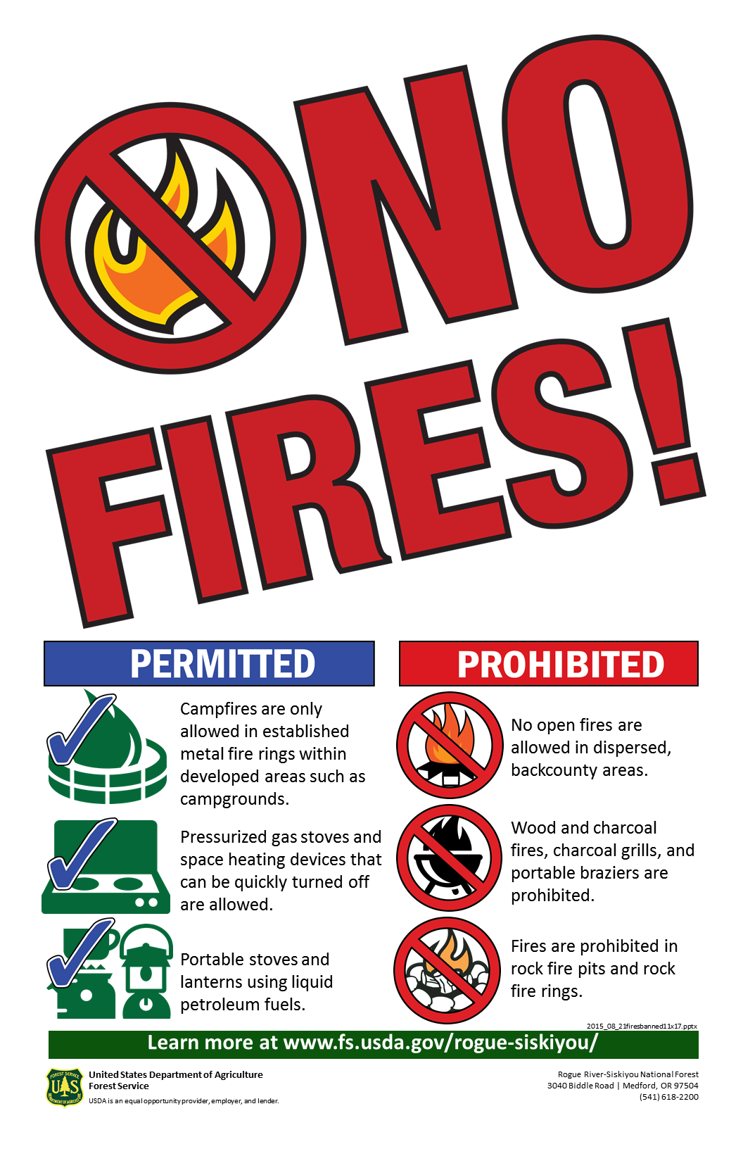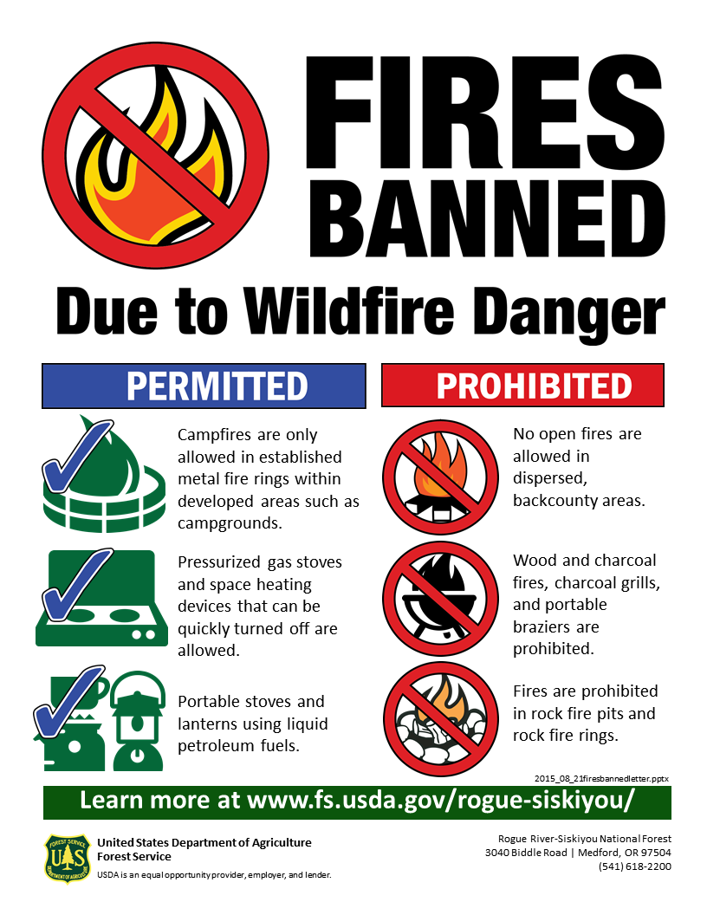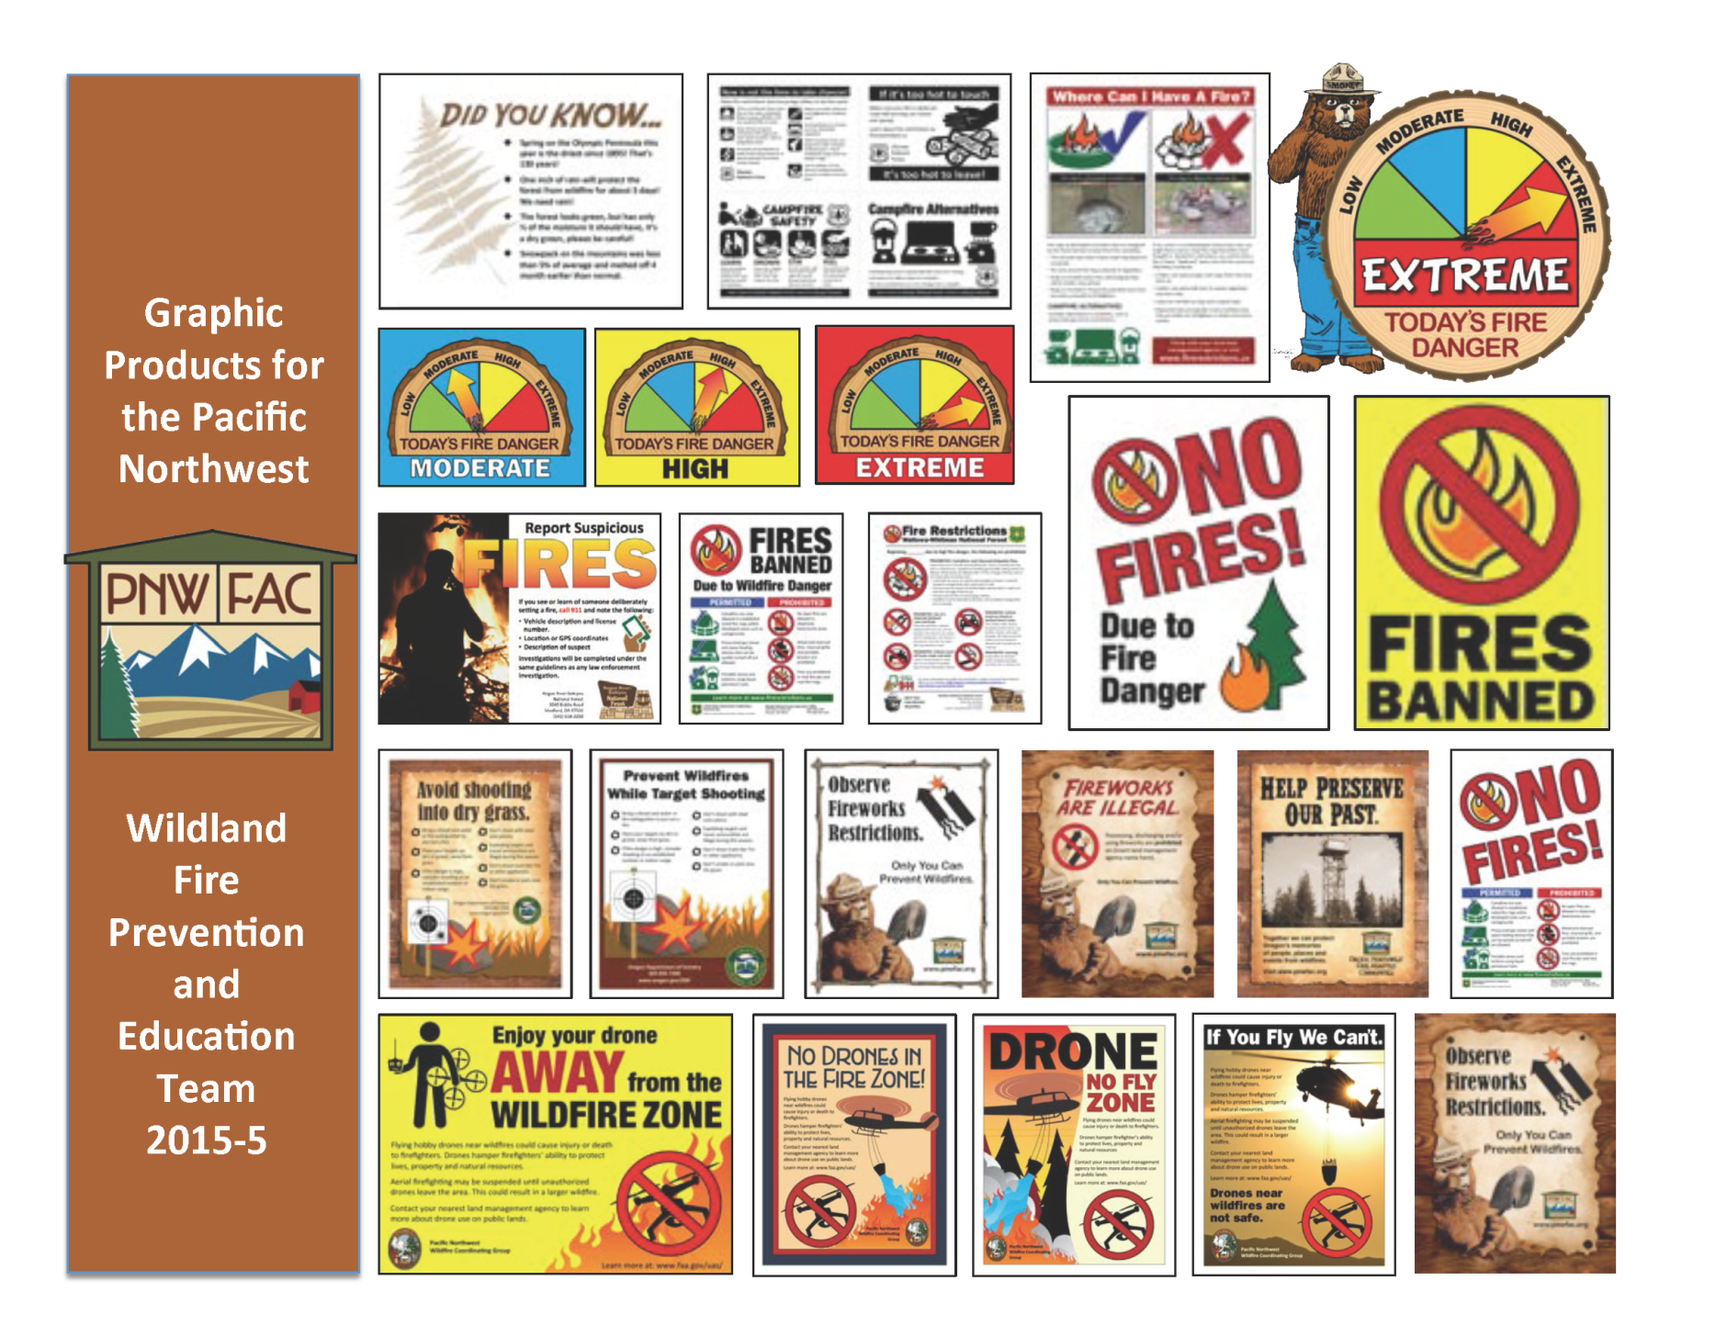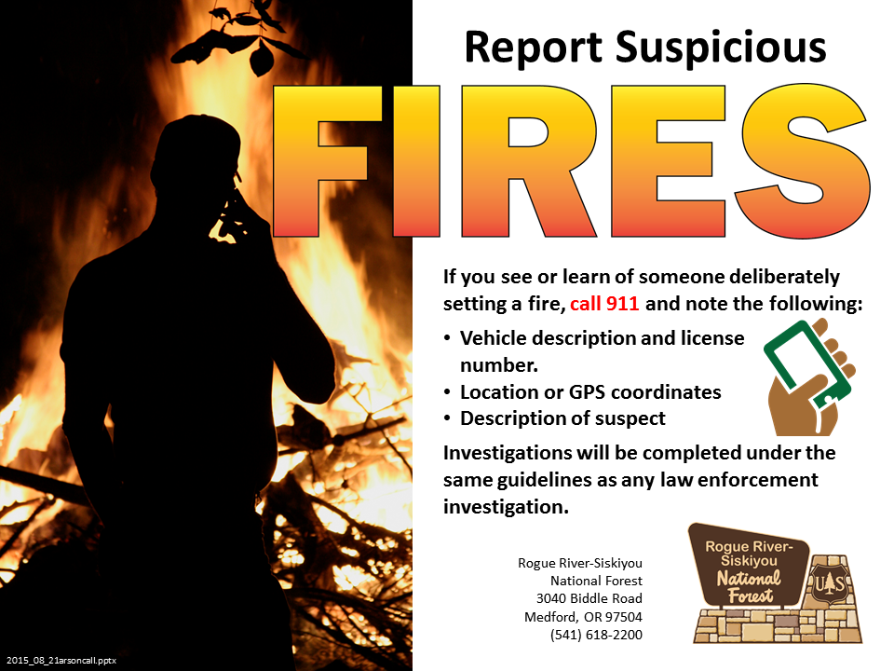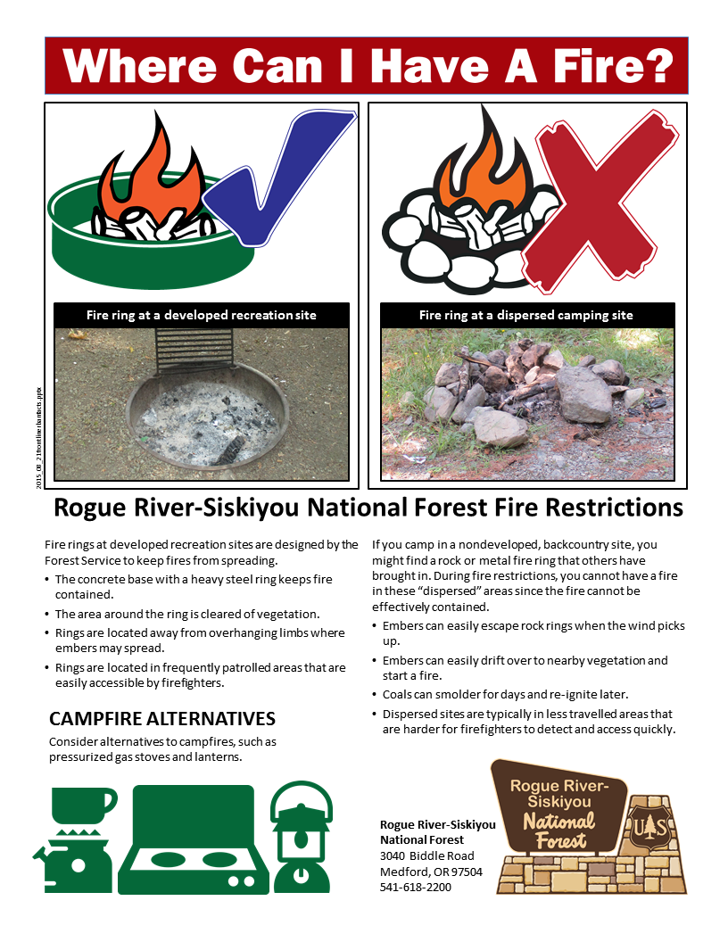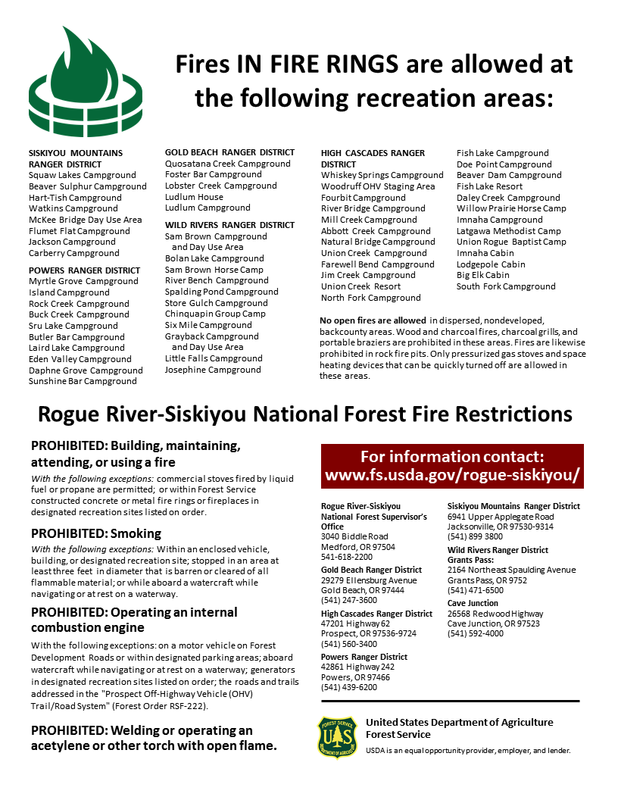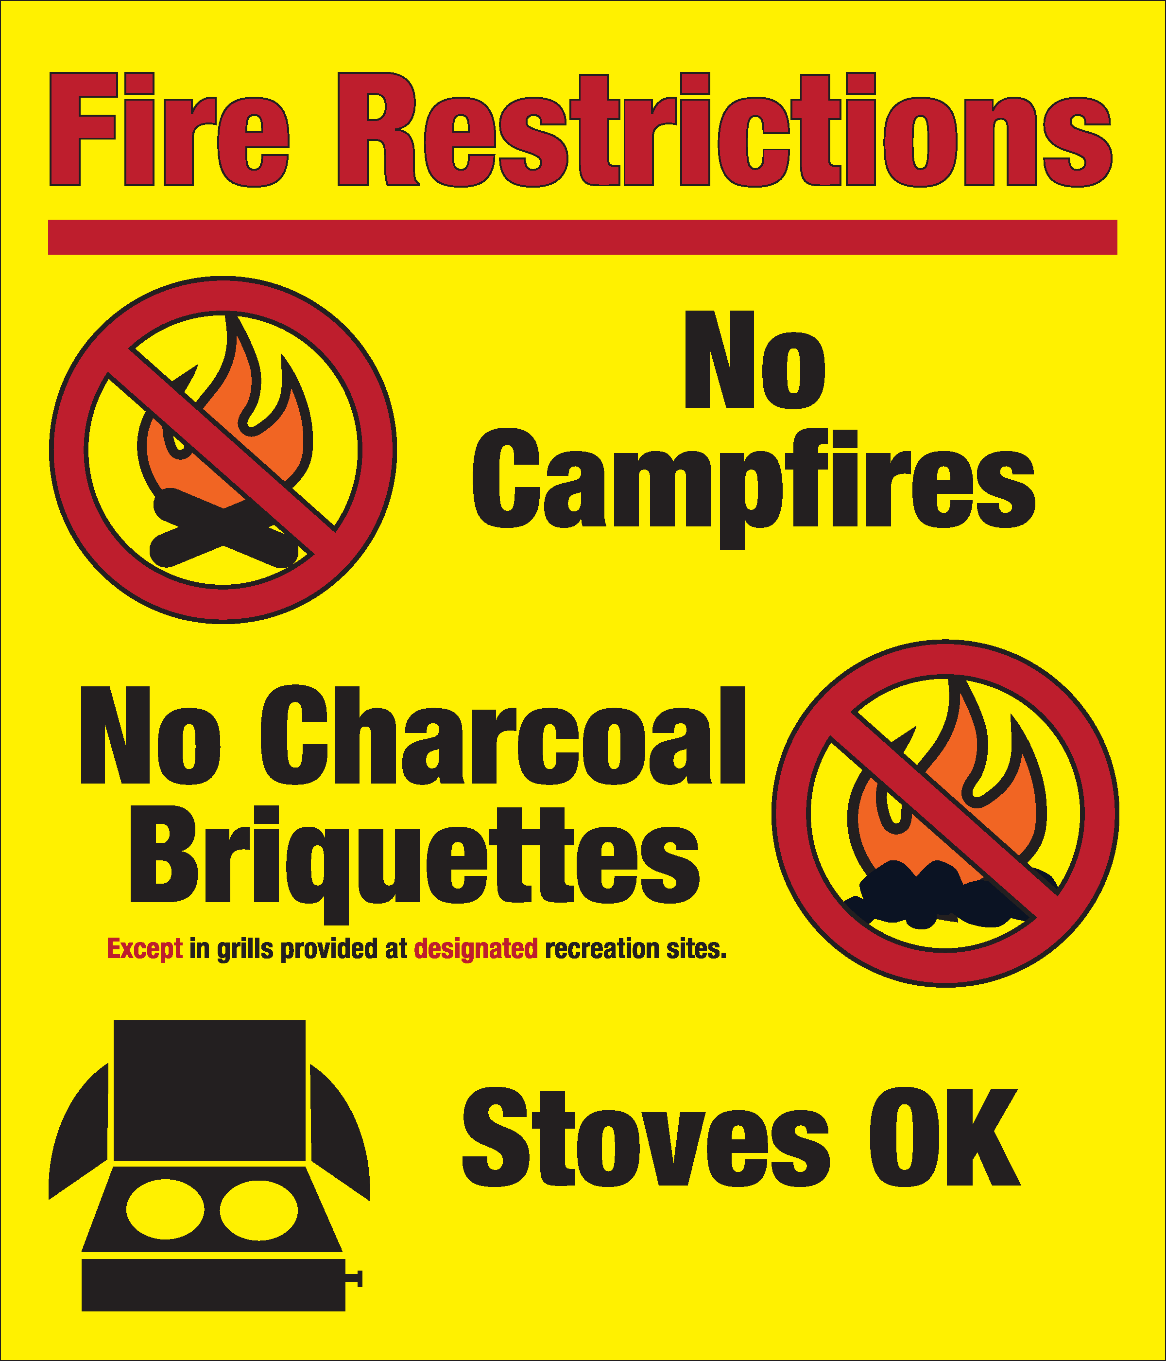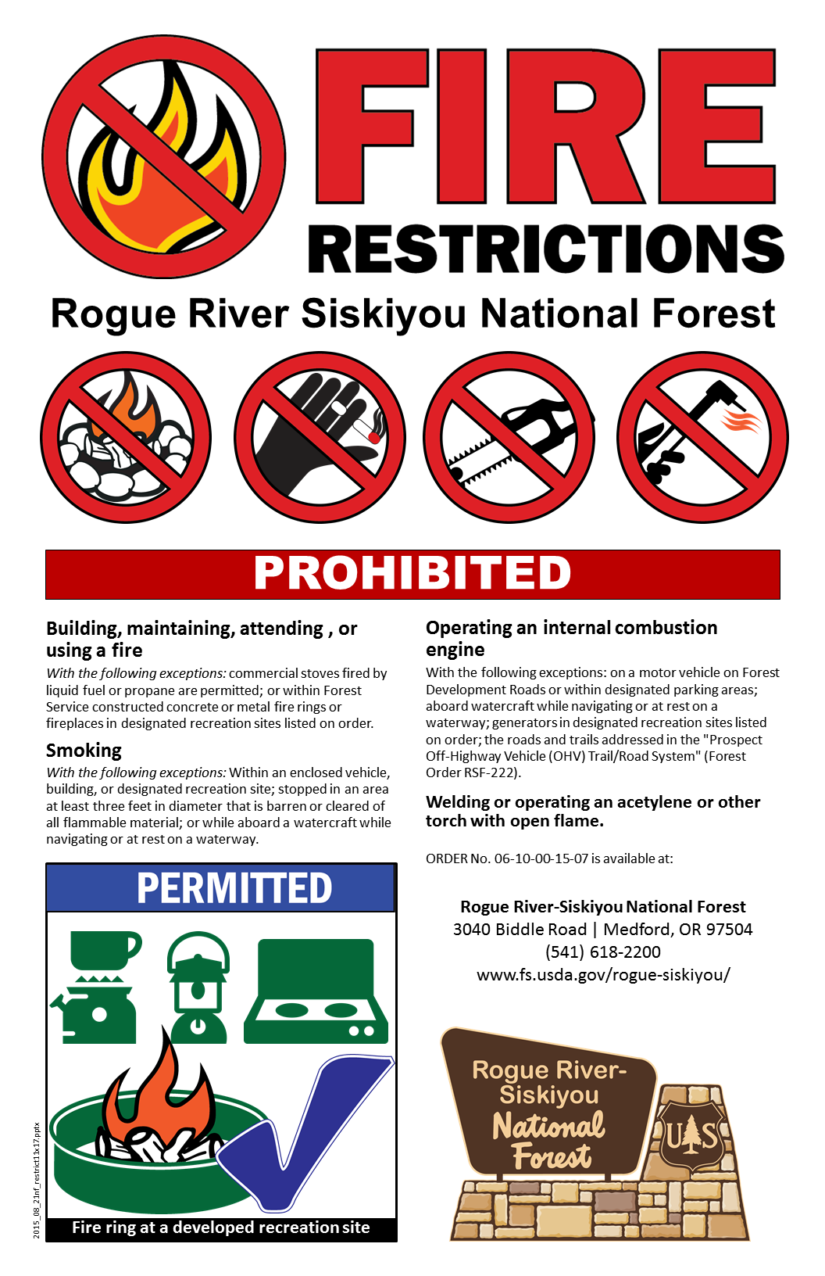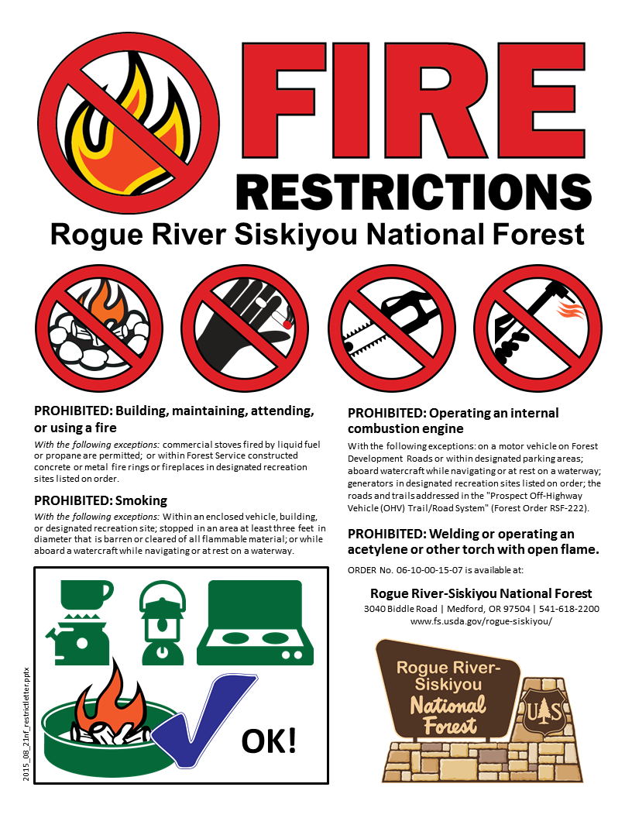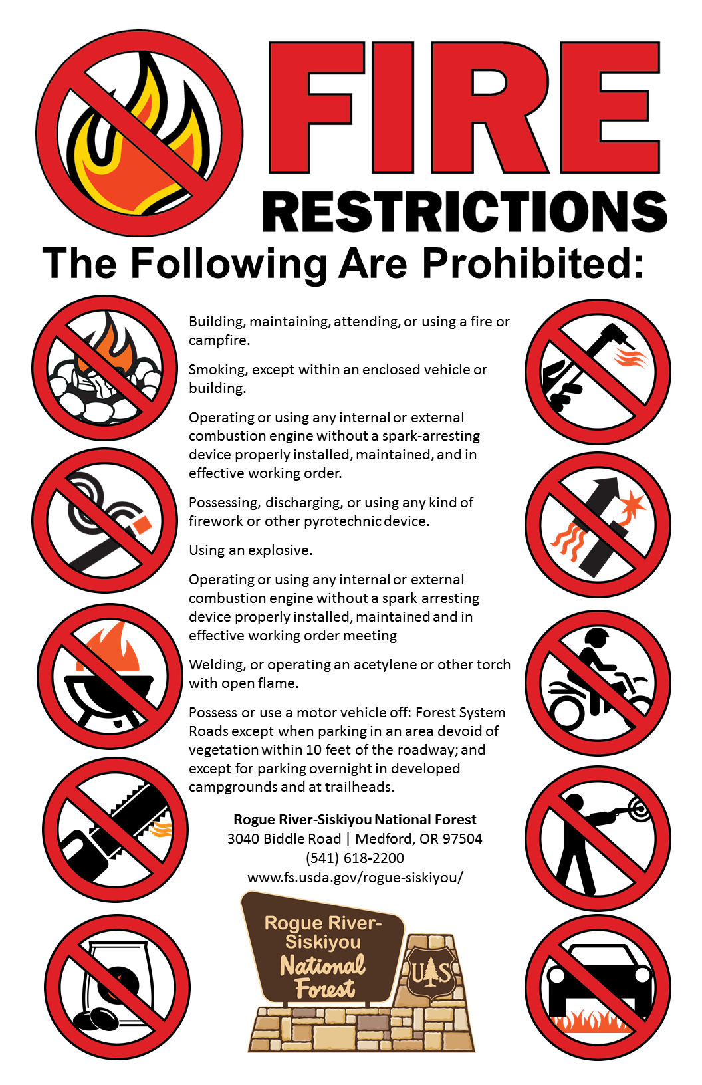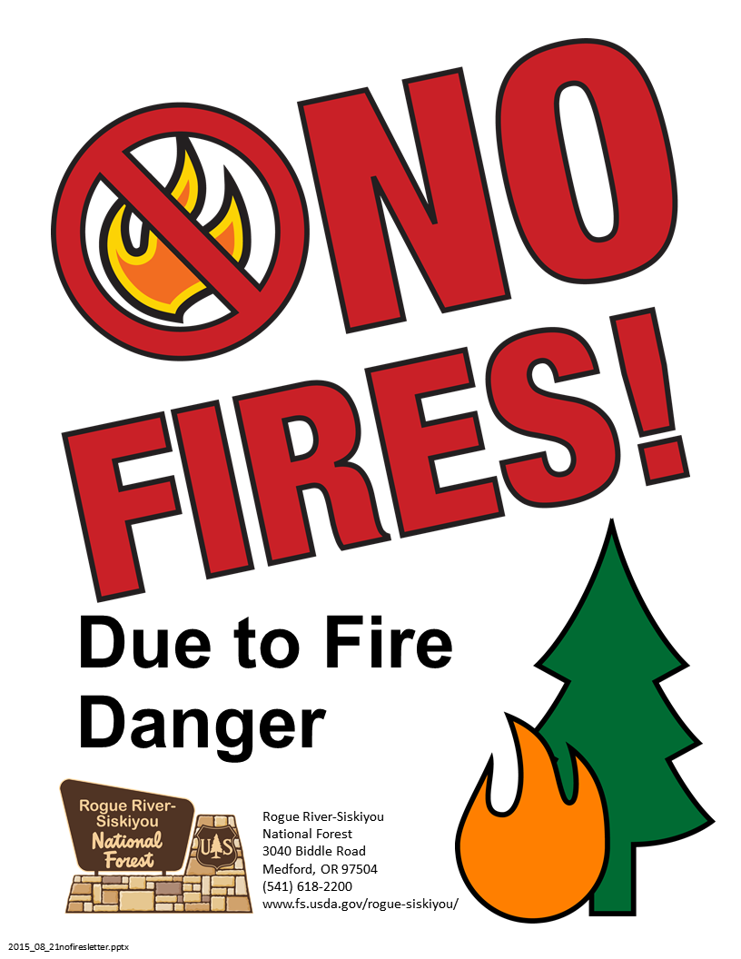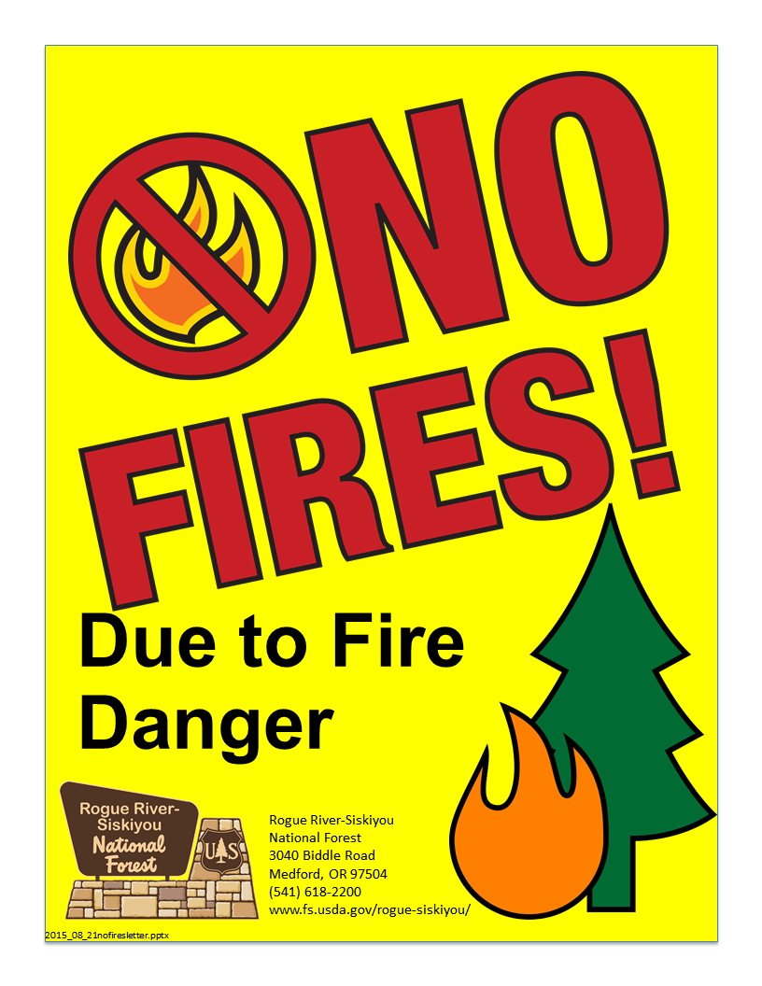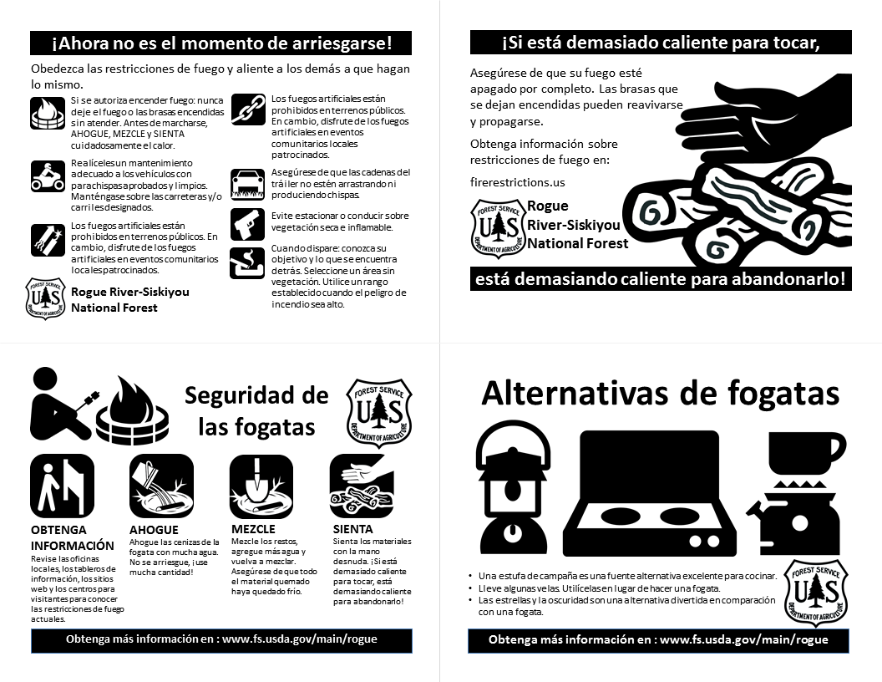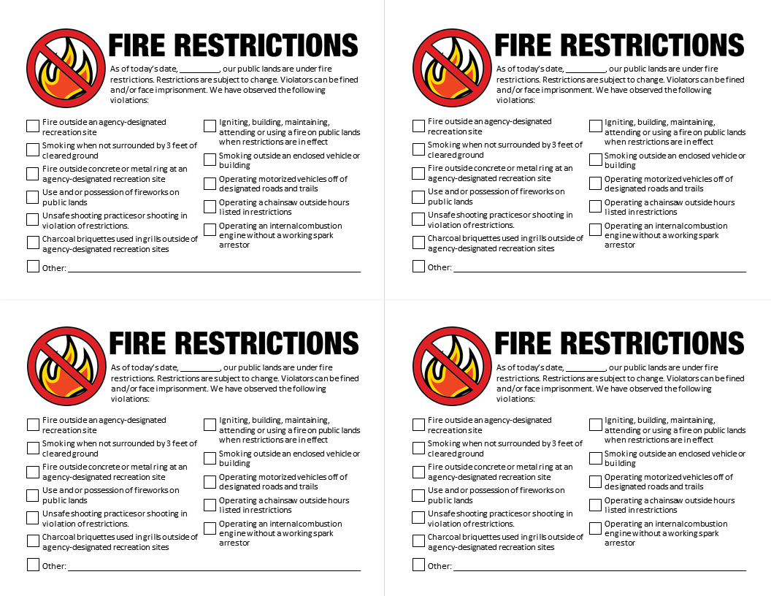

Appendix K – Sample Routing Form and Contact List

Action | FOREST ORDER ROUTING FORM  Responsible Official(s) | Initials / Date
Prepare proposed Order |  | _____________
Prepare enforcement plan | LEI with appropriate Staff input | _____________
Review proposed Order & approve enforcement plan |  | _____________
Approve Order | Forest Supervisor (Unless emergency, Deputy or Acting Should Not Sign) | _____________
Post Order (36 CFR 261.51) |  | _____________
Prepare news releases for Order, describing the order and management objectives. |  | _____________
Implement plan | Forest LEO, FPO’s and Prevention Techs | ______________
Complete Case File Filing  (Assigns number and distributes) |  | _____________
 | Respective Team Leader  REHLM  ADM  NRTL  FIRE | ______________

FSM 5353, R-6 Supplement 50, requires all Subpart B Orders include an explanation of the need for the order and an enforcement action plan

Agreements
___________________, 541-618-____

Contracting and Acquisition Management
Bradly Reed, Supervisory Contract Specialist, 541-618-2026

Forest Staff/Deputy Forest Staff Officer
_________________, Pacific Northwest Strategy Coordinator, 541-618-______

Fire and Aviation Management
Eric Hensel, Fire Staff Officer, 541-618-2100,
Syndy Zerr, Deputy Fire Staff/ Operations, 541-618-2101
Rob Budge, Deputy Fire Staff/ Fuels, 541-618-2102
Amanda Lucus Rice, Aviation Officer, 618-2104
Law Enforcement and Investigations
Javier Masiel, Patrol Captain, 541-618-2152

Office of the General Counsel
Beverly Li, Associate Regional Attorney, 503-808-5969

Public Affairs
Virginia Gibbons, Public Affairs and Staff Officer, 514-618-2113
Chamise Kramer, Public Affairs Specialist, 541-618-2050

Recreation, Engineering, Heritage, Lands & Minerals
Roy Bergstrom, Forest Staff Officer for Recreation, Engineering, Heritage , Lands and Minerals, 541-618-2061
___________________, Wilderness – WSR, 541-618-____
___________________, Developed Sites and Fee Demo, 541-618-____
___________________, Heritage, 541-618-____
Julie Martin, Forest Recreation Program Manager, 541-618-2066

Resources
Allen Hahn, Resources Staff Officer, 541-618-2050
David Krantz, Forest Planner, 541-618-2126

Appendix L - Coordination with Others

Suggestions of agencies and interests that need to be consulted may include:
  - Regional Office and adjacent National Forest System units
  - District Rangers and staff
  - Fire management staff and appropriate fire dispatch center
  - Other federal agencies (BLM, USF&WS, DOE, NPS, etc.)
  - Tribes
  - Researchers
  - Congressional members
  - State officials and land and resource agencies o Emergency Management Office
    - State parks
    - Transportation departments o State forester
    - Wildlife agency
  - County and city officials
  - General public
  - Private landowners
  - Commercial interests o Vendors
    - Chambers of commerce
  - Permittees and contractors o Grazing permittees o Oil and gas lessees
    - Special use permittees (utility, research, outfitter-guides, lodges, resorts, etc.)
    - Timber Sale contractors o Construction contractors o Service contractors
    - Supply contractors o Mining operators o Concessionaires
    - Cooperators and volunteers

Appendix M - Entry/Activity Permit Process and Sample Permit and Sticker

- Process
  - Any individual or organization needing to access closed portions of the forest for commercial or non-commercial purposes must have an entry permit and a numbered sticker.
  - The original entry/activity permit form must be given to the responsible party such as the private homeowner, special use permittee, range permittee, researcher, etc.
  - If there are several people who need entry/activity permits from the same organization/household, give the original entry permit and a sticker to the primary person responsible and initialed copies (in blue ink) of the original permit and stickers to all other authorized individuals. (Note: All license plate numbers must be listed on the original entry/activity permit.)
  - Entry permits must include one route of travel to and from the destination, the effective dates of the permit, sticker number(s), and a list of all other authorized individuals and vehicles (including license plate numbers).
  - Stickers must include valid dates, route of travel, and the name of the responsible individual/organization. (Note: All information on stickers should be written in black, permanent ink.)
  - Stickers must be placed in the top, center of the windshield facing out. Entry/activity permit must be kept with the responsible party or in vehicle for the duration of its effective dates.
  - Entry/activity permits for anywhere on the forest can be issued from any same forest district office. (Example: INSERT FOREST SPECIFC EXAMPLE.) This information should be shared between affected districts.
  - In order to receive an entry/activity permit, individuals/organizations need to provide the following documentation: photo identification or driver’s license (Note: driver’s license required for those operating a motor vehicle) and proof of residence (example: property tax records) or business operation (example: special use permit). All motor vehicles shall have approved spark arresters.
  - Each District Ranger must establish pre-approved criteria for issuing special use permits for specific uses that occur outside of normal activities. These are those uses such as University research/education, Game and Fish studies. An example of pre-approved criteria would be: a fire extinguisher, shovel, fire prevention plan.

- Approving Officials
  - Anyone authorized by the District Ranger may sign entry/activity permits.

USDA – Forest Service
Make Regional Form or Forest Form
NATIONAL FOREST ENTRY/ACTIVITY PERMIT
Pacific Northwest Region
R6-____-__ (_-__)

Permittee: |  | This National Forest, or portions thereof, are restricted or closed to public entry because of extreme fire danger.  Persons whose business requires them to enter, may be issued an entry/activity permit. The permittee is responsible for preventing fires and for reporting any fire he discovers. This permit is non-transferable.  The permittee may not smoke, use any fire or internal- combustion engine-driven vehicles or equipment while within this National Forest during the permit period except as provided in the conditions as stated below.  I hereby agree to the terms and conditions of this permit and will require all those in my party to do the same.  Permittee: Issued By: Title:
Address:
Auto License | Telephone:
Destination(s):
Route of Travel: (to and from)
Purpose of visit:
Permit valid  from: to: 20 |  | Forest: | District:
Conditions of this permit (vehicle and equipment use and inspection, fire tools required, spark arresters/mufflers, smoking and fire restrictions, watchmen, patrolmen, etc.)

The permittee is responsible for all other persons, employees, agents or contractors authorized to enter under this permit, if any (use separate sheet if needed).

Name: Name:

Address: Address:

Relationship: Relationship

The permittee, his/her party, employees, agents and persons under contract to him/her must comply with the terms of this permit. Violation of these regulations is punishable as a Class B misdemeanor, by a fine of not more than $5000 for an individual or $10,000 for an organization, or imprisonment for not more than six (6) months or both. 16 USC § 551, and 18 USC §§ 3559 and 3571.

This permit may be terminated at the discretion of the District Ranger

(Sample Vehicle Sticker)

Route of Travel/Destination
FOREST SERVICE ENTRY PERMIT
1291

Date

Appendix N - Signing

All forests are encouraged to use the UNICOR signs for the various fire ratings, closures and restrictions. These have been approved for use by the agency. If you need special signing, follow the region’s printing and purchasing guidelines.

The website for UNICOR is: http://fsweb.wo.fs.fed.us/eng/unicor/cover.htm

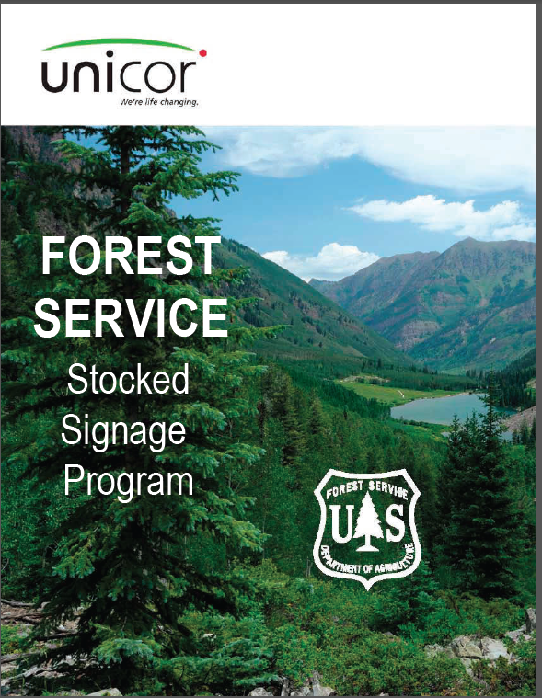

Appendix O - Fire restrictions and/or closures and the National Recreation Reservation Service

This is to assist in contacting customers and notifying NRRS that 1) a forest fire restriction and/or closure is going to be in effect and 2) the forest fire restrictions and/or closures are rescinded.
- Inventory and Points of Contact must by verified by the forest NRRS coordinator at the beginning of each calendar year.

- Administrative closures reflected by forest fire restrictions and/or closures shall be initiated by Points of Contact at the forest level or by the regional office.

- The forests must notify NRRS inventory as soon as the forest fire restriction and/or closure decision is made.

- Units must make sure that the forest fire restriction and/or closure actually closes specific campgrounds or other developed sites.

- If the unit prohibits use outside the site but allows use in the site to continue then that advisory must also be forwarded to NRRS.

- Forests must estimate the time that the forest fire restriction and/or closure is going to be in effect.

- Once the forest fire restriction and/or closure is rescinded, the forest must notify NRRS Inventory as that action occurs.

- Forests must estimate the number of cancelled reservations and provide estimates to the fiscal section that administrative charges will be incurred for each reservation cancelled per the Contract Line Items Number Charges. These are estimated to be approximately
$20 per cancellation.

- If there are customers that are affected, the Reserve America Customer Service staff will proceed with notifying each customer and re-booking them to another site or Field Location.

Appendix P – Sample Letters

Sample Letter for Agreement Notification

Re: Agreement No. _______________
Dear Cooperator:
This is to inform you that effective , the National Forest is under a Stage III Fire Closure. Based on the attached Special Order, we are stopping any further work authorized by the referenced agreement as of the date of the closure.

We will notify you in writing when the area/Forest closure is lifted. As necessary, we’ll renegotiate the terms of the agreements with you at that time. All agreed-to negotiations will be in writing as a modification to the agreement. In the event the closure adversely affects your ability to continue the project, you have the option to terminate the agreement in accordance with Clause .

If you have questions regarding this notification in terms of the project, please call the project manager , at _. If you have questions regarding the agreement, call the administrative contact, , at .
Sincerely,

Forest Supervisor
National Forest Enclosure

Sample Letter for Stage III
Fire Closure with Timber Sale Purchasers

Dear :
Enclosed is a copy of Interagency Order #

that implements a stage III fire

closure of the National Forest. Under this order no further operations will be permitted on the Timber Sale, contract # .

You will be notified when this closure order is rescinded.

If you have questions regarding this closure order, operations, or conditions on the Timber Sale Area please contact me or Forest Service Representative _.
Sincerely,

Contracting Officer
_National Forest Enclosure

Sample Letter for Oil and Gas Lessees
To all Oil and Gas Companies Doing Business on the _______ Ranger District
Dear Sir or Madam:
I would like to thank you for attending the fire meeting we held last week regarding possible fire restrictions and the affects these restrictions could have on your operations on the ______ Ranger District. As fire danger increases and as fire restrictions are placed upon the Forest, we decided that operations can probably continue with prior written permission for activities on the District. As restrictions go into effect, we will inform the various producers on the District as to what these restrictions entail and work with each operator on written permission and alternatives that may be needed to continue your operations. A great way to keep you and your employees informed is to look at the web site maintained by the Rogue River-Siskiyou National Forest at http://www.fs.usda.gov/rogue-siskiyou/.

I also need to remind you that the Forest Service and BLM pursue fire suppression costs for all human caused fires. The operator is responsible for the cost of suppressing all fires caused by their operation, and for all damage to any property of the USDA Forest Service or third parties. The Forest Service reserves the right to participate in extinguishing any fires cause by the operator and shall reimburse the Forest Service for the cost of all suppression activities ordered or directed by the Forest Service. I do not want to alarm you into not reporting fires or not informing us that a small fire occurred at your operating site and that your work force was able to suppress the fire, as all fires must be reported to the Forest Service, I just want to let you know that you are responsible for costs in suppression of fires if the fire is caused by your operations.

I would like to ask that you keep the District informed as to when you move in drill rigs, completions or workovers this fire season. This will help our fire suppression forces know where industry activity is occurring which will help provide safety for your personnel working in the field in the event of a fire. I do not want to make this a formal process but if you could just give the office a call and let ________________ know when and where you are moving a rig and expected length of stay, that will be sufficient. In addition, we now have e-mail capability at the office and you can also e-mail __________ to let her/him know of your plans.

_______________________@fs.fed.us

Enclosed are guidelines that we will use by the different levels of fire restrictions. Please remember that there may be more needed in certain fuel models but we think this ought to work for 90% of your operations.

I think we made some great strides at this meeting and again I would like to thank you all for attending. In addition, my staff is also available to help you in briefing your crews or sub contractors regarding fire severity and restrictions if any are in place. If you have any questions, please give myself, __________ or ___________ a call at (541) ___-____. We look forward to working with you and hopefully we will have a safe and normal fire season.

Sincerely,

__________________
District Ranger Enclosures
cc: SO
BLM FMO
FMO

Fire Restriction Levels and Fire Precaution Needs for Oil and Gas Operations
on the ___________ RD

Level 1 - ERC < 38 Normal Operations, no extra fire precautions needed.

Level 2 - ERC 38-74 This level usually restricts campfires and smoking to campgrounds and picnic areas only.

In addition to your normal operating procedures:

- Crew briefings on fire precautions and fire suppression.
- Designated smoking areas only to approved on-site locations as designated by the crew supervisor or in vehicles.
- Fire suppression tools and extinguishers are available at all work sites and in vehicles.
* A person has been designated as a fire guard and or scout during working operations. This can be a general worker or immediate supervisor on the job site. No extra personnel is required under this level of restriction.

Level 3 - ERC 74-82 This level usually restricts all smoking, campfires, and chainsaw use during certain hours and various heavy equipment working in the woods.

In addition to those listed in level 2 restrictions, operations must include:

- Smoking only inside vehicles or at well sites.
- Prior approval by the _________ District Ranger must be obtained for such activities such as welding, clearing, flaring, and chainsaw use. We anticipate that this will be a verbal authorization followed by written approval either in a formal letter form or e-mail.
- Operations such as road grading, rock crushing, road surfacing, and other operations occurring on mineral soil may continue without approval by the District Ranger.
- 80 barrels of fresh water will be available for fire suppression and a minimum of 300 feet of 1 1/2 inch hose with nozzle will be available at work locations.

Level 4 - ERC 83+ Restrictions include Forest closure In addition to Level 3 restrictions,
- A fire guard or scout will be designated for all operations. This person's job will be detached from the normal work operations and their entire job will be to act as a fire guard/scout. This scout will remain on the job site for a minimum of one hour after all work has been completed for the day.
- The District Ranger or the District FMO will contact the producers to inform them of the fire severity level. Some considerations that companies will be asked is to see if there are other work alternatives that might be accomplished or possible delay some operations until the fire severity lessens. Some alternatives might include, night operations when temperatures are lower and the humidity is recovering, etc.
- Written approval is required from the Carson National Forest Supervisor. Please initiate that request through our office and we will initiate the approval from the District office. This may take an extra 3 or 4 days to gain prior approval, as this request is not delegated down to the District's authority.

Level 5 - ERC 83+ Restrictions include Forest Closures.

Level 5 has the same ERC levels plus incorporates other factors such as storm fronts approaching with associated high winds, many fires going on within the immediate area and fire suppression resources are scarce, other significant factors that might affect fire behavior.

- Same as level 4.

Emergency phone numbers and to report a fire:

___________ Ranger District (5415) ___-____ Office Hours 8:00 to 4:30
Emergency 911
_______ Dispatch (541) ___-____ Office Hours ______ to _____
BLM _______District (541) ___-____ Office Hours 8:00 to 4:30

