**Indian Land Cessions Map Image and Ancillary Geospatial Data Files**

April 15, 2013, M.Martischang, US Forest Service – Eastern Region, mmartischang@fs.fed.us

Indian Land Cessions Map images are downloaded as files in JPEG2000 format from the Library of Congress (LOC) and carry the extension “*.jp2”. Out of the 67 Royce Cessions Maps that LOC scanned, 54 loaded into and displayed in ArcMap in their original *.jp2 file format. These 54 *.jp2 image files were georeferenced and, as a result of the georeferencing and basic metadata processes, now have four other ancillary files associated with them. GIS software uses these four other associated files, along with the image file, to make the images geospatially aware and useable in GIS software with other thematic data layers. The graphic below identifies each of five files in a georeferenced and complete “family of *.jp2 related files”:

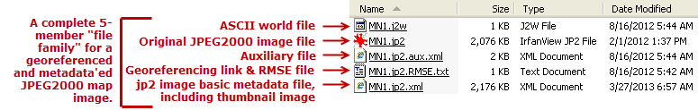

The 13 *.jp2 map files that did not display in ArcMap were converted to simple JPEG (extension *.jpg) format (quality set at “85”) and then loaded, displayed, and georeferenced in ArcMap. This conversion resulted in enlarging a file-family from five to seven members as illustrated in the graphic below (bare minimum metadata was populated on the *.jp2 image; complete metadata was populated on the georeferenced *.jpg image):

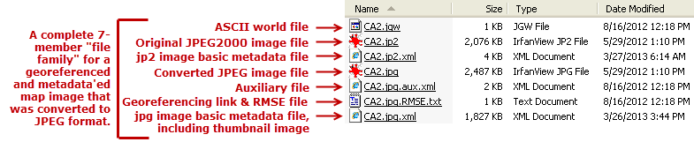

**Copying or Sharing These Image Files:**

*.jp2 image files are just as they were when originally downloaded from LOC and can be viewed/printed using any image viewer that can open JPEG2000 format files. If someone just wants the picture, not for georeferenced use in a GIS, then the *.jp2 and/or *.jpg file is the only file that need be copied or transferred. However, if someone is seeking to use the image as georeferenced and in combination with other thematic layers in a GIS, the entire 5‑ or 7-member family of files must be copied or transferred.

**Viewing JPEG2000 Image Files:**

Just about any kind of software on a PC these days can open JPEG (extension *.jpg) images, however, few can open JPEG2000 (extension *.jp2) images. *.jp2 images use a more recently developed and higher performance image compression and re-sampling algorithm that is by and large unsupported by the mainstream image software industry (including Adobe Photoshop). ArcGIS software recognizes the format, but then again, few people have ArcGIS loaded on their PCs, especially for use as just an image viewer. LOC suggests, among a couple other viewers, acquiring the extremely versatile “IrfanView” (<http://www.irfanview.com/>) software as a mainstream freeware image viewer that can be downloaded and installed on a PC making it possible to open *.jp2 files (and just about every other image file format known to exist). Most GIS persons have IrfanView on their PCs and could be consulted to help with viewing, printing, and/or converting *.jp2 files to more common image formats (*.png, *.jpg, *.tiff, *.gif, *.bmp, etc.). At the LOC Indian Land Cessions site JPEG2000 is the only image file format the Royce Cession Maps can be downloaded in.

(continued)

**How to Reload the Link Table to Examine and/or Improve Upon Link Points, Transformation, and RMSE:**

After each Cessions Map was georeferenced Link Table data were saved at the same filing location as the map imagery in ascii files with the double-extension of “*.RMSE.txt”. Reloading this original 1st order (affine) transformation link data for a given map could help with future accuracy assessments or provide a starting point for adding additional link points to achieve more spatially accurate 2nd or 3rd order transformation and rectifications (e.g., as preparation for digitizing Cession polygons). To reload link and transformation data, open the “georef_CessionMaps.mxd” and make sure you have the “Georeferencing” toolbar loaded to your ArcMap session:  . Then click on Add Data  and choose one georeferenced map image (e.g. AL.jpg). The image will load georeferenced to the state boundary vectors. It will also be listed in the Layer dropdown box of the Georeferencing toolbar and all the georeferencing tools will be active:  . From the Georeferencing toolbar click on the Link Table tool:  . An empty Link Table will open. Click on the Load… button in the lower left corner of this window and a file navigation window will open. Navigate to where the “AL.jpg.RMSE.txt” file is stored and select it. The link points used to georeference the image will load and be listed as well as indicated on the map with red and green crosshair markers.