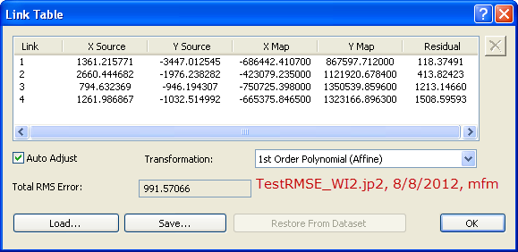

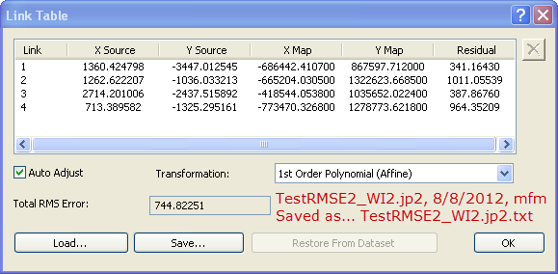

**Content of TestRMSE2_WI2.jpg.txt:**

1360.424798 -3447.012545 -686442.410700 867597.712000

1262.622207 -1036.033213 -665204.030500 1322623.668500

2714.201006 -2437.515892 -418544.053800 1035652.022400

713.389582 -1325.295161 -773470.326800 1278773.621800