Directions for Posting Data to
ftp.nifc.gov
04/04/06
Background
Ftp.nifc.gov has been established as an official posting site for interagency wildland fire incident support. This single site provides a focal point for incidents and to download data where available, upload incident relevant data (such as remotely sensed images and incident GIS data), as well as share incident information for decision making with interagency partners such as Active Fires (www.activefires.net) and GEOMAC.

The ftp site is hosted at the USDA National Information and Technology Center (NITC) in Kansas City, Mo.

The NWCG Information Resources Working Team (IRMWT) has established a Task Group in order to provide interagency direction and support. This FTP Task Group has been instrumental in establishing this system, and will continue to provide long term coordination and oversight. For more information please contact: Cladys Crabtree: Task Group Chair– 208-387-5214, or Dale Guenther: Support and Planning – 503-808-2188.

Procedures for Accessing the site
A password will be necessary to upload information to the site, but one is not needed to download data (anonymous). The site is design that each subject area (Predictive Services), or for incidents each Geographic Area Coordination Center (GACC) has the ability to manage their own directory.

Each subject area and GACC has designated a representative to provide their username and passwords for the calendar year. To access the Username and Password for your GACC during refer to the contact list below. The list of GACC contacts are a combination of Intelligence Coordinators at the GACC offices, and GIS Coordinators from the Geographic Area.

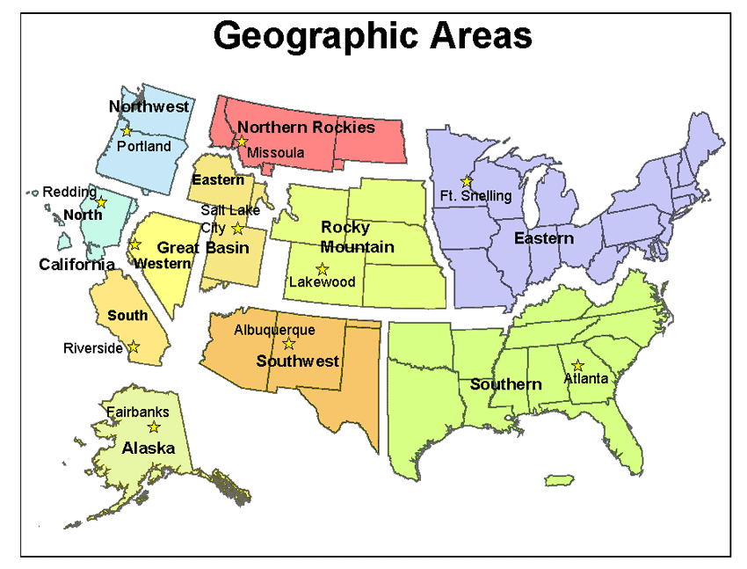

Subject Areas
Subject Area | Contact | Phone | Email
Predictive Services | Robyn Heffernan | (208)387-5874 | robyn_heffernan@nifc.blm.gov

Geographic Area Coordination Center (GACC)
GEOGRAPHIC AREA | CONTACT | PHONE | EMAIL
ALASKA | Sean Triplett | 907-356-5587 | sean_triplett@blm.gov
CALIFORNIA NORTH ZONE | Corey Ferguson | 916-640-1049 | cferguson@fs.fed.us
CALIFORNIA SOUTH ZONE | Bruce Risher | 951-276-6721 | brisher@fs.fed.us
EASTERN | Steve Marien | 612-713-7322 | stephen_marien@nps.gov
GREAT BASIN EAST | Deb Hamill | 801-531-5320 | dhamill@fs.fed.us
GREAT BASIN WEST | Randy Dzialo | 775-861-6450 | Tandy_dzialo@nv.blm.gov
NORTHEN ROCKIES | Julie Polutnik | 406-329-4995 | jpolutnik@fs.fed.us
PACIFIC NORTHWEST | Kim Kelly | 503-808-2741 | kim_kelly@blm.gov
ROCKY MOUNTAIN | Marco Perea | 303-445-4303 | marco_perea@blm.gov
SOUTHERN | Renee Jacokes | 404-347-2588 | rjacokes@fs.fed.us
SOUTHWEST | Jay Ellington | 505-842-3874 | jayellington@fs.fed.us

Filing

The suggested method for accessing the ftp server is using ftp client software. Each agency supports commercial ftp software. Contact your friendly agency IT staff for instructions using this software. Access to this ftp site may be through an Internet Explorer browser as well.

Technical Issues

Requests are made via telephone or e-mail during staffed business hours:
1-800-253-5559 or 208-387-5290
FAX: 208-387-5292
fire_help@dms.nwcg.gov
Emergency requests are made via pager during non-staffed business hours at 1-800-253-5559.

Staffing Levels
The National Information Systems Team, shall provide first level support requested through established support channels during staffed business hours and via 2 hour call back outside of staffed business hours.
The F&AM Applications Helpdesk is staffed Monday through Friday 0730 to 1700 mountain time, excluding holidays.

Compliance Service Goal
Respond to 90% of support calls within 2 hours during staffed business hours.

Directory Structure

INCIDENT_
SPECIFIC
ALASKA
PACIFIC_NW
ROCKY_MTN
2006_BLOSSOM
ICS_GENERAL_
STAFF
SOUTHWEST
SOUTHERN
CALIF_N
GREAT_BASIN_W
GREAT_BASIN_E
EASTERN
CALIF_S
N_ROCKIES
GIS
BASE_DATA
DOCS
INCIDENT_DATA
TOOLS
PRODUCTS
DATE
(MMDDYYYY)
WFSA/MMA
FINANCE
OPERATIONS
LOGISTICS
PLANNING
BASE_INFO
FIRE_
PLANNING
FTP_SITE_POC
PREDICTIVE_
SERVICES

BASE_INFO
STATE_DATA
TOOLS
HISTORIC

