August 22, 2017
Suppression Repair:
Suppression repair map built and is located in the X:\2017_Blanket_Creek\projects and X:\2017_Spruce\projects.
Information received for suppression repair has been given in the form of handwritten edits on hardcopy maps, gps tracks and points. In addition, drawings on the map to identify locations that have been repaired or in need of rehab work.
As of August 22, 2017 the following total miles of rehab have been completed for each agency based on what has been received by READ’s:
Blanket Fire: (Suppression_Repair_Rehab_Blanket.xls)
X:\2017_Blanket_Creek\incident_data\SuppressionRepair\data_exports\Excel\Suppression_Repair_Rehab_BLANKET.xls
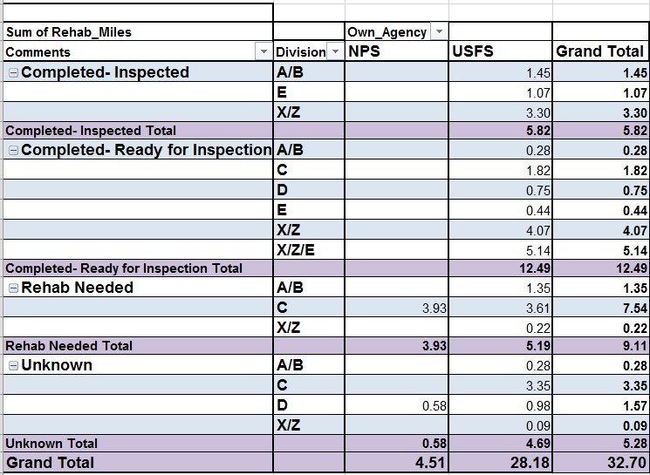

Completed- Inspected: 5.82 miles
- NPS: 0 miles
- USFS: 5.82 miles
Completed- Ready for Inspection: 12.49 miles
- NPS: 0 miles
- USFS: 12.49 miles
Rehab Needed: 9.11 miles
- NPS: 3.93 miles
- USFS: 5.19 miles
Unknown: 5.28 miles
- NPS: 0.58 miles
- USFS: 4.69 miles

Spruce Fire: (Suppression_Repair_Rehab_SPRUCE_082117.xls)
X:\2017_Blanket_Creek\2017_Spruce_Lake\incident_data\SuppressionRepair\data_exports\EXCEL\Suppression_Repair_Rehab_SPRUCE_082117.xls
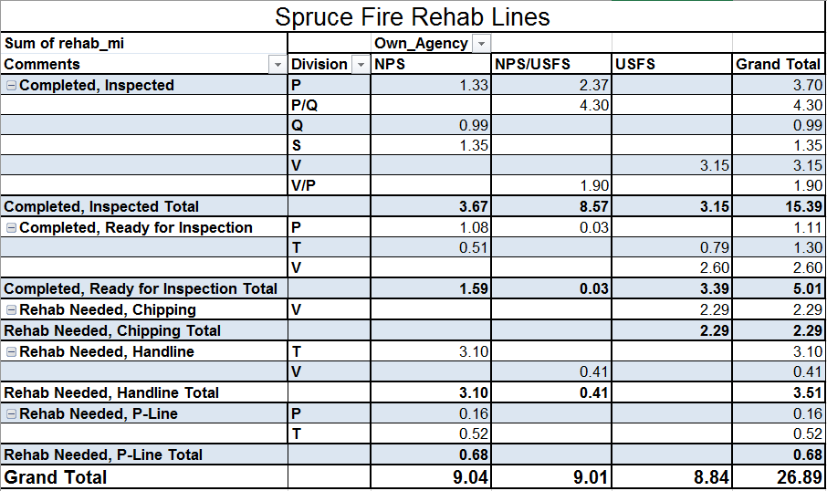

Completed- Inspected: 15.39 miles
- NPS:3.67 miles
- NPS/USFS: 8.57 miles
- USFS: 3.15 miles
Rehab Needed: 6.48 miles
- NPS: 3.78 miles
- NPS/USFS: .41 miles
- USFS: 2.29 miles

Broken Lookout:
As of 8/21/2017 two data points have been received by field observers noting a road washout and needed road chipping.

***The following information for suppression repair maps can be found at the following locations:
*Data for Blanket Suppression Repair can be found under:
- X:\2017_Blanket_Creek\projects\Blanket_SUPPRESSION_REPAIR.mxd
  - Shapefiles for the listed suppression repair map are located under the following folder:
    - X:\2017_Blanket_Creek\incident_data\SuppressionRepair
      - Data includes READ and FOBS field data
        - X:\2017_Blanket_Creek\incident_data\SuppressionRepair\
*Data for Spruce Suppression Repair can be found under:
- Shapefiles for the listed suppression repair map are located under the following folder:
  - X:\2017_Blanket_Creek\incident_data\SuppressionRepair\
    - BrokenLookout_Suppression_Repair_topo_ortho_36x36_land_20170821_OR_CLP_0004531.mxd
    - X:\2017_Blanket_Creek\incident_data\SuppressionRepair\data_exports\spruce_rehab_points.shp
    - X:\2017_Blanket_Creek\incident_data\SuppressionRepair\data_exports\spruce_rehab_lines.shp
*Data for Broken Lookout Suppression Repair can be found under:
- X:\2017_Blanket_Creek\2017_Spruce_Lake\projects
    - BrokenLookout_Suppression_Repair_topo_ortho_36x36_land_20170821_OR_CLP_0004531.mxd
    - X:\2017_Blanket_Creek\2017_Spruce_Lake\incident_data\SuppressionRepair\Broken_Lookout

