Incident Name:  Jolly Mountain  WA-OWF-000361 | IR Interpreter(s):  Tina Rotenbury  trotenbury@fs.fed.us | Local Dispatch Phone:  CWICC  509-415-3320 | Interpreted Size:  916 acres  Growth since last IR Perimeter:  278 Acres
Flight Time:  0148 MDT  Flight Date:  08/22/2017 | Interpreter(s) location:  Russellville, AR  Interpreter(s) Phone:  479-886-0878 | GACC IR Liaison:  Jim Grace  GACC IR Liaison Phone:  541-771-4521 | National Coordinator:  Tom Mellin  National Coord. Phone:  505-301-8167
Ordered By:  Sonya Feaster, SITL  520-349-6550 | A Number:  A-20 | Aircraft/Scanner System:  N144Z / Phoenix | Pilots/Techs:  Pilot: Ramsey Pilot: Boyce Tech: Kaz
IRIN Comments on imagery:  Imagery was good. |  | Weather at time of flight:  Clear | Flight Objective:  Map Heat Perimeter/Isolated, Scattered and Intense Heat Sources
Date and Time Imagery Received by Interpreter:  08/22/2017 – 0156 MDT |  | Type of media for final product:  Shape files, KMZ, PDF, and IRIN Log  Digital files sent to: NIFC FTP @  ftp.nifc.gov/incident_specific_data/pacific_nw/2017_Incidents_Washington/2017_Jolly_Mountain_WAOWF_000361/IR/20170822
Date and Time Products Delivered to Incident:
08/22/2017 – 0450 MDT
Comments /notes on tonight’s mission and this interpretation:

Started with pervious IR shift perimeter from 8/21/2017
Some growth on the northwest perimeter with intense heat with isolated heat just outside perimeter
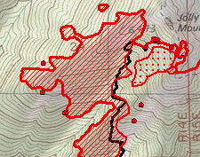
Intense heat on the south perimeter with some perimeter growth on the south edge of fire.
Areas of scattered heat and isolated heat sources within the perimeter.
Small perimeter to the east has isolated heat source outside perimeter.
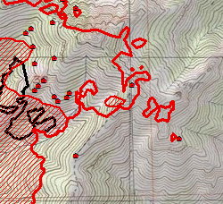

Smaller perimeter to the North has several more isolated heat sources detected.

