# Road 11 Fire

WA-WFS-000101

July 2020

## Executive Summary

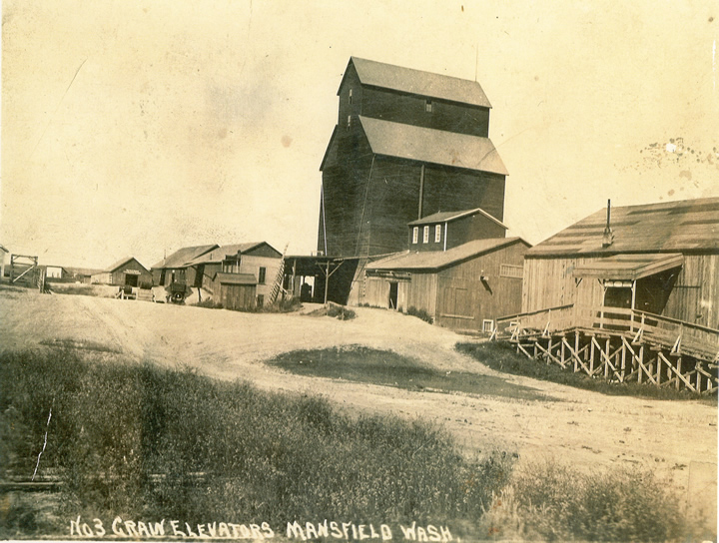

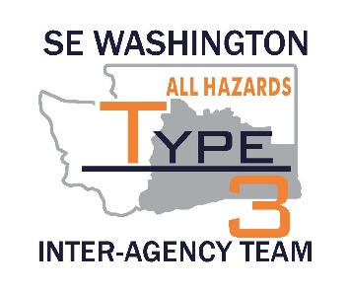

Bob Gear Dale Jordan Tyler Caille

SEWA-IMT-3 Fire Chief Fire Chief

INCIDENT COMMANDER Douglas Co. 1 Douglas Co. 5

Douglas Johnson

#### Objectives

* Provide for firefighter and public safety at all times. This includes the application of the “10 and 18”, LCES, and the Risk Management Process.
* Fight fire aggressively to limit acreage burned while providing for firefighter and public safety.
* Maximize opportunity for cost saving without jeopardizing public or firefighter safety.
* Maintain best management practices to limit the spread and exposure of the COVID-19 virus within the crew, on the line, in camp, and to the surrounding community.
* Act professionally and in a manner that fosters good relationships with the public, private landowners, elected officials and other stakeholders.
* Follow agency policies at all times and respect the policies of the host agency.

**Opening Statement**

On July 11, 2020 SEWA IMT 3 (Team 3) was mobilized to manage the Road 11 fire Southwest of the town of Mansfield Washington in the Douglas County. The fire had been managed very well by local resources prior to our arrival.

Team 3 received an in-brief at 2200 on July 11, 2020 at the Incident Command Post (ICP) at the Mansfield School and a Delegation of Authority was created by the local team and signed by both the agency representatives and Bob Gear the Incident Commander of the team. Team 3 assumed command of the fire at 0800 hours on Sunday, July 12, 2020.

Priorities were placed on protecting the values at risk to the north and west of the fires, including realizing the trigger point for evacuation of the town of Mansfield. Strike teams were assigned to the line as they arrived and were briefed on the line by their line supervisors.

Agency Administrators, Agency Representatives, and Cooperators were all very engaged and present during this incident. This enabled Team 3 to be much more successful during our stay here.

On Wednesday, July 15th at 0800 the Road 11 Fire delegations of authority was rescinded and the fire re-delegated to the local agency. 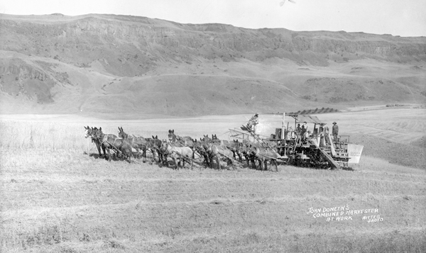

**COMMAND**

The “Road 11” fire started while the region preparedness level was at 2 meaning there were was a low level of initial attack and none too few large fires. Orders were placed for a total of 10 engine strike teams, three type 2IA crews, one type 1 crew and 1 type 2 dozer. For unknown reasons only 2 type 2IA of the three requested crews were dispatched. A request was placed to State Mobilization to determine what happened in the ordering process, which has not been answered at this time. The T1 crew was eventually dispatched on the evening of 7-12 worked half a shift on 7-13 and was then re-assigned to a new fire start outside the City of Wenatchee.

Weather, with wind gusts to 40 mph, carried the fire from initial attack through the evening of July 12th. However from an overall management standpoint lack of cell phone coverage and WiFi coverage caused problems in ordering and tracking resources, as well as some issues associated with radio coverage from the command post to the field.

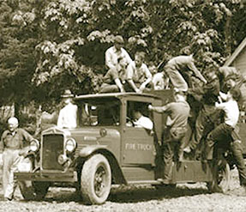

Holding onto the fire through the wind on July 12th and working through the communication issues.

Building plans and maps without WiFi was a challenge but the team, specifically the Planning section, did a good job of overcoming the challenges and getting plans and maps out.

The community and the agencies we worked for were extremely supportive and specifically the agencies, fire DOT and law were extremely engaged and provided valuable and timely feedback throughout the incident.

In summary this was a short assignment that went well. The local agencies were obviously very familiar with large fires and the mobilization process and their responsibilities. The transition process went well and much assistance was provided to the team to start off well.

#### Safety

On Saturday July 11, 2020 SEWIMT#3 was mobilized to the Road 11 Fire. One (1) ALS Ambulance Line Ambulance (Ballard) was utilized for 24 hour line coverage. One (1) BLS Ambulance (Douglas #5) was utilized for camp and to assist if needed on the line.

COVID mitigations were used throughout the incident utilizing the National Wildland Fire Response Plans and the Pacific Northwest IMT COVID Response Plan. The Douglas County Emergency Management was used to initially supply the incident with hand sanitizer and face masks. The Douglas County Health District was notified at 0900 hours on Sunday July 12 regarding the fire situation, camp size, and mitigation measures that were put in place.

The main challenge identified to use improvement was the transitioning of IA resources and check in of those resources. Ensuring a supply of masks, hand sanitizer, along with limiting the number of people at one time will be utilized during future transitions.

No accidents or injuries occurred during this incident.

***Information***

Information Section responded with the management team Saturday evening, hit the ground running coordinating with media outlets in regards to Team 3 assuming command of the fire. The section maintained communications with media individuals throughout the fire, with twice daily updates, participated in several interviews with individual radio, television, print and online newspapers and provided information on fire conditions, evacuations and road closures to the local residents and public.

Staffing:

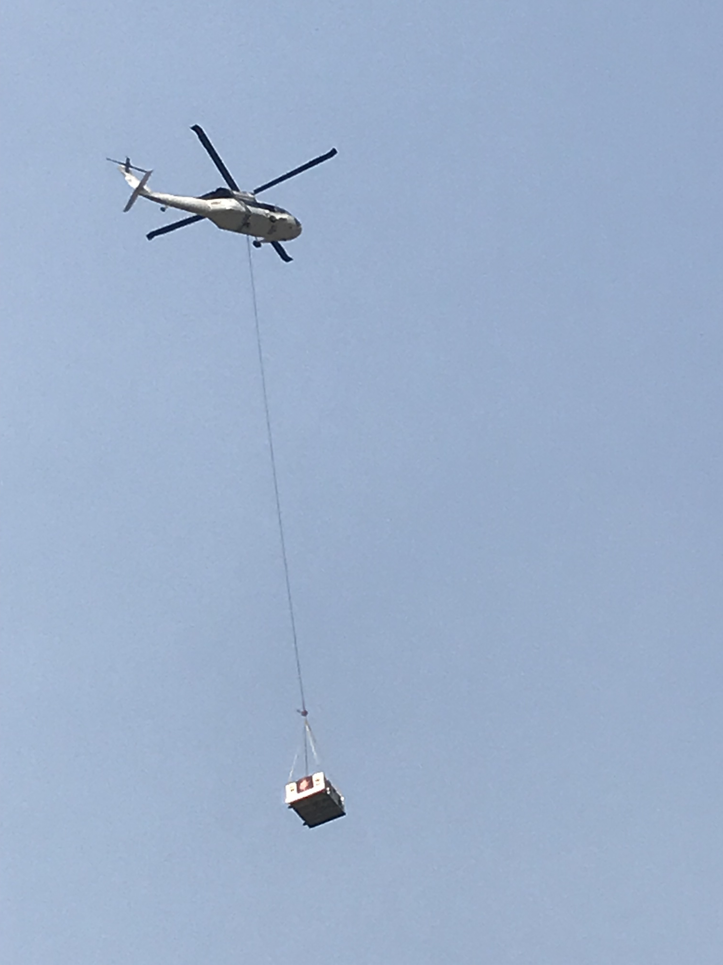

Ben Shearer, PIO2 July 11-12, 2020

Dana Leavitt, PIO2T July 12-15, 2020

Challenges:

Managing expectations for in-person interviews and visits to the fire by various media in response to COVID-19 protocols and procedures.

Non-existent base camp information sharing with the team and crew members, which in past years was handled information sandwich boards.

Downloading the QVC for the incident map due to lack of internet service during the early days of the deployment.

The extremely spotty internet and cellular telephone service over the first two days limited our ability to provide timely responses to telephone calls and emails.

Phone and internet communications tend to be an issue when we respond to Douglas County.

Successes:

The section supported the team by providing daily PIO updates for the twice daily IAPs, twice daily incident updates and coordinated general public enquiries with team members as appropriate.

Internet platforms and communications:

The Southeast Washington Interagency Incident Management Team Facebook page was the one platform that the public and media constantly monitored for information about the fire and had several thousand views over the life of the fire. There were many positive comments on the nature of the information provided.

The incident google telephone line and associated internet website was very helpful in maintaining contact with the public and media when telephone calls were not picked up as they occurred.

Communications with media outlets included:

On-site video interviews, numerous telephone interviews and several virtual interviews;

Over 90 regional and statewide media contacts were kept informed with twice daily incident updates.

Opportunities:

To continue to refine communication techniques while following COVID-19 protocols during media engagements. Using the virtual communication platforms to conduct interviews and share updates will continue to be developed for future team assignments.

Work with team to enhance internal communications and information sharing with firefighters and crews while in base camp that meet our protocols for social distancing.

Agency/Community Concerns:

We need to look into seeing if we can add a COLT to the automatic order for IMT in this area. Waiting 24 hours for communications adds a strain to an already rapidly changing event.

**GENERAL STAFF**

***Operations***

Pe-Arrival / Team Delegation: Team 3 was requested to manage the Rd 11 fire at approximately 1730 on 7/11. Most team members were on site at the ICP by 2300. I was able to arrive at 2030 and worked with DCSO and local fire personnel to acclimate to the fire area and observe fire behavior. Chief Gear had ordered 2 x Type IA crews, 1 x Type 1 crew, 6 x Strike teams and the complete Type 3 team.

Local resources were stretched by fire behavior which was primarily wind driven through light flashy fuels with some inhibition in live fuel moisture. Humidity rose significantly and temperatures dropped leading to a significant slowing of fire growth during the night.

Resources arrived overnight with a delayed operations briefing allowing for significant resource deployment in the morning.

We originally planned on 4 divisions which were large geographically due to internal inconsistency in burn and the perimeter road system. We only had 3 x divisions supervisors who we combined what were expected to be the slowest two divisions. We maintained manageable span of control.

Resources were deployed and engaged prior to the wind picking up which allowed for management of multiple flare-ups close to structures and the perimeter fire line but we had to utilize air attack for situational awareness and to coordinate the Type 1 helicopter drops which were instrumental in maintaining the fire inside the control lines (mostly simply where the fire stopped naturally). We were able to utilize the ordered resources to their capacity and downsized once the incident was stabilized to control costs and return resources to available status. Fuel was largely not available due to internet issues so we traveled 15+ miles for fuel. Minor issue.

We implemented the COVID plan with our objectives. There were a number of trainees on the incident and they received experience which will contribute to increased certification.

We had generally very positive interaction and feedback from public with operational personnel. We did have one complaint of traffic near a home – we left on good terms and avoided the area for the duration of the incident.

#### Plans

Utilized e-Isuite for check-in, IAP’s, demob, costs, and reports.

Briefings to line resources were held at the Mansfield School daily at 0600 and 1800.

The Planning Section was staffed by 1 PSC3, 2 PSC3 (t), 1 GISS (t), and 1 SCKN (t). They produced a daily IAP for the incident. Electronic copies were posted daily on the ftp site.

GISS (t) Produced products that included the large briefing area map, planning, operations, IAP and transportation maps. In addition, special products, such as resource and ownership maps were produced as needed. Map products were posted to the ftp site daily.

Documentation was organized to national standards. Documentation for the Road 11 Fire was given to the Washington State Fire Marshal’s Office, as they were the payment agency.

### Finance

Staffing was marginally adequate with two people.

Initial information at in-brief led me to believe that this would be a more complex incident as to how it turned out.

Air cost are not complete do to air desk being busy.

Check in information sharing between plans and finance were addressed and a solution arrived at the next assignment.

This was the first assignment with the new I Suite software. It presented some challenges, but were overcome.

A lack of printers hindered our operations until school printer was utilized.

Resource data was adequately captured in I Suite.

### Logistics

ICP for the Road 11 Fire was located at the Mansfield School in Mansfield, WA. The facility was great to work with giving us the space and facilities needed to maintain a functioning ICP. There was adequate room to facilitate physical distancing. A facility walk-through was completed by the Logistics section with nothing of concern noted. A post-use inspection and walkthrough will be completed with the school officials on the last day of the assignment. A facility use agreement was completed with the school and Washington State Patrol State Mob Staff.

Portable toilets were ordered through Apple Valley Pumping out of Wenatchee, WA. 40 toilets including 4 for the line were delivered and placed around camp. Handwash stations and hand sanitizing stations were also ordered. A total of 10 hand wash stations and 9 hand sanitizing stations were delivered. This was everything they had available for hand wash stations and sanitizing stations as so many are already rented this year due to COVID-19. These items have been set for demobilization for Wednesday 7/15/2020.

An Ice trailer with 2 pallets of ice was ordered through The Ice House in Wenatchee. It was delivered and set up in a timely manner. This unit has been set for demobilization for Wednesday 7/15/2020.

4 pallets of water and 3 pallets of assorted Gatorade was ordered through Wienstien Beverage in Wenatchee. This product was also delivered in a timely manner and payment information was given to WSP to contact them for payment. Any extra will be given to the local fire district for re-stock of their supply from initial attack.

Breakfast and Dinners were ordered through Columbia Valley Brewing in Wenatchee. Dinner count for 7/12 was 325, 7/13 – 275, 7/14 – 140. Sack breakfasts for 7/13 – 325, 7/14 - 225. Lunches were ordered through

Chelan IGA, 7/13 – 325 and 7/14 – 325. Columbia Valley Brewing will invoice WSP for payment.

A shower trailer was ordered through CWICC and was filled with Wildfire Services out of Yakima, WA. A potable water truck, and grey water truck were also ordered to support the shower unit. These items arrived in a very timely manner and provided excellent service to the camp.

Communicationswere intermittent when I arrived to the incident. The IA crews were using a local fire service tactical repeater off of Goat Mountain north of Chelan. It was very weak along Division M. I built a new program and switched them over to the DNR Chelan Repeater closer to the incident.

Tactical freqs were spotty along divisions due to the nature of the rocks and terrain and advised OPS to use lookouts to relay radio traffic within the divisions.

Cell and radio signal from within the Mansfield school was weak and spotty. I ordered a FirstNet Colt from the DNR Duty Tech. They arrived within 10 hours of the first call and installed it at the school. I also ordered a kit of FirstNet cell phones to go with the Cow from Olympia DNR.

It was thought that the FirstNet Colt would give us high speed internet (one of the reasons it was ordered) but was informed after the install that it is very limited on data and was inoperable. Following that information the school let us on the local school WIFI to mitigate.

The Comm Unit was staffed by myself and a night RADO. I installed a base station for us to use inside the school as portables were mostly unreadable.