|  |
| --- |
| Crooked Creek Fire READ Report |
| WY-SHF-000519 October 3, 2015 |
| Tim Kramer, BLM, and Lucinda Jann, USFS |

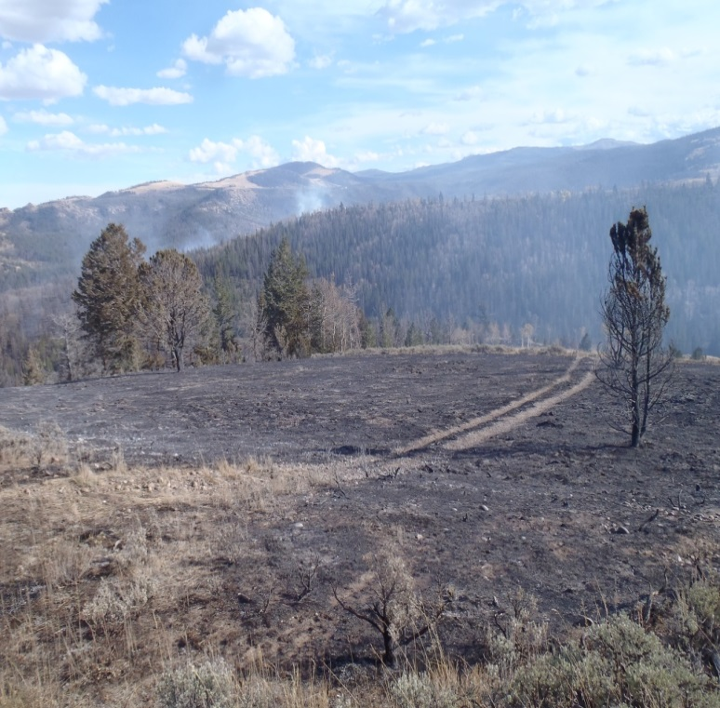

**Resource Advisor Report for the Crooked Creek Fir**e

**MEMO TO:** Rick Metzger and Curtis Bryan, Agency Administrators for the Forest Service and BLM respectively

**FROM:** Tim Kramer and Lucinda Jann, Resource Advisors

**INCIDENT DATE(S):** Sept. 28 – unknown (incident 93% contained 10/3), 2015

**Overview:**

The Crooked Creek Fire (incident (WY-SHF-000519) was reported Monday September 28th early afternoon. The cause of the fire has not been determined. The fire lies 15 miles northwest of Dubois, WY. The elevation ranges from 7900 to 8600 feet and lies west of the Crooked Creek drainage, spanning a small ridge before running through the N. Fork Crooked Creek drainage and up another unnamed ridge. Vegetation type is a mix of open mountain sagebrush steppe, lodgepole, aspen, mixed conifer and Douglas fir. The fire burned across private, US Forest Service and BLM administered lands. The fire at the time of this report, 10/2/15, is 93% contained and covers 359 acres.

Jay Slagowski, the SZ Shoshone NF FMO served as the first ICT3 prior to the incident being transitioned to ICT2-Rocky Mountain IMT Black, Shane Greer IC, end of shift Tuesday Sept 29. At end of shift (2000) Friday Oct. 2, the ICT2 transitioned the incident to ICT4, with Mike Franchini serving as the IC. Varieties of both ground and aerial resources have responded to the incident and were assigned to the fire. Resources assigned to the incident include numerous Federal and County Type 4 and Type 6 engines, four Type 1 hotshot crews, one squad of Missoula smokejumpers, one dozer, one Type 1 air attack, one type 3 helicopter, one type 1 helicopter and one air tanker with fire retardant. Other supportive resources were assigned to the incident after transition to a Type 2 organization.

Most of the fire activity and fire growth occurred between Monday, September 28 and Wednesday September 30, with crew performing line securing and mop-up duties on Thursday October 1 and Friday October 2, 2015. On the night of October 1, 2015 through October 2, 2015 an anticipated and significant moisture event blanketed the fire area, dropping between .25” and .50” of moisture over the fire area and significantly moderating fire behavior. This has led to the transition of the incident back from the Type 2 organization to the local unit as a Type 4 incident. It is not known if this is a fire season ending moisture event at the time of this report. The anticipated containment date is not known at the time of this report on October 3, 2015.

Fire personnel primarily accessed the fire by taking the Teton Valley Ranch road, the ownership of the private land off Hwy 287/26. Fire personnel utilized existing ranch 2-track roads in addition to a newly constructed dozer line to access the fire.

**Resources Threatened, Damaged, or Destroyed:**

* Teton Valley Ranch Camp lies below Sand Butte on Crooked Creek. No damage occurred to the numerous buildings, outbuildings and facilities.
* The Teton Valley Ranch has numerous 2-tracks on their 2300 acre property. Some of these 2-tracks were dozed to create fire break. Rehabilitation to some of those lines, including possible installation of a culvert and small corduroy puncheon over one identified wet crossing will be proposed in recommended rehabilitation measures below.
* Historic Tie Hack cabins are in a meadow on the property. The fire did not burn these buildings.
* Portions of the fire were within moose and mule deer crucial winter range. 45 acres of crucial moose winter range and 52 acres of crucial mule deer winter range were burned in the fire.
* 2,169 feet of FS/BLM boundary worm fence were destroyed in the fire and will need to be rebuilt.
* A Cadastral Survey Boundary Marker is located on the ridge at the FS/BLM boundary and was not damaged by the fire.
* The burnt area ranges from sagebrush steppe to various conifer forested communities. Slopes are variable from flat to in excess of 45%. Soils range from loamy to gravelly loam and sandy with erosion potential ranging from moderate to extreme. Photo points were established to provide baseline conditions immediately post-burn and may be used in the future to monitor long-term vegetation recovery.
* 142 acres of the burn are managed as part of the BLM Crooked Creek grazing allotment; allotment number 4900193. Permittee is Teton Valley Ranch. Approximately 108 acres of the burn are managed as a part of U.S.F.S. Warm Springs grazing allotment; allotment number 05188. The permittee is Jim Buline and Brad Eastman.
* Numerous water sources are within and adjacent to the fire perimeter; Crooked Creek and its tributaries as well as developed ponds within these drainages. There was no damage to these water sources. Water was utilized for ground and aerial water operations
* The fire area is known habitat area Threaten and Endangered species including gray wolf, Canada lynx, and grizzly bear. The area is potential habitat for Northern Goshawk, which is a BLM sensitive species
* No additional range improvements were damaged by the fire or crews responding to the incident.
* No other issues, resources, or concerns have been identified.

**Rehabilitation Completed during Fire Suppression:**

None.

**Additional Rehabilitation Recommended and Rational:**

* Dozer lines on existing 2-tracks would not be fully recovered. They would be water barred in intervals ranging from every 100-400 feet, depending on slope and soil texture. Dozer lines constructed off from existing 2-tracks would be slashed back in, utilizing the large, woody, and vegetative materials removed during construction of the dozer line. They would be stabilized with water bars at intervals between 75-200 feet depending on slope and soil texture to prevent erosion. This would be done to allow proper rehabilitation and prevent expansion of existing 2-tracks. There are 9680 feet of dozer line built on existing 2-track roads that will need to have water bars installed at above mentioned intervals and 6445 feet of dozer line off of existing 2-tracks that will need to be slashed back in. Slash in rehabilitation will be implemented with tracked skid steer or mini-excavator. Water bars constructed with appropriate machinery as determined by Forest Service engineers and to specifications as defined in **Wyoming Forestry Best Management Practices-Water Quality Protection Guidelines**, page 30. Hand lines that were constructed were inspected and determined not to warrant rehabilitation.
* There is no immediate identified need to revegetate burned areas.
* FS/BLM boundary fence. Approximately 2,170 feet of fence line was burnt or damaged during the fire. 2,170 feet will need to be reconstructed prior to livestock turn-out.
* Forest Service and BLM grazing allotments burnt during the fire will each need at least 2 growing seasons rest from grazing to allow proper vegetative recovery post-fire. Utilization of temporary electric fence may be an option to allow utilization of surrounding unburned grazing pasture on Forest Service and BLM allotments.
* Roads utilized for control lines will need stabilization and installation of water bars as mentioned above.
* There are no known noxious weeds within the fire perimeter. The area should be monitored for the potential expansion from adjacent known infestations of Canada Thistle, Musk Thistle, and Spotted Knapweed. Chemical or biological control of noxious weeds may be necessary within the burn area.
* Water sources used for fire suppression activities should be monitored for potential aquatic invasive species introduced during fire suppression activities.

**Other information:**

* Fire Perimeter Map and Suppression Repair Plan
* Noxious Weed Location Map
* Fire Resource Advisors photographs

**Crooked Creek Fire Photographs Taken 9/30/15-10/1/2015**

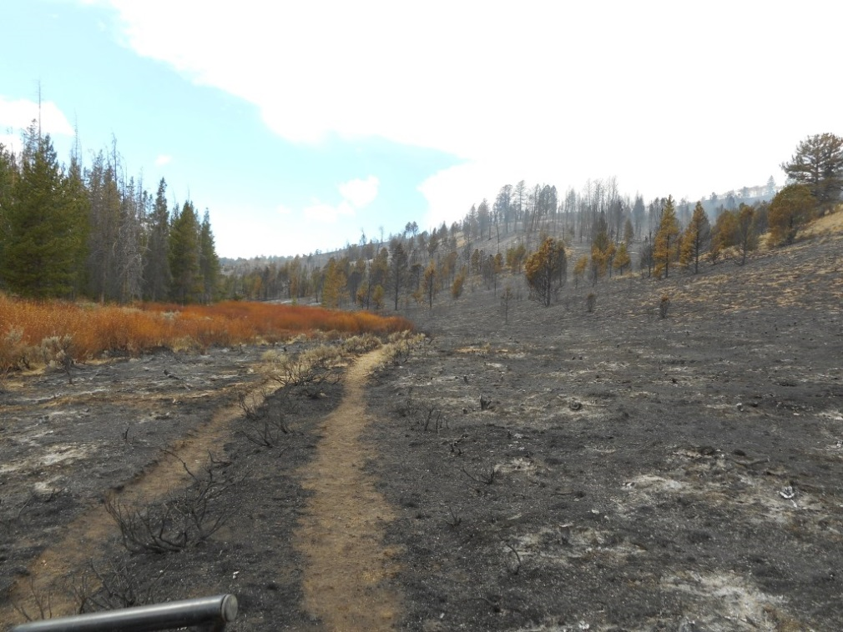

Photo 1: Burnt Slope adjacent to riparian area on unnamed fork of Crooked Creek.

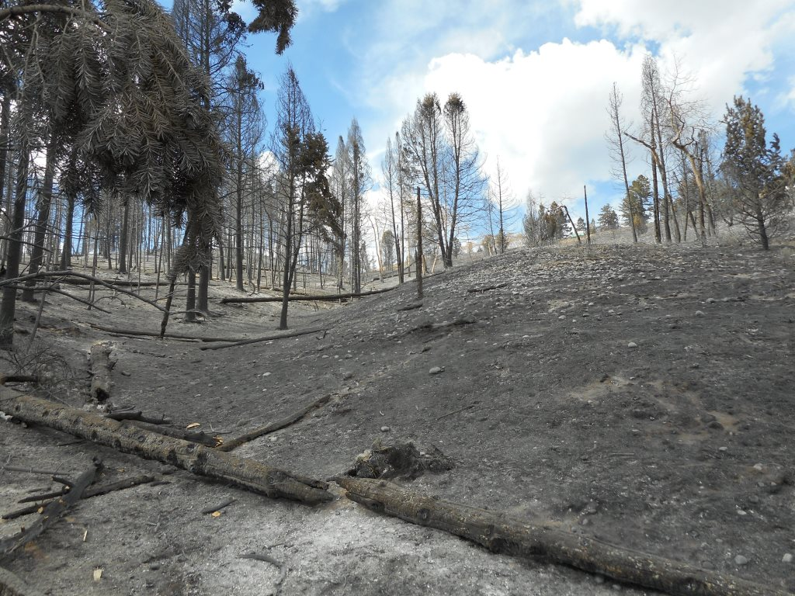

Photo 2: Mid-slope burnt conifer and sagebrush

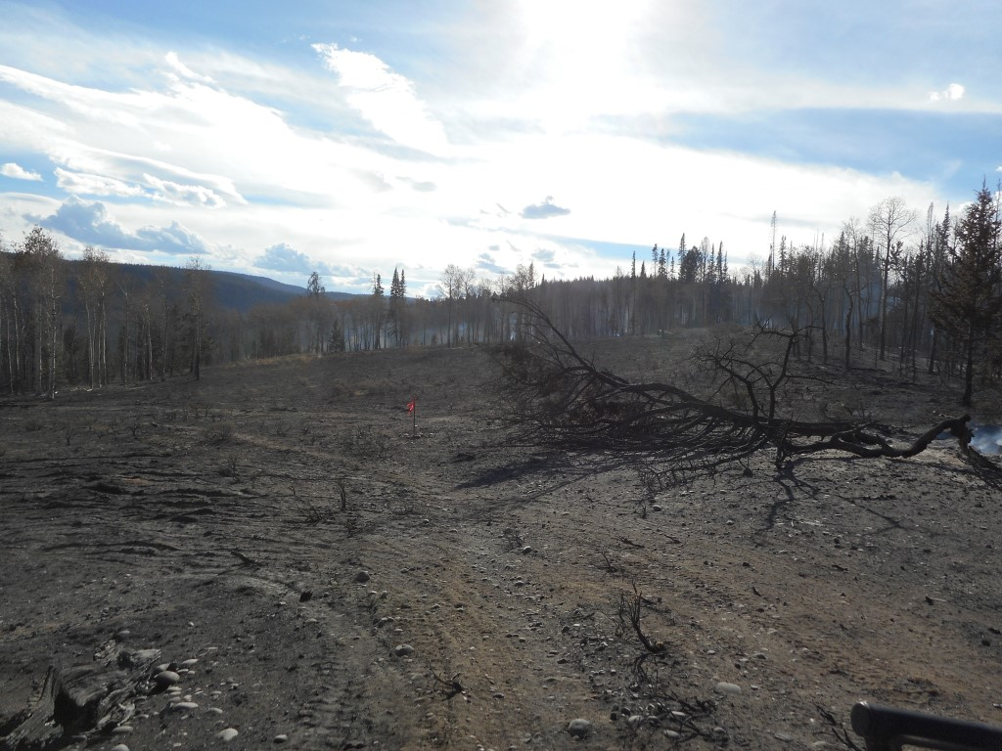

Photo 3: Burnt conifer/sagebrush on Forest Service-BLM boundary

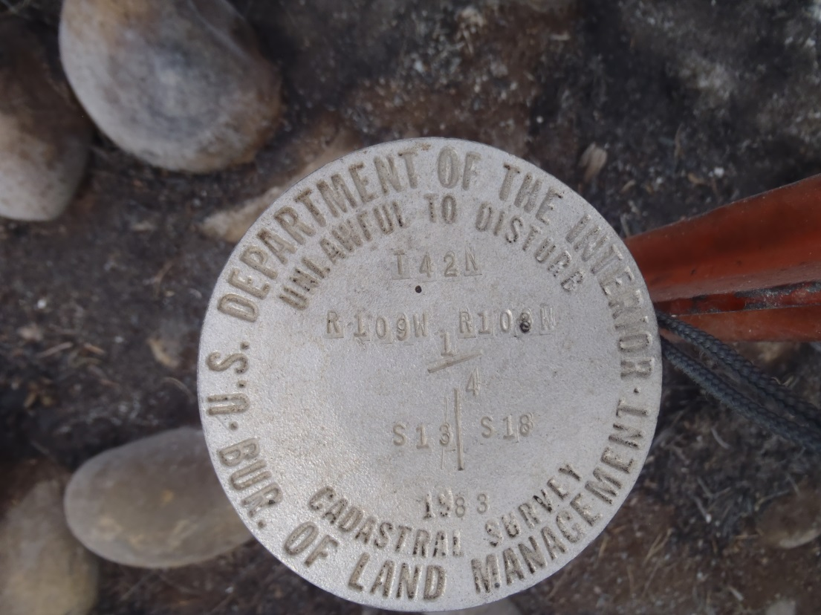

Photo 4: Cadastral brass cap on BLM-F.S. boundary within burnt area

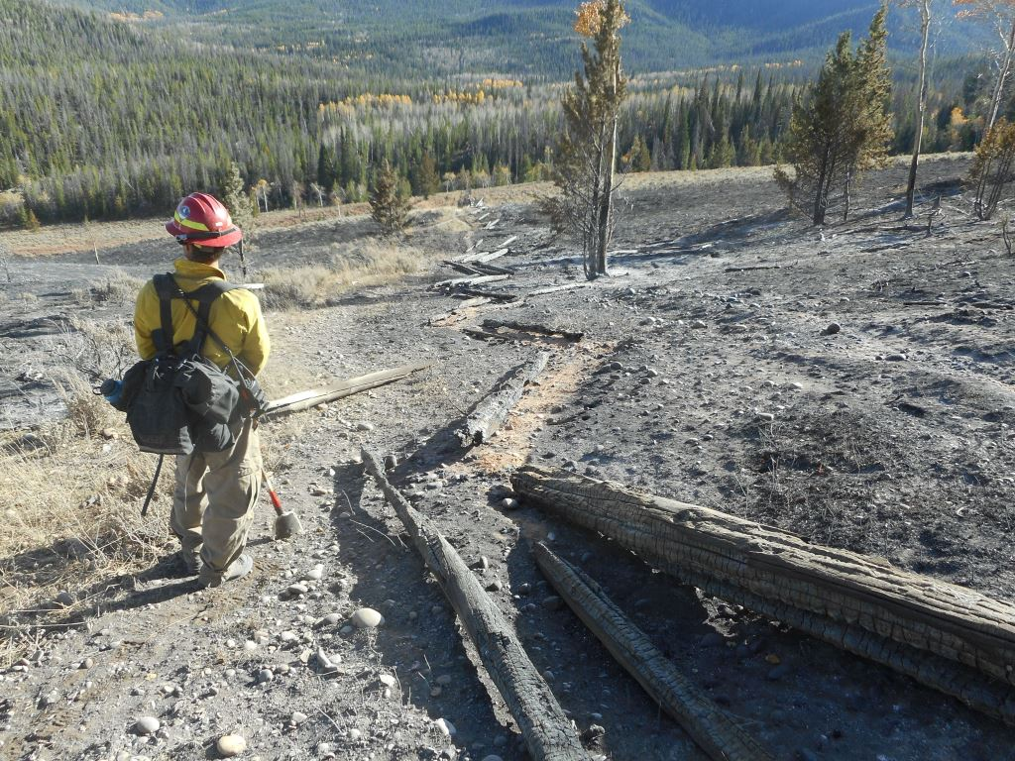

Photo 5: Burnt F.S.-BLM boundary fence

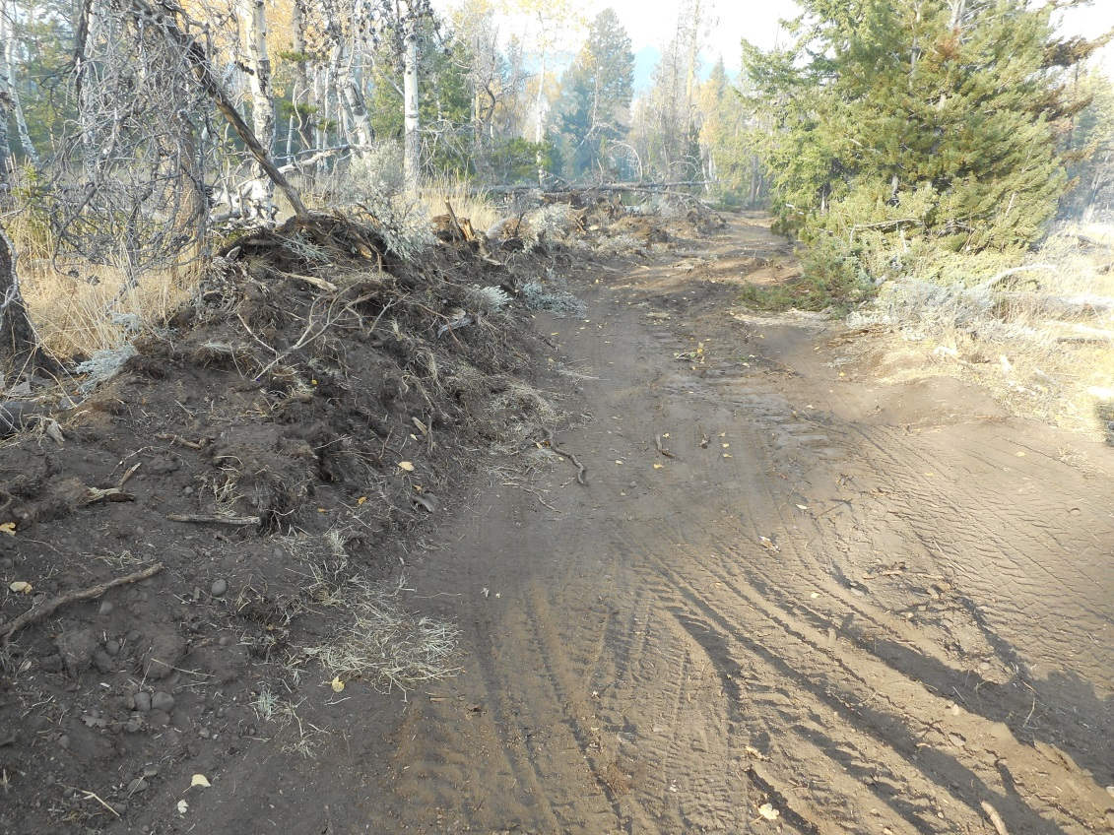

Photo 6: Dozer line constructed off of existing 2-tracks

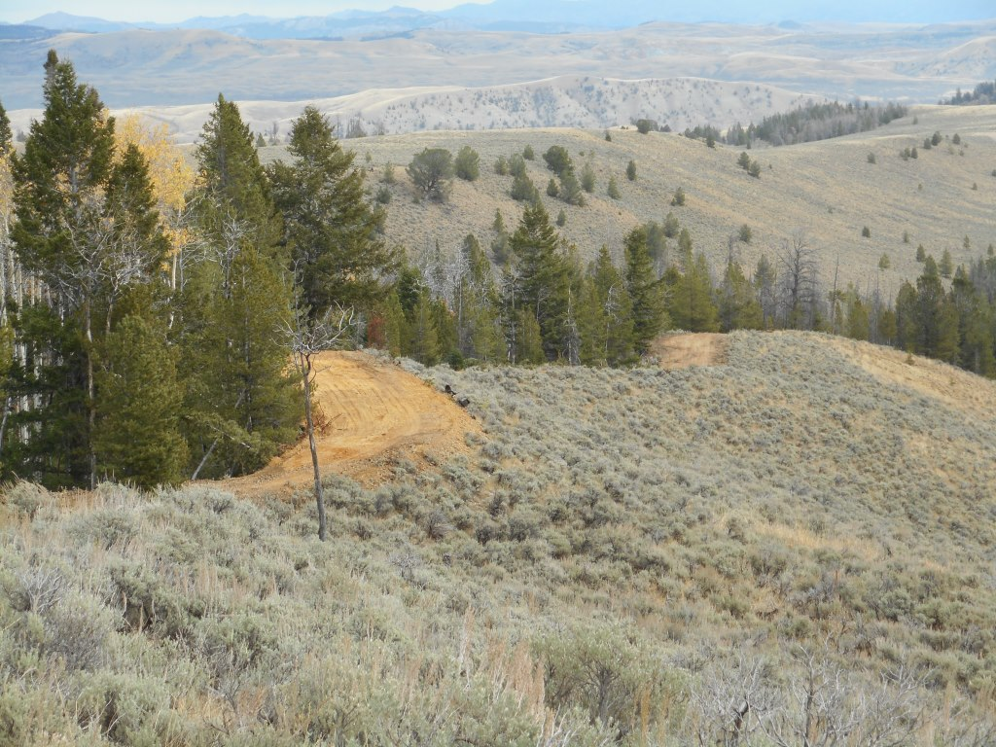

Photo 7: Dozer line on existing 2-track

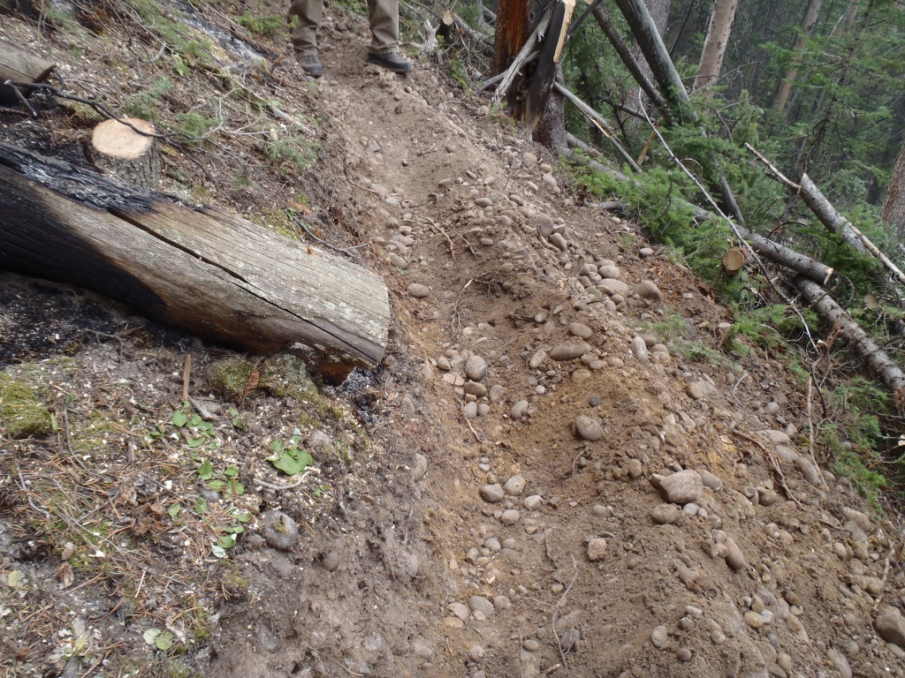

Photo 8: Deep cupping of hand-line on west edge of fire