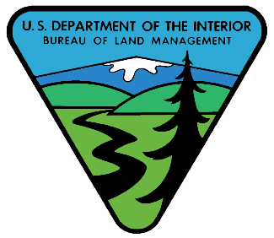 | South Dakota Field Office  1-1-2022  BLM Avenza Maps  100K Series Maps

https://drive.google.com/drive/folders/1hRLXwUejUDTPls81n6ycwWQNM167B6sc?fbclid=IwAR1siQFeuQZEQc9MsRMvpygWigmrV8jqqdyfn6naJnUc_kQzEESzCY08ETw

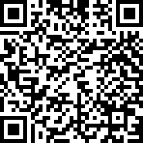  QR Code | - Open Avenza Maps on your device.  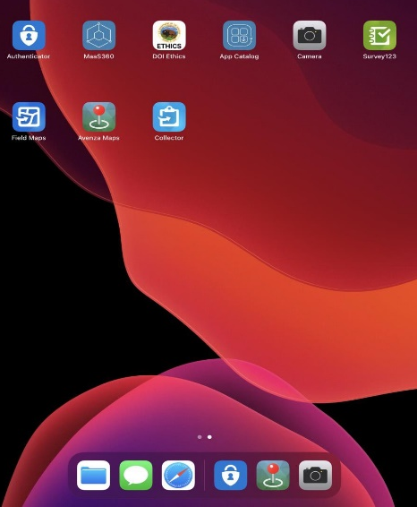
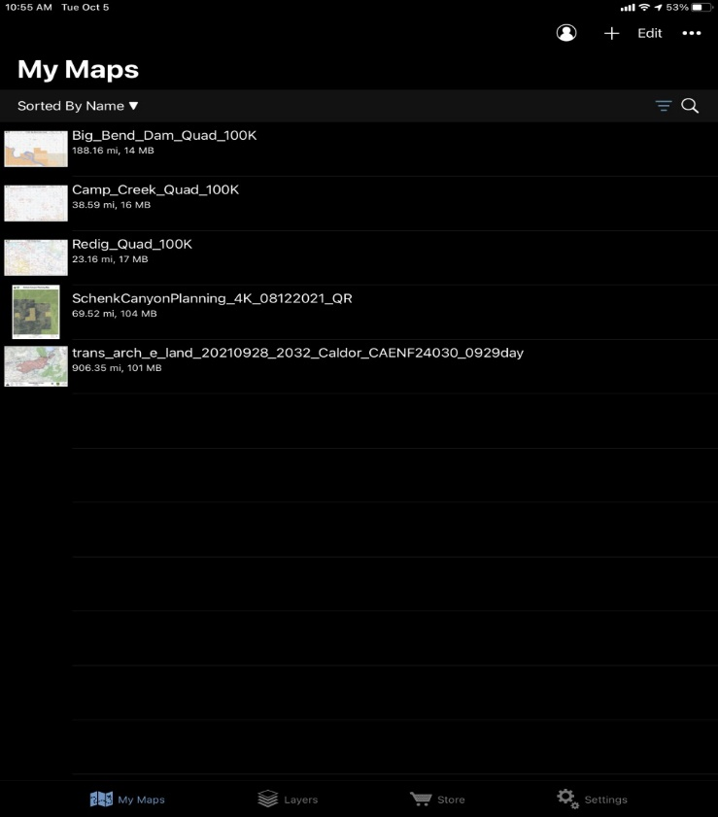
- Tap the “+” sign to import map

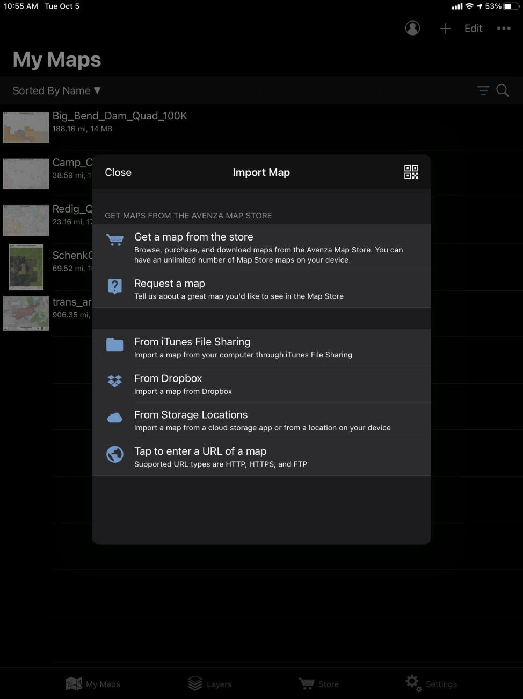
#3 The “Import Map” page opens, tap the QR Code symbol, this should open your device camera. Hold the camera up to the QR Code to scan it. Your web browser should open and navigate to a Google Drive.

#4 Next select the map you want and double tap it to download to your device
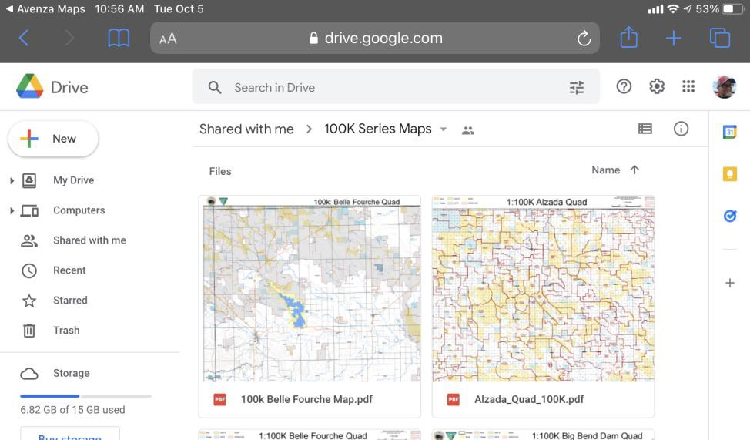

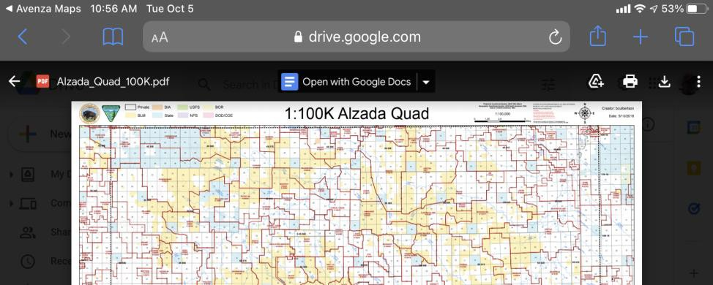
4a. You may need to tap the download icon to download to your device
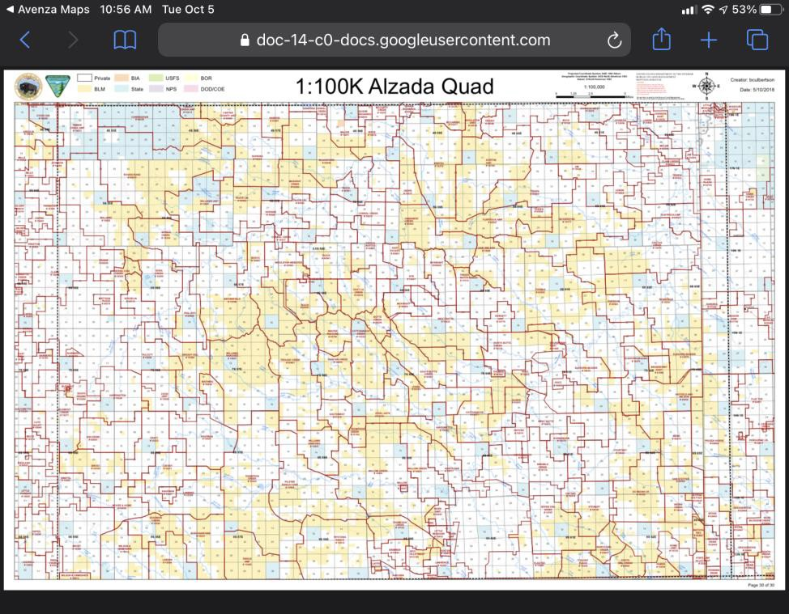  #5 The selected Map will open in a new window. Next, tap the square with arrow icon to open with Avenza maps |  | 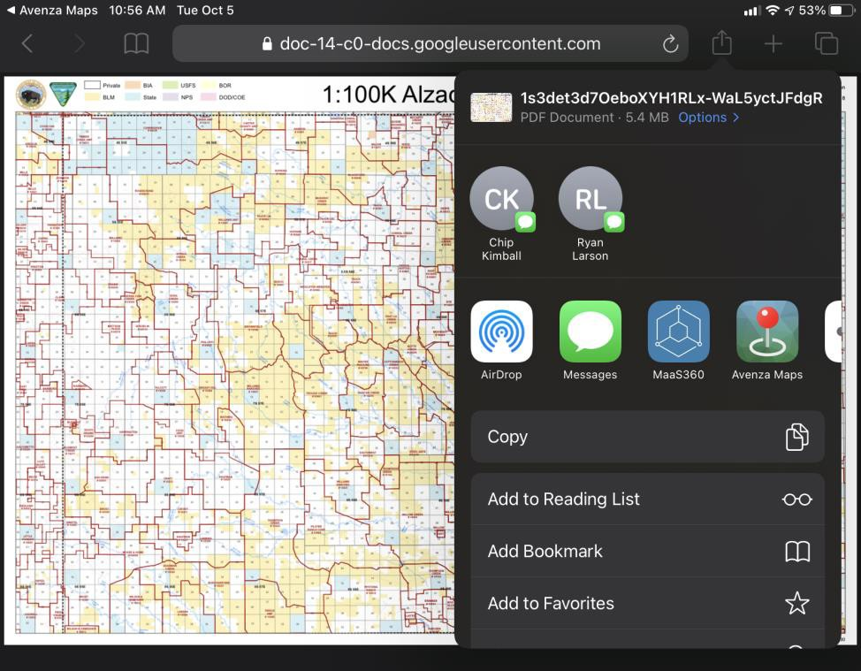
#6 Once finished, the Map should load  into Avenza Maps and be ready for use. | 