HEALTH AND SAFETY MESSAGE
SAFETY starts with YOU
We are ALL accountable for SAFE behaviors

INCIDENT: County Line Fire | DATE: April 22, 2012 TIME: Day
Major Hazards and Risks: OVERHEAD HAZARDS, ANIMALS, TRAVEL
Overhead Hazards – Snags and Green trees – Overhead hazards continue to be a concern within the burn area. Snags can be fire weakened and are naturally in a state of weakened structural integrity. Green trees can also become a hazard due to fire weaken structure. All trees can be vulnerable during erratic and high winds during thunderstorms. Be vigilant, speak up, flag hazards and mitigate if it can be accomplished in a safe manner.
Animal Contact – Possibility of animal contact has increased due to addition moisture and standing water. Animals that had previously been congregated in wet areas are now moving out across the landscape. This includes most all species but of most concern are the snakes and alligators. Again be vigilant, notify others and avoid the area whenever they are spotted.
Travel – De-mobing and Re-mobing – Mobilizing either to an incident or from an incident or between fires, puts a lot of stress on our lives. We have a lot on our minds, personal issues, possible fatigue from the incident we are leaving and excitement for what lies ahead. We are often driving in towns and country we have never seen before. With all these things going on in our lives we can easily not pay attention to the task at hand while driving, parking a vehicle, crossing a busy street or many other activities that could lead to an accident.

Watch Out Situation of the Day  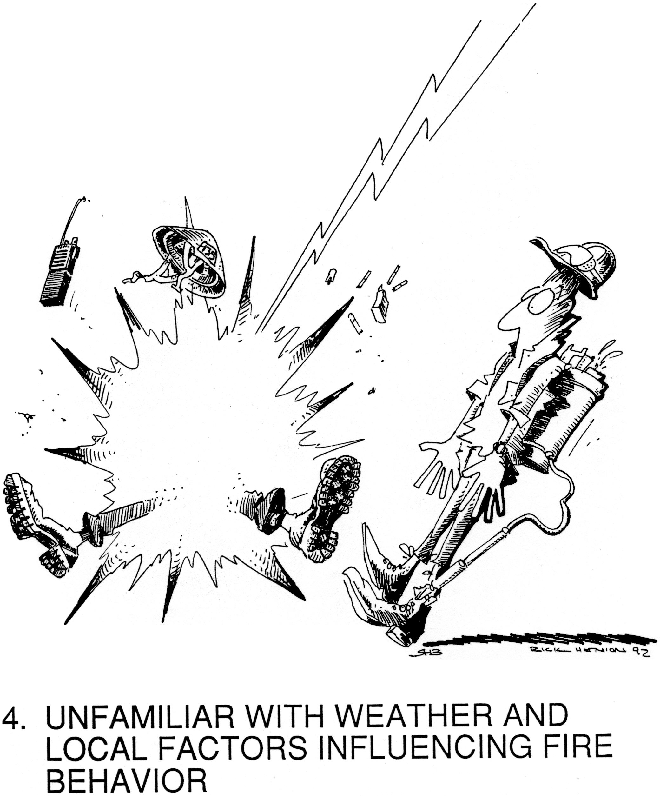 | What to Do Following Snake Bite:  Do  - Remain calm.  - Immediately your supervisor or DIVS.  - Immobilize the bitten area.  - Keep affected area at or below the heart.  - Limit victim's movement.  - Remove all jewelry (i.e. rings, bracelets, watch, etc.), restrictive clothing and any constricting item before swelling occurs…keep in consideration the victim’s location and need for PPE during transport.  - Safely try to observe snake's identifying traits  (i.e. colors, patterns and size).  Don't  - Don't use a tourniquet.  - Don't drink or apply alcohol.  - Don't cut or suck the wound.  - Don't apply ice.  - Don't attempt to catch the snake.  - Don't attempt to kill the snake.  - Don't touch/handle a dead snake.  Prevention Tips  - Be cautious around shrubs, tall grass, and areas surrounding canals, lakes and swamps. - Always wear protective gloves and shoes when working outdoors. -Look before sitting, stepping or reaching near or around rocks and logs

Incident Safety Officers: Larry Holsomback, Brad Lidell, Tom Krueger, Glen Stapleton & Buddy Kelley (T)

