HEALTH AND SAFETY MESSAGE

INCIDENT: Florida - County line Fire | DATE: Monday, April 23, 2012 TIME: Day Shift
Major Hazards and Risks:
Travel and Change
If you are leaving, read this…

Your assignment doesn’t stop when you walk away from demob. Your final assignment is to arrive safely at home. The 2-to-1 work-rest policy applies.

* Drive defensively. Human nature ensures we are less patient when driving home; don’t let impatience cause unsafe behavior.
* No driver will drive more than 10 hours within any duty-day.
* Multiple drivers in a single vehicle may drive up to the 16 hours limitation provided no driver exceeds the individual driving time limitation of 10 hours.
* Do not drive past 2200 hours. Do not eat and drive at the same time.
* Don’t use the cell phone while driving, pull off the road or call during your stretch breaks.

If you are staying, read this…

Common Denominators of Fire Behavior on Tragedy Fires: Tragedies have occurred in periods of reduced fire activity, transitions, and mop-up stage. Maintain your situational awareness. Focus on your assignment. Manage distractions.

Communications: As the transition takes place, the need to effectively communicate on the fire is important. Take personal responsibility to ensure that people you interact with know what they need to know. Transition brings new faces and different ways of communicating. Make it work.

We look forward to seeing you on a future assignment with the SAIMT. 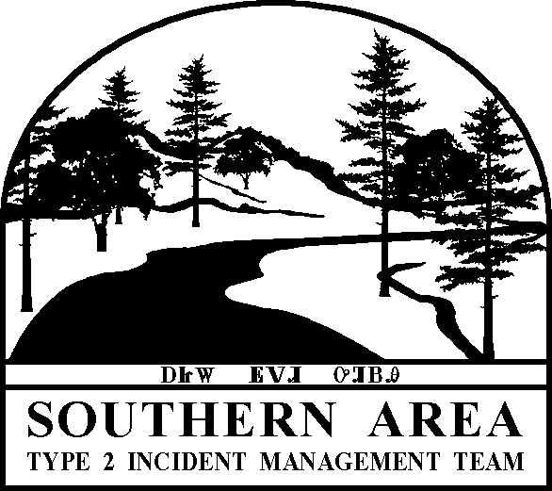

Team Safety Officers: Larry Holsomback, Brad Lidell, Tom Kreuger and Buddy Kelley (T)

