Incident Name:  Cowbell  FL-BCP-017033 | IR Interpreter(s):  Tammy Hocut | Local Dispatch Phone:  678-320-3003 | Interpreted Size:  21,845 acres  Growth last period:  1 acre
Flight Time:  2122 EDT  Flight Date:  April 27, 2017 | Interpreter(s) location:  Jasper, AR  Interpreter(s) Phone:  870-446-5878 | GACC IR Liaison:  Scott Wilkinson  GACC IR Liaison Phone:  501-538-5827 | National Coordinator:  Tom Mellin  National Coord. Phone:  505-842-3845
Ordered By:  Michael Williams | A Number:  A-43 | Aircraft/Scanner System:  N144Z/Phoenix | Pilots/Techs:  Dan Johnson, Eddy Netcher/ Woody Smith
IRIN Comments on imagery:  Imagery was good |  | Weather at time of flight:  Partly cloudy | Flight Objective:  Map Heat Perimeter/Isolated, Scattered and Intense Heat Sources
Date and Time Imagery Received by Interpreter:  April 27, 2343 EDT |  | Type of media for final product:  NIFC FTP – 4 Shapefiles, KMZ files, IR Log and PDF Map  Digital files sent to:  /incident_specific_data/southern/Florida/17_Cowbell /IR/20170428  Email to: Blue.sit.unit@gmail.com (Michael Williams)
Date and Time Products Delivered to Incident:
April 27, 2357 EDT
Comments /notes on tonight’s mission and this interpretation:

- Started interpretation with 04/27 IR fire perimeter.
- About an acre fire perimeter increase around the Dark Strand area with scattered heat.
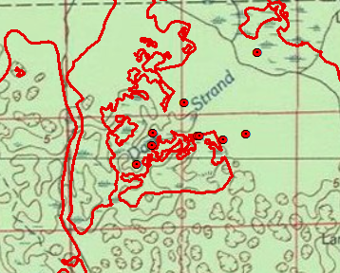
- A few isolated heat sources in the northwest, west and south central part of the fire.

