Hurricane Irma Relief response
[Recipient Name]
Thank you for your contribution to the success of the Hurricane Irma Relief Response
Lee county LSA
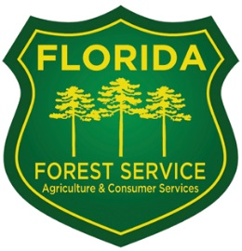 |  | Presented By: [Signatory name(s)]  On This Day: [Click to select a date]

