Hurricane Irma (LSA Green Team)
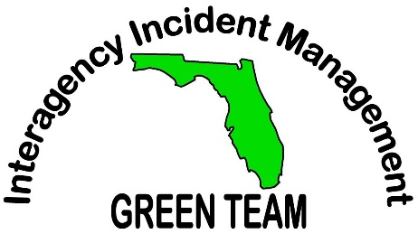
Food Service Hours:
Breakfast: 0600 – 0800
Lunch: 1100 – 1300
Dinner: 1800 – 2000

