Incident Name:  MM 87  FL-FPR-170001 | IR Interpreter(s):  Tammy Hocut | Local Dispatch Phone:  678-320-3003 | Interpreted Size:  516 acres  Growth last period:  0 acres
Flight Time:  2255 EDT  Flight Date:  April 28, 2017 | Interpreter(s) location:  Jasper, AR  Interpreter(s) Phone:  870-446-5878 | GACC IR Liaison:  Scott Wilkinson  GACC IR Liaison Phone:  501-538-5827 | National Coordinator:  Tom Mellin  National Coord. Phone:  505-842-3845
Ordered By:  Laurie Oliver  970-759-9611 | A Number:  A-7 | Aircraft/Scanner System:  N144Z/Phoenix | Pilots/Techs:  Dan Johnson, Eddy Netcher/ Woody Smith
IRIN Comments on imagery:  Imagery was good |  | Weather at time of flight:  Clear | Flight Objective:  Map Heat Perimeter/Isolated, Scattered and Intense Heat Sources
Date and Time Imagery Received by Interpreter:  April 28, 2353 EDT |  | Type of media for final product:  NIFC FTP – 4 Shapefiles, KMZ files, IR Log and PDF Map  Digital files sent to:  /incident_specific_data/southern/Florida/17_MM87 /IR/20170429  Email to: Laurie Oliver  970-759-9611  Cowbell.plans@gmail.com
Date and Time Products Delivered to Incident:
April 29, 0355 EDT
Comments /notes on tonight’s mission and this interpretation:

- Started interpretation with 04/28 IR heat perimeter.
- No change in fire acres.
- A few isolated heat sources on both the west and east side of the fire.
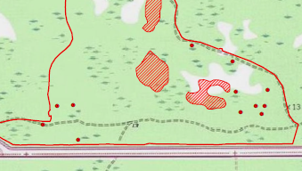
- 3 islands of intense heat on the central/east side of the fire.
