Incident Name:  MM 87  FL-FPR-170001 | IR Interpreter(s):  Tammy Hocut  870-446-5878 | Local Dispatch Phone:  678-320-3003 | Interpreted Size:  504 acres  Growth last period:  -12 acres
Flight Time:  2226 EDT  Flight Date:  May 01, 2017 | Interpreter(s) location:  Jasper, AR  Interpreter(s) Phone:  870-446-5878 | GACC IR Liaison:  Scott Wilkinson  GACC IR Liaison Phone:  501-538-5827 | National Coordinator:  Tom Mellin  National Coord. Phone:  505-842-3845
Ordered By:  Laurie Oliver  970-759-9611 | A Number:  A-12 | Aircraft/Scanner System:  N144Z/Phoenix | Pilots/Techs:  Dan Johnson, Eddy Netcher/ Woody Smith
IRIN Comments on imagery:  Imagery was good |  | Weather at time of flight:  Clear | Flight Objective:  Map Heat Perimeter/Isolated, Scattered and Intense Heat Sources
Date and Time Imagery Received by Interpreter:  May 02, 0016 EDT |  | Type of media for final product:  NIFC FTP – 4 Shapefiles, KMZ files, IR Log and PDF Map  Digital files sent to:  /incident_specific_data/southern/Florida/17_MM87 /IR/20170502  Email to: Laurie Oliver  970-759-9611  Cowbell.plans@gmail.com
Date and Time Products Delivered to Incident:
May 02, 0034 EDT
Comments /notes on tonight’s mission and this interpretation:

- Started interpretation with updated fire perimeter from incident.
- No new IR heat perimeter growth, but there was a reduction of 12 acres due to updated incident fire perimeter.
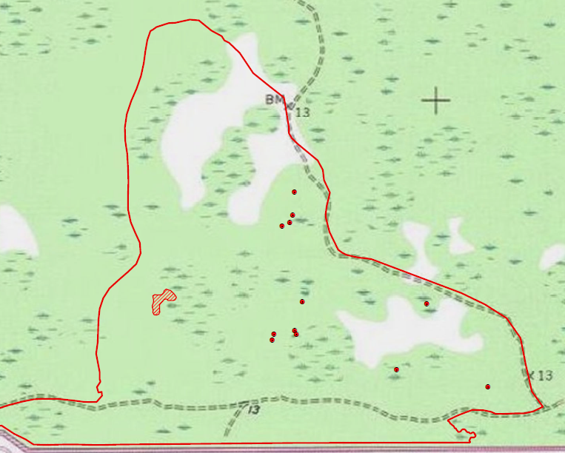
Reduction in acres in this area
- Some isolated heat sources in the central and east side of the fire. One small intense heat polygon on the west side of the fire.

