Incident Name:  Parliament  FL-BCP-017026 | IR Interpreter(s):  Tammy Hocut | Local Dispatch Phone:  678-320-3005 | Interpreted Size:  26,369 acres  Growth last period:  0 acres
Flight Time:  2158 EDT  Flight Date:  April 29, 2017 | Interpreter(s) location:  Russellville, AR  Interpreter(s) Phone:  479-886-0878 | GACC IR Liaison:  Scott Wilkinson  GACC IR Liaison Phone:  501-538-5827 | National Coordinator:  Tom Mellin  National Coord. Phone:  505-842-3845
Ordered By:  Laurie Oliver  970-759-9611 | A Number:  - 13 | Aircraft/Scanner System:  N144Z/Phoenix | Pilots/Techs:  Dan Johnson, Eddy Netcher/ Woody Smith
IRIN Comments on imagery:  Imagery showed lots of clouds. |  | Weather at time of flight:  Cloudy | Flight Objective:  Map Heat Perimeter/Isolated, Scattered and Intense Heat Sources
Date and Time Imagery Received by Interpreter:  April 29, 2017 2350 EDT |  | Type of media for final product:  NIFC FTP – 4 Shapefiles, KMZ files, IR Log and PDF Map  Digital files sent to:  /incident_specific_data/southern/Florida/17_Parliament/IR/20170430  Email to: Laurie Oliver(Cowbell.plans@gmail.com)
Date and Time Products Delivered to Incident:
April 30, 2017 0100 EDT
Comments /notes on tonight’s mission and this interpretation:
- Started with 04/29 IR perimeter.
- No fire growth.
- Lots of cloud cover over 95% of area.
- 1 isolated heat source just to the north.
- 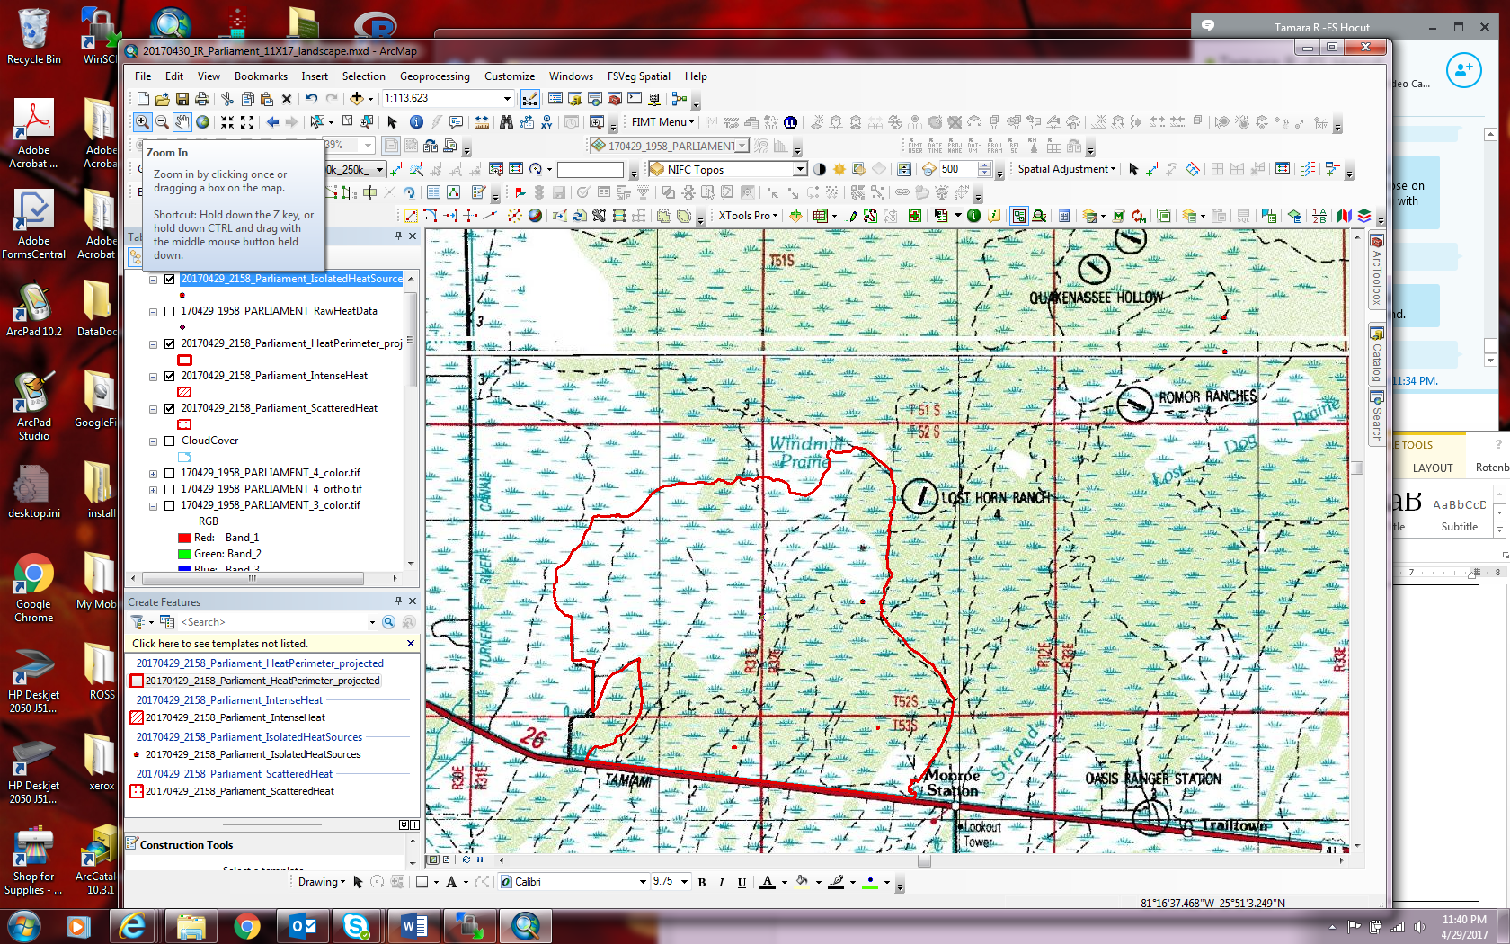

- 2 very small intense heat sources on south side of the fire.
- 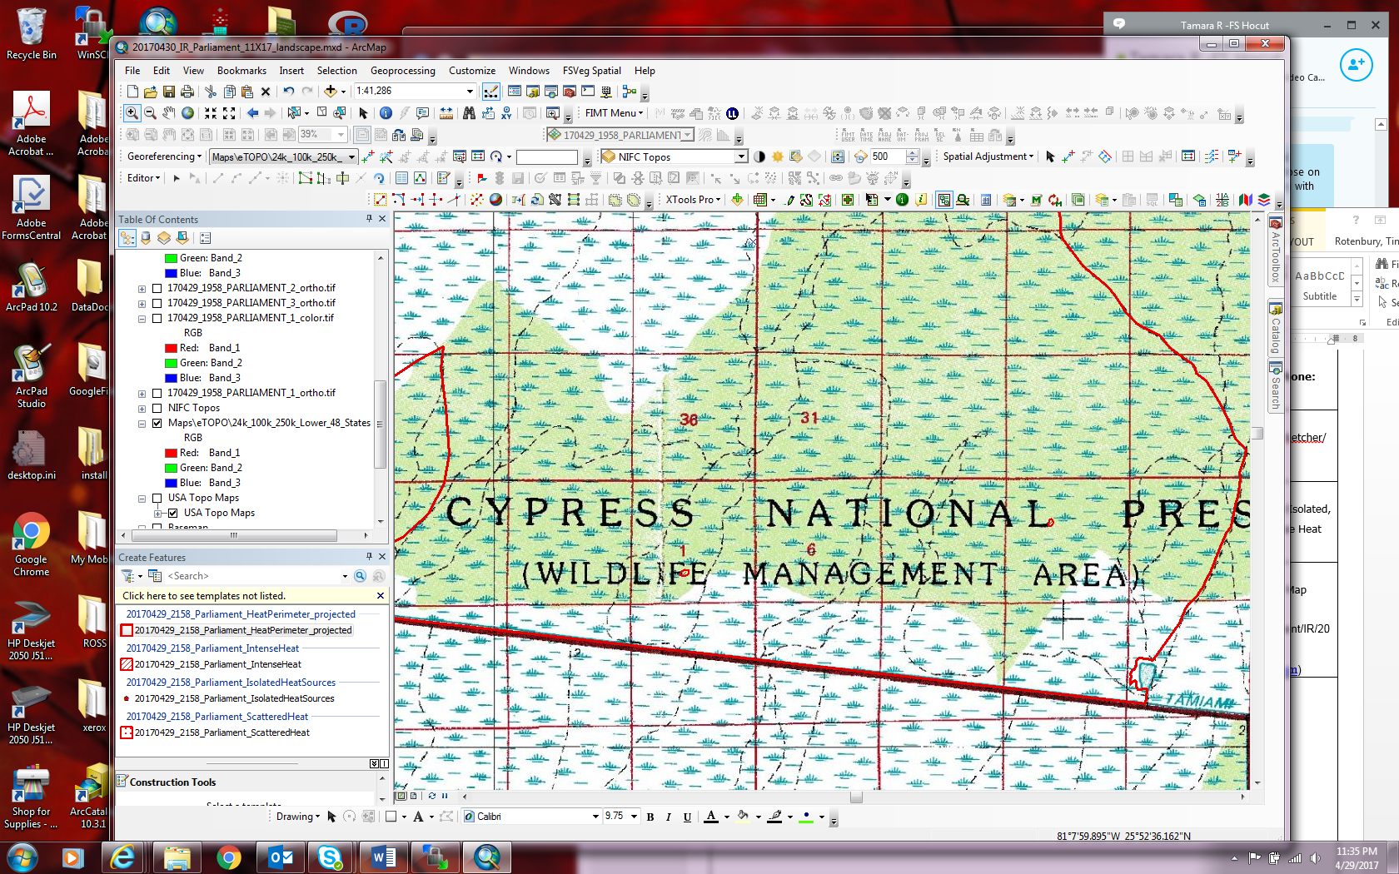

- 2 isolated heat sources to the North east of fire perimeter just north of Romor Ranches 81 0' 38.427" W 25 59' 59.745" N and 81 0' 39.512" W 26 0' 39.813" N

