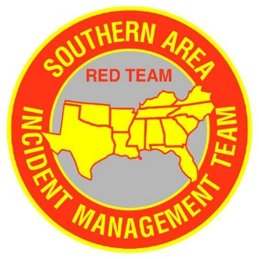
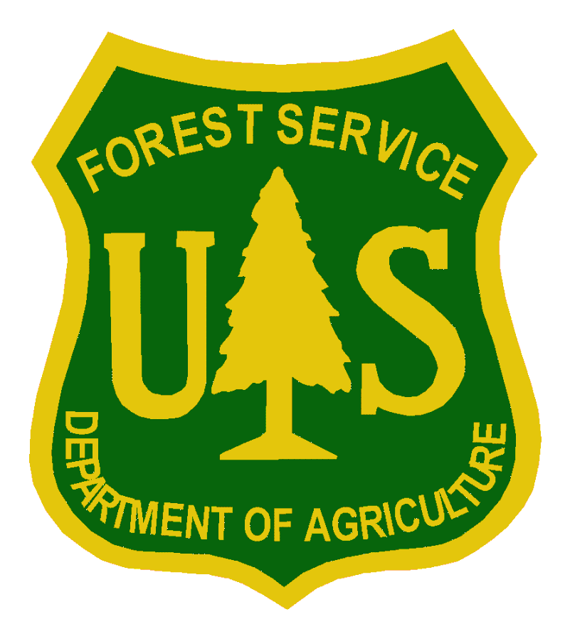
FL-FNF Hurricane Michael
Incident Objectives

- Provide for safety of incident personnel using a deliberate assessment of risks.
- Provide for good communications both internally and externally with emphasis on road and recreation openings/closings.
- Develop a long term strategy for 3-6 months and 6-12 months regarding opening of facilities, trails, roads, timber sales and other natural resource needs.
- Develop a proposed course of action regarding fire and fuel management and potential staffing to guide efforts for the next twelve months.

