Guidelines
There are four main processes required to establish and maintain an NWCG data standard:
- Develop a New NWCG Data Standard
- Change an Existing NWCG Data Standard
- Maintain an Existing NWCG Data Standard
- Evaluate a Request for Waiver of NWCG Standard

- NWCG data standards will be mapped to agency-specific data standards to ensure that wildland fire systems can also interface with agency systems
- Exceptions to use of NWCG data standards will be managed by the DAWG
- NWCG data standards will be published and accessible to all interested parties
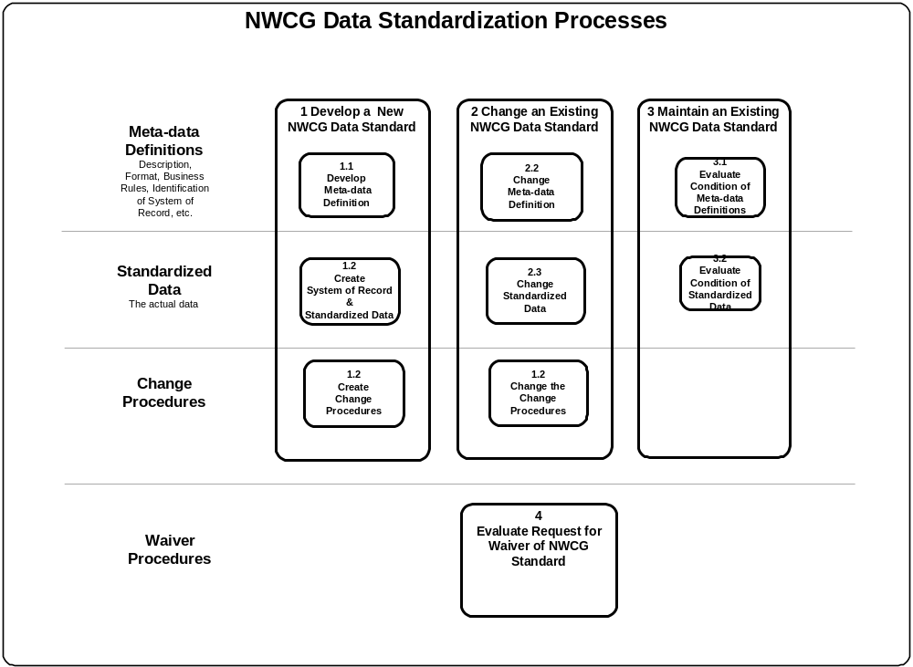

An NWCG data standard is created for data that is common or shared between one or more NWCG systems. Data standards fall into the following two stewardship categories:
- Data whose meta-data definition origination occurs in the wildland fire community
Examples:

- Unit Identifier Code
- Fire Number
- Resource Status
- Fuel Type

- Data whose meta-data definition origination occurs outside the wildland fire community.
Examples:

- State Code
- Agency Name
- Date
- Address

Process Diagram Templates
The process diagram templates on the following pages are provided as an initial starting point for development of data standardization procedures. The content may be customized based on the type of data standard and stewardship organization will need to be considered when establishing procedures. The format (presentation and layout) may also be changed, with the emphasis on ease of understanding and usability.
The following diagrams provide a high-level graphical view of the major processes required for developing a data standard. See Appendix B – How to Read A Process Diagram.
The diagrams should be supported with a more detailed process narrative. The narratives should identify who, how, and what for each process. An example of a process narrative is provided in Appendix C - Sample Process Narratives.
- Develop a New NWCG Data Standard
The following diagram depicts the process for developing a new NWCG data standard. This process may be initiated by many different entities including: an NWCG project team, working team, or advisory group; a system manager, a software development group, a data steward, the DAWG, etc. for data standardization.
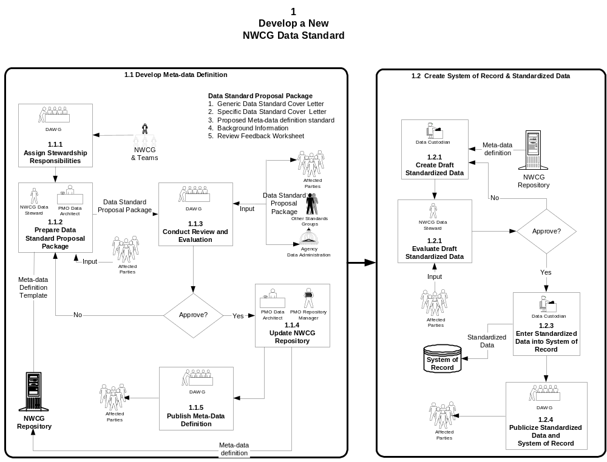
The processes show the separation between the meta-data definition and the standardized data. A meta-data definition is always required, but a standardized data set is optional. For example, the data item called “State Code” has a standardized data set as defined by the U.S. Postal Service. State Codes are often implemented as a pick-list in an application to limit data entry to an established set of data values. The data item called “First Name” does not have an established set of data values and therefore will not have a standardized data set.
- Change an Existing NWCG Data Standard
The following diagram depicts the processes for making a change to an existing NWCG data standard. Any affected party within the wildland fire community can initiate a proposed change. Affected parties may include: project teams, system managers, data custodians, data stewards, users, NWCG working teams/advisory groups, etc.
The processes show the separation between the meta-data definition and the standardized data. A change to the meta-data definition will, most likely, result in a change to the standardized data set. Conversely, a change to the standardized data set may not affect the meta-data definition.
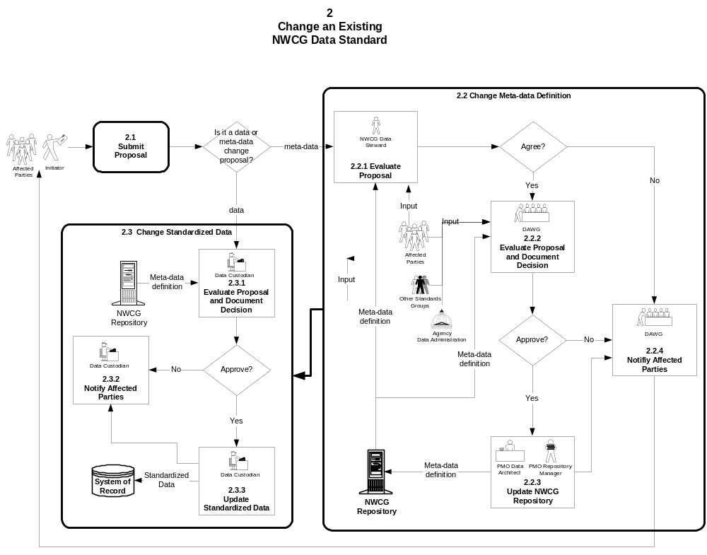
- Maintain an Existing NWCG Data Standard

The following diagram depicts the process for maintaining an existing NWCG data standard. The DAWG may establish a schedule to evaluate existing data standards for currency and usability.

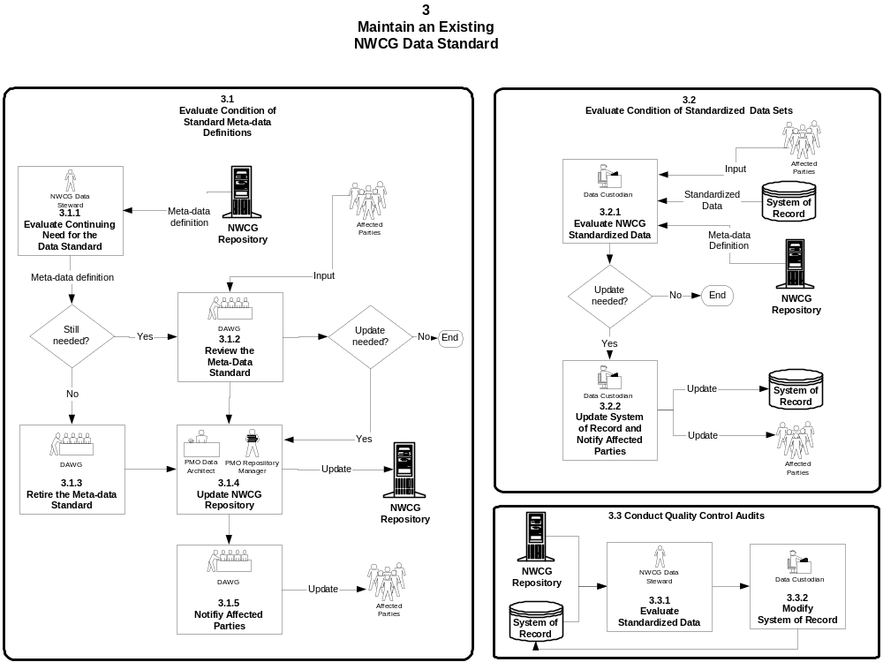
- Evaluate Request for Waiver of NWCG Standard

The following diagram depicts the process to be used when an NWCG project or system desires exemption from an NWCG standard.
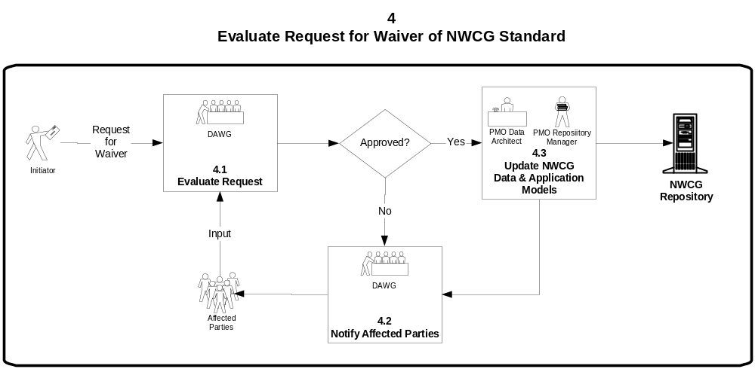
A waiver may be granted by the NWCG DAWG for:
- legacy applications that are able to achieve compliance by means other than the use of the subject standard
- Systems where the costs of implementing the subject standard are significantly higher than the benefits warrant

The requestor shall draft an application to the NWCG DAWG chairperson for a waiver providing the following information:

- An outline of the reasons why the data standard should not be implemented in the specific application
- A risk assessment and cost-benefit analysis of continued operation in a non-compliant mode
- Approval of the waiver request by decision officials of the project/system, if applicable

The DAWG will notify the requestor in writing of the disposition of the waiver within 60 days of receipt.

Appendices

Name: |  | Description:
Data Attribute Name | Unit Identifier | The business term in it’s unabbreviated form.
Abbreviation | Unit ID | The short form of the attribute name using standard abbreviations.
Contacts: |  | Description:
NWCG Working Team  or Associated Group | National Coordinators | The organization(s) that are the source of the attribute’s definition and maintenance.
Data Steward | Karin Frost | The person(s) responsible for the attribute meta-data definition.
System of Record | NICC Unit Identifier Database | The manual or automated system that serves as the authoritative source for accurate data values.
Custodian | - Each Geographic Area will assign a data custodian.  - Karin Frost (acting NICC Unit ID Database) | The person(s) responsible for the maintenance and quality of the actual data.
Definition: |  | Description:
Description | A code used within the interagency wildland fire community to uniquely identify a particular organization. | The textual definition of the attribute.
Length | 6 | The maximum allowable length.
Data Type | Alpha-Numeric | e.g. Alphabetic, binary, numeric, alpha-numeric
Format | XX-XXXX | The format of the data characters. X = alpha-numeric, 9 = numeric
Case Sensitivity | UPPERCASE | Indicates whether or not the data is to be upper, lower, or mixed case.
Data Entry Standards | XX = State Code or International Code  XXXX = unique code that identifies an office | Stewardship belongs to U.S. Postal Service  Example: ID = Idaho, CA = California
Example | ID-BOF = Boise National Forest located in the state of Idaho. | An example of a valid data entry.
Business Rules |  |  | Description:
- A Unit Identifier must be unique throughout the wildland fire community.  - An organization can have only one Unit ID.  - A Unit Identifier is designated for government (federal, state, and local) organizations only.  - . |  |  | Business rules are a set of conditions that govern the data attribute so that it occurs in a way that is acceptable to the business (or customer). A business rule is a statement that defines or constrains some aspect of the data.  There may be many business rules that pertain directly to the attribute, or to its relationship to other attributes.

System Association(s) |  | These will need to be validated by system business community.
System Name | Alias/Synonym | Why (How is the attribute used?)
ROSS |  | - Administrative office for an incident, person, vendor, financial code, or other office  - ROSS User’s Office  - Resource Provider/Owner  - Dispatch Office (requesting, placing, assigning, etc.)  - Contact/dialog office for incident, resources, etc.  - Office affiliations (dispatch hierarchy/ agency hierarchy)
ICBS |  | - Customer (government office or private entity).  - Provider (government office or vendor)
IQCS |  | - Administrative office for a person or an event.
Fire Reporting |  | - Administrative office for an event.
EFF Payroll |  | - Administrative office for an event.  - Hiring location of an EFF employee (to calculate rates of pay mileage, etc.)*
Isuite (ICARS, ITIME, IRSS) |  | - Administrative office for an event or a person  - Hiring location of an EFF employee (to calculate rates of pay mileage, etc.)*
Funding Analysis Applications:  - Fire Pro (NPS/BIA)  - NFMAS (FS)  - NFSMAS (BLM)  - FireBase (FWS) |  | - Office identification.  * This may not be appropriate usage of the Unit Identifier.

Applicability
- This standard is applicable for representation of data files for data interchange.
- This standard applies to all existing NWCG applications.
- This standard applies to the acquisition of all applications software, whether commercial off-the-shelf (COTS) products, or custom-designed applications.
- This standard is not applicable to the presentation on a printed report or a computer monitor.

Provision for Waiver
A waiver may be granted by the NWCG DAWG for:
- Legacy applications that are able to achieve compliance by means other than the use of this standard.
- Systems where the costs of implementing this standard are significantly higher than the benefits warrant.
The requesting office shall draft an application to the NWCG DAWG for a waiver providing the reasons why the date data standard should not be implemented in the information collection. This application shall contain:
- An outline of the reasons why the data standard should not be implemented in the specific application.
- A risk assessment and cost-effectiveness evaluation of continued operation in a non-compliant mode.
- Approval of the waiver request by decision officials within the requesting office, if applicable.
The DAWG shall notify the applying office in writing of the disposition of the waiver within 60 days of receipt.

Maintenance
This standard is one of several applicable to all NWCG applications; as such, it will be reviewed, and the NWCG DAWG will schedule updates at designated intervals. Reviews shall occur at time intervals not to exceed 5 years.

The purpose of the process diagram is to identify the major functions necessary to complete the process described in the title. The diagram also identifies contacts that should be made with the outside world (people, organizations, or systems).
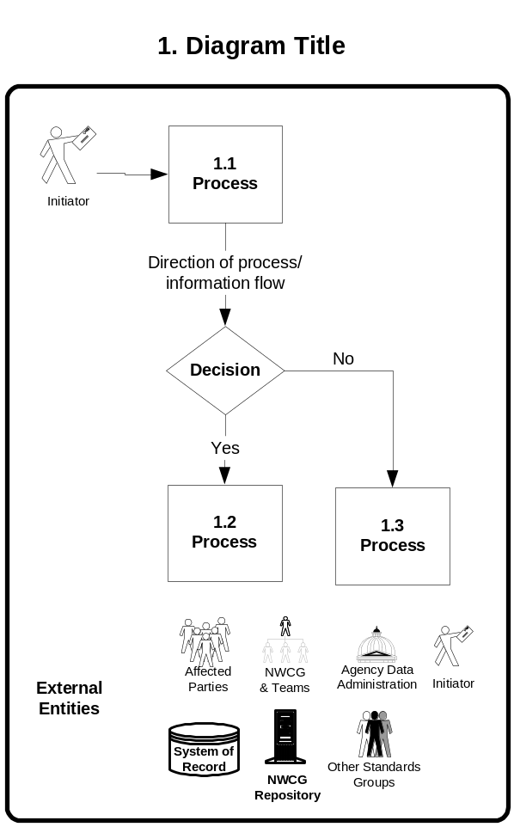

The box depicts a process to be performed by one of the data stewardship parties. The box includes an identification number and a short description.

The arrow shows the path or direction that the procedure should follow and can also include a description of the information being sent.

The diamond depicts a decision point in the procedures.

The external entities depict people, organizations, or systems that require interface during or after the process.
A process narrative is used to provide the procedures of how to accomplish the processes identified on the process diagram. The following text provides an example of step-by-step instructions on how to “Change an Existing NWCG Data Standard” to support the process diagram presented on page 5 of the main document. This sample is provided as both a template and an example of the level of detail necessary to develop data standardization procedures. The data steward is not required to use this format, but should ensure that the main subject areas are covered as appropriate. The key to developing procedures is that they are understandable and useable.

2. Change an Existing NWCG Data Standard

  - Develop Standard Meta-data Definition

    - Assign Stewardship Responsibilities
      - Designate NWCG Data Stewardship Group
Because data definitions are representative of the information needs of the business community, it is important to identify a business group to provide stewardship for each data standard. that Data stewardship The DAWG will identify the appropriate NWCG working team that will provide stewardship for the data entities identified on the NWCG Enterprise Data Model, maintained by the NWCG IRM Program Management Office. The stewardship group’s role will be facilitated by that group’s data steward on the DAWG.
      - Designate NWCG Data Steward
The data stewardship group will designate a person to serve as the point of contact and representative. A person may serve as data steward for more than one data entity.

    - Prepare Data Standard Proposal
The data steward will work with the data stewardship group and other interested parties to prepare a Data Standard Proposal and submit it to the DAWG. The

Data Standard Proposal will consist of:
            - NWCG Meta-Data Definition form (see Appendix A)
            - A sample set of data (optional)
            - Discussion Paper (optional) that .

The data standard proposal must meet the following criteria:
- The DAWG data steward for the business area being represented in the data standard has agreed to the contents of the data standard proposal
- The NWCG Data Architect has agreed that the data standard proposal follows sound data management practices

    - Conduct Review and Evaluation of Proposed Data Standard
The DAWG Chair will prepare a cover letter for the proposal and attach a “Review Feedback: Proposed NWCG Data Standard”
The DAWG will distribute a “Request for Review of a Proposed NWCG Data Standard” to NWCG Working Team Chairs, all members of the NWCG IRM Working Team, and NWCG Project Managers.

The IRM Working Team will be responsible for distributing the data standard proposal to interested parties within their respective agencies, such as data administrators, system managers, user groups, etc.
      - The DAWG will identify all interested parities such as standards groups (FGDC, ISO, etc.)
      - If necessary, the DAWG will submit the Data Standard Proposal to identified stakeholders (affected parties, interested parties, and agency data administration contacts) for review and comment. The proposal will include the due date for response. Non-response will be considered as agreement or acceptance.
- The DAWG will evaluate responses and make a decision to approve or disapprove the proposal. All issues and decisions will be documented.
        - If approved, proceed to 1.1.3 Update NWCG Meta-Data Repository
        - If not approved, send the rejected proposal and supporting documentation back to the data steward for re-work.

    - Update NWCG Meta-Data Repository
      - Enter the standard meta-data definition into the NWCG Data Repository.
      - Update the NWCG Enterprise Model, if necessary

    - Publish Meta-Data Standard
      - Publish the meta-data standard and associated documentation in a public forum to ensure access by all stakeholders.
      - Distribute notification of the new standard meta-data definition to all affected parties.

  - Create System of Record & Standardized data
    - Create Draft Data Set
      - The data custodian will utilize the standard meta-data definition (stored in the NWCG Data Repository) to gain a full understanding of the meta-data standard. The data steward will assist, if necessary.
      - The data custodian will construct a proposed standardized data set and submit it to the data steward for review.

    - Evaluate Draft Data Set
      - The data steward will review the proposed standardized data set to ensure the essence of the meta-data definition has been implemented in the data set and that the impact on existing systems has been considered.
        - If approved, proceed to 1.2.3 Enter Standardized data.
        - If not approved, send the proposed data set back to the data custodian for re-work with supporting documentation.

    - Enter Standardized data in System of Record
      - The data custodian will enter approved standardized data into the designated system of record.

    - Publicize Standardized data and System of Record
      - Publish the standardized data and associated documentation in a public forum to ensure access by all stakeholders.
    - Distribute notification of the new standardized data to all affected parties.

