Meeting Location

US DOI National Business Center Aviation Management
300 E. Mallard Dr., Ste 200 Boise, Idaho 83706-3991

GTG Participants
Name | Membership
Susan McLellan | Eastern States GTG Member (Chair)
Bill Leenhouts | USFWS GTG Member (Co-Chair)
Luther Arizana | BIA GTG Member
Kathie Hansen | NPS GTG Member
Katy Hipke-Madrid | BLM GTG Member
Sean Triplett | USFS GTG Member
John Guthrie | USGS GTG Member
Glenn Buettner | Western States GTG Member
Brian Sorbel | NPS Technical Advisor
Kim Kelly | BIA Technical Advisor
Gerald Barnes | BIA Technical Advisor
Dorothy Albright | Facilitator
Jim Menakis | IRMWT Liaison via teleconference

Invited Guests
Andy Wilson | USFS Technical Advisor
Shari Shetler | IRMWT Chair
Allen Deitz | NWCG PMO
Gladys Crabtree | NPS IRMWT Member
Tom Cable | USFS NIMO Team
Tom Zimmerman | USFS Area Command/WFDSS
Darrel Van Buren | National Infrared Coordinator
Kevin Hyde | WFDSS RAVAR
Mike Morris | USFS
Andrew Bailey | North Carolina Forestry GIS Coordinator

Introduction - Sue McLellan, Chair

Agency Updates:
Glen Buettner – Western States
Regional Western States Risk Assessment
ACTION ITEM: Glen to get a list of State Contacts for each State
ACTION ITEM: Sue to get a list of State Contacts for each State
- IRMWT to help tie in to State Support on the technical side
- Need good network to share information
- Hiring Freeze within agency
Discussion from Group – GTG should aid in providing a stronger presence/ support at the GACC Level as well as subregional groups.

Brian Sorbel / Kathie Hansen– Park Service
Positions History
- FY 99-00 9 Park Level Positions were created.
- Gladys IT Program Lead then Doug Stephen filled roll.
- Dave Hammond RM Representation
- NE, NW Capital, Pacific Rep
- National Coordination Role vacant Kathie currently filling in.

Projects
- FSPRO/RAVAR Brian was detailed to Missoula RAVAR Lab
- Data Manager for Park Service

Sean Triplett - USFS
- BLM AFS One Fire zone
- Adoption of Wildland Fire Decision Support System (WFDSS)
- Direct Protection Areas (DPA) prior to FPA being initiated
- Areas of high values at risk, and identify dispatch for response times
- Hesitation from BLM to jump into the DPA – A lot of work for not a certain turn around
- BLM working on Nationwide Image for Fire for Fire Laptop Deployment
- Fires in Northern AK

Dorothy Albright– R5 USFS
Working on the 2008 Fire Siege Report with an interagency team (Cal Fire, FS, NPS, California OES). Similar to 2007 Siege Report.

John Guthrie – USGS
- GEOMAC – Running under ACAMI should be faster
- Streamstats (ArcGIS Server) BAER Team stuff – Watershed Delineations/Streamshed
RDDS system functional

NFPORS – Upload multiple perimeters? Download data?
Federal Data asks we can get it pulled down.
Provide John a data dump of Starting @ 2008

Who is maintaining Geomac – OWF provides funding
Upgrade using ACAMA – Worldwide cache
At what point does the OWF decide there is a need for a technical upgrade
Should be the business community – Public Affairs? Randy Erdly
Two Public Affairs sites (GeoMac / Inciweb ) need to consider discussion consolidation
ACTION ITEM: Katy to connect with Randy Erdly on Geomac and Inciweb site.

Bill Leenhouts - USFW
- Planning on retiring.
- RLGIS – Work in Progress
- Positions – collateral duties
- Need some Regional Coordination - creating more business practices infrastructure

Sue McLellan - Eastern Rep
- Southern Risk Assessment / maintained and updated
- Florida Canopy Characteristics – Sanborn
- Within States Farm Bill State Assessment and response plan in 2 yrs
- State Private Forestry Redesign
- The South is looking at biofuels and carbon sequestration issues – fuel out of pine trees?
- Put up land for carbon credits
- Hurricane Response appeared good this season.

Luther Arizana - BIA
- BIA back on the internet but FTP not available yet
- Criteria List in what needs to be initiated (where does ftp fall on this?)
- Email attachments…all encrypted
- Blocked to outside email accounts (hotmail, etc)
- All admin rights stripped
- BIA Trustnet – no admin rights
- Fire Laptops – Rogue systems
- 100 approved fire laptops

OCIO – focus is on BIA only personnel Fire a unique entity for OCIO

- GIS shop geographic data service center is down.
- National Geospatial Resource Center will be the place of GDSC
- NGRC Handling training, licensing, tribal/regional assistance
- Licensing handling – issues due to tribal needs as well
- Cleaning up GDSC data up

NGRC – Enterprise Geospatial Committee (BIA 12 Regions)
Each Region to give a GIS Rep

National Fuels GIS mostly covering these roles

Two GIO Positions instituted
- Strategic Planning
- Remote Sensing / Tribal Liaison

November OCIO summit – 3 full days for NGRC

Jerry Barnes - BIA
HPAS Fuels Allocation –
WFMI data used, cleaning up data for Large Fires and Fire Starts, Missoula lab ERC layer for Problem fire days
Logic model for 2010 reviews.

Katy Madrid - BLM
- ArcGIS Ser ver
- Thin Client Testing

ACTION ITEM: Make a recommendation to have an Agency Update Form that is mailed or transferred for each meeting - Katy/Glen

NWCG Reorganization Shari Shetler – Chair IRMWT
Spoke to GTG about plans for NWCG restructuring

NWCG New Management Structure

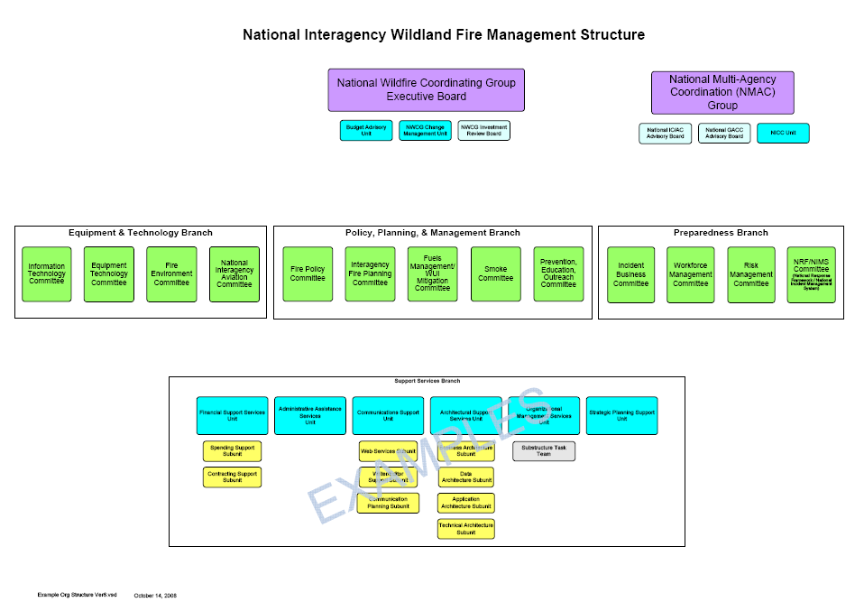

Establishing NWCG Groups
A methodology has been developed to help provide consistency in the way NWCG groups are defined. By utilizing the concept of a central “data store” to hold definitional information, and developing templates that can be populated from that information, standard “look-and-feel” documents can be created. A “write once, read-many” model will help assure this uniformity in a group’s presentation documents such as Charters, web pages, and Standard Operating Procedures.
To establish a group, certain information must be defined so that the following documents can be completed:
- Group Charter: This document has the main intent of formally authorizing a group’s existence. The charter is designed to be very generic and high-level so that moderate changes in the group’s business practices, membership, or deliverables will not require charter modification and approval. It broadly sketches the business area scope of the group, shows where they fit in the organization, and specifies the types of groups they are allowed to spawn.

- Group Overview: This document provides more detailed information about the intent of the group. Slight adjustments in the scope or mission of a group can be changed here without having to re-charter. Examples of information in this document include:

- Strategic intent | - Scope
- Vision | - Products
- Mission | - Major Activities
- Mission Goals | - Boundary Rules

- Group Standard Operating Procedures: This document describes the rules and processes by which the group conducts its business. Examples include:

- Decision Making | - Subgroups
- Meeting Frequency | - Member Tenure
- Communication Protocols | - Issue Resolution

- Group Roster: This document identifies the individuals that will fill the membership of the group.

NWCG Operating Principles and Guidelines serves as an umbrella document that provides standard high-level guidance and policy applicable to all NWCG groups.
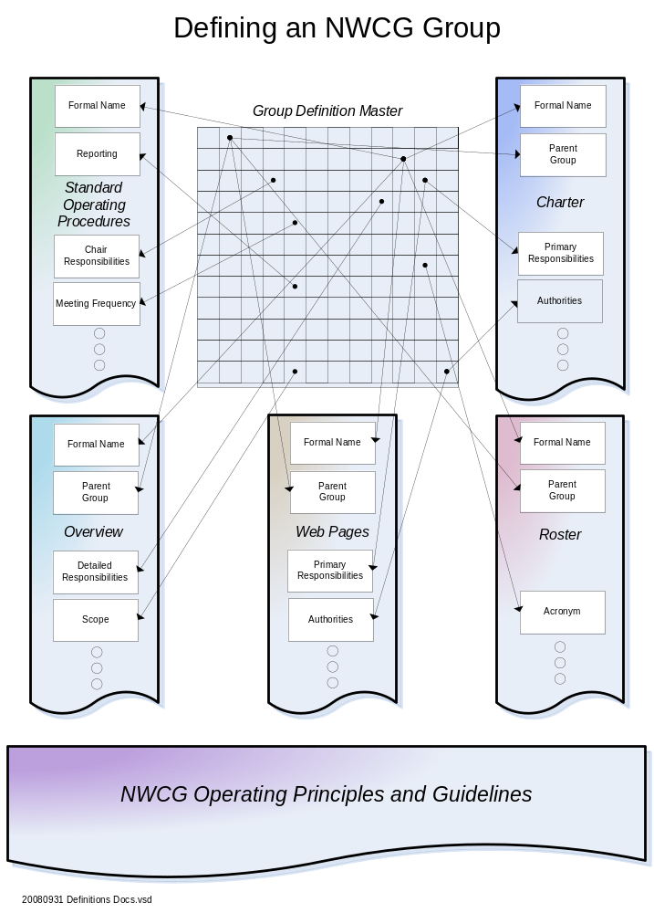Discussion on NWCG Reorganization:
- Shari /Jim both agreed and thought that the things should start to look a little clearer with new re-org and re-chartering.

- Branch Coordinators Committee and Subcommittee are part of putting a proposal together

- Include Support Services (meeting set up, notes, writer, editor, etc).

- Proposals handled at the Branch Level and then the handed up.

- Timeline is being worked on for Committees to be propped up for the structure.
Need to get each Committee Chartered
Fire Environment committee is the first Chartered

- Shari sees a structure in terms of Task Teams (pull together inter-disciplinary committees)

- Branch Coordinators set up an annual work plan and budget.

- Templates will be available for Chartering as well as the Supportive Document, Strategic Plan, Communication Plan, to help streamline the process for Groups.

- By January IRMWT should be ready to re-do charter

Some benefits seen with the New Organizational Structure.
- Hierarchy in NWCG Organization, any group can define their own self organization.
- Autonomy to self define and get the work done.

- Can expand to larger Fire/GIS Community – our job is coordination.

- GTG Mission is still basically the same – be able to plug in current strategic plan into the template.

- NWCG scope has expanded is encompassed to include much of the same work that the GTG has expanded with the GAO direction.

- States included as appropriate on each Committee depending on business need.

- Subgroups, Units all Chartered through their Parent Group.

- IRMWT will recharter as the an IT Committee – See ITC Charter [draft v1 10-27-2008].doc

- Reprecussions of reorganization, will be that all groups need to be re-chartered including GTG sometime after January.
See Charter _QuickStart_Template_v3.doc
Inter-Operability Oversight Group - Interagency CIO Group created to assist with InterAgency It/Communication Issues (Includes Fire, Law Enforcement, etc.)

- Meet four times a year and IRMWT can be the vehicle via the GTG to get issues resolved as well as potential funding.

- Proposal on issues to go up through NWCG (Inciweb/Geomac/IAP Maps, etc.)

End to End Reporting Sytem

John Noneman –IRWIN
- Gathering what is going on different systems, authoritative resources
- That’s why we did FORS.
- This is not a development Project / it’s an information gathering process to build the business case to go through the 300 process. Shari will make sure that the GTG is kept up to date.

- Meeting of OCIO and Radio Folks? Follow up meeting.
- On radios and idea of wildland fire IT Investment Fire Process
- Fire needs to have an idea of IT Investments (need a big picture view)
- Agencies going to their own agencies without the interagency picture in mind (no data standards, system standards, many ineffeciencies in development).

Wildland Fire Investment Process
One step process to work with the National Wildland Fire Process that should streamline proposals for each Agency. IT Investment Process – Agency versus Interagency

Process would include:
- 1 single proposal
- Idea – proposal development – business community – proposal review function – IRB – Authorization FEC – Agency Specific IRB – Funding comes from an Agency – Then to Development Process –

Business Change Management Unit (BCMU)
- Proposal for new system
- Review in respect to the Wildland Fire Enterprise

Challenges are different agencies perspectives on what a IT Investment Review would look like.

- Carol Seres PMO a draft for an investment review board - Business change management unit .

- Who would review? Currently groups don’t see them needs a process with an overview of the business.
- IT, GTG, Fire Environment Committee, Enterprise

- BCMU to help put the package together to go to the IRB. Do the staff work with the Interagency work in mind.

- This would include small and big projects with some thresholds in-between each process…could include data standard, application, data systems

- Strategic Intent of the project

- Baseline would come from the National Wildland Fire Architecture Plan to define priorities.

Shari /Jim both agreed and thought that the things should start to look a little clearer with new re-org and re-chartering.

- Branch Coordinators Committee and Subcommittee are part of putting a proposal together

- Include Support Services (meeting set up, notes, writer, editor, etc).

- Proposals handled at the Branch Level and then the handed up.

Timeline is being worked on for Committees to be propped up for the structure.
- Need to get each Committee Chartered
- Fire Environment committee is the first Chartered

Discussion of GTG Chair Position Rotation:

Two year vice chair and chair position – rotation of agencies has been the current procedure based on the GTG charter. This worked well in the past because agencies knew that they were next in the rotation and could anticipate this responsibility. It is a 4 year commitment. With so many new members, there was a need to revisit the rotation process.

Bill plans to retire end of calendar year. Uncertain of how will USFW replace Bill?

Alternatives for consideration:
- Skip over USFW for the Chair and rotate to the next agency
- Choose a new chair based on nomination.

Discussion:
If the Chair leaves before the end of term:

#1) Agency replaces vice chair remains
If replacement has experience can fill the role, if not the position rotates to the next member
#2) Vice Chair moves next agency on rotation becomes vice chair
#3) Nominate Chair and Vice Chair -

Maximum Term? Allow Consecutive Terms?

Suggestion made to vote in chair and get rid of the Agency rotation.

Change Charter to include voting for chair and vice chair
Vote :
Rotation = 0
Voting: Unanimous

Two Year Term Vote – 6
One Year Term Vote – 2
Consensus – vice chair and chair 2 year terms
- Two years - Chair
- Two years – Vice Chair

Therefore GTG voting members will vote for a new vice chair every 2 years.

Qualifications for Vice Chair
- Experience as determined by GTG
- Supervisory approval
- Wants to actually do the job – “honor”

Nominees
Katy Madrid Hipke
Kathie Hansen – vice
John Guthrie
Glen Buettner – vice
Sean Triplett
Dorothy Albright
Andy Wilson
BIA Rep - ?

The results of the ballot process: Katy Madrid will be the new Chair 2009 with Glen Buettner as the Vice Chair.

ACTION ITEM: When we rewrite charter to refine changes in the Chair and Vice Chair nomination process.

FTP Site - Kim Kelly, PNW Coordination Center, BIA
- Good fire season – very little downtime
- Helpdesk was outstanding
- Need to identify a business lead/sponsor in order to keep service going
- Has been identified as a very valuable service to the Fire community.

ACTION ITEM: IRMWT Identified a need for an Issue Paper – Kim working with Gladys to
Accomplish. Kim will keep GTG posted on where FTP is headed for next season.

Data Standards: The DAWG - Allen Dietz, NWCG PMO
Data Administration Work Group
Data Standard Proposed follows the process to

Get Diagram from Allen Dietz

- DAWG assigns the data standard stewardship

- Data standard needs the three elements Business Rep, Business Group, GTG and Constituents

- Create the Data Standard Forms and packet for submittal to the DAWG.

- DAWG membership one rep from each of the Working Teams.
It is going through a revision. Membership is in fluctuation.

- The proposed Fuels Standards was delayed because there was no Business Lead from Fuels.

- Any existing NWCG standard is exempt, but any new standards have to include NWCG standard.

ACTION ITEM: Kim Kelly will find out where the Fuels Group are at with the Data Standard.

- Two Business Communities could be appropriate

- Complexity with the Standard slowed the process down and flagged a need for a business lead

- Question on new standard new group – need to get involved to support their business need.

- Standard timeframes – not a viable option due to the variability of standards.

- FORS – Fire History Data Standard.

- OMB – data standardization in order to gain funding for new projects and systems.

- Copy of Data Standard Template for the notes.
Form designed to include both business and GIS communities and a discussion area for greater documentation.

- There is a change process for each standard, with the availability to identify a custom process. Note: Include link.

CTSP Update - Gladys Crabtree / Michael Morgan

NWCG CTSP Update

- Budget is a recurring issue that threads it way through much of what we have planned. Would like to know status so that plans can be made. With no budget comes minimal to no planned activities.

- CTSP Conference - Still in planning stages. Have verbal commitments from multiple individuals for training sessions. Planned for the week of March 9, 2009 in Boise, Idaho in the multipurpose room of the Jack Wilson building.

- CTSP Training - holding pattern. California training may be post-poned. Budget is a big impact. Historically each participant has had dollars acquired through various means to attend as a cadre member, but those are getting harder to find. We are expanding the cadre list to provide some regional overlap. Course will also be modified as needed to reflect changes in the camp environment as the thin client project proceeds.
  - California - Nov 3-7, 2008
  - Florida - ?
  - Minnesota - ?

- Continued interaction with IBA - Phase 3
- Thin Client Project - at a status quo. Six servers in possession, but kits not fully fleshed out. Will be proceeding with a minimal test next season unless additional funds & personnel are made available prior to fire season.

Security Whitepaper - Attached is the current version. Has been viewed/reviewed by a number of people. IBA project needs it approved and finalized.

Brian Lamb
NWCG CTSP Chair
907.356.5597

Whitepaper for IBA on Security – issues bring to Brian Lamb CTSP Chair
See 20081001 Security White Paper #001 – Incident Computer Security Procedures.doc

There is a CTSP training course 3 day – informal, not an official NWCG course.

Standard encryption format?? Gladys No, not on an incident

Thin Client - Gladys Crabtree

Thin Client Server and Terminals
Incident Management Team Information Technology
Kit Pilot Project Update
(Thin Client/Terminal Server)

The interagency Terminal Server/Thin Client Task Group met the week of September 22nd to discuss the project priorities, discuss goals for FY09, and assign action items.

Goals for 2009:

- Continue full-scale deployment testing of the system including caching concept, deployment, technical support, team transition, and tear-down. We have 6 complete kits (compared to one last year) to deploy this fire season for testing purposes. Ideally, we will have kits in trailers that can be deployed as one complete system. A complete system contains the server kit (server, UPS, Keyboard/monitor, switch), Thin Client kits (10 laptops, 10 desktops with monitor/keyboard), Network kits (switches, power strips, cables), and printer kit (2 printers).

- The team will be presenting project goals and funding requirements to NWCG in late November. The task team will be requesting $ which will cover FTEs for project management, detailed cost-benefit analysis, help desk support, training, procurement of trailers. At this point, no additional hardware will be purchased until field testing is complete.

- Provide training to Computer Tech Specialists (CTSPs) for the set-up and administration of the system this year.

Regardless if NWCG provides the $, the project could move forward but certainly not to the extent if we had additional $. The ad-hoc group is capable of supporting one, maybe two systems next year without additional funding, but it may be a struggle. Team members have their normal duties and most are part of incident management teams. We will need to reassess the project and goals if there is not much support from NWCG.

Missoula Technology & Development Center (MTDC) will be fully engaged with the group and testing. Our involvement includes:

- Providing project coordination until a project manager is assigned (if that occurs is yet to be determined)
- Developing and testing a wireless solution for the terminal server/thin client system (need to discuss with CIO security about wireless equipment specifications and protocols)
- Testing the use of a remote (off-site) server for those instances where a camp has good/secure internet service (ie, school, district office). In this model, there is no need to deploy a server at camp. Provides easier administration, extends life of server (no transport or harsh environment), better physical security, etc.
- Develop deployment documentation
- Design trailer for storage and deployment
- Continue testing equipment and software
- Develop and analyze user and CTSP questionnaires

The Thin Client Project team members:
Name | Agency | Location
David Potter | Bureau of Indian Affairs | NIFC, Boise, ID
Brian Lamb | Bureau of Land Management | Alaska Fire Service
John Noneman | Bureau of Land Management | NIFC, Boise, ID
Mike Morgen | Bureau of Land Management | NIFC, Boise, ID
Nichole Owen | Bureau of Land Management | NIFC, Boise, ID
Jody Lane | Forest Service | Vallejo, CA
Tyler Hackney | Forest Service | Missoula, MT
Steve Simon | Forest Service | Billings, MT
Matt Cnudde | Forest Service | NIFC, Boise, ID
Bob Roth | Forest Service | Missoula, MT
Jon Holden | Forest Service | McClellan, CA
Gary Stewart | Forest Service | Boise, ID
Gina Bald | Forest Service | R4
Gladys Crabtree | National Park Service | NIFC, Boise, ID
Erik Torres | National Park Service | Boise, ID
Peter Paul | National Park Service | Mt. Rainier, WA
Don Winter | National Park Service | Mt. Rainier, WA
Andy Trent | Forest Service | MTDC, Missoula, MT
Wes Throop | Forest Service | MTDC, Missoula, MT
Kevin Snyder | ISG Consulting | Washington, DC
Art Clinton | Forest Service | Washington, DC

Andy Trent
USFS - Missoula Technology & Development Center
5785 W. Broadway
Missoula, MT 59808
Phone: (406) 329-3912
Cell: (406) 210-0695
Fax: (406) 329-3719
Email: atrent@fs.fed.us

6 kits
1 machine NFDRS

Goals 2009:

Katy Looking to GTG to assist with software and configuration of GIS software
Have thin laptops and look at other classes such as NFDRS and GPS courses

- NFDRS – provide feedback on configuration that works with ArcGIS, .FGDB etc.

- Looking at cargo trailers with office space

- Why thin client and not private vendor? The current issue is security and information sensitivity.

- Laptops will be able to RDP into the thin client server

- Future looks to be a mixture of laptop and thin client.

- CTSP Group looking to set up a GSTOP like document to outline best practices

- Cost benefit analysis

Ideal situation would be the ability to compare GIS on laptop and server to understand performance needs.

Phased approach –
Centralized Servers (may be off the incident)
Ability to host data on Thin Client

NIROPS IRIN – Darell VanBuren
1960’s IR Imagery since development
All now is currently digital conversion from film

- Predators, Hawks, U2’s – 16,000 images

- Calfire got together and decided on standard format we need (DOD, DOE, Fire Feds)

- Utilize different platforms, and own aircraft

- Remote Sensing and Geospatial Arm – RSAC is the R&D for the NIROPS Program
- They review all of the data and vendor info coming in, Information to the IC’s
- That is accurate and timely

- IR Flight and IR Interpreter at the same time – now we can keep IR Interp remotely and have the map to the IC the same night.

- Thanks to the FTP Board (provide the service) – so they can provide the customer service that they have been able to do.

ACTION ITEM: NIROPS close out in Boise next week. Kim will connect with the NIROPS Group for a call on ftp.

PODS – 4 or 5 interpreters in one area and break out information.
Action Item: Darrel Van Burren - Talk to Gladys about an IRIN Thin Client to Support Pod.

Order scanner with the interpreter

S443 – Class for IRIN
Would like to get S443 back into NWCG as official class

IRIN currently as a technical specialist – would like to get it as an official position

KML format was good and agree that both shapefile and KML formats are useful.
KML conversion processing needs to be looked into to provide a cleaner KML export.

Downlink capabilities available

Working with Phoenix data handout – See Working with Phoenix Digital Data 20080514-rj.doc

Who does Pods report to? How do we give a status review? IRIN looking to develop SOPS for the
Pods.

Regional Coordinators – help with programming and flight for the aircraft.
Military and Pod

Each Interpreter managing the POD – need to try and identify a POD Leader
Interpreter could be working on several fires

ACTION ITEM: Sean Triplett – If GTG to help the IRIN group move the S443 course through the 310-1 system, and SOPS, there needs to be a two way street and IRIN will need to become more involved.

ACTION ITEM: Darrell Van Buren to find a focal person to help facilitate coordination on assisting to further develop S443.

NIROPS Lost IRIN as a technical specialist and will need to work to re-institute.

GTAG Update – Kathie Hansen

GPS – 4 Courses
Kathie Hansen will share dates and locations for the GPS course
http://www.odf.state.or.us/gis/gtag/gtag.html

Classes are being taught where there are requests.
There is minimum of 8 students needed to put on a course.
Lead Instructor, Coordinator , and a local coach

Smoke Jumpers – will be taking a singular course in Boise
SJ’s looking to diversify their skills in helping to provide burn plans etc.

Trying to move more training to distance learning but GPS is not truly designed for this as it is designated a field course.

Course is focused towards for Fire Fighter – Operations oriented FOBS
Some GISS, some Search and Rescue

Lower attendance due to travel restrictions

Suggestion to do more train-the-trainer and make modules available online on the GTG page,

Kathie did some modular work in the past, no feedback on the modules

Currently teaching Garmin Map 76S
Looking at Garmin 60 CSx for the class – color and usb connection. GTAG is unsure how to get $ to purchase receivers.

Don Wascho – retirement / job change

GISS - Joe got a dump from ROSS GISS , IRIN

Sean gave the group locations and dates. http://www.odf.state.or.us/gis/gtag/gtag.html

California will be hosting a course in San Bernadino

Updating the course material

Workflow and step by step process

Migrated a GPS section in the course

Vacancies (BIA, BLM)

Eric Schmeckpepper, Carl Brown, Kathie Hansen, Karrie Mich, Sean Triplett, Emmor Nile

Talked about the Thin Client for inclusion in the course? Look for an opportunity to do this.

Note: If there is an issue with training function groups bring it forward in a white paper to the IRMWT to help them intervene with other training groups

PNWCG group working on a crosswalk analysis – SITL needs an OPS qualification
Looking at reviewing position

GIS – Involvement in other functional areas – Dorothy Albright
– schematic of various stakeholders and where NIMO, Area Command, Theater of Operations, MAC fit in.

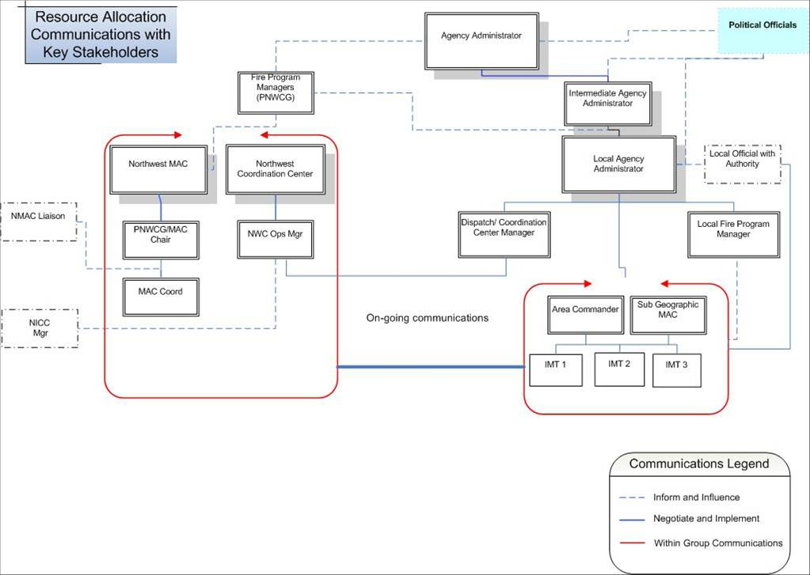

NIMO – Tom Cable, IC NIMO

http://199.134.225.50/nimo_teams/boise_nimo/index-01.shtml

See NIMO_Who We Are.doc
Four Teams (maybe teams 5 & 6 in future)
All four teams are FS Teams (next may be interior)

Comprised of Private industry, and Fed Folks

Note: A copy of Tom Cable’s powerpoint is provided in a separate document.

Major Duties – 9

- NIMO assisting with the Training and qualifications (working with Tom Z team on WFDSS)
- All Hazard

How can GTG support NIMO Operations? See What is NIMO-GTG.ppt

Not sure what to ask from GISS/GTG Support.

We do need products in terms of FSPRO/RAVAR

Evaluate and display probability of success for a fire?

- IMT’s need help seeing the big picture. Not sure if they fully understand what is out there and available.
- We believe we are being supported by the GIS community. We don’t know if we are asking the right questions.
- To look at the fuels and topography ahead of the fire
- Analysis to support long term planning & management decisions = WFDSS, RAVAR
Would like to be able to evaluate and display the “probability of success” of a selected alternative. IC’s & AA’s want this

Ability to manage a several fires at once in terms of a service center.

Need better support from IRIN, and better coordination.

ACTION ITEM: GTG can help let the IC’s know what is available; some problems with IR information.

December 8th 9th and 10th Reno IC AAR – Agenda - consider a poster display?

Capacity building – do you go help support a new type 2 team? Yes part of the mission.

Designed to go on long term assignments.

NIMO teams comprised of 7 Members – command and general staff. There are 4 NIMO teams: Portland, Boise, Atlanta, and Phoenix.

Are there going to be less Type I Teams? Most likely not.

Take advantage of the opportunity of a GTG member to go out with the NIMO Teams to understand needs.

Assist with information to the IC’s

ACTION ITEM: Develop a matrix of technology to help assist the NIMO team – Models, hardware, software, SOPS documentation.

ACTION ITEM: GTG Member to take NIMO Team up on their offer to go on NIMO Assignment (Dorothy to help coordinate)

Chair and Vice Chair Votes – 2009/2010

Katy Madrid-Hipke - Chair
Glen Buettner – Vice Chair

Additional GIS customers for Strategic Decision Making – Kim Kelly / Dorothy Albright

Increase in the number of GISS and GIS Specialist (THSP and other Non-GISS) being order to assist with NMAC, GMACs, Area Command, and NIMO Teams. Some development of non Incident related products and requests. Develop a list of new products and incorporate information and resources for data to provide information within training sessions, web outreach, etc.

Staffing Goal –
Task Team –
Staffing GIS Skills Training
Define Geospatial Skills
Develop Wildland Fire Skills and Abilities
Project that develops geospatial skill set for the wildland fire

RAVAR – Kevin Hyde

NOTE: A copy of Kevin’s Powerpoint is provided as a separate document.

DOI Agencies starting to take on a large active role – NPS, BLM
Research will be eventually handing this over to the Agencies to manage.

New Process RIVAT (a mini RAVAR but based on buffers not probabilities).
New Process BAER-VAR

BIA – differential viewing – resources can be mapped in eye view only.
Trust
Heritage – password protected
Pre-positioned Trust Documentation

http:/www.fs.fed.us/rm/wfdss_ravar

GIS – SOPS

410-1 Symbology – IOSWT
Bob Leverton – John to follow up for Bob Leverton
Get Updates into the 410-1 from the SOP’s.

Updates for SOP’s
Aviation
IRIN
DHS?

410-1 – up for review , expectation that the IOS W/T will update sometime this year, as yet unscheduled. Typically a 2 year update process.

ACTION ITEM: John Guthrie will be lead for making contact with IOS.

Get a count on the SOP’s published. Had to make PMS Reports on the PMS Website.
Insert the PMS tracking sheet

ACTION ITEM: Kim Kelly will take a lead on what needs to be changed in the SOP’s.
- Symbology
- WFDSS, AMR, Management Action Points
- Public Meeting Map

ACTION ITEM: Kathy Hansen agreed to take lead on templates.

ACTION ITEM: John Guthrie will lead Task Team for Symbology – with the focus on getting the SOPS synched up to the 410-1 Need to be ready to meet 410-10 Timeline – John Guthrie to find out what the timeline is.

Task Team for Changes to SOP
- Symbology
- New Fire Datasets/Maps/etc. WFU/WFDDS/AMR/

Need to talk about the review and update process and how to update documentation.

Glossary of solution tools?

GIS – Website

Contract a total redesign of the Web for the NWCG Committees work teams redesign.

Under NWCG.GOV ,
Content Management Page for the opportunity to update.

Needed and requested needs for the Web site? Dynamic Database to be incorporated.

GTG will probably get questionnaires asking for what web services might be needed.

Basic business information – roster, meeting minutes, etc will go on the New redesigned web page
Other business can currently still remain on the NWCG GIS page.
Federal Compliance, Agency Compliance

DOI, USDA – domains – NIFC.GOV (under the domain of the dept of the interior)
Various CIO’s are the managing heads for the Domains.
NWCG.GOV – will now be the chair under the NWCG

John Guthrie – USGS doesn’t want to do anything but maintain web site

ACTION ITEM: IRWT will recommend GTG as one of the test groups when the Web page is being redesigned in Feb 2009

DHS – Kathie Hansen and Sean Triplett

- Homeland Security GIS working group.
- GTG should be included – Bob Anderson and Vanessa

- Sean will be working to this group, Jack Sheffie.

- John Perry – Acting Operations for FEMA Nebraska Center

- Task Order and building and organization, difficult to order single resources

- Hired via ESF4 – USGS, Remote Sensing folks, Hydrology, GISS, Fire Fighters

ACTION ITEM: Distribute list of DHS group participants and documentation (Sean)

Work for ESF5 even if order by ESF4

USAR ?

Why is this group important – Different Positions being identified- some task books identified
Define credentials for the Geospatial Positions

- FEMA getting involved and onsite – on Fires now and becoming more involved.
- Manages certain level of aircraft/airspace

- I700, I800 – Courses for ESF4 Training

- Doesn’t appear to be a big workload

ACTION ITEM: Sean Triplett to act as the GTG –Rep on the DHS Working Group.

ACTION ITEM: Sean Triplett to research better coordination of FEMA orders for GISS orders.

ACTION ITEM: IRWWT Chair Shari Shetler to let the NWCG rep know that the GTG is coordinating with this DHS group.

Aviation Resource Management
Powerpoint Presentation From DOI Aviation Business Center
http://www.nbc.gov/

Arlyn Miller, National Helicopter Specialist
arlyn_miller@nbc.gov

Area Command - Tom Zimmerman

- 10 People to allocate resources and set priorities of incidents and Manage Incidents.

- Works with the GMAC

- Delegation of Authority by Agency Administrator to reduce their span of control.

- All Risk Assignments

- 2007 GACC authorized Area Command to provide Decision Support
- Supervised Decision support group, GIS group, long term assessment team.

2008 – 3 analyst, GIS, and long term assessments with Decision Support in Northern California Assignment with internal team only

- Expand and contract based on need.

- Theatre Command – Larger Scale Span and Control

- Direction from Agency Director to the IC goes through Area command

GIS Needs for Area Command –
- WFDSS – FSPRO/RAVAR
- Accommodate Full time GIS member on the team
- Assist in showing Predicted Risk/Cost

4 National Area Command Teams

Get a list of positions that make up an Area Command Team
The Area Command organization operates under the same basic principles as ICS. Typically, an Area Command will comprise the following key personnel, all of whom must possess appropriate qualifications and certifications:
1. Area Commander (Unified Area Command).
The Area Commander is responsible for the overall direction of the incident management teams assigned to the same incident or to incidents in close proximity. This responsibility includes ensuring that conflicts are resolved, that incident objectives are established, and that strategies are selected for the use of critical resources. The Area Command is also responsible for coordinating with Federal, State, local, tribal, and participating private organizations.
2. Area Command Logistics Chief.
The Area Command Logistics Chief provides facilities, services, and materials at the Area Command level and ensures the effective allocation of critical resources and supplies among the incident management teams.
3. Area Command Planning Chief.
The Area Command Planning Chief collects information from various incident management teams to assess and evaluate potential conflicts in establishing incident objectives, strategies, and priorities for allocating critical resources.
4. Area Command Support Positions.
The following positions are activated as necessary.
a. Area Command Critical Resources Unit Leader.
The critical resources unit leader tracks and maintains the status and availability of critical resources assigned to each incident under the Area Command.
b. Area Command Situation Unit Leader.
The situation unit leader monitors the status of objectives for each incident or IMT assigned to the area command.
c. Area Command Public Information Officer.
The PIO provides public information coordination between incident locations and serves as the point of contact for media requests to the Area Command.
d. Area Command Liaison Officer.
The liaison officer helps maintain off-incident interagency contacts and coordination.
e. Area Command Aviation Coordinator.
An aviation coordinator is assigned when aviation resources are competing for common airspace and critical resources, and works in coordination with incident aviation organizations to evaluate potential conflicts, develop common airspace management procedures, and prioritize critical resources.

Decision Support Specialist – ReRap/Farsite Technical Specialist

- No IBA functions identified.

- Different GISS – Products , Tasks, Datasets Different, Fire Perimeter, Fire Progression, FSPRO, RAVAR,

- GIS Person to be identified who can scope out needs of Area Command Team –
E.g. John Pilsworth – State of Montana Area Command GIS person on Zimmerman’s Team

- NICC website has different area command teams listed.

- Geographic Regional Editors

- Area Command most likely initiated by an agency Unit

- Area Command connected with Incident – Business process to tie in with Area Command Coordination between Area Command Teams and IC Teams – so there aren’t duplication of efforts

- Complex Fires and not having the ability to get information from Area Command to IC’ Teams.

- Incident GISS to connect with Area Command GISS

WFDSS – Tom Zimmerman

Why Decision Support?
NOTE: A copy of Tom’s Powerpoint is attached as a separate document.

2009
- Should include Full Suite –

- Could replace some Dispatch and Fire Reporting Processes

- How can states contribute or benefit from WFDSS. Project still looking into

- GTG Role – Data Standards, Data Needs, Feedback to WFDSS Team, File Types
ACTION ITEM: Kim to get Gladys the AAR on WFDDS

Next Meeting

Next Conference Call December 15th, 1pm Eastern
ACTION ITEM: Katy to get a call line.

Spring Meeting ??? Options

- April 27th – May 1
FS/BLM Tools Conference
Snow Bird Conference, UT
Lead – Andy Wilson

- March 9th CTSP Conference
Boise, ID
Lead – Katy Hipke

- March/April
Missoula , MT
Lab Presentations
Lead – Jim Menakis

Will gather information and discuss further.
ACTION ITEM Summary

- ACTION ITEM: Glen to get a list of State Contacts for each State

- ACTION ITEM: Sue to get a list of State Contacts for each State

- ACTION ITEM: Katy to connect with Randy Erdly on Geomac and Inciweb site.

- ACTION ITEM: Make a recommendation to have an Agency Update Form that is mailed or transferred for each meeting - Katy/Glen

- ACTION ITEM: When we rewrite charter to refine changes in the Chair and Vice Chair nomination process.

- ACTION ITEM: IRMWT identified a need for an Issue Paper – Kim working with Gladys to
- Accomplish. Kim will keep GTG posted on where FTP is headed for next season.

- ACTION ITEM: Kim Kelly will find out where the Fuels Group are at with the Data Standard.

- ACTION ITEM: Kim will connect with the NIROPS Group for a call on ftp. NIROPS close out in Boise next week.

- ACTION ITEM: Darrel Van Burren - Talk to Gladys about an IRIN Thin Client to Support Pod. (Kim)

- ACTION ITEM: Sean Triplett – If GTG to help the IRIN group move the S443 course through the 310-1 system, and SOPS, there needs to be a two way street and IRIN will need to become more involved.

- ACTION ITEM: Darrell Van Buren to find a focal person to help facilitate coordination on assisting to further develop S443.

- ACTION ITEM: GTG can help let the IC’s know what is available; some problems with IR information.

- ACTION ITEM: Develop a matrix of technology to help assist the NIMO team – Models, hardware, software, SOPS documentation.

- Action Item: GTG Members to take NIMO Team up on their offer to go on NIMO Assignment (Dorothy to help coordinate)

- ACTION ITEM: John Guthrie will be lead for making contact with IOS.

- ACTION ITEM: Kim Kelly will take a lead on what needs to be changed in the SOP’s.

- ACTION ITEM: Kathy Hansen agreed to take lead on templates.

- ACTION ITEM: John Guthrie will lead SOP Task Team for symbology.

- ACTION ITEM: IRMWT will recommend GTG as one of the test groups when the Web page is being redesigned in Feb 2009 (Allen Deitz)

- ACTION ITEM: Distribute list of DHS group participants and documentation (Sean)

- ACTION ITEM: Sean Triplett will act as the GTG –Representative on the DHS Working Group.

- ACTION ITEM: Sean Triplett to research better coordination of FEMA orders for GISS orders.

- ACTION ITEM: Shari Shetler, IRWWT Chair, to let the NWCG representative know that the GTG is coordinating with this DHS group.

- ACTION ITEM: Kim to get Gladys the AAR on WFDDS

- ACTION ITEM: Katy to get a call line for Dec conference call.

