NFDRS Thin Client Test - GIS Processing Exercise

- Copy New Dataset to your Faculty Working Directory
Copy and Paste the entire Utah folder into your Faculty Work Directory E:\Faculty\kkelly

- Open up the Utah.mxd
Turn on Fire_Occurance_All_Fires

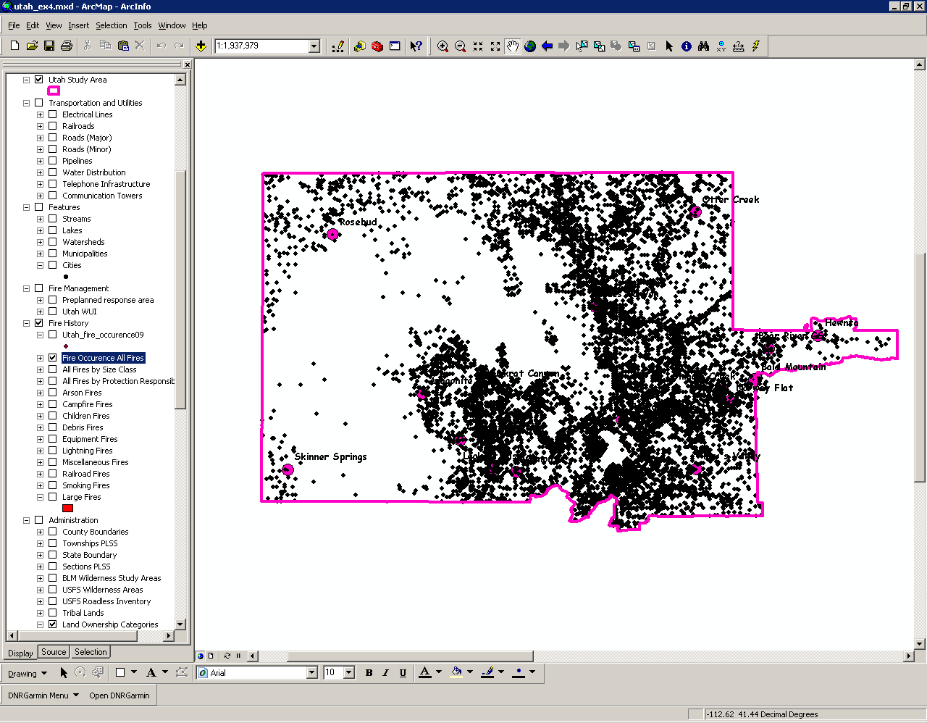

- Add the E:\Faculty\yourname\utah\Temp\Test_Utah_FDR_Areas.shp to your Utah.mxd file.

- Join the Fire_Occurance_All_Fires with the Test_Utah_FDR_Areas
Right click on Fire_Occurance_All_Fires and choose the Join option
Use the following inputs to the dialogue box.

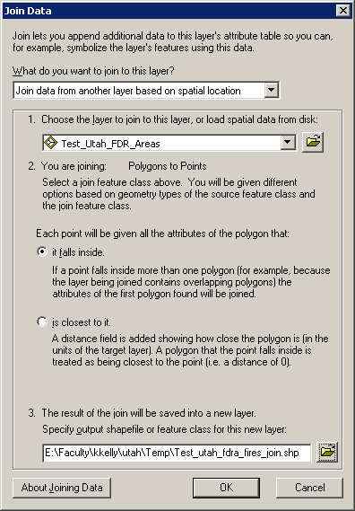

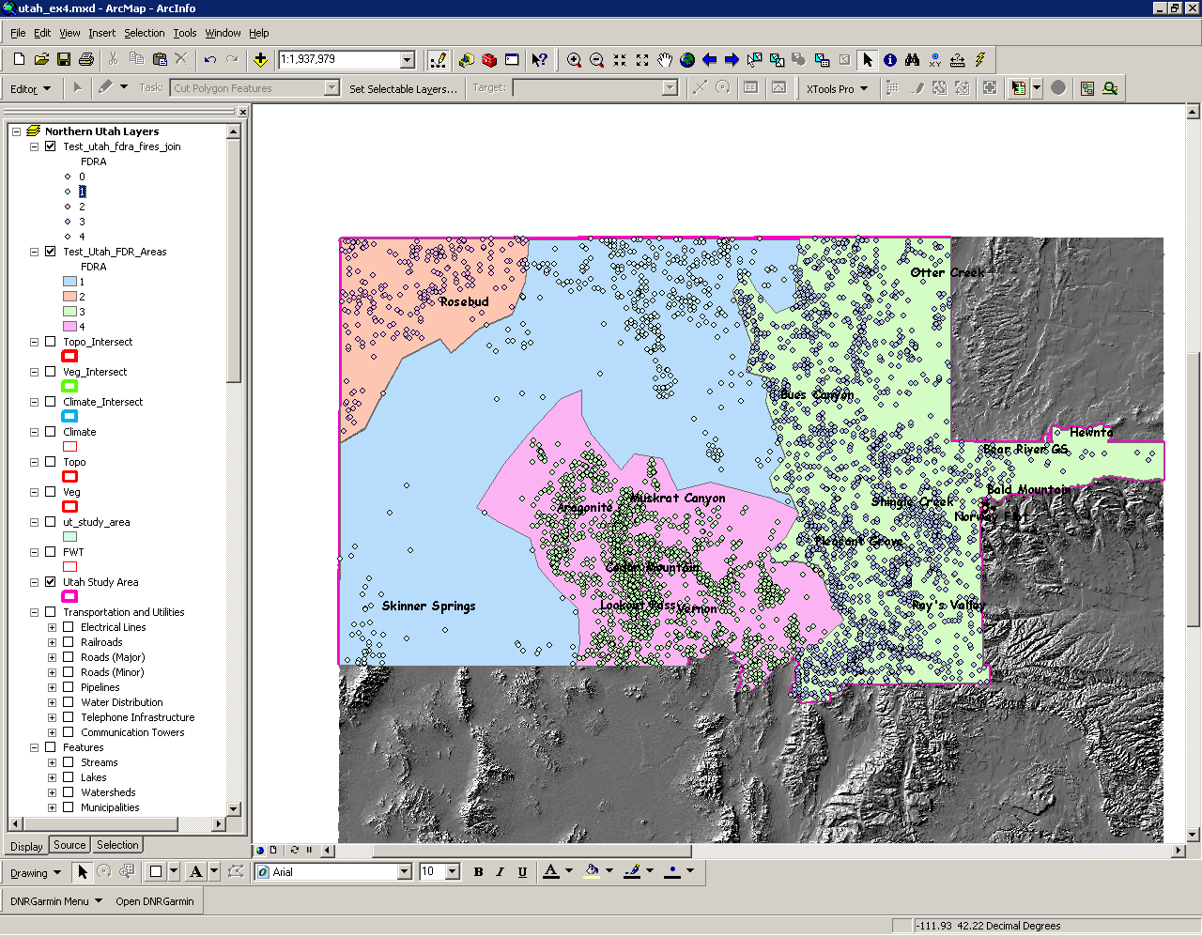

- Query Lightning Fires from the newly created test_utah_fdra_fires_join.shp
Right click on test_utah_fdra_fires_join.shp
Select Properties
Select the Definition Query Tab
Fed_Cause = 1
Select OK

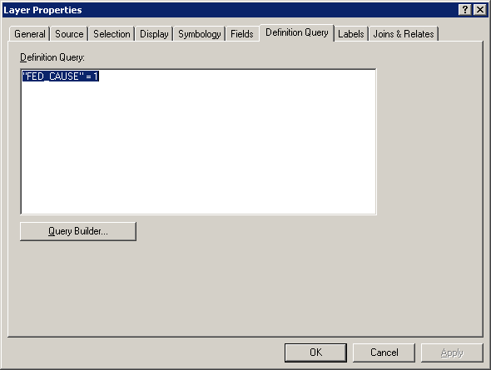

- Export Lightning Fires to a new Shapefile
Right click on test_utah_fdra_fires_join.shp
Select Export Data
Select OK
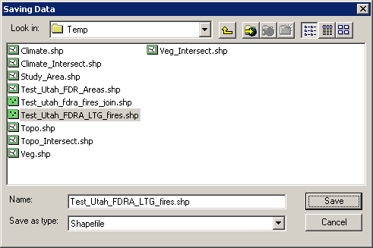

- Add exported data to the map layer?
Select Yes.

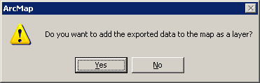

8) Save .mxd and close.

