State and Private Forestry Assessment Tool—
File Upload Using FTP

Draft USDA Forest Service
August 2009

Prepared for:

Mike Barrowcliff
USDA Forest Service
Fire & Aviation Management
National Interagency Fire Center
3833 S. Development Ave
Boise, Idaho 83705

Phone: 208-387-5294
E-mail : mbarrowcliff@fs.fed.us

Prepared by:

ESRI
380 New York Street
Redlands, California 92373-8100

Copyright © 2009 ESRI
All rights reserved.
Printed in the United States of America.

The information contained in this document is the exclusive property of ESRI. This work is protected under United States copyright law and other international copyright treaties and conventions. No part of this work may be reproduced or transmitted in any form or by any means, electronic or mechanical, including photocopying and recording, or by any information storage or retrieval system, except as expressly permitted in writing by ESRI. All requests should be sent to Attention: Contracts and Legal Services Manager, ESRI, 380 New York Street, Redlands, CA 92373-8100 USA.

The information contained in this document is subject to change without notice.

U.S. GOVERNMENT RESTRICTED/LIMITED RIGHTS
Any software, documentation, and/or data delivered hereunder is subject to the terms of the License Agreement. In no event shall the U.S. Government acquire greater than RESTRICTED/LIMITED RIGHTS. At a minimum, use, duplication, or disclosure by the U.S. Government is subject to restrictions as set forth in FAR §52.227-14 Alternates I, II, and III (JUN 1987); FAR §52.227-19 (JUN 1987) and/or FAR §12.211/12.212 (Commercial Technical Data/Computer Software); and DFARS §252.227-7015 (NOV 1995) (Technical Data) and/or DFARS §227.7202 (Computer Software), as applicable. Contractor/Manufacturer is ESRI, 380 New York Street, Redlands, CA 92373-8100 USA.

@esri.com, 3D Analyst, ACORN, Address Coder, ADF, AML, ArcAtlas, ArcCAD, ArcCatalog, ArcCOGO, ArcData, ArcDoc, ArcEdit, ArcEditor, ArcEurope, ArcExplorer, ArcExpress, ArcGIS, ArcGlobe, ArcGrid, ArcIMS, ARC/INFO, ArcInfo, ArcInfo Librarian, ArcInfo—Professional GIS, ArcInfo—The World's GIS, ArcLessons, ArcLocation, ArcLogistics, ArcMap, ArcNetwork, ArcNews, ArcObjects, ArcOpen, ArcPad, ArcPlot, ArcPress, ArcQuest, ArcReader, ArcScan, ArcScene, ArcSchool, ArcScripts, ArcSDE, ArcSdl, ArcSketch, ArcStorm, ArcSurvey, ArcTIN, ArcToolbox, ArcTools, ArcUSA, ArcUser, ArcView, ArcVoyager, ArcWatch, ArcWeb, ArcWorld, ArcXML, Atlas GIS, AtlasWare, Avenue, Business Analyst Online, BusinessMAP, CommunityInfo, Data Automation Kit, Database Integrator, DBI Kit, EDN, ESRI, ESRI BIS, ESRI—Team GIS, ESRI—The GIS Company, ESRI—The GIS People, ESRI—The GIS Software Leader, FormEdit, GeoCollector, Geographic Design System, Geography Matters, Geography Network, GIS by ESRI, GIS Day, GIS for Everyone, GISData Server, JTX, MapBeans, MapCafé, MapData, MapIt, Maplex, MapObjects, MapStudio, ModelBuilder, MOLE, MPS-Atlas, NetEngine, PC ARC/INFO, PC ARCPLOT, PC ARCSHELL, PC DATA CONVERSION, PC STARTER KIT, PC TABLES, PC ARCEDIT, PC NETWORK, PC OVERLAY, PLTS, Rent-a-Tech, RouteMAP, SDE, Site•Reporter, SML, Sourcebook•America, Spatial Database Engine, StreetEditor, StreetMap, Tapestry, the ARC/INFO logo, the ArcAtlas logo, the ArcCAD logo, the ArcCAD WorkBench logo, the ArcCOGO logo, the ArcData logo, the ArcData Online logo, the ArcEdit logo, the ArcEurope logo, the ArcExplorer logo, the ArcExpress logo, the ArcGIS logo, the ArcGIS Explorer logo, the ArcGrid logo, the ArcIMS logo, the ArcInfo logo, the ArcLogistics Route logo, the ArcNetwork logo, the ArcPad logo, the ArcPlot logo, the ArcPress for ArcView logo, the ArcPress logo, the ArcScan logo, the ArcScene logo, the ArcSDE CAD Client logo, the ArcSDE logo, the ArcStorm logo, the ArcTIN logo, the ArcTools logo, the ArcUSA logo, the ArcView 3D Analyst logo, the ArcView Data Publisher logo, the ArcView GIS logo, the ArcView Image Analysis logo, the ArcView Internet Map Server logo, the ArcView logo, the ArcView Network Analyst logo, the ArcView Spatial Analyst logo, the ArcView StreetMap 2000 logo, the ArcView StreetMap logo, the ArcView Tracking Analyst logo, the ArcWorld logo, the Atlas GIS logo, the Avenue logo, the BusinessMAP logo, the Data Automation Kit logo, the Digital Chart of the World logo, the ESRI Data logo, the ESRI globe logo, the ESRI Press logo, the Geography Network logo, the GIS Day logo, the MapCafé logo, the MapObjects Internet Map Server logo, the MapObjects logo, the MOLE logo, the NetEngine logo, the PC ARC/INFO logo, the Production Line Tool Set logo, the RouteMAP IMS logo, the RouteMAP logo, the SDE logo, The Geographic Advantage, The Geographic Approach, The World's Leading Desktop GIS, Water Writes, www.esri.com, www.geographynetwork.com, www.gis.com, www.gisday.com, and Your Personal Geographic Information System are trademarks, registered trademarks, or service marks of ESRI in the United States, the European Community, or certain other jurisdictions.

Other companies and products mentioned herein may be trademarks or registered trademarks of their respective trademark owners.

Document Change History

Change/Review History
Date | Description | Person Responsible
8/04/2009 | Draft | Richard Lawrence

Table of Contents

Section Page

1.0 S&PFAT FTP Function Overview 1
1.1 What is the S&PFAT FTP Function and How Does It Relate to S&PFAT? 1
1.2 S&PFAT Inputs 1
1.3 How are S&PFAT Inputs Used? 2
1.4 Purpose of This Document 2

2.0 The FTP Process 4
2.1 FTP Overview 4
2.2 FTP Workflow for Windows Explorer 4

1.0 S&PFAT FTP Function Overview

1.1 What is the S&PFAT FTP Function and How Does It Relate to S&PFAT?

The State and Private Forestry (S&PF) Assessment Tool (S&PFAT) File Transfer Protocol (FTP) function is a function that allows a user to upload his local data to the S&PFAT system for analysis. User data is an important component of the S&PFAT system because it provides state, regional, and national S&PF stakeholders with the ability to analyze data that is specific to their interests, jurisdictions, and mandates.

The S&PFAT provides a web-based tool to guide forestry planning and decision-making. Specifically, S&PFAT produces thematic maps that contain information about the potential for implementing forest management practices.

1.2 S&PFAT Inputs

The user-provided data inputs to the S&PFAT system are map layers that are stored in a raster-based spatial format that is compatible with ArcGIS. A raster is defined as: a grid of x and y coordinates on a display space wherein the grid values connote some defined data characteristic. The reader is referred to the following website for supported raster dataset file formats:

http://webhelp.esri.com/arcgisdesktop/9.3/index.cfm?id=2650&pid=2640&topicname=Supported_raster_dataset_file_formats

Technical specifications for raster dataset files can be found at the following website:

http://webhelp.esri.com/arcgisdesktop/9.3/index.cfm?TopicName=Technical_specifications_for_raster_dataset_formats

Raster-based map files must be synchronized according to format and resolution prior to being analysis-ready. Synchronization means that all layers that will be used in a single analysis must have a common format. An analysis is defined as a combination of raster map layers and processing rules that are performed using geographical algorithms to produce an output raster map that is defined by the parameters of the analysis. An example might be analyzing fire risk, percent forest cover, and wild land-urban interface to produce an output map of urban areas at risk. The following characteristics indicate the format requirements for synchronization:

- Each file is smaller than 2 Gb in physical disk size
- For national data, 1-km resolution for all layers commonly grouped in an analysis is the recommended grid resolution. While finer resolution can be used, it will significantly lengthen processing time.
- For regional data, 250-m resolution for all layers commonly grouped in an analysis is the recommended grid resolution. While finer resolution can be used, it will significantly lengthen processing time.
- For state data, 100-m resolution for all layers commonly grouped in an analysis is the recommended national grid resolution. While finer resolution can be used, it will significantly lengthen processing time. Larger states, such as Texas or Alaska also will require additional processing time.
- All layers associated in a single analysis must have a common geographic extent, pixel size, pixel alignment, datum, and projection in order for the analysis to produce meaningful results.

Synchronized raster inputs are prepared ahead of time and are then made available to the S&PFAT system as the raw materials for an analysis. In some cases, raster inputs that were previously loaded into the system by other users may be available for analysis.

1.3 How are S&PFAT Inputs Used?

Raster inputs not already loaded must physically be brought into the S&PFAT system for analysis. This is accomplished by using standard FTP functionality that is typically available within the Microsoft Windows operating system. While other FTP applications can be used, this document will only address Windows-based FTP.

Once the input files are moved from the user's machine to the S&PFAT system using FTP, the data inputs become available to be loaded automatically into the S&PFAT system. The S&PFAT provides end-user tools through the S&PFAT user interface that are used to associate input layers with analyses and other analysis-associated features such as theme variants and alternatives. Definitions for and definitions of theme variants and alternatives are beyond the scope of this document and may be found in S&PFAT system documentation.

1.4 Purpose of This Document

This file upload guide provides the information needed for users to upload their own, local, synchronized raster input files into the S&PFAT system for analysis. The guide contains the steps that are required to successfully do the following:

- Start the Microsoft Windows FTP program.
- Access the remote computer where the S&PFAT resides in order to upload synchronized raster input files from a user’s local machine into the S&PFAT file repository.
- Login to the standard file structure required by S&PFAT using a username and password that is provided later in this document.
- Use commands to create a unique user file, a standard file structure, and then upload synchronized raster input files into the standard file structure.
- File names may not contain restricted characters according to MS Windows standards. The restricted characters are: / , \ , ? , % , * , : , | , “ , > , < , . (period), and spaces. The file name also should be no longer than 25 characters. Other than these guidelines, there are no restrictions on file names. However, it is suggested as a best practice that labels indicative of file content and resolution (national, regional, state) be employed to provide clues and helps to end users of the data.

2.0 The FTP Process

2.1 FTP Overview

To begin using the FTP application, the user starts the Windows Explorer application. From there, the user executes a series of graphically guided steps in the FTP user interface to upload synchronized raster input files. Following the FTP upload process, the user will have moved synchronized raster input data from their local computer to the servers that host the S&PFAT system. At that point, the raster input data can be grouped into an S&PFAT analysis.

2.2 FTP Workflow for Windows Explorer

The following steps are required for users to upload their synchronized raster input data into the S&PFAT system. This process assumes that the user will be using the FTP application available in Windows Explorer.

1. The user opens Windows Explorer by right-mouse selecting the START button located at the bottom left corner of the desktop.

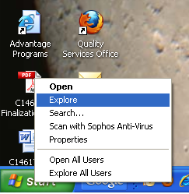
2. The Start Menu exploring window opens.

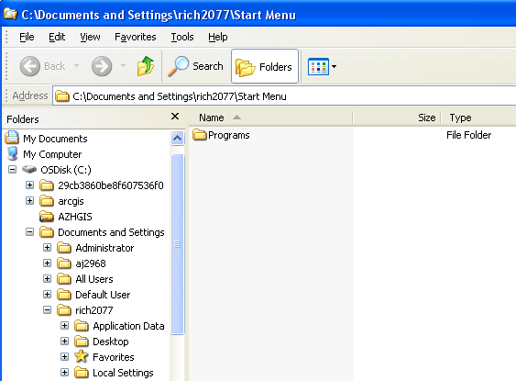

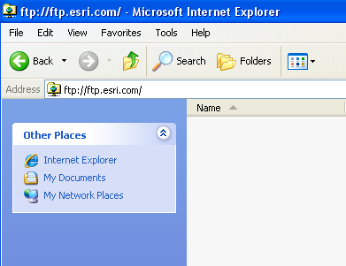
3. The user clicks inside the address window and types the following: ftp://usfs_st4@ftp.esri.com
ftp://usfs_st4@ftp.esri.com

The user presses <ENTER> on the keyboard and one of the following scenarios will occur:

- FIRST TIME USERS—the system will appear as shown in the First Time User diagram below.

- ALL OTHER USERS—the system will appear as shown in the ALL OTHER USERS diagram below.

- FIRST TIME USERS—if the first time user has entered the correct information, the resulting dialog appears as shown, and the user proceeds to Step 4:

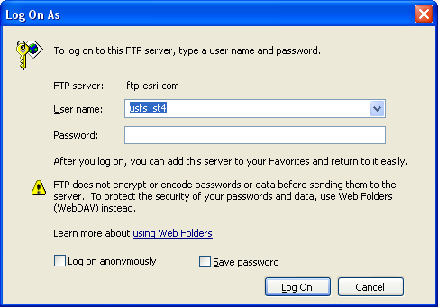
- ALL OTHER USERS—if users have entered the information correctly and they have previously used the FTP system to upload input data files, then the dialog appears as shown below, and the user proceeds to Step 5:

4. The user clicks on the File menu item to open the file menu dropdown and selects Login As… The user can now proceed to Step 5.
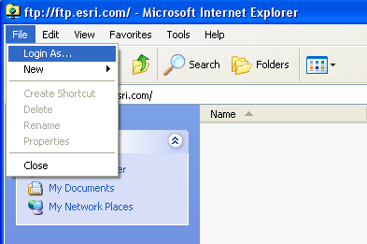

5. In the Log On As dialog that opens, the user types usfs_st4 as the User name as shown in the figure below.
usfs@stage4

6. In the Password: field as shown in the figure above, the user types: usfs@stage4
[please note that only stars will appear in the Password field (e.g. ******)]
**********

The user clicks the Log On button on the lower right of the Log On As dialog.

7. The Explorer window now appears. If other users have already registered and are using the S&PFAT system, the window may already contain several entries in the form: emailaddress@xxxxx.xxx. The user right clicks inside the main Explorer window to open the menu dialog and selects New and then Folder.

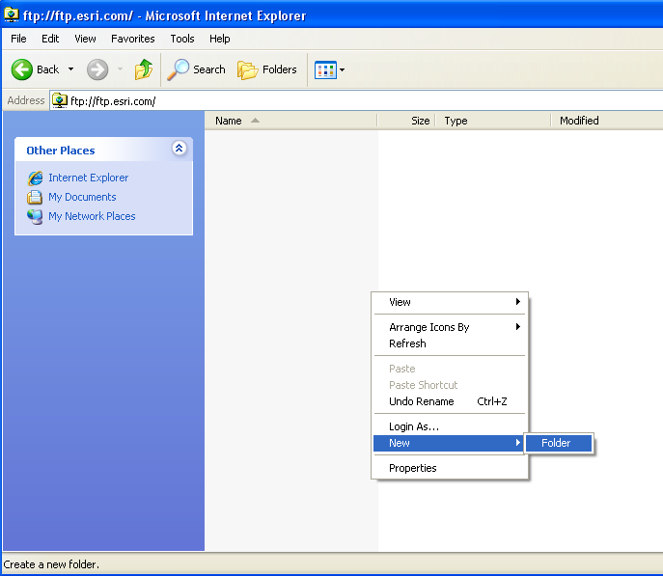

8. A new folder will appear in the window. The user must enter a new folder name in the space provided based upon their permanent email address that was used to log into the current S&PFAT session. The email address must appear in the following format: myemailaddress@emailcarrier.xxx, where xxx refers to the suffix of the user’s email service provider. For example, if John Doe works for the USFS, then his folder name would be: jdoe@fs.fed.us.

If John Smith had his own email account with an independent email service provider whose domain was provider.com, then his folder name might be:

John_Smith123456@provider.com.

Again, this email address must match EXACTLY the email address that was used by a system user when they logged into the S&PFAT system.

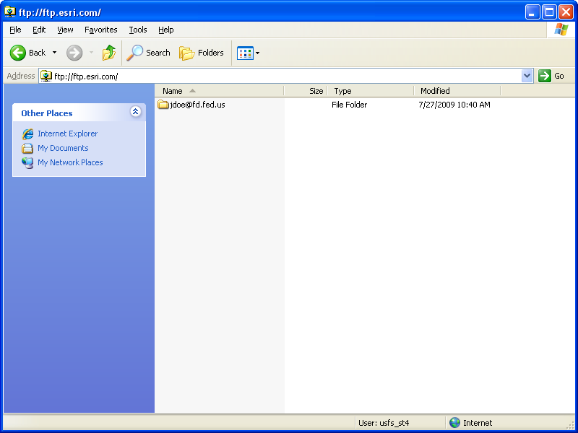
9. The user opens the jdoe@fs.fed.us folder that was just created by double clicking on the newly created folder name in the explorer window (in this case, jdoe@fs.fed.us).

10. Using the same right-click, New / Folder functionality from Step 7 above, the user may create one or more new folders inside of the jdoe@fs.fed.us folder just created. The folders to be created depend upon the type of data the folders will contain. The folder names must match EXACTLY one or all of the folder names shown below:

- National
- Regional
- State

The result should look something like the following, dependent upon the number of folders that are created:

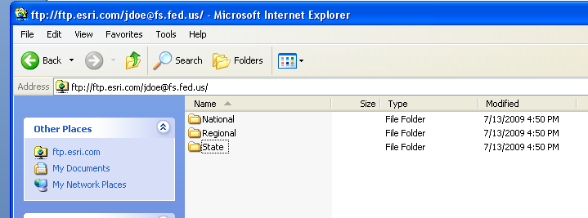

11. State and Regional users must also create a subfolder within their respective State or Regional folder using the following conventions:

- National—the user need create no subfolders and proceeds directly to Step 12.

- Regional—the user creates a subfolder that is named EXACTLY as defined below, with NO SPACE between the two words:

    - Northeastern Region users type: NortheasternRegion
    - Western Region users type: WesternRegion
    - Southern Region users type: SouthernRegion

- State—the user creates a subfolder that is named using the standard, capitalized, two-letter state abbreviation, EXACTLY as shown below:
    - For Arizona, the user types AZ
    - For Alabama, the user types AL
    - For Colorado, the user types CO
    - …and so forth.

12. The data now are ready to upload into one or more of the folders just created. First, while keeping the existing explorer window open, the user opens a new explorer window and navigates to the directory on the user’s local computer where the raster input files are stored. A best practice for performing this data transfer step is to have both folders open, side by side, to make dragging and dropping of the data easier to see, do, and verify.

Open the folders in both windows to the lowest possible level so that they appear as in the diagram below.

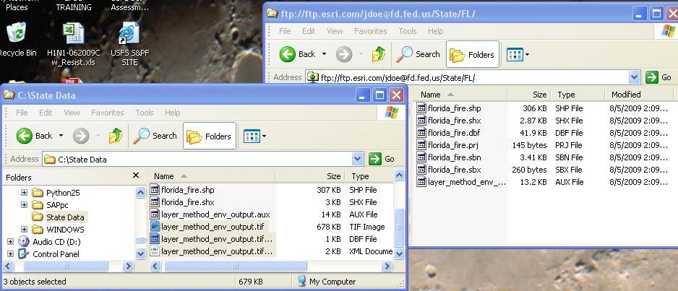

Remember, raster input data may consist of more than one physical file. One or more of the following procedures can be used to upload the raster input data into their appropriate destination folders:

- For National Data: the user drags and drops national raster input files into the National folder.

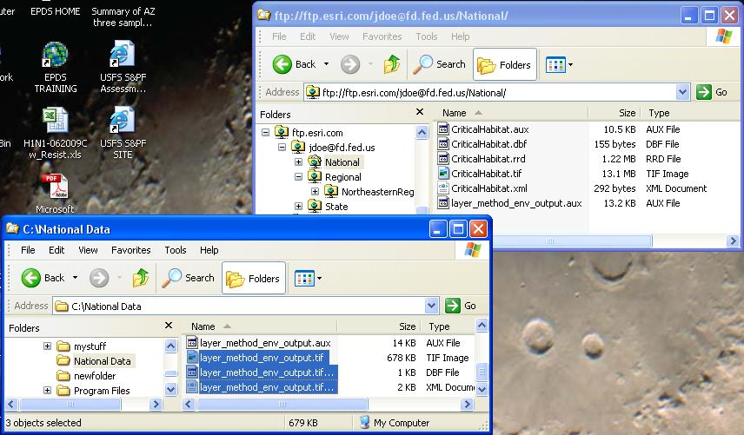

- For Regional Data: the user drags and drops regional raster input files FOR THEIR REGION into the appropriate Regional folder.
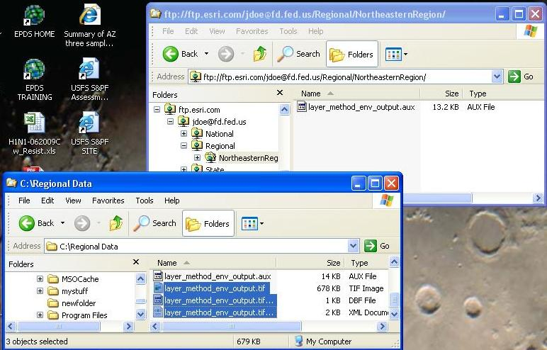

- For State Data: the user drags and drops their state raster input files FOR THEIR STATE into the appropriate State folder.

13. This completes all of the steps that are required to transfer raster input files from a user’s local machine to the S&PFAT FTP file store. The user may confirm that the file transfer was successful by checking that all the files that were dragged and dropped into the target FTP folder actually appear in the target FTP folder.

14. Alternatively, the user may check the S&PFAT system’s data directory to see the names of the uploaded files following the automated completion of Step 14 below. File transfer to the S&PFAT system will occur periodically every few hours, so the user must wait for time to pass in order to confirm that the files are actually available to the S&PFAT system.

15. At this point, an automatic computer routine periodically (every few hours) will transfer the uploaded raster input files to the S&PFAT system. The user then employs the standard S&PFAT user interface to Add a New Layer. After adding a new layer, the user may use other functions such as Edit a Layer or Delete a Layer to configure an analysis that includes the uploaded input raster data.

16. The user may now close the explorer window for the target data folder in order to log out of the FTP server. The user may also close all other windows that may be open on the desktop at this time.

