Opportunity to Reduce Hydrologic Modification
Okefenokee Wilderness Area, Vicinity of Dragline Road and Pine Island Road

Drainage of wetlands was a common practice in the past. The drainage ditch from Dragline Road and Pine Island Road is one of several attempts to reduce the extent of wetlands. There were many reasons why drainage of wetlands was so popular. Many thought of reducing mosquitos and snakes. Others thought improved growth for pine or farming. Whatever the reason, drainage was a common.

Roads with ditches were often used to help remove surface water, and also sometimes used to extend the effect of a drainage canal to adjacent areas. Roads also contribute to hydrologic modification, especially those located at the wetland interface.

The key to drainage rehabiliation is to allow enough stormwater drainage to prevent road flooding, but retain what would have normally been naturally retained. Some road ditching and conveyance of stormwater is still necessary to protect the road facilities.

The benefits of retaining more water on this section of the Okefenokee Wilderness are:
- Returning a more natural hydrologic condition and wilderness function
- Less fuels would accumulate from pine trees along the Swamp Edge Break and in some areas Perimeter road margins
- More hydrophytic plants including hardwoods
- Hydric soils retain water and less likely to burn
- During periods of drought, this area may not be as dry and less likely to carry fire

This opportunity would need further evaluation or other issues to consider.

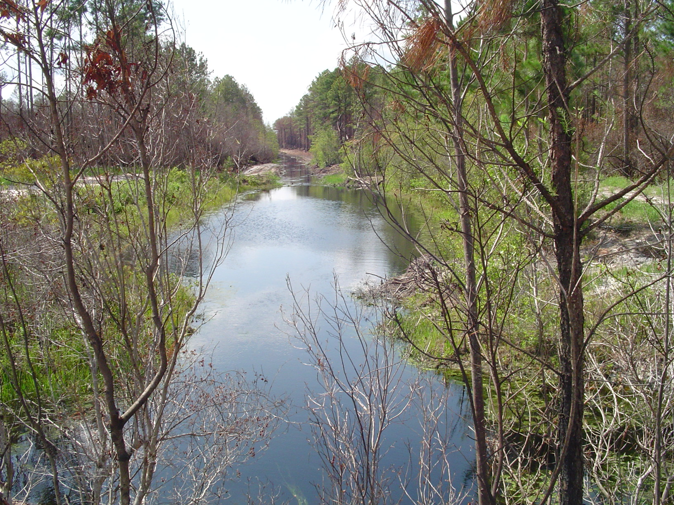

Drainage canal from Drag Line and Pine Island road intersection at Swamp Perimeter and Edge that is draining wilderness to the Suwannee River.
WF Hansen 6-26-07

