Hydrologic Modification from Suppression With State of GA
Vicinity of Coyote Trail and Battle Bay Road

I met with Dennis Martin, GA Forestry Rehab Coordinator and John Colberg, his replacement concerning the suppression activities outside of perimeter road that were impacting flow of water in the vicinity of Coyote Trail and Battle Bay Road.

Various road ditches and canals were dug at some point in the past prior to this fire to remove surface water and to a certain degree drain the area for pine management. Drainage of wetlands was a fairly common practice until a few decades ago.

The suppression activities appear to have completely filled in a drainage canal in one section east of Battle Bay road and there is debris and berm filling drainage canal or drainage improvement ditch west of Coyote Trail. The canals and ditches used to drain potentially are draining portions of the swamp, but this was not fully evaluated at this time. There may be opportunities to work with landowner to maintain drainage pattern on private but consider reducing the amount of drainage from the wilderness, except for perhaps storm water that would flood the roads. Keeping a wetter swamp would be a deterrent to fire.

Dennis Martin may mention this to the landowner to see if they would have any concerns if less of the water from the wilderness area was being drained across his land. There is some potential that without this drainage, the private lands could become wetter.

Suppression pile west of Coyote Trail Road completely filling channel
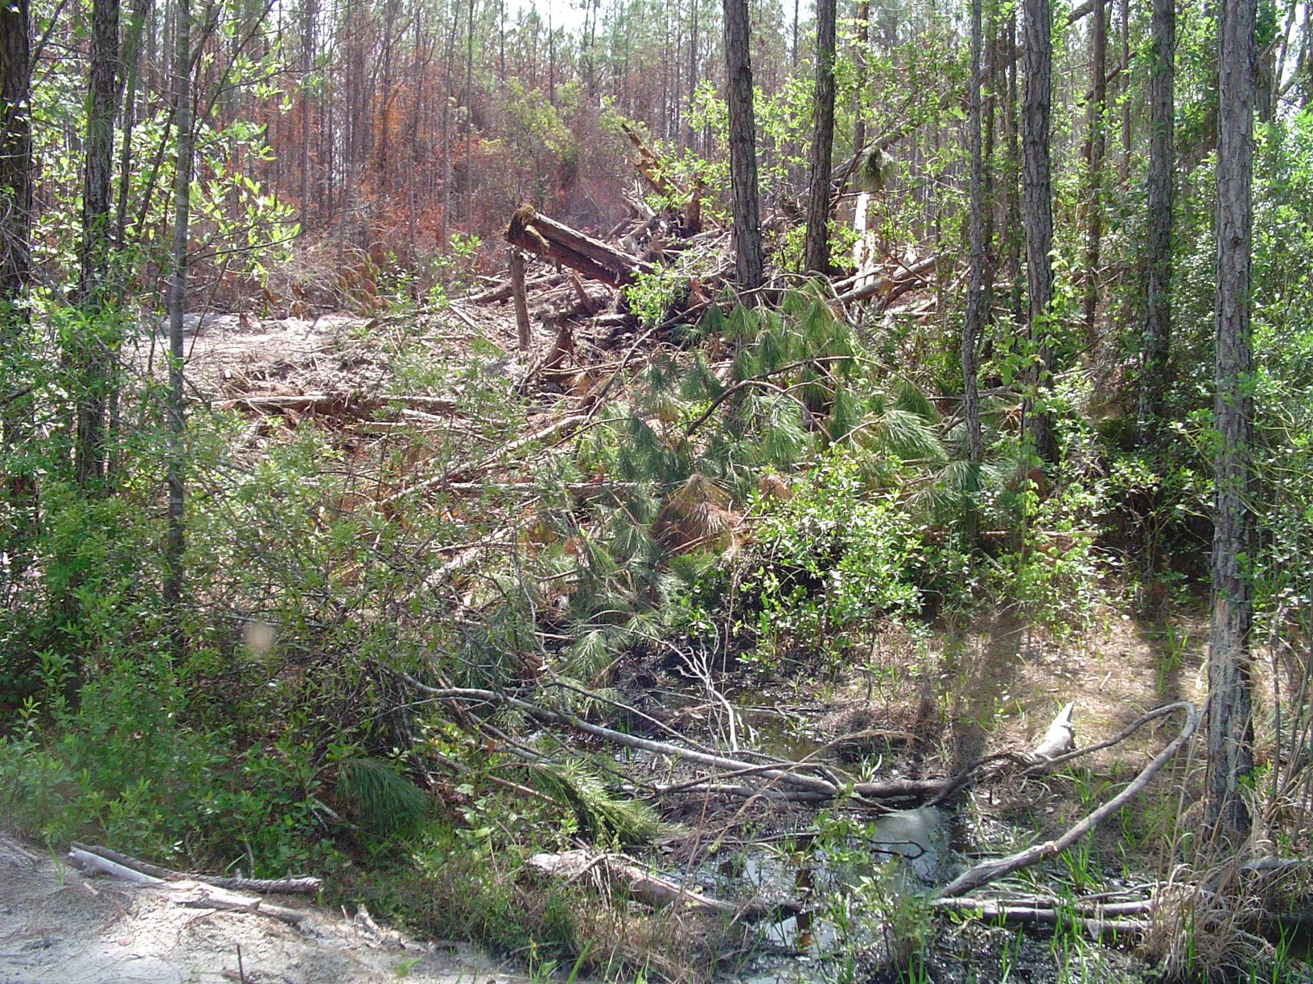

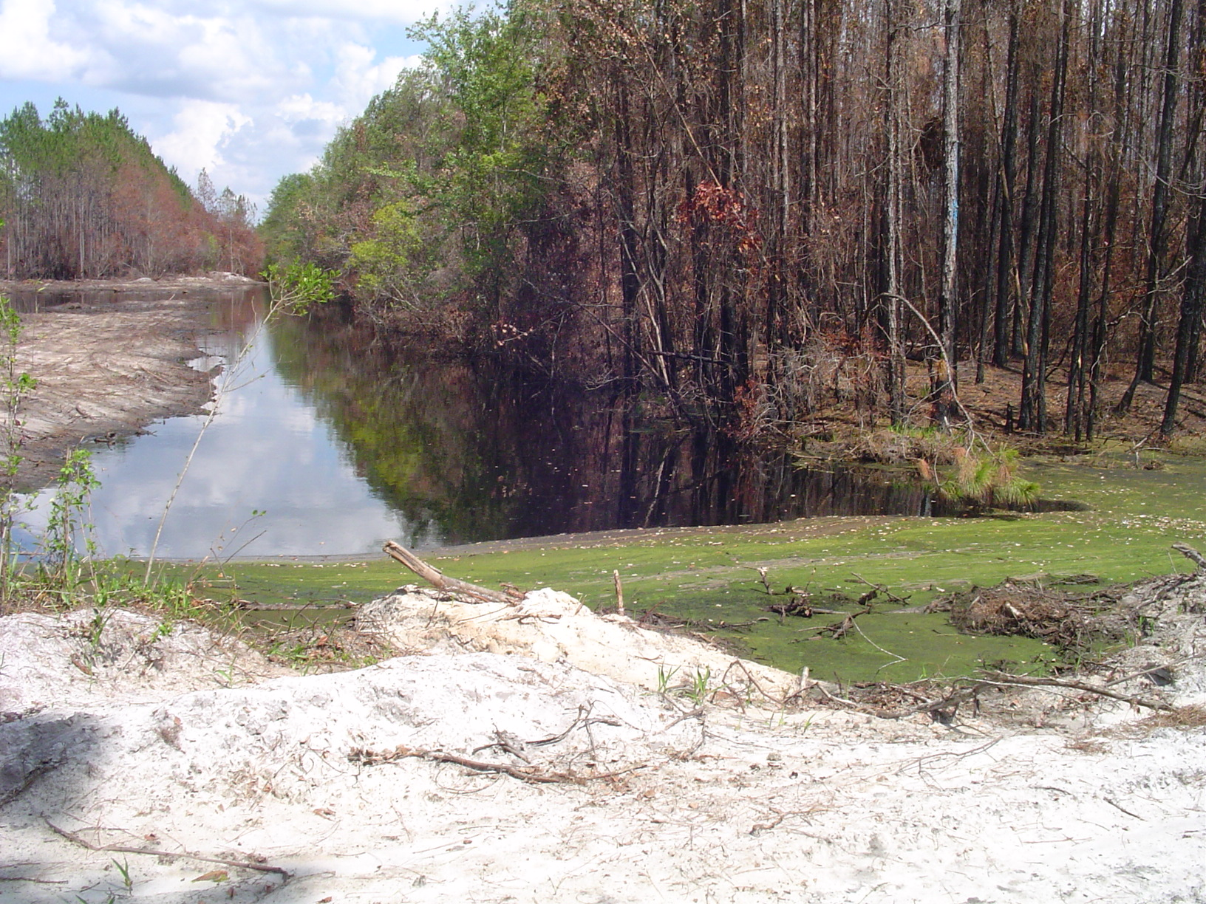
WF Hansen 6-26-07

Water piling up at culvert east of Coyote Trail Road in ditch. Water is currently flowing over the road just to the north of this picture.

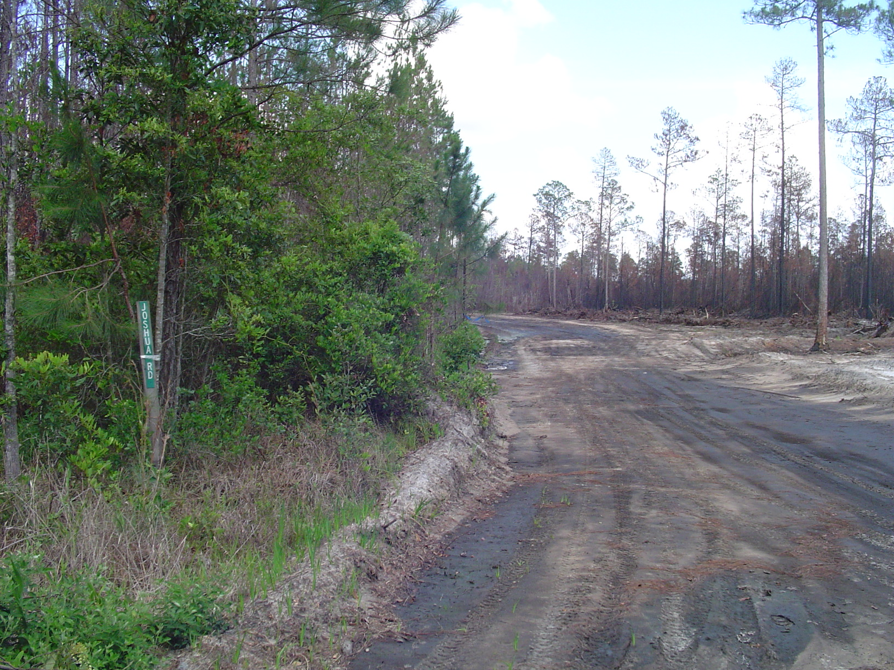

Suppression fireline that apparently filled drainage canal

WF Hansen 6-26-07

