Incident Name:  West Mims  GA-OKR-017006 | IR Interpreter(s):  Tammy Hocut | Local Dispatch Phone:  912-496-7366  Brantley Boatright | Interpreted Size:  59,318 acres  Growth last period:  10,905 acres
Flight Time:  2044 EDT  Flight Date:  April 24, 2017 | Interpreter(s) location:  Russellville, AR  Interpreter(s) Phone:  479-886-0878 | GACC IR Liaison:  Scott Wilkinson  GACC IR Liaison Phone:  501-538-5827 | National Coordinator:  Tom Mellin  National Coord. Phone:  505-842-3845
Ordered By:  Billy Whitworth | A Number:  A-75 | Aircraft/Scanner System:  N144Z/Phoenix | Pilots/Techs:  Dan Johnson, Eddy Netcher/ Woody Smith
IRIN Comments on imagery:  Good imagery. |  | Weather at time of flight:  Clear | Flight Objective:  Map Heat Perimeter/Isolated, Scattered and Intense Heat Sources
Date and Time Imagery Received by Interpreter:  April 24, 2017 2211 EDT |  | Type of media for final product:  NIFC FTP – 4 Shapefiles, KMZ files, IR Log and PDF Map  Digital files sent to:  /incident_specific_data/southern/Georgia/2017_West_Mims_Fire/IR/20170425  Email to: Billy Whitworth  bwhitworth@tfs.tamu.edu  josephkmock@fs.fed.us  erobertson@gfc.state.ga.us  annabeth_purcell@nps.gov  mtorbett@gfc.state.ga.us  john.mosley@bia.gov  Liz_Struhar@nps.gov
Date and Time Products Delivered to Incident:
April 25, 2017 0130 EDT
Comments /notes on tonight’s mission and this interpretation:

- Started interpretation with 04/24 IR fire perimeter per SITL instructions.
- Significant growth on east side of fire with a lot of intense heat. Growth extends out to Honey Island on northeast side of fire.
- Large growth between Middle Strange Island and Honey Island growing toward Honey Island Prairie.
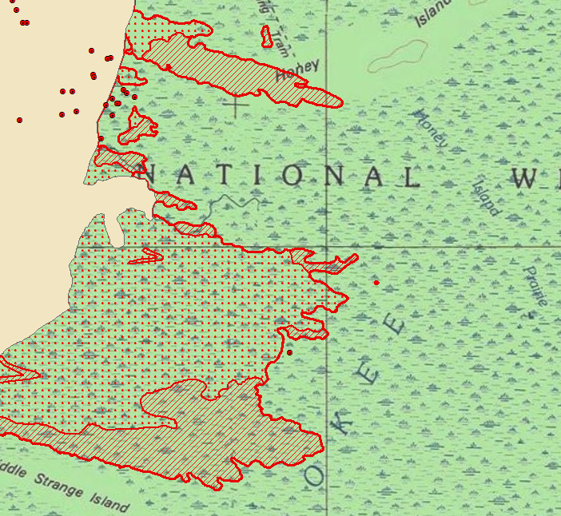
- Large growth on south east side of fire out to Mitchell Island and Moonshine Ridge.
