Incident Name:  West Mims  GA-OKR-017006 | IR Interpreter(s):  Tammy Hocut | Local Dispatch Phone:  912-496-7366  Brantley Boatright | Interpreted Size:  94,664 acres  Growth last period:  7,796 acres
Flight Time:  2119 EDT  Flight Date:  April 28, 2017 | Interpreter(s) location:  Russellville, AR  Interpreter(s) Phone:  479-886-0878 | GACC IR Liaison:  Scott Wilkinson  GACC IR Liaison Phone:  501-538-5827 | National Coordinator:  Tom Mellin  National Coord. Phone:  505-842-3845
Ordered By:  Billy Whitworth | A Number:  A-79 | Aircraft/Scanner System:  N144Z/Phoenix | Pilots/Techs:  Dan Johnson, Eddy Netcher/ Woody Smith
IRIN Comments on imagery:  Good imagery |  | Weather at time of flight:  Clear | Flight Objective:  Map Heat Perimeter/Isolated, Scattered and Intense Heat Sources
Date and Time Imagery Received by Interpreter:  April 28, 2017 2350 EDT |  | Type of media for final product:  NIFC FTP – 4 Shapefiles, KMZ files, IR Log and PDF Map  Digital files sent to:  /incident_specific_data/southern/Georgia/2017_West_Mims_Fire/IR/20170429  Email to: Billy Whitworth  bwhitworth@tfs.tamu.edu  josephkmock@fs.fed.us  erobertson@gfc.state.ga.us  annabeth_purcell@nps.gov  mtorbett@gfc.state.ga.us  john.mosley@bia.gov  Liz_Struhar@nps.gov  tingram@gfc.state.ga.us  bkline@gfc.state.ga.us  kmurphy@gfc.state.ga.us  kengregor88@gmail.com  Shannon.bowman@freshfromflorida.com  hmorton@gfc.state.ga.us  gpmartin@fs.fed.us
Date and Time Products Delivered to Incident:
April 29, 2017 0330 EDT
Comments /notes on tonight’s mission and this interpretation:
- Started interpretation with 04/28 IR perimeter.

- New heat perimeter mapped on 04/27 around 2 miles north of the main fire grew to the south.
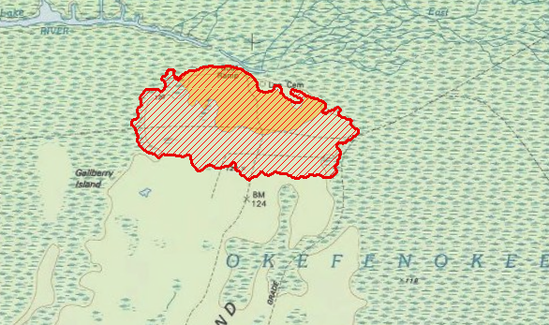

- Some growth west of Bugaboo Island.
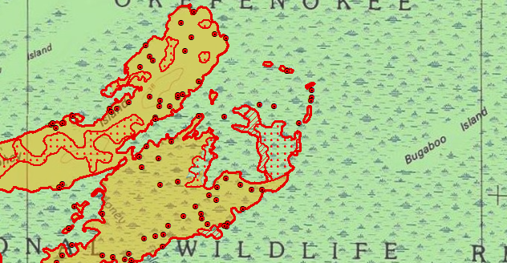

- Most of the fire growth was on the east side of the fire between Chesser Prairie on the north side to Soldiers Camp Island on the south side of the fire growth. A new fire polygon was mapped in the Chesser Prairie area with isolated heat sources outside the main fire perimeters.
