Incident Name:  West Mims  GA-OKR-017006 | IR Interpreter(s):  Tammy Hocut | Local Dispatch Phone:  912-496-7366  Brantley Boatright | Interpreted Size:  100,166 acres  Growth last period:  4,918 acres
Flight Time:  2134 EDT  Flight Date:  April 30, 2017 | Interpreter(s) location:  Russellville, AR  Interpreter(s) Phone:  479-886-0878 | GACC IR Liaison:  Scott Wilkinson  GACC IR Liaison Phone:  501-538-5827 | National Coordinator:  Tom Mellin  National Coord. Phone:  505-842-3845
Ordered By:  Billy Whitworth | A Number:  A-85 | Aircraft/Scanner System:  N144Z/Phoenix | Pilots/Techs:  Dan Johnson, Eddy Netcher/ Woody Smith
IRIN Comments on imagery:  Good imagery |  | Weather at time of flight:  Clear | Flight Objective:  Map Heat Perimeter/Isolated, Scattered and Intense Heat Sources
Date and Time Imagery Received by Interpreter:  April 30, 2017 0001 EDT |  | Type of media for final product:  NIFC FTP – 4 Shapefiles, KMZ files, IR Log and PDF Map  Digital files sent to:  /incident_specific_data/southern/Georgia/2017_West_Mims_Fire/IR/20170501  Email to: Billy Whitworth  bwhitworth@tfs.tamu.edu  josephkmock@fs.fed.us  erobertson@gfc.state.ga.us  annabeth_purcell@nps.gov  mtorbett@gfc.state.ga.us  john.mosley@bia.gov  Liz_Struhar@nps.gov  tingram@gfc.state.ga.us  bkline@gfc.state.ga.us  kmurphy@gfc.state.ga.us  kengregor88@gmail.com  Shannon.bowman@freshfromflorida.com  hmorton@gfc.state.ga.us  gpmartin@fs.fed.us
Date and Time Products Delivered to Incident:
May 1, 2017 0150 EDT
- Started interpretation from 04/30 IR perimeter.
- Growth with intense heat on heat polygon to the far north around Billy’s Island with an additional heat polygon on the west side.
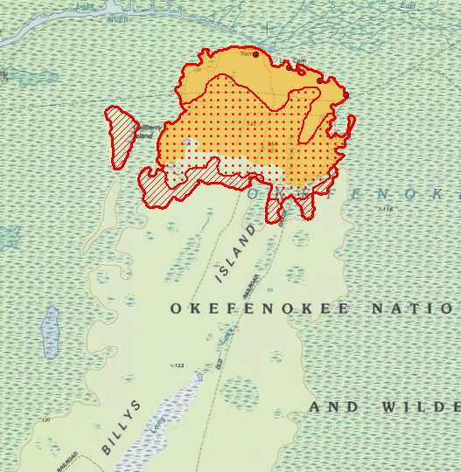
- Growth within interior unburned island.
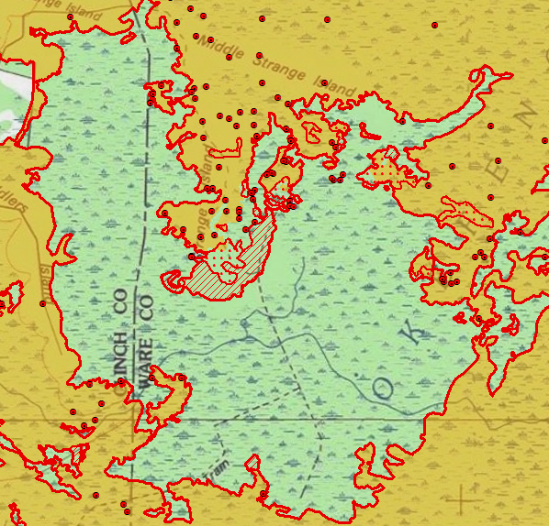
- Main fire heat perimeter growth was on the south side of the fire at Soldiers Camp Island burning toward Roasting Ear Island.
