Incident Name:  West Mims  GA-OKR-017006 | IR Interpreter(s):  Tammy Hocut | Local Dispatch Phone:  912-496-7366  Brantley Boatright | Interpreted Size:  107,846 acres  Growth last period:  7,329 acres
Flight Time:  2056 EDT  Flight Date:  May 02, 2017 | Interpreter(s) location:  Russellville, AR  Interpreter(s) Phone:  479-886-0878 | GACC IR Liaison:  Scott Wilkinson  GACC IR Liaison Phone:  501-538-5827 | National Coordinator:  Tom Mellin  National Coord. Phone:  505-842-3845
Ordered By:  Billy Whitworth | A Number:  A-87 | Aircraft/Scanner System:  N144Z/Phoenix | Pilots/Techs:  Dan Johnson, Eddy Netcher/ Woody Smith
IRIN Comments on imagery:  Good imagery |  | Weather at time of flight:  Clouds on the east side of the fire. | Flight Objective:  Map Heat Perimeter/Isolated, Scattered and Intense Heat Sources
Date and Time Imagery Received by Interpreter:  May 03, 2017 0029 EDT |  | Type of media for final product:  NIFC FTP – 4 Shapefiles, KMZ files, IR Log and PDF Map  Digital files sent to:  /incident_specific_data/southern/Georgia/2017_West_Mims_Fire/IR/20170503  Email to: Billy Whitworth  bwhitworth@tfs.tamu.edu  josephkmock@fs.fed.us  erobertson@gfc.state.ga.us  annabeth_purcell@nps.gov  mtorbett@gfc.state.ga.us  john.mosley@bia.gov  Liz_Struhar@nps.gov  tingram@gfc.state.ga.us  bkline@gfc.state.ga.us  kmurphy@gfc.state.ga.us  kengregor88@gmail.com  Shannon.bowman@freshfromflorida.com  hmorton@gfc.state.ga.us  gpmartin@fs.fed.us  Michael_dueitt@fws.gov  vedge@gfc.state.ga.us  jbrand@fs.fed.us  jburgettpcfd502@gmail.com  tbowerman@centurylink.net  jkhiers@ttrs.org  garyjrvs@gmail.com  tfaust2849@aol.com  rsmith8459@comcast.net  eschmeckpeper@fs.fed.us  larrysmith@fs.fed.us  blazincajun@att.net  torreya66@yahoo.com  c_plante@fws.gov  jherrin@tfs.tamu.edu  jschwartz01@fs.fed.us  aspascarella@fs.fed.us  shane_sturgill@nps.gov  mock102177@yahoo.com
Date and Time Products Delivered to Incident:
May 03, 2017 0250 EDT
- Started interpretation from 05/02 updated fire perimeter from incident.
- Growth in heat perimeter around Billys Island with a new additional island south of Jones Island along road with a lot of intense heat.
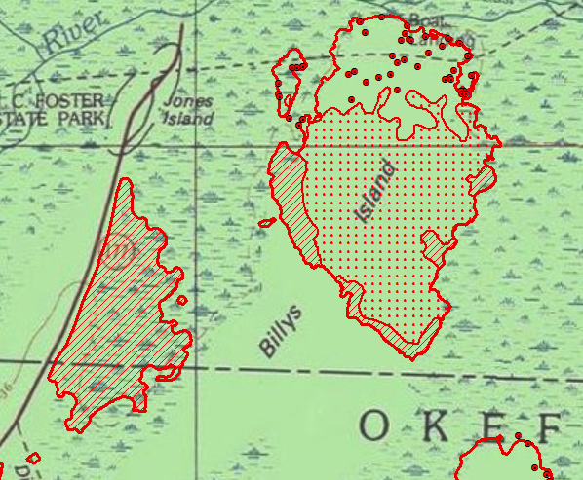
- There is an isolated heat source at Gallberry Island at 82°20'50.237"W 30°49'15.492"N,
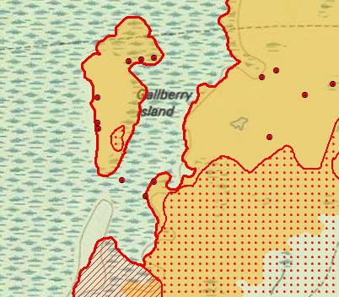
- Isolated heat source outside main fire perimeter at 82°19'6.993"W 30°47'15.294"N
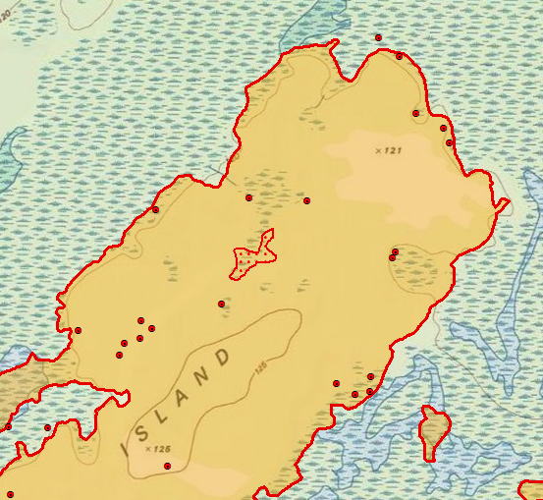
- Large growth closing in large interior unburned island on the west side of the fire.
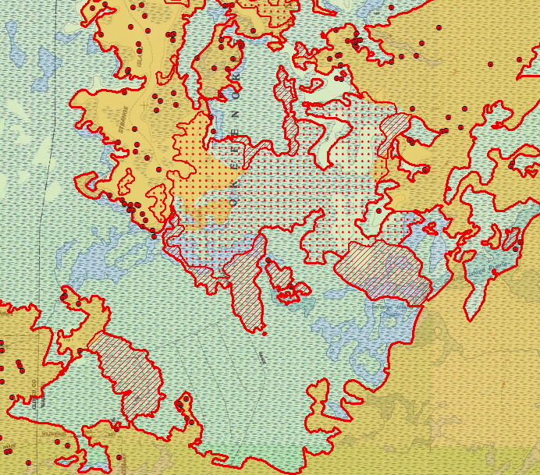
- Large growth on the southeast side of the fire east of Roasting Ear Island.
