Incident Name:  West Mims  GA-OKR-017006 | IR Interpreter(s):  James “Buck” Buchanan | Local Dispatch Phone:  912-496-7366  Brantley Boatright | Interpreted Size:  140,404 acres  Growth last period:  6,657 acres
Flight Time:  2201 EDT  Flight Date:  May 08, 2017 | Interpreter(s) location:  Kosciusko, MS  Interpreter(s) Phone:  601-663-6927 | GACC IR Liaison:  Scott Wilkinson  GACC IR Liaison Phone:  501-538-5827 | National Coordinator:  Tom Mellin  National Coord. Phone:  505-842-3845
Ordered By:  Billy Whitworth | A Number:  A-119 | Aircraft/Scanner System:  N144Z/Phoenix | Pilots/Techs:  Dan Johnson, Don Boyce/ Charles Kazimir
IRIN Comments on imagery:  Good imagery. |  | Weather at time of flight:  Clear | Flight Objective:  Map Heat Perimeter/Isolated, Scattered and Intense Heat Sources
Date and Time Imagery Received by Interpreter:  May 08, 2345 EDT |  | Type of media for final product:  NIFC FTP – 4 Shapefiles, KMZ files, IR Log and PDF Map  Digital files sent to:  /incident_specific_data/southern/Georgia/2017_West_Mims_Fire/IR/20170509  Email to:  michael_dueitt@fws.gov  jbrand@fs.fed.us  jburgettpcfd502@gmail.com  tbowerman@centurylink.net  jkhiers@ttrs.org  garyjrvs@gmail.com  tfaust2849@aol.com  rsmith8459@comcast.net  gatorsmithla@yahoo.com  blazincajun@att.net  torreya66@yahoo.com  c_plante@fws.gov  jherrin@tfs.tamu.edu  jschwartz01@fs.fed.us  aspascarella@fs.fed.us  shane_sturgill@nps.gov  josephkmock@fs.fed.us  spweaver@mindspring.com  bkline@gfc.state.ga.us  Shannon.bowman@freshfromflorida.com  hmorton@gfc.state.gs.us  david.jones@ncagr.gov  casey_teske@nps.gov
Date and Time Products Delivered to Incident:
May 09, 2017 0430 EDT
- Started interpretation from 05/07 IR heat perimeter as directed by incident.
- Growth in heat perimeter south of Billys Island further onto New Island.
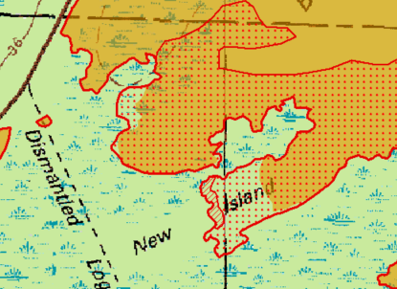
- There was further small pockets of growth south of Honey Island.
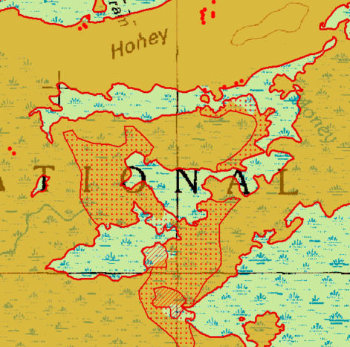
- There was further growth detected east of Fiddlers Island and south of Strange Island.
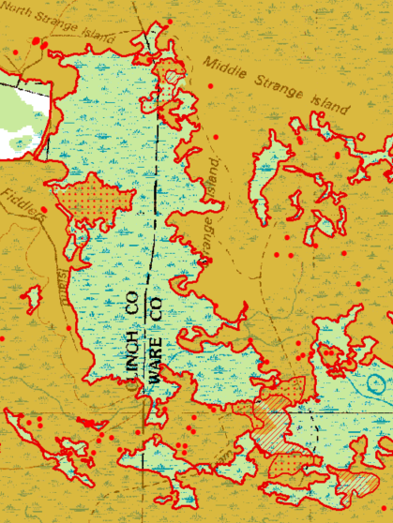

- The most significant growth to the perimeter was between Moniac and St. George, crossing Hwy 94 and the railroad.
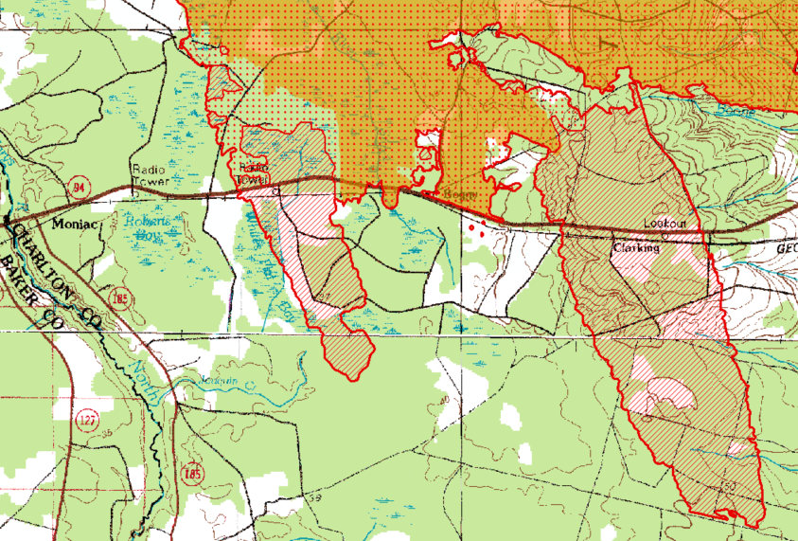
- Two isolated heat sources were found outside the main heat perimeter to the east. They both appeared to be very near houses in Folkston and West of Hilliard.
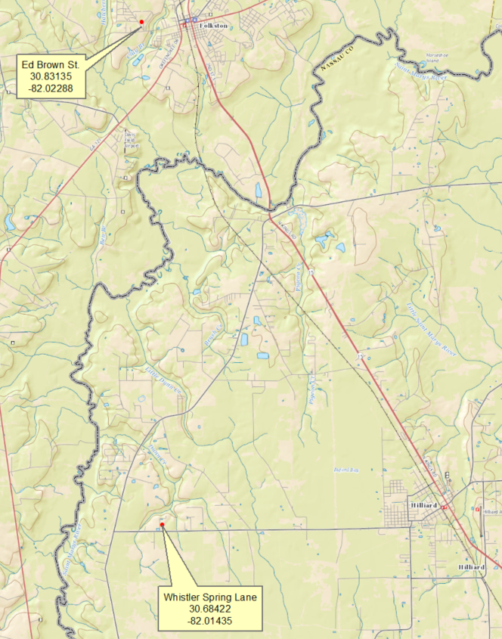

There was also an isolated heat source found about 3.5 miles south on the edge of the last flight line. It appears to be in the edge of a field, but due to the location on the imagery, this location may not be accurate.
