Fires on the Nantahala NF Acreage Summery
11/08/2016
Fire | PCODE | Incident # | Acres | Last update & time
Boteler | P8KSX017 (0811) | NC-NCF-160247 | 2532 | 11/08/2016, 0953
Knob | P8KS4V17 (0811) | NC-NCF-160275 | 644 | 11/05/2016; 2309
Tellico | P8KS5P17 (0811) | NC-NCF-160280 | 3417 | 11/08/2016; 0915
May Branch | P8KS5Q17 (0811) | NC-NCF-160282 | 175 | 11/05/2016; 2309
Moss Knob | P8KS5S17 (0811) | NC-NCF-160281 | 7 | 11/07/2016; 0953
Cliffside | P8KS4X17 (0811) | NC-NCF-160278 | 101 | 11/05/2016; 2309
Dick’s Creek | P8KSN417 (0811) | NC-NCF-160242 | 726 | 11/08/2016; 0915
White Water | P8KS7R17 (0811) | NC-NCF-160303 | N/A | 11/07/2016; 0953
Ferebee Fire | P8KS7E17 (0811) | NC-NCF-160299 | 1132 | 11/08/2016; 0915
Falls | P8KS0Y17 (0811) | NC-NCF-160249 | n/a | 11/05/2016; 2309
Moses Creek | P8KS1B17 (0811) | NC-NCF-160253 | 30 | 11/05/2016; 2309
Jones Gap | P8KS1F17 (0811) | NC-NCF-160257 | 115 | 11/05/2016; 2309
Jarrett Knob | P8KS4W17 (0811) | NC-NCF-160277 | n/a | 11/05/2016; 2309
Wine Spring | P8KS4L17 (0811) | NC-NCF-160272 | 95 | 11/05/2016; 2309
Grape Cove | P8KS0Z17 (0811) | NC-NCF-160252 | 35 | 11/05/2016; 2309
Buck Creek Fire | P8KS6K17 (0811) | NC-NCF-160305 | 8 | 11/07/2016; 0953

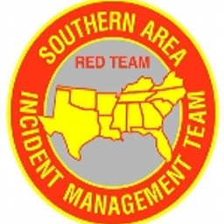

SOUTHERN AREA
TYPE 1 INCIDENT MANAGEMENT TEAM
MIKE DUEITT, INCIDENT COMMANDER

