Go to Google Chrome
- In the upper right hand corner of the page, click the three diagonal dots :
- Next, select “More tools”
- Then, select “Extensions”
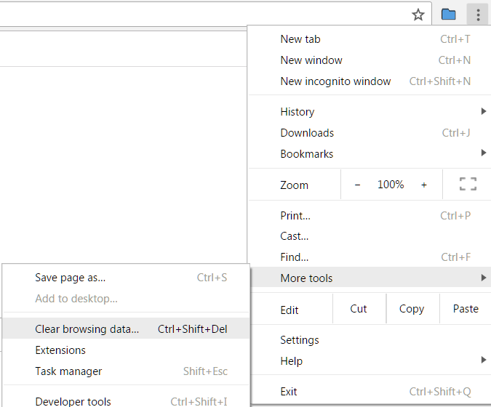
1
2
3

- Scroll to the bottom of the page, then select “Get more extensions”:
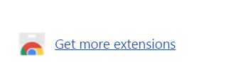

- Enter “Tab Slideshow” into the search bar:
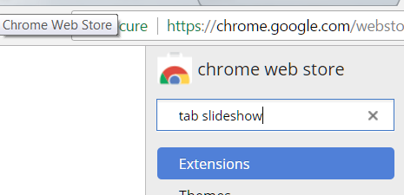

- Select the free “Tab Slideshow”
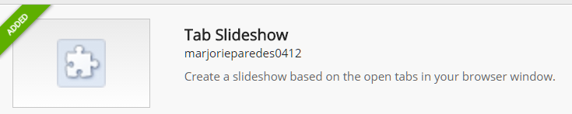

- Look at the upper right corner of the page and a blue folder should appear active: