Potential Smoke Impacts Daily Report

Fire Spread and Emissions Profile Predicted for May 9, 2011
Rate of Spread |  | PM_{2.5} Hourly Emissions
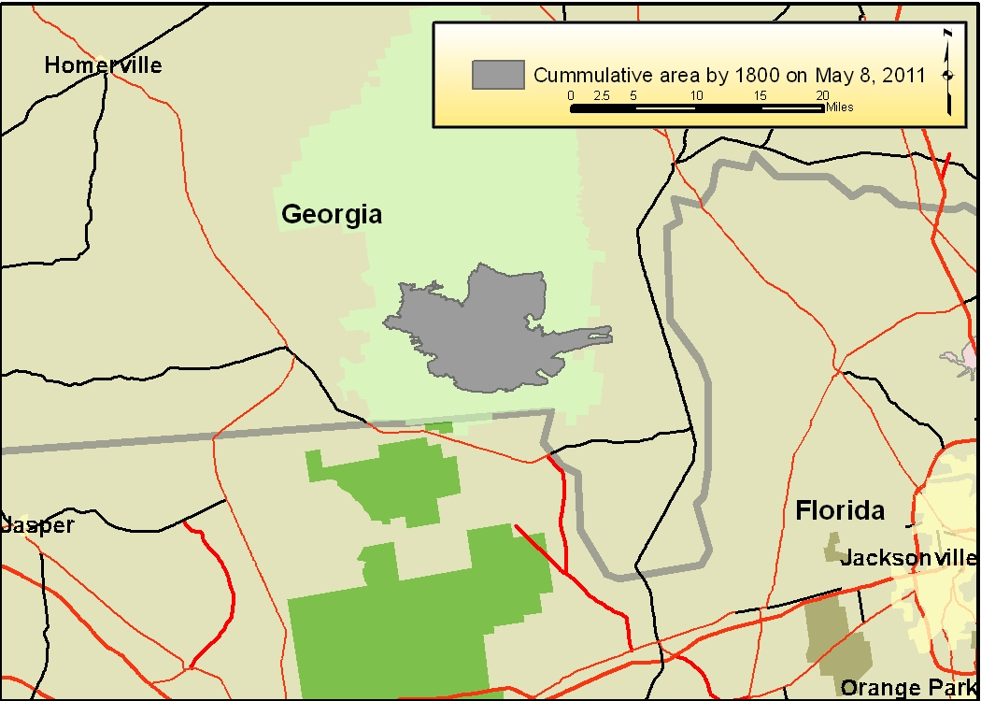
The gray polygon shown above is the approximate total area burned by 1800 hours on May 8. Based upon the rate of spread between May 7 – 8 it has been assumed the rate of active fire spread will continue to blacken approximately 533 acres per hour. The estimated blackened acres for May 9 are 12,792 acres. |  | The average consumption was estimated to be 13 tons per acre, and this includes 3.6 tons per acre of duff consumption. Smoldering (drifted PM_{2.5}) emissions are predicted to occur throughout the nighttime. Atmospheric stability is predicted to be moderately unstable until about 1800 then atmospheric conditions will become less favorable for smoke dispersal.
Air Quality Index Forecast for May 9, 2011
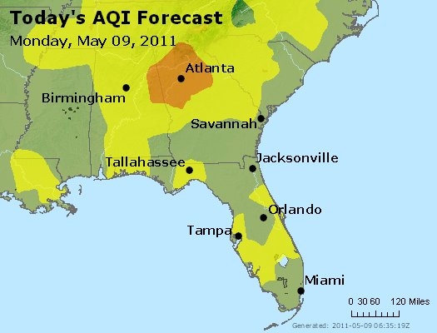 | AQI |  | State air regulatory agencies provide forecasts using the Air Quality Index (AQI). The colors of the AQI correspond to different pollution concentrations and related health warnings.  Code green (good air quality) is predicted near the Honey Prairie wildfire. However, there is a high likelihood the air regulatory agencies have not included the smoke from the wildfire in their AQI prediction.

Forecasted Smoke Dispersion and Air Quality Impacts for May 9, 2011
(HYSPLIT Meteorological File: May 9, 2011 UTC06)
Daily PC HYSPLIT Smoke Dispersion Forecast Results | Hourly PC HYSPLIT Smoke Dispersion Forecast Results
Hourly AQI
Good
Moderate
Unhealthy for Sensitive Groups
Unhealthy
Very Unhealthy
Hazardous

The PC HYSPLIT result above allows you to compare the results to a benchmark that reflects the 24 hour PM2.5 standard (35 ug/m3). The only color showing for this run is Turquoise and it represents those areas that would have a 24 hour average concentration higher (including a background concentration of 10 ug/m3) than the benchmark on May 9. Scattered unhealthy levels of fine particulates may exceed the daily PM_{2.5} National Ambient Air Quality Standards (NAAQS) over a wide area. | The PC HYSPLIT result above allows you to view a compilation of all the predicted hourly results for May 9, 2011. The Environmental Protection Agency does not have a 1-hour NAAQS or AQI values. The 1-hour categories used in this analysis were developed by the California Resources Board. Very Unhealthy or Hazardous fine particulate concentrations are predicted to occur with 30 miles of the wildfire and are persistent after 1900 hours. Furthermore, a shift in wind directions is predicted for today.
The results above are best viewed in Google Earth®. The file name for the 24-hour daily results (left graphic) is:
HoneyPrairie_May09_Daily_HYSPLITconc_0509_morning.kmz

The file name for the 1-hour results (right graphic) is:
HoneyPrairie_May09_Hourly_HYSPLITconc_0509_morning.kmz

Forecasted Smoke Dispersion for May 10, 2011
(HYSPLIT Meteorological File: May 9, 2011 UTC06)
Hourly PC HYSPLIT Smoke Dispersion Forecast Results
Hourly AQI
Good
Moderate
Unhealthy for Sensitive People
Unhealthy
Very Unhealthy
Hazardous

The modeling predictions above are for May 10, 2011. Very Short-term (1-hour or less) Unhealthy or Hazardous fine particulate matter concentrations are predicted to be present within 30 miles of the wildfire. Numerous areas are predicted to have unhealthy air quality, including Waycross, GA.

