Potential Smoke Impacts Daily Report

Daily PC HYSPLIT Forecasted Smoke Dispersion and
Air Quality Index Forecast for May 13, 2011
(HYSPLIT Meteorological File: May 13, 2011 UTC06)
Daily AQI
The PC HYSPLIT results above allow you to compare to a benchmark that reflects the 24-hour PM_{2.5} standard (35 ug/m3). The Orange polygon represents those areas where the 24-hour average concentration (including a background concentration of 10 ug/m3) is greater than the benchmark on May 12. This area (within 45 miles of the burn unit) is where unhealthy levels of fine particulates could occur and the value exceeds the daily PM_{2.5} National Ambient Air Quality Standard (NAAQS).

State air regulatory agencies provide forecasts using the Air Quality Index (AQI) that correspond to different pollution concentrations and related health warnings. Code green or yellow (good to moderate air quality) is predicted for the monitoring sites within the region.
The results above are best viewed in Google Earth. The filename is: HoneyPrairie_May13_Daily_HYSPLITconc_0513_morning.kmz

Hourly PC HYSPLIT Forecasted Smoke Dispersion for May 13, 2011
(HYSPLIT Meteorological File: May 13, 2011 UTC06)
Hourly AQI
Short-term (1-hour or less) concentrations of Unhealthy, Very Unhealthy or Hazardous fine particulate matter concentrations are predicted for today. Folkston, GA and others to the northeast of the burn unit are predicted to have the air quality significantly degraded from smoke attributed to the wildfire. Heavy smoke concentrations should be anticipated along highways. The high concentrations of fine particles combined with the predicted high relative humidity may result in smoke/fog formation in some location. If super-fog forms then there will be an increase likelihood of vehicle accidents because visibility quickly degraded for the motorists.

The results above are best viewed in Google Earth. The filename is: HoneyPrairie_May13_Hourly_HYSPLITconc_0513_morning.kmz

Fire Spread and Emissions Profile Predicted for May 13, 2011
Rate of Spread | PM_{2.5} Hourly Emissions
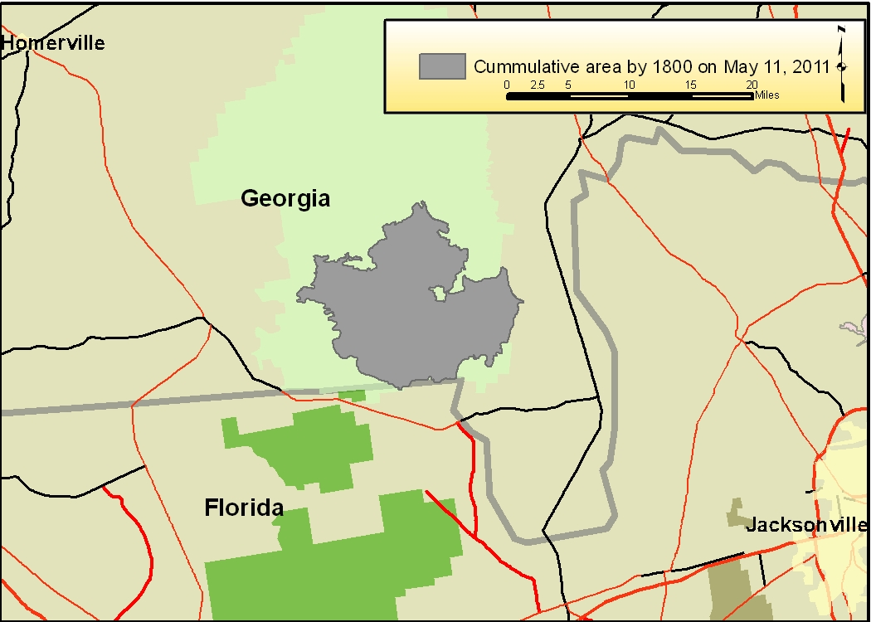
The gray polygon shown above is the approximate total area burned by 1800 hour on May 11. This analysis assumed the rate of active fire spread will continue to blacken approximately 550 acres per hour and this is based upon the average rate of spread between May 7 – 10. The estimated total blackened area by May 11 at 1800 hours was 78,238 acres. | The average consumption was estimated to be 13 tons per acre, and this includes 3.6 tons per acre of duff consumption. Smoldering (drifted PM_{2.5}) emissions are predicted to occur throughout the nighttime. Atmospheric stability is predicted to be moderately unstable until about 1800 then atmospheric conditions will become less favorable for smoke dispersal.

Hourly PC HYSPLIT Forecasted Smoke Dispersion for May 14, 2011
(HYSPLIT Meteorological File: May 13, 2011 UTC06)
Hourly AQI
The hourly modeling predictions above are for May 14, 2011. Folkston, Woodbine and other communities to the northeast of the wildfire are likely to experience poor air quality. Heavy smoke concentrations should be anticipated along highways and possibly Interstate 95 in the early morning hours.

The results above are best viewed in Google Earth. The filename is: HoneyPrairie_May13_Hourly_HYSPLITconc_0513_morning.kmz

