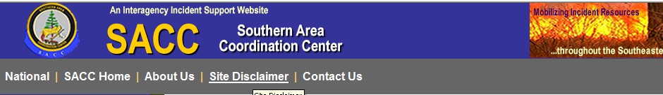

SOUTHERN FIRE BEHAVIOR OUTLOOK

FORECAST VALID FOR: August 10, 2011 | DATE/TIME ISSUED: August 10/0800 Hrs
NEXT UPDATE: August 11, 2011 | SIGNED: Warren Appelhans

*This is a general fire behavior outlook for the Southern Geographic Area. It is intended to provide wildland fire managers with an overall view of fire behavior potential and to assist wildland firefighters with making sound decisions and maintaining situational awareness based on current and expected fire behavior. This outlook is not intended to replace onsite observations or spot weather forecasts issued by the National Weather Service.

Some products provided in the outlook often are not updated prior to posting. Refer to updated information on the Southern Area Coordination Center Website as it becomes available:
http://gacc.nifc.gov/sacc/index.htm

Fire Weather Summary:
***Red Flag Warnings/Fire Weather Watches and Advisories***
There are no Red Flag Warnings/Fire Weather Watches and Advisories currently in effect in the Southern Area.

- For complete fire weather information and specific detailed forecasts see:
http://www.weather.gov
- Refer to the MesoWest Regional Surface Maps to access weather observations.
http://mesowest.utah.edu/index.html
- For updated fire danger and fuel moisture values link to:
http://wfas.net/

Fuels Conditions:

State of the Fuels will be updated weekly or as the conditions warrant.

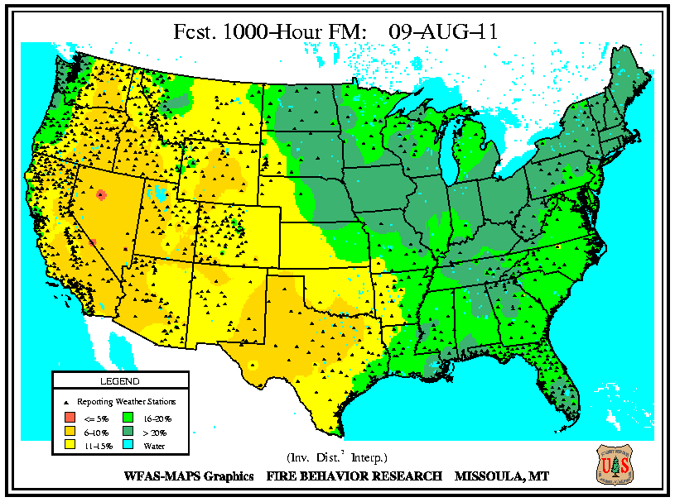

The 1000 hr fuel moistures are near or setting new record lows. It is taking longer to control the fires and extinguish the residual heat in the larger fuels. Fires are spreading and growing in the absence of wind. Texas had a fire that grew 3,000 acres in two hours with less than a 5 mile per hour wind.
WFAS—10 Hour Forecast Fuel Moisture WFAS — KDBI 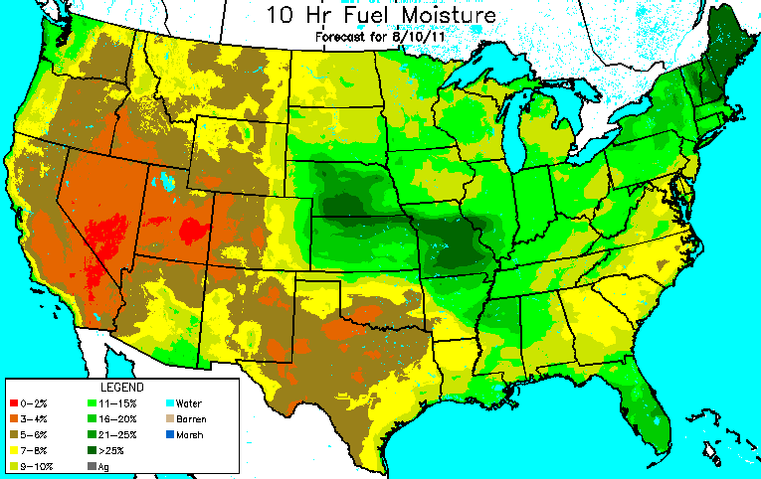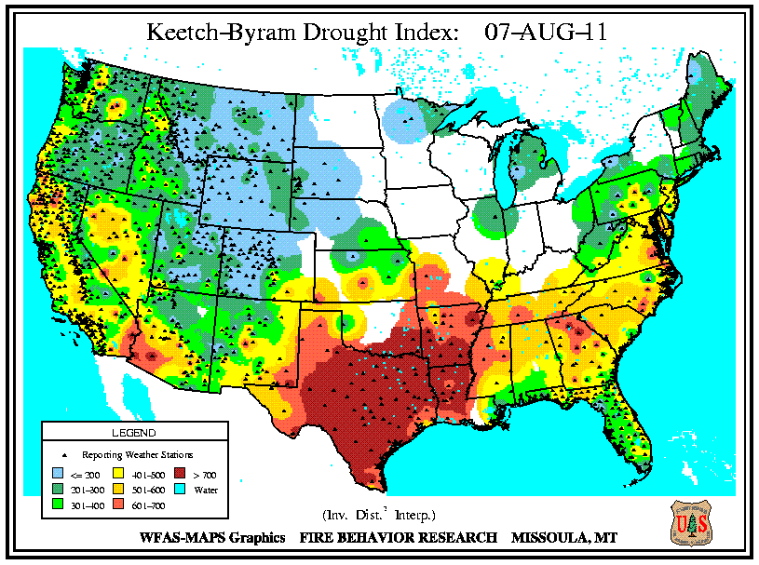

Southern Area 2 – 24 hour precip, ending August 10, 2011@ 06:47
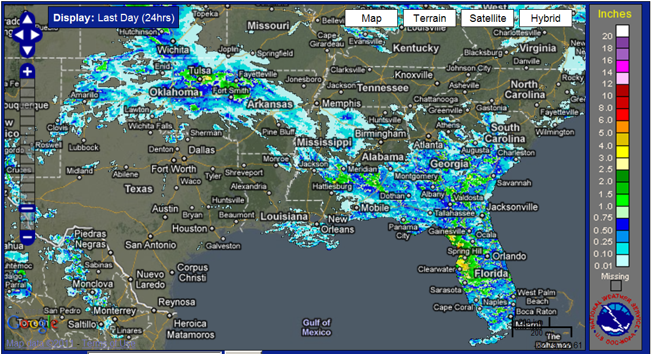

Southern Area ERC-G Summary Ending Aug 9, 2011
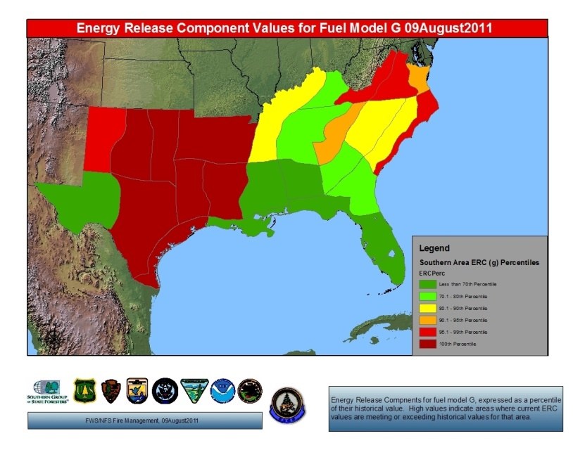

Fire Behavior OutlookBe aware of Thunderstorms in the areas of your fire winds from storms 30 miles or more away could affect your fire.

Texas and Oklahoma Plains
Very High probability of large fire growth. Fires can be fuel and or terrain driven with low wind speeds. Fine fuel moistures continue to be extremely dry with little rebound overnight. Oklahoma City southwest to Fort Stockton expect winds 15 to 20 miles per hour. Any new starts have the potential to become a large fire. Escape on existing fire could see rapid rates of spread in a short time.

Southwest Arkansas, Northern Louisiana, Texas and Oklahoma
High probability of large fire growth. Like the very high probability areas, the majority of this area has not received precipitation for several weeks so live fuels are cured or extremely dry. Rapid rates of spread with wind speeds below 5 miles per hour. Resistance to control is very high larger fuels being consumed is taking longer for securing the fires.

South Eastern Arkansas, Central Louisiana and Inland Coastal Texas
Moderate fire behavior can be expected today with any new start These areas are forecast to have low fine fuel moistures and KDBI values continue to be high.

Piedmont area North Carolina
Low /Moderate fire behavior can be expected today with any new start in the pine stands. These areas have forecasted low fine fuel moistures and low RH recovery.

Coastal Region of Texas, Northern Arkansas, North East Oklahoma and Geographic Area East of the Mississippi
Low fire behavior expected. These areas have received enough precipitation over the last week to moderate ERC and KDBI values. Rain is expected over the area for the next several days. Ignitions may become established but should not spread rapidly.

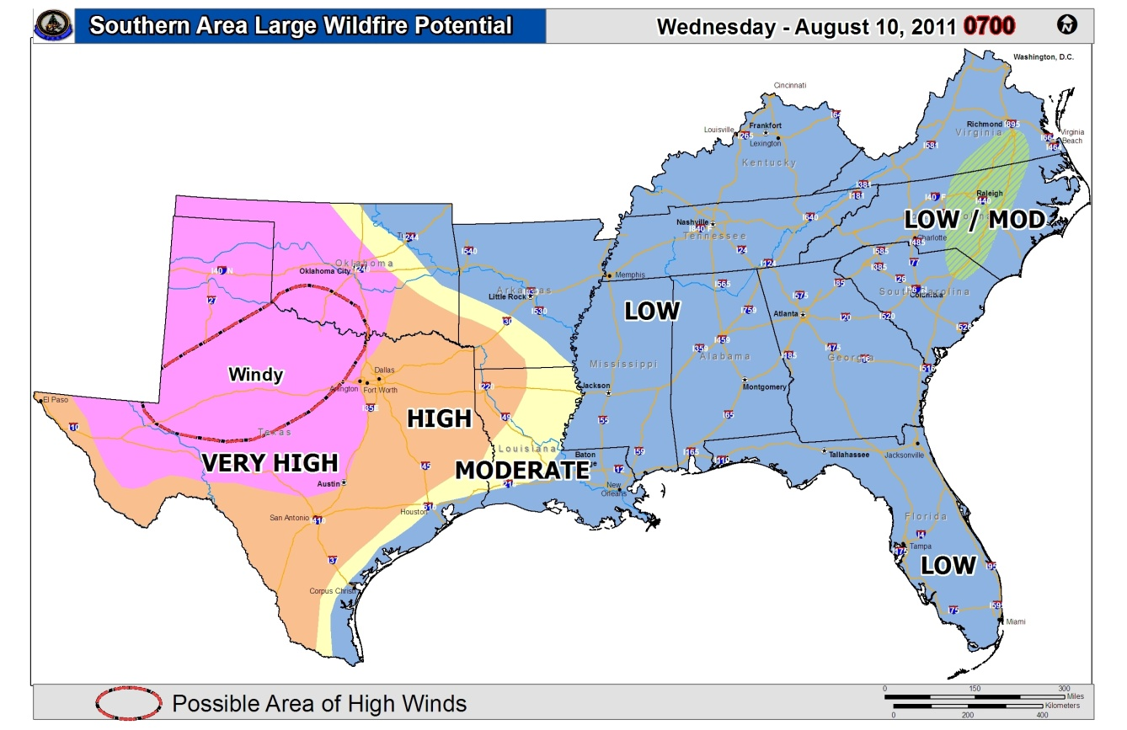

This product is intended to depict GENERAL fire behavior potential in the Southern Area. Information summarized from various sources applicable to the geographic area scale and is not intended to provide site specific fire behavior conditions. Individual fire behavior forecasts using fuels, weather and topography must be used for specific incidents.

FIRE BEHAVIOR INTERPRETATION:
Visual assessment of active flame length and evaluation of potential effectiveness of various resources and capabilities. The implications of observed or expected fire behavior are critical components of suppression strategies and tactics, in particular terms of determining resistance to control, effectiveness and safety of various resources.
FIRE BEHAVIOR ADJECTIVE RATING | FLAME LENGTH  (FEET) | INTERPRETATION FOR FIRE MANAGEMENT
LOW | 0-4 | Generally attack at the head or flanks are successful, handline should hold fire with very little resistant to control.
MODERATE | 4-8 | Fire is too intense for direct attack at the head. Handline cannot be relied upon, additional support from engine, dozer, tractor plow or air support is needed.
HIGH | 8-11 | Fire can present control problems; torching, crowning and spotting can be expected. Control efforts at head of fire are often ineffective.
VERY HIGH | 11+ | Crown runs, intense surface burning and spotting are common; control efforts at head are ineffective.
EXTREME |  | Although uncommon, can best be described as erratic fire behavior that goes beyond human methods of control or prediction. Rare events such as well developed and sustained fire whirls, independent crowning and plume dominated fire growth.

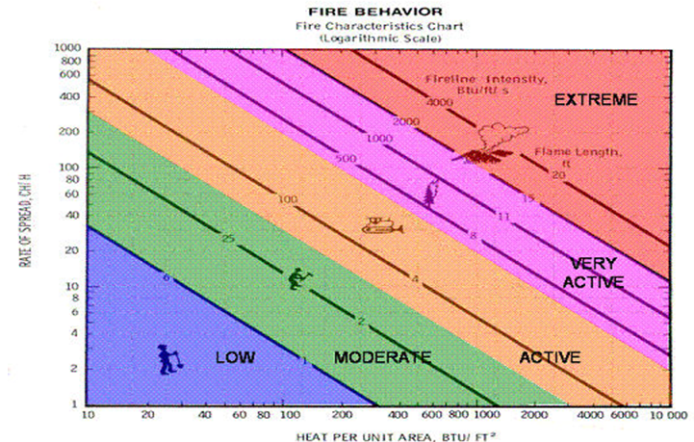
Outlook:
The Hauling Chart is an excellent tool for measuring safety and potential effectiveness of fireline resources. Additionally, the Hauling Chart is also a useful tool to help firefighters get a prespetive on the relative difficulty of constructing and holding a control line as affected by resistance to line construction by fire behavior.

Expect fires in Eastern Texas as the fuels continue to dry over the next several days will become more resistant to control. Northern Arkansas fuel moistures will increase with the recent rains and frontal passage moderating the fire behavior.

Stay updated by viewing the Southern area 7 day Significant Fire Potential product:
http://gacc.nifc.gov/sacc/predictive/outlooks/Fire_Potential.htm
Longer range outlooks reference the Climate Prediction Center link:
http://www.cpc.ncep.noaa.gov/index.php

