SOUTHERN FIRE BEHAVIOR OUTLOOK
FORECAST VALID FOR: August 29, 2011 | DATE/TIME ISSUED: August 29/0930
NEXT UPDATE: August 30, 2011 | SIGNED: Robb Beery

*This is a general fire behavior outlook for the Southern Geographic Area. It is intended to provide wildland fire managers with an overall view of fire behavior potential and to assist wildland firefighters with making sound decisions and maintaining situational awareness based on current and expected fire behavior. This outlook is not intended to replace onsite observations or spot weather forecasts issued by the National Weather Service.

Some products provided in the outlook often are not updated prior to posting. Refer to updated information on the Southern Area Coordination Center Website as it becomes available:
http://gacc.nifc.gov/sacc/index.htm

Fire Weather Summary:
***Red Flag Warnings/Fire Weather Watches and Advisories***
There are Red Flag Warnings today for Central Alabama, Western Florida Panhandle and Fire Weather Watches for the Western end of the Red River Valley in Texas and Oklahoma.

For complete Warning information in Florida: FL NWS Red Flag Warning
For complete Warning information for Alabama: AL NWS Red Flag Warning
For complete Watch information for Oklahoma and Texas: OK/TX NWS Fire Weather Watch

- For complete fire weather information and specific detailed forecasts see:
http://www.weather.gov
- Refer to the MesoWest Regional Surface Maps to access weather observations.
http://mesowest.utah.edu/index.html
- For updated fire danger and fuel moisture values link to:
http://wfas.net/

Fuels Conditions:

State of the Fuels will be updated weekly or as the conditions warrant.

Observed 10 Hr FM Sunday August 28, 2011
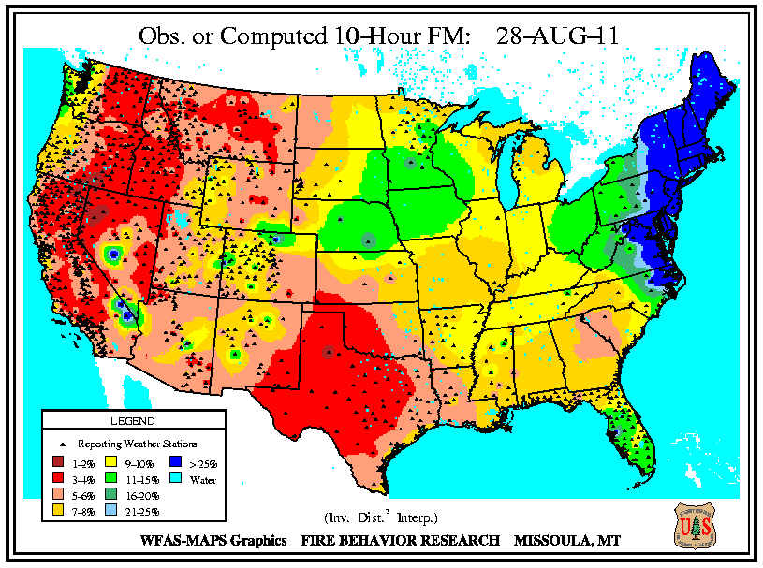

The 10 hour fuel moistures continue to remain at low levels and are becoming low in an increasingly larger area. With lower fuel moistures in the 100 and 1000 hours it is taking longer to control the fires and extinguish the residual heat in the larger fuels. In many areas the larger down fuels are consuming to white ash.

WFAS—10 Hour Forecast Fuel Moisture WFAS — KDBI 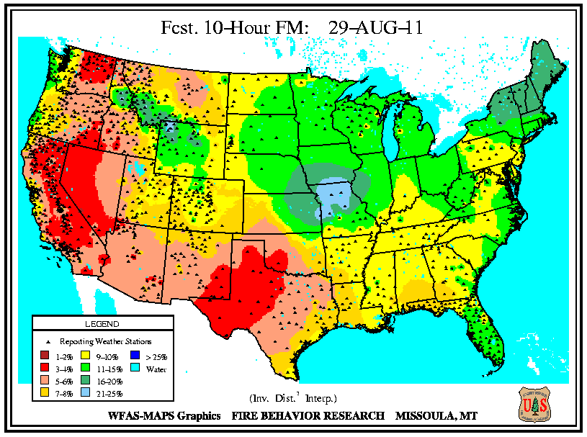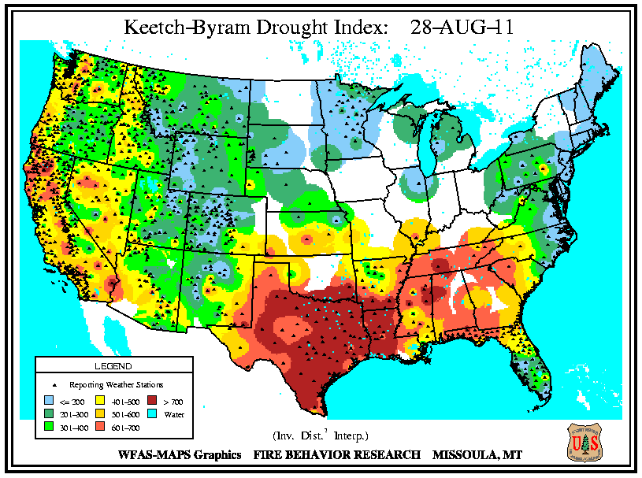

Southern Area – Precipitation for August 28, 2011 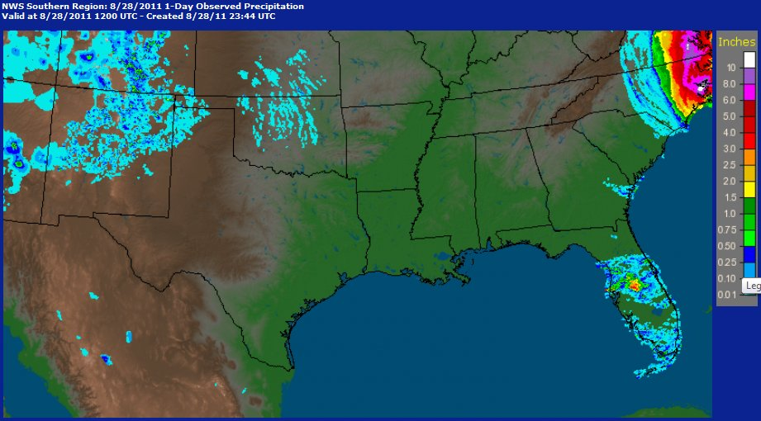

Southern Area ERC-G Summary Ending Aug 28, 2011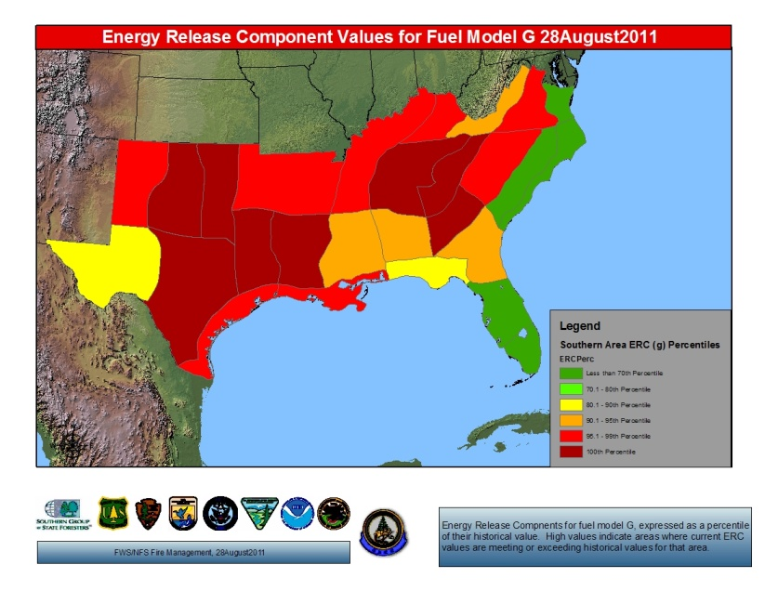

Fire Behavior Outlook

Increased Fire Weather Outlook: A dry air mass caused continues to cover most of the Southern Area. This will dramatically lower daytime RH, reduce overnight RH recovery and increase the drying and availability of 10 and 100 hr fuels. There will also be increased winds that accompany the dry air mass and high atmospheric instability that will encourage large fire growth for any fires that become established.

Central Texas
Very High probability of large fire growth. RH values will become critical over the next few days. Fine fuel moistures continue to be extremely dry. With the Low RH recovery you could see fires become more active earlier in the day. Drought stress on live fuels increases the fuel load and allows rapid escalation to extreme behavior.

Western Texas, North Central Texas, Texas Panhandle, East Texas and Western Oklahoma
High probability of large fire growth. High temperatures combined with low relative humidity and low fine fuel moisture will allow any new starts to have the potential to become a large fire. Low fuel moistures in the larger fuels could increase the intensity of any fires in areas with large ground fuels. Expect to see high rates of spread influence from thunderstorms.

Western Louisiana, Alabama, Mississippi, Western Georgia and Southern Appalachia
Moderate probability of large fire growth. Dry air continues to push down to create low relative humidity and low fine fuel moisture allowing any new starts to have the potential to become a large fire. Fine fuel moistures continue to remain low. Extremely unstable atmospheric conditions can contribute to large fire potential.

Coastal Region of Texas, Eastern Louisiana, Northeast Oklahoma, and Eastern Coastal Areas
Low fire behavior expected. These areas continue to receive some scattered precipitation and ERC remains within seasonal values. The good RH recovery over night and scattered precipitation will help increase the fine fuel moistures. Ignitions may become established but should not spread rapidly.

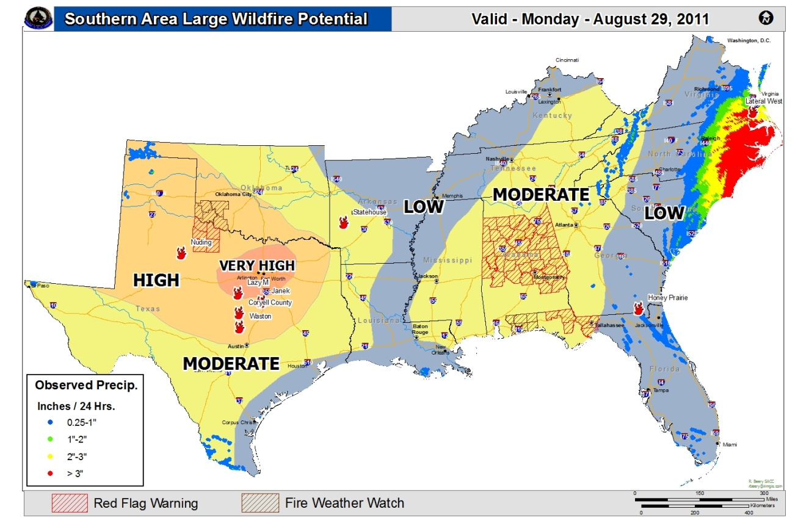

This product is intended to depict GENERAL fire behavior potential in the Southern Area. Information summarized from various sources applicable to the geographic area scale and is not intended to provide site specific fire behavior conditions. Individual fire behavior forecasts using fuels, weather and topography must be used for specific incidents.

FIRE BEHAVIOR INTERPRETATION:
Visual assessment of active flame length and evaluation of potential effectiveness of various resources and capabilities. The implications of observed or expected fire behavior are critical components of suppression strategies and tactics, in particular terms of determining resistance to control, effectiveness and safety of various resources.
FIRE BEHAVIOR ADJECTIVE RATING | FLAME LENGTH  (FEET) | INTERPRETATION FOR FIRE MANAGEMENT
LOW | 0-4 | Generally attack at the head or flanks are successful, handline should hold fire with very little resistant to control.
MODERATE | 4-8 | Fire is too intense for direct attack at the head. Handline cannot be relied upon, additional support from engine, dozer, tractor plow or air support is needed.
HIGH | 8-11 | Fire can present control problems; torching, crowning and spotting can be expected. Control efforts at head of fire are often ineffective.
VERY HIGH | 11+ | Crown runs, intense surface burning and spotting are common; control efforts at head are ineffective.
EXTREME |  | Although uncommon, can best be described as erratic fire behavior that goes beyond human methods of control or prediction. Rare events such as well developed and sustained fire whirls, independent crowning and plume dominated fire growth.

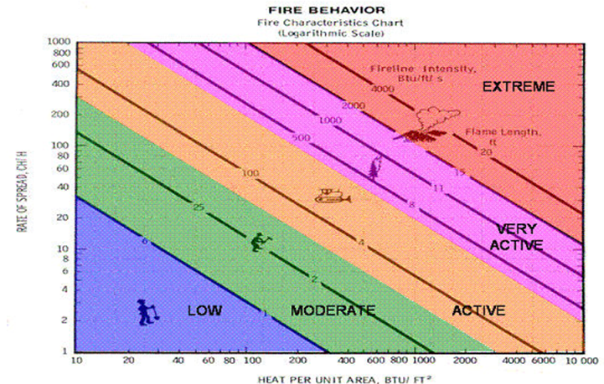
Outlook:
The Hauling Chart is an excellent tool for measuring safety and potential effectiveness of fireline resources. Additionally, the Hauling Chart is also a useful tool to help firefighters get a prespetive on the relative difficulty of constructing and holding a control line as affected by resistance to line construction by fire behavior.

Frontal passage over a fire could see a switch in wind direction. West could see increased fire behavior and large fire potential rise as the high temperatures and low relative humidities continue to dominate the areas. East could see some decrease in the 1 hour fuel moistures with the dry air subsiding from Hurricane Irene. Fires that get established in large fuels and dry soils will prolong incident duration.

Stay updated by viewing the Southern area 7 day Significant Fire Potential product:
http://gacc.nifc.gov/sacc/predictive/outlooks/Fire_Potential.htm
Longer range outlooks reference the Climate Prediction Center link:
http://www.cpc.ncep.noaa.gov/index.php

