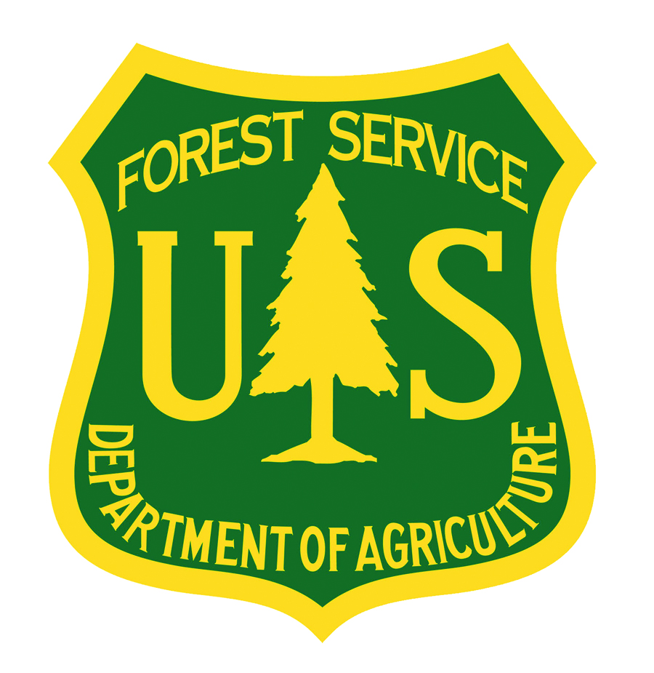
U.S. Forest Service Fire and Aviation Management
Modular Airborne Firefighting Systems (MAFFS) Facts

*The U.S. Forest Service owns 8 operational MAFFS and one spare.

*MAFFS are portable fire retardant delivery systems that can be inserted into military C-130 aircraft to convert them into Airtankers when needed.

*Military C-130s equipped with slide-in MAFFS units can drop up to 3,000 gallons of fire retardant or water on wildfires. They can discharge their entire load over an area one-quarter of a mile long by 60 feet wide in under five seconds or make variable drops. Once the load is discharged, the MAFFS system can be refilled in less than 12 minutes.

*Four military installations provide C-130s to fly MAFFS missions - the 153rd Airlift Wing, Wyoming Air National Guard, Cheyenne; the 145th Airlift Wing, North Carolina Air National Guard, Charlotte; the 146th Airlift Wing, California Air National Guard, Port Hueneme; and the 302nd Airlift Wing, Air Force Reserve, Peterson Air Force Base, Colorado.

*The U.S. Forest Service reimburses the military for all costs associated with MAFFS, per the Economy Act.

*In 2011, MAFFS activations included support to fires in Mexico, Texas, New Mexico, and Arizona.

*The number of MAFFS flights each year varies with wildfire activity. Since 2000, military C-130s equipped with MAFFS systems delivered a total of approximately 10.3 million gallons of retardant on wildfires, an average of about 850,000 gallons per year, as follows:

2000 – 2.1 million gallons
2001 - .5 million gallons
2002 – 1.6 million gallons
2003 - .15 million gallons
2004 - .87 million gallons
2005 - .88 million gallons
2006 – 1.5 million gallons
2007 - .2 million gallons
2008 – 1.3 million gallons
2009 – 0 gallons
2010 – 12,000 gallons
2011 – 1.2 million gallons

