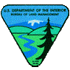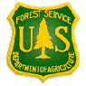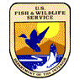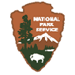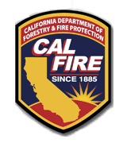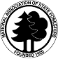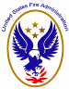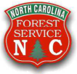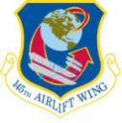

National Interagency Fire Center
3833 S. Development Avenue
Boise, Idaho 83705

May 10, 2012

Dear Friend:

From May 7 through 10, 2012, MAFFS 7 and MAFFS 8 of the Air National Guard 145th Airlift Wing from Charlotte, North Carolina conducted recertification training out of Greenville, South Carolina. Personnel from different federal agencies supported the effort and worked closely with the crews of the 145th Airlift Wing. This was essential recertification training for the air crews. The recertification training was completed as anticipated and was very successful. These aircraft and their crews are now ready to actively support wildland fire suppression efforts anywhere they are asked to go.

On behalf of all of the MAFFS pilots and crews, and on behalf of all of the MAFFS activation managers, dispatchers, mechanics, and other support personnel, we thank you for your part in supporting this MAFFS effort. Please extend our appreciation to those on your staff who helped make this training effort a success.

Sincerely,

Frank Domingues, MLO
MAFFS Liaison Officer

