

[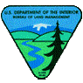](http://www.blm.gov/)[](http://www.fs.fed.us/)[](http://www.fws.gov/)[](http://www.nps.gov/)[](http://www.bia.gov/)[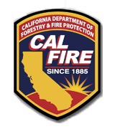](http://www.fire.ca.gov/)